Neural Network From Scratch
— and in PyTorch —
A Complete Beginner's Guide to This Project
This document explains, in plain language, what this project is, why it exists, and how every piece of it works — written for a reader with no prior knowledge of neural networks, Python, or the math involved.

1. What Is This Project, in One Paragraph?
This project builds a very small artificial brain called a neural network twice. The first version is built completely from scratch, using nothing but basic math operations, so that every single step the network performs is visible and explained. The second version builds the exact same thing again, but using a popular professional tool called PyTorch, which real companies use to build much larger versions of the same idea. Both versions are then compared side by side to prove they learn the same thing, confirming that the hand built version is correct.
Why build it twice?
Building it from scratch proves you understand what is happening underneath. Building it again in PyTorch proves you can also use the professional tool that real-world projects rely on. Showing both, side by side, with matching results, is much stronger proof of understanding than either one alone.

Who is this document for?
This document assumes no prior background. It does not assume you know what a neural network is, what Python or PyTorch are, or what calculus terms like 'derivative' or 'gradient' mean. Every term is explained the first time it appears.

2. What Is a Neural Network?
A neural network is a mathematical system, loosely inspired by how brain cells (neurons) connect to each other, that learns to turn an input into a correct output by looking at many examples.
Think of it like teaching a child to recognize the difference between cats and dogs. You don't explain the rules in words you just show many photos labeled 'cat' or 'dog', and over time the child's brain adjusts itself until it gets better at telling them apart. A neural network does the same thing, except the 'adjusting' is done with numbers and math instead of biology.

The basic building block: a neuron
A single neuron in this kind of network does one simple thing. It takes some numbers in, multiplies each one by an importance value (called a weight), adds them all up, adds one more adjustment number (called a bias), and then passes the result through a simple shaping function. That's the entire job of one neuron. A real network is just many of these neurons, arranged in layers, connected together.

Why 'layers'?
Neurons are organized into layers. The first layer receives the raw input (for example, two numbers). Each following layer takes the previous layer's output as its own input. The final layer produces the network's answer. A network with at least one layer in between the input and the output is called a layer in the 'hidden' position hence the common term hidden layer.
Why do we need a hidden layer at all?
Some problems cannot be solved by a network with no hidden layer, no matter how it's tuned. This project uses exactly this kind of problem (explained in the next section) specifically to demonstrate why hidden layers matter.

What does 'learning' actually mean here?
Learning means slowly adjusting every weight and bias in the network, a tiny bit at a time, so that the network's answers get closer and closer to the correct answers across many repeated attempts. This adjustment process has a name gradient descent and it is one of the central ideas explained later in this document.

3. The Problem This Project Solves: XOR
Before building anything, every machine learning project needs a problem to solve. This project uses a famous, deliberately small problem called XOR (pronounced 'ex-or', short for 'exclusive or').
XOR takes two numbers, each either 0 or 1, and produces one answer, also 0 or 1, following this rule: the answer is 1 if the two input numbers are different from each other, and 0 if they are the same.
Input A | Input B | Correct Answer
0 | 0 | 0
0 | 1 | 1
1 | 0 | 1
1 | 1 | 0

Why is this problem special?
Imagine plotting these four pairs of numbers as four dots on a piece of graph paper. The two pairs that should produce '1' end up on opposite corners of a square, and the two pairs that should produce '0' end up on the other two opposite corners. If you try to draw a single straight line on that graph to separate the '1' dots from the '0' dots, it is mathematically impossible —every straight line you try will always have at least one dot on the wrong side.
Why this matters: A network with no hidden layer can only ever draw a straight line to make its decisions. Since no straight line can solve XOR, this problem proves concretely, not just in theory why a hidden layer is necessary. A hidden layer lets the network bend that straight line into a curve, or really, into multiple straight-line pieces that combine to act like a curve.
This exact limitation was famously pointed out by researchers Minsky and Papert in 1969, and it is part of why neural networks with hidden layers became the standard approach going forward.

4. The Math Behind It (Explained Simply)
This section explains every mathematical idea used in this project, one at a time, in plain language first and then with the actual formula. None of this requires advanced math background — just basic arithmetic and a willingness to follow each idea slowly.

4.1 — Vectors and Matrices (just organized lists of numbers)
A vector, in this project, is just a list of numbers. For example, the XOR input (1, 0) is a vector with two numbers in it. A matrix is a grid of numbers like a spreadsheet made up of rows and columns. In this project, every layer's collection of weights is stored as a matrix, because each neuron needs its own row of weight values, one weight per input it receives.

4.2 — What a Weight and a Bias Actually Are
A weight is a number that controls how much one particular input matters to one particular neuron. A large positive weight means 'this input strongly increases my output.' A large negative weight means 'this input strongly decreases my output.' A weight near zero means 'I mostly ignore this input.'
A bias is a single extra adjustment number added on top, letting a neuron shift its decision point even if every input were zero — similar to a 'default leaning' a neuron has before it even looks at any input.

4.3 — The Forward Pass (how a prediction is made)
The 'forward pass' is the process of taking an input and producing a prediction. For one layer, it happens in two simple steps:
- Multiply every input by its matching weight, add them all together, then add the bias. This combined result is usually called z.
- Pass z through a shaping function (explained next), producing the layer's actual output.
z = (weight1 * input1) + (weight2 * input2) + ... + bias
output = shaping_function(z)
This output then becomes the input to the next layer, and the same two steps repeat, until the final layer produces the network's overall prediction.

4.4 — The Shaping Function (“Activation Function”)
Without a shaping step, stacking layers would be pointless mathematically, multiple plain layers stacked together collapse down into being exactly the same as just one layer. The shaping function, properly called an activation function, is what gives a network the ability to bend and curve its decisions instead of staying limited to straight lines.
This project uses two different shaping functions, depending on the situation:
- Sigmoid — squeezes any number into a result between 0 and 1. Useful for a final answer that should look like a yes/no probability.
- ReLU — short for 'Rectified Linear Unit.' Its rule is simple: if the number is negative, output zero; otherwise, output the number unchanged. ReLU turns out to help networks learn faster and more reliably in many cases, for reasons explained later in this document.

4.5 — Loss: How 'Wrongness' Is Measured
After making a prediction, the network needs a single number describing how wrong that prediction was. This project uses a method called Mean Squared Error: subtract the correct answer from the prediction, square the result (multiply it by itself), and that squared number is the 'loss.' A loss of zero means a perfect prediction; bigger loss values mean bigger mistakes.
loss = (prediction - correct_answer)^2
Squaring matters for two reasons: it makes big mistakes count much more heavily than small ones, and it keeps the function smooth, which the next section depends on.

4.6 — Gradient Descent: How the Network Actually Learns
Once we know how wrong a prediction was, we need to know which direction to adjust every weight to make it less wrong next time. This is what a derivative tells us in calculus: given a small change to one number, how much does another connected number change in response? Applied here, a derivative answers: 'if I nudge this one weight slightly, does the loss go up or down, and by how much?'
Once we know that direction for every single weight in the network, we move every weight a small step in the direction that reduces the loss. This step-by-step process is called gradient descent, and the size of each step is controlled by a setting called the learning rate.
weight = weight - (learning_rate * direction_to_reduce_loss)
A practical note on learning rate: too large a learning rate causes the network to overshoot and bounce around erratically without settling; too small a learning rate makes learning correct but extremely slow. Finding a reasonable middle ground is part of training any neural network.

4.7 — Backpropagation: Finding the Direction for Every Weight, Efficiently
A network with multiple layers has many weights, all affecting the final loss indirectly, through each other. Backpropagation is the technique used to efficiently work out the 'direction to adjust' (the derivative) for every single weight in every layer, by starting at the output layer (where the loss is known directly) and working backward, layer by layer, toward the input.
This 'working backward' process relies on a calculus idea called the chain rule, which says: if A affects B, and B affects C, then to find out how A affects C, you can multiply together how A affects B and how B affects C. Backpropagation applies this idea over and over, layer after layer, all the way from the output back to the very first layer which is exactly why it's called 'back'-propagation.

5. Part One: Building It From Scratch
This part of the project builds the entire neural network using only basic numerical operations, with no machine learning library doing any of the work automatically. This is done using a programming language called Python, and a helper library called NumPy, which is simply a tool that makes working with lists of numbers (vectors) and grids of numbers (matrices) fast and convenient.

5.1 — File: neural_network.py
This file contains two building blocks, written as what programmers call 'classes' think of a class as a blueprint or template for creating an organized object that holds both data and the actions that can be done with that data.
- Layer — represents one layer of neurons. It stores that layer's weights and bias, and knows how to do a forward pass and a backward pass for itself.
- Network — represents the whole stack of layers, chained together. It knows how to run a full forward pass through every layer in order, and a full backward pass through every layer in reverse order.

5.2 — How the Layer Building Block Works
When a Layer is first created, it fills its weights with small random numbers, rather than zeros. This matters: if every weight started out identical, every neuron in that layer would always behave identically too, forever they would never become different from each other, no matter how much training happened. Starting with small random values avoids this problem.
During the forward pass, the Layer remembers the input it received and the result before shaping (the value called z, from section 4.3). It needs to remember these because the backward pass, which happens later, needs them to calculate its directions correctly.
During the backward pass, the Layer receives a signal from the layer after it, saying 'here is how sensitive the final loss is to each of your outputs.' Using that signal, plus the remembered input and z value, the Layer calculates three things: how much to adjust its own weights, how much to adjust its own bias, and what signal to pass backward to the layer before it. That third item is the entire reason this process is called backpropagation every layer hands a signal back to the one before it.

5.3 — How the Network Building Block Works
The Network simply holds a list of Layer objects, in order. Its forward pass calls each layer's forward pass one at a time, feeding each layer's output into the next layer as input. Its backward pass does the same thing, but in reverse order, starting from the last layer and ending at the first.
The Network also has a method (an available action) called train_step, which performs one complete round of learning on one example: run a forward pass to get a prediction, calculate the loss, calculate the initial backward signal from that loss, then run the backward pass through every layer.

5.4 — File: train_xor.py
This file actually uses the building blocks above to solve the XOR problem. It does five things, in order:
- Defines the four XOR examples and their correct answers.
- Creates a Network with 2 inputs, 4 hidden neurons, and 1 output.
- Repeats the training step thousands of times (each full pass through all four examples is called an epoch), recording the loss each time.
- Prints the network's final predictions, to confirm they now match the correct answers.
- Draws a chart of how the loss changed over time, and saves it as an image.
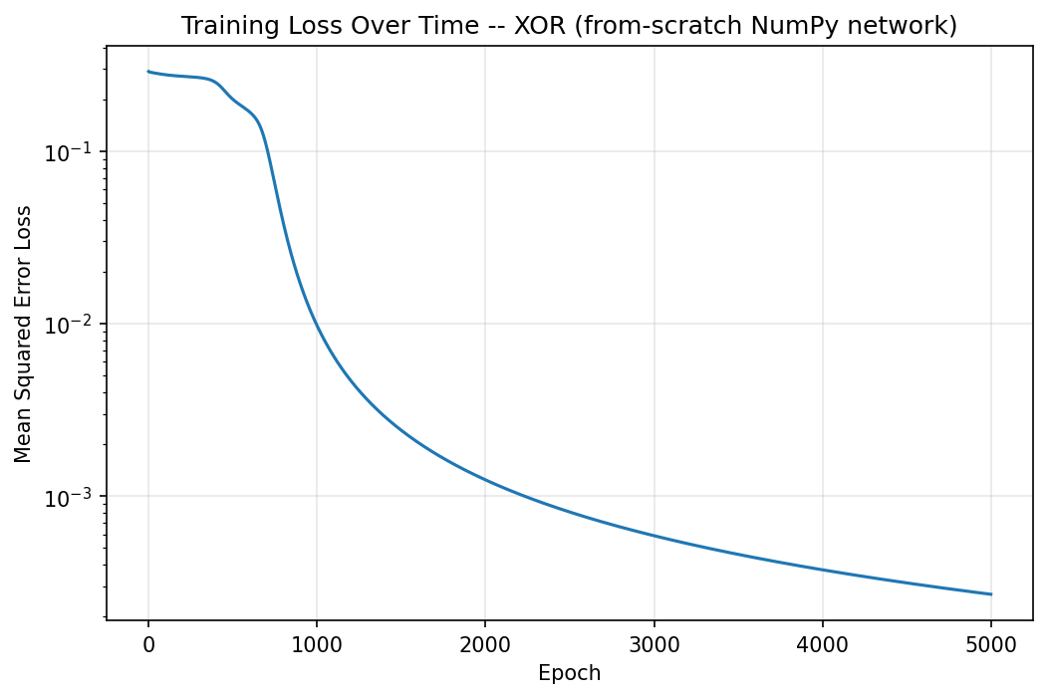
Figure 1 — Loss over time for the from-scratch network, trained on XOR. The loss starts around 0.29 and drops to about 0.0003, proving the network learned successfully.
Notice the shape of this chart: the loss stays roughly flat for the first several hundred rounds, then drops sharply, then continues improving slowly for the rest of training. This is a very common and recognizable pattern in neural network training, not a sign of anything going wrong.

6. Part Two: Rebuilding It in PyTorch
PyTorch is a free, widely used software library that companies and researchers rely on to build real, large-scale neural networks. This part of the project rebuilds the exact same network from Part One, but using PyTorch's tools instead of hand-written code, to show both that the same understanding transfers to a professional tool, and that the results match.

6.1 — The Single Biggest New Idea: Automatic Differentiation
In Part One, every single step of the backward pass every direction calculation was written out by hand. PyTorch automates this entire process using a feature called autograd (short for 'automatic gradient calculation'). As PyTorch runs the forward pass, it secretly keeps a record, behind the scenes, of every mathematical operation that happened. Later, when asked to run the backward pass, it replays that record in reverse, automatically working out every direction needed without a programmer writing a single line of backward-pass math by hand.
Important: this is not a different kind of math. It is the exact same chain-rule process from section 4.7, just performed automatically by the library instead of manually by a person.

6.2 — File: pytorch_network.py
This file defines the network using PyTorch's standard building block for any trainable model, called nn.Module. Inside it, instead of manually creating a weights grid and a bias list as in Part One, the code creates two nn.Linear objects PyTorch's built-in version of exactly what a Layer was in Part One. Each nn.Linear object automatically creates and stores its own weights and bias internally.
The forward pass here looks almost identical in spirit to Part One's: run the input through the first layer, apply a shaping function, run that result through the second layer, apply a shaping function again, and return the result as the prediction.

6.3 — File: train_xor_torch.py
This file trains the PyTorch network on the same XOR data. The overall shape of the process is the same as Part One (repeat: predict, measure loss, adjust, repeat), but the actual adjustment step uses three specific PyTorch instructions, always called in this exact order:
- optimizer.zero_grad() — clears out any leftover direction information from the previous round. This step exists because PyTorch, by default, adds new direction calculations on top of old ones rather than replacing them so without clearing first, old and new calculations would incorrectly mix together.
- loss.backward() — tells PyTorch to perform the entire automatic backward pass described in section 6.1.
- optimizer.step() — applies the gradient descent adjustment (section 4.6) to every weight and bias in the network, all at once.
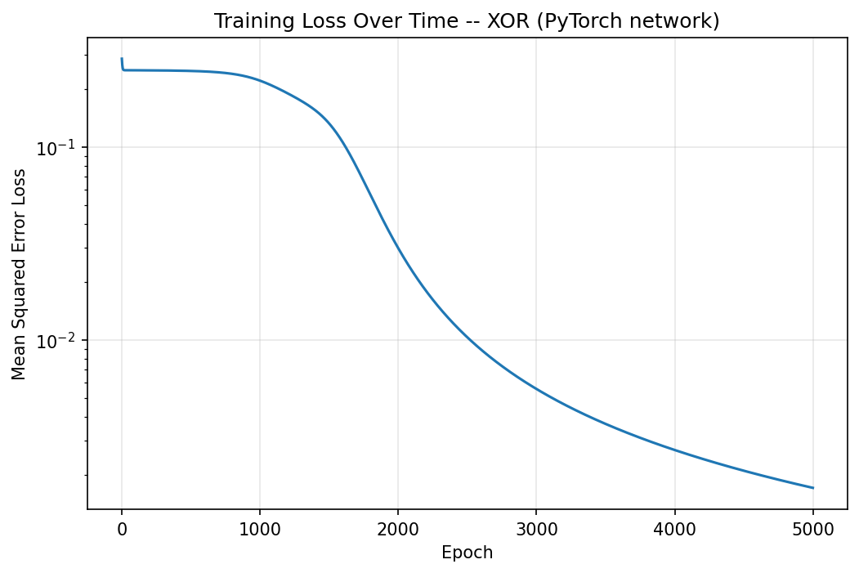
Figure 2 — Loss over time for the PyTorch version, trained on the same XOR problem. The overall shape matches Figure 1, confirming similar learning behavior.

7. Comparing Both Versions
A separate file, compare_losses.py, trains both versions the from-scratch one and the PyTorch one back to back, using identical settings, and then draws both of their loss charts on the very same graph. This single chart is the strongest piece of evidence in the whole project.
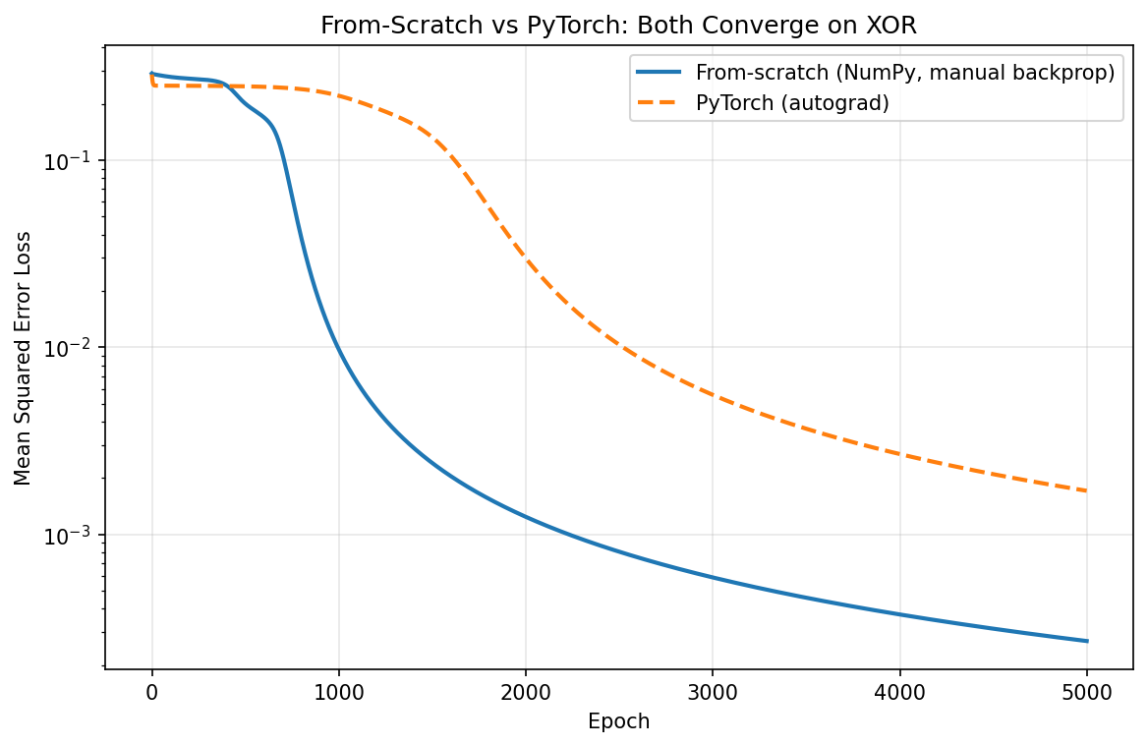
Figure 3 — Both versions overlaid on one chart. Both curves trend downward toward a very small loss, confirming the hand-written backward-pass math agrees with PyTorch's automatic version.
The two lines are not perfectly identical, and that is expected, not a mistake. Part One updates its weights after looking at each individual example one at a time, while the PyTorch version updates its weights after looking at all four examples together at once (a technique called batching). Different update timing naturally produces a slightly different learning curve, even though both are solving the exact same underlying math.

Summary comparison table
Concept | From Scratch | PyTorch
Weights & bias | Created manually with random numbers | Created automatically by nn.Linear
Forward pass | Written out by hand, step by step | Same idea, using built-in PyTorch pieces
Remembering values for later | Manually stored by the programmer | Done automatically by PyTorch's autograd
Backward pass | Entirely hand-written chain-rule math | One line: loss.backward()
Weight adjustment | Hand-written subtraction formula | One line: optimizer.step()
Clearing old directions | Not needed — recalculated fresh each time | Required: optimizer.zero_grad()

8. A Harder Test: The Moons Dataset
XOR only has four data points, which makes it an excellent first example but a poor one for actually seeing the shape of what a network has learned. To see an actual learned boundary, this project also trains the PyTorch network on a different, richer dataset called 'moons' two curved, crescent-shaped clusters of points, generated using a tool called scikit-learn, that, like XOR, cannot be separated by a single straight line.

8.1 — How a Decision Boundary Picture Is Made
The picture is not drawn directly. Instead, the program covers the entire picture area with a fine grid of thousands of points, asks the trained network to make a prediction for every single one of those points, and colors each point according to its prediction. The boundary line that appears is simply the place where the coloring flips from one prediction to the other — it emerges naturally out of thousands of individual predictions, rather than being calculated as one single curve.

8.2 — A Real Problem That Came Up, and How It Was Fixed
The first attempt at this used the same Sigmoid shaping function as the XOR network. Training got stuck: the loss stopped improving at a fairly high value, and the resulting boundary picture showed only a single straight line, even though this problem needed a curve to be solved properly.
The cause is a well-known issue called the vanishing gradient problem. Recall from section 4.6 that learning depends on calculating a direction (a derivative) for every weight. Sigmoid's derivative is never larger than 0.25, and shrinks toward zero quickly the further its input is from the middle. In a network with several layers, these small numbers get multiplied together repeatedly during the backward pass, and the result can shrink so much that learning effectively stalls.
The fix: switching the hidden layer's shaping function to ReLU, introduced in section 4.4. ReLU's derivative is exactly 1 for any positive input, so it does not shrink the direction signal as it passes backward through it. This single change allowed training to continue improving well past the point where it previously got stuck, and the boundary picture changed from a straight line into a properly curved shape.
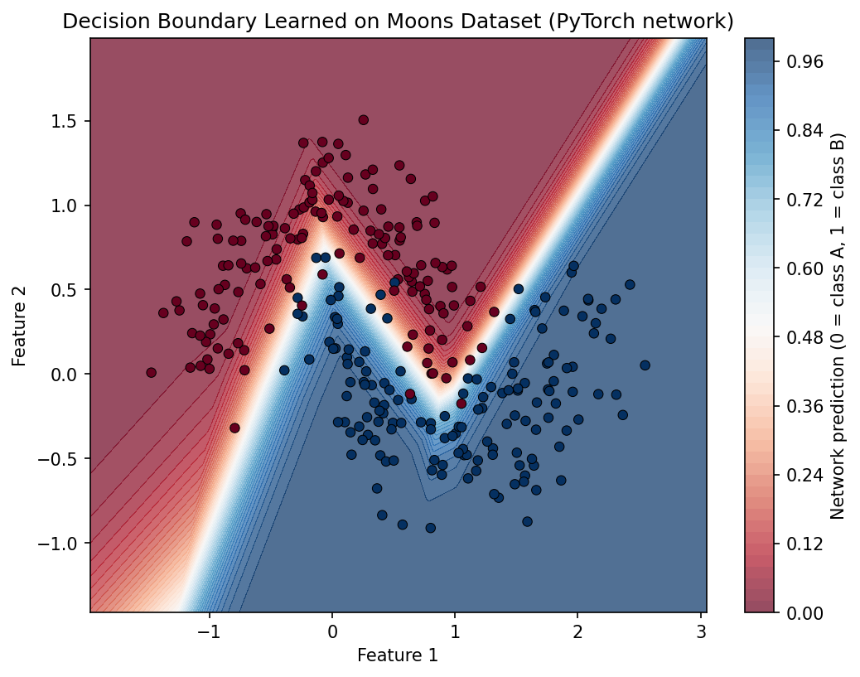
Figure 4 — The decision boundary learned on the moons dataset, after switching to ReLU. Notice the boundary bends in straight-line segments to follow the crescent shapes, rather than curving smoothly.
The slightly angular, 'kinked' look of this boundary is not an imperfection it is a direct and expected consequence of using ReLU, which itself only ever produces flat, straight-line segments. A network using Sigmoid or a similar smooth shaping function instead would have produced a smoother, rounded-looking boundary.

9. Project File Structure
All of the files described in this document are organized into folders as follows:
nn-from-scratch-and-pytorch/
|-- from_scratch/
| |-- neural_network.py (Layer and Network building blocks, hand-written)
| `-- train_xor.py (trains the from-scratch network on XOR)
|-- pytorch_version/
| |-- pytorch_network.py (same network, built using PyTorch)
| `-- train_xor_torch.py (trains the PyTorch network on XOR)
|-- compare_losses.py (runs both versions, plots both loss curves together)
|-- decision_boundary.py (trains on the moons dataset, draws the boundary picture)
|-- outputs/ (all generated chart images are saved here)
`-- requirements.txt (the list of tools this project depends on)

What each tool/library mentioned in this project actually is
- Python — the programming language all of this code is written in. Widely used in data science and machine learning.
- NumPy — a Python library for fast, convenient work with vectors and matrices (lists and grids of numbers).
- Matplotlib — a Python library used to draw charts and graphs, such as the loss curves in this document.
- PyTorch — a professional machine learning library, used throughout the real-world industry, that automates much of the manual work shown in Part One.
- scikit-learn — a Python library that includes ready-made tools for generating sample datasets, such as the moons dataset used in section 8.

10. Glossary of Every Term Used in This Document
Term | Meaning
Neural network | A system of connected, simple math units (neurons), organized in layers, that learns to map inputs to correct outputs from examples.
Neuron | A single unit that multiplies its inputs by weights, adds a bias, and applies a shaping function.
Layer | A group of neurons that all receive the same input and pass their output onward together.
Hidden layer | Any layer that sits between the input and the final output layer.
Weight | A number controlling how strongly one input affects one neuron's output.
Bias | An extra adjustable number added to a neuron's calculation, independent of its inputs.
Forward pass | The process of feeding an input through the network to produce a prediction.
Backward pass / Backpropagation | The process of working backward from the loss to determine how every weight and bias should be adjusted.
Activation function | A shaping function applied after a neuron's weighted sum, allowing the network to learn curves rather than only straight lines. Examples used here: Sigmoid, ReLU.
Loss | A single number measuring how wrong a prediction was, compared to the correct answer.
Mean Squared Error | The specific method this project uses to calculate loss: square the difference between prediction and correct answer.
Gradient | The calculated 'direction and amount' to adjust a particular weight or bias to reduce the loss.
Gradient descent | The technique of repeatedly nudging every weight and bias slightly in the direction that reduces loss.
Learning rate | A setting controlling how large each adjustment step is during gradient descent.
Epoch | One complete pass through the entire set of training examples.
Derivative | A calculus concept describing how much one quantity changes in response to a small change in another.
Chain rule | A calculus rule allowing the effect of A on C to be calculated by multiplying the effect of A on B by the effect of B on C, when A affects C only through B.
Vanishing gradient problem | A training problem where gradients shrink too much while passing backward through multiple layers, causing learning to stall.
Autograd | PyTorch's feature that automatically performs backpropagation, without requiring hand-written backward-pass code.
nn.Module | PyTorch's standard base structure for building any trainable network.
nn.Linear | PyTorch's built-in version of a single layer, automatically managing its own weights and bias.
Optimizer | A PyTorch object responsible for applying the gradient descent update to every weight and bias.
Batching | Processing multiple training examples together at once, instead of one at a time.
Decision boundary | The dividing line (or curve) a trained network uses to separate one predicted category from another.
XOR | A simple logic problem used in this project specifically because it cannot be solved without a hidden layer.
Reproducibility | Setting a fixed starting point for random numbers (a 'seed') so that running the same code twice produces the exact same result both times.

11. What This Project Demonstrates, in Summary
- A working understanding of how a neural network makes a prediction (the forward pass).
- A working understanding of how a neural network learns from its mistakes (loss, gradients, backpropagation, gradient descent).
- The ability to translate that understanding into both raw, hand-written code and a professional library (PyTorch).
- The ability to verify a hand-written implementation is correct, by comparing it against a trusted, professional tool.
- Encountering and correctly diagnosing a real training problem (vanishing gradients), and fixing it appropriately (switching to ReLU).
Together, these pieces show not just that code was written and ran successfully, but that the underlying mathematical and computational ideas behind it are genuinely understood.

