**SMART SDLC – AI – ENHANCED SOFTWARE DEVELOPMENT LIFECYCLE**

**1.Introduction**

Team Leader : DIVYA DHARSHINI.R

Team Member : KAVYA.R

Team Member : PAVITHRA.R

Team Member : THEJA SREE.P

Team Member :THILAGAVATHY.S

**2. Project Overview**

* **Purpose**:The purpose of this project is to build an AI-powered tool that analyzes software requirement documents (PDFs or text input) and automatically generates code in different programming languages.
* It helps developers quickly transform requirements into structured formats and working code, reducing manual effort and speeding up the software development lifecycle.

**Features**:

**Requirement Analysis**

***Key Point*:** Structured analysis

***Functionality*:** Extracts functional, non-functional, and technical requirements.

**Code Generation**

***Key Point*:** AI-powered code writing

***Functionality*:** Generates code in Python, JavaScript, Java, C++, and more.

**PDF Support**

***Key Point*:** Document input flexibility

***Functionality*:** Extracts text from PDF files using PyPDF2.

**Interactive UI (Gradio)**

***Key Point*:** User-friendly interface

***Functionality*:** Provides a tabbed interface with sections for analysis and code generation.

**3. Architecture**

* **Frontend (Gradio)**:  
  Provides an easy-to-use web UI with tabs for *Code Analysis* and *Code Generation*. Supports PDF uploads, text inputs, and real-time outputs.
* **Backend (Transformers + PyTorch)**:  
  Uses IBM Granite LLM for analyzing requirements and generating code. Runs on CPU or GPU (if available) for efficient inference.
* **PDF Processing (PyPDF2)**:  
  Extracts and processes text from uploaded documents for requirement analysis.

**4. Setup Instructions**

**Prerequisites:**

* Python 3.9 or later
* pip & virtual environment tools
* Required libraries: torch, transformers, gradio, PyPDF2

**Installation Process:**

1. Clone the repository.
2. Install dependencies:
3. pip install -r requirements.txt
4. Run the project:
5. python smartsdlc.py
6. A Gradio shareable link will open for usage.

**5. Folder Structure**

project/

│

├── smartsdlc.py # Main project script

├── requirements.txt (optional)

└── (future modules can be added here)

**6. Running the Application**

* Launch the script with python smartsdlc.py.
* Access the Gradio UI in your browser.

Navigate between:

**Code Analysis Tab** → Upload PDF or type requirements → Get structured analysis.

**Code Generation Tab** → Describe requirement → Select language → Generate AI code.

**7. API / Function Documentation**

**generate_response(prompt, max_length)** – Sends a prompt to Granite LLM and returns response.

**extract_text_from_pdf(pdf_file)** – Reads and extracts text from PDF.

**requirement_analysis(pdf_file, prompt_text)** – Organizes requirements into categories.

**code_generation(prompt, language)** – Generates code in the specified language.

**8. Authentication**

(Current version runs in open environment. Future updates may add:)

* API Key / Token Authentication
* Role-based access control
* User session history tracking

9. User Interface

**Sidebar with tabs**:

*Code Analysis* → PDF upload / text input → Requirement breakdown.

*Code Generation* → Requirement input → Select language → Generated code output.

**Real-time outputs**: Textboxes display results instantly.

**10. Testing**

**Unit Testing**: Verified PDF text extraction and LLM response functions.

**API Testing**: Checked Gradio UI interactions with functions.

**Manual Testing**: Uploaded various PDFs and generated code outputs.

**Edge Case Handling**: Empty PDFs, large text inputs, invalid file formats.

**11. Screenshots**

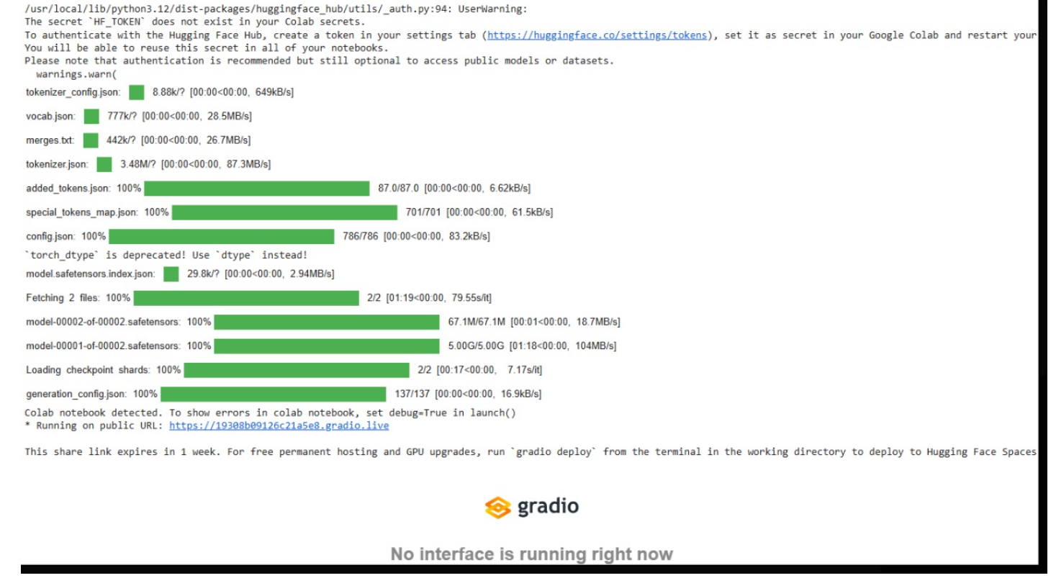

**12. Known Issues**

* Large PDFs may take longer to process.
* Code generation accuracy depends on clarity of requirements.

**13. Future Enhancements**

* Multi-file project code generation.
* Direct code export (ZIP file).
* GitHub auto-commit integration.
* User authentication and session history.