Smart water management

A smart water management project is an initiative aimed at optimizing water usage, reducing waste, and ensuring the efficient and sustainable management of water resources. Such projects often leverage advanced technologies and data-driven solutions to achieve these goals. Here are the key components and aspects of a smart water management project:

**IoT Sensors and Devices:**

Installation of IoT-enabled water meters, sensors, and devices to collect real-time data on water consumption, quality, and infrastructure condition.

**Data Collection and Analysis:**

Gathering and analyzing data from IoT devices to monitor water usage patterns, identify leaks, and assess water quality.

Use Python, Node.js, or other server-side languages and libraries to handle data efficiently.

**Web-Based Data Platforms:**

Create a web-based platform or dashboard where data from various water-related sources, such as IoT sensors and meters, can be collected and visualized in real-time.

Utilize web technologies, like React Native or Flutter, to build cross-platform mobile apps.

**Remote Monitoring and Control:**

Enable remote monitoring and control of water infrastructure, allowing operators to make real-time adjustments and respond to issues promptly.

**Data Visualization**:

Use web technology to create interactive charts, graphs, and maps that display water consumption, water quality, and infrastructure data in a user-friendly manner.

**Alerting and Notifications:**

Set up alerting systems that send notifications through web and mobile apps when anomalies or critical events occur, such as leaks or contamination.

**User Portals:**

Develop web-based user portals that allow consumers and stakeholders to access their water consumption data, view bills, and receive personalized insights.

**Mobile Apps for Remote Access:**

Create mobile apps that provide users with remote access to water management features, including monitoring and controlling water-related devices.

**Data Security:**

Implement robust security measures to protect sensitive data and ensure the privacy of user information, particularly

Use HTTPS for secure data transmission and ensure that user data remains private.

**User Authentication**:

Implement user registration and authentication to secure user accounts and data.

**Testing and Quality Assurance:**

Thoroughly test the mobile app and IoT device communication to ensure it works reliably and securely.

**Reporting and Analytics:**

Offer reporting and analytics tools through web applications, allowing users to generate customized reports on water usage and infrastructures

**Python program For connecting mobile app with smart water management iot program**

From flask import Flask, request, jsonify

App = Flask(__name__)

# Endpoint to receive water data from the mobile app

@app.route(‘/update_water_data’, methods=[‘POST’])

Def update_water_data():

Data = request.get_json()

# Process and store the water data

# Your logic here…

Return jsonify({‘message’: ‘Water data received successfully’})

# Endpoint to retrieve water data for the mobile app

@app.route(‘/get_water_data’, methods=[‘GET’])

Def get_water_data():

# Retrieve and send water data to the mobile app

# Your logic here…

Water_data = {‘temperature’: 25, ‘ph_level’: 7.2} # Replace with actual data

Return jsonify(water_data)

If __name__ == ‘__main__’:

App.run(debug=True)

This is a basic Flask app with two endpoints: one for updating water data and another for retrieving water data

Connecting Mobile app with Smart water Management IOT Project:

To connect a mobile app with a smart water management IoT project, you need to establish a communication interface between the app and the IoT devices or sensors. Here’s a step-by-step guide on how to do it

**Iot device Setup:**

Set IoT devices, such as water meters, sensors, or valves, that are compatible with your smart water management project.

**Hardware setup:**

Use a water management sensor (like a ultrasonic sensor,water level sensor,) with Arduino to measure water levels.

Connect the sensor to Arduino according to its datasheet.

Connect Arduino to an IoT module (e.g., ESP8266, ESP32) for internet connectivity.

**Mobile App Development:**

- Develop the mobile app for iOS and/or Android using the relevant development tools and programming languages (Swift/Kotlin for native development, or JavaScript/Flutter for cross-platform development).

**Cloud Setup:**

Create an account on a cloud platform that supports IoT data storage (e.g., ThingSpeak, Firebase).

**Programming the Arduino:**

Write the code to read data from sensors and control actuators. Use libraries if available for the specific sensors you’re using.

Implement logic for collecting and storing data over time.

Set up communication interfaces (e.g., Wi-Fi, GSM, LoRa) to send data to a central server or cloud platform for remote monitoring and control

**Construct the Request:**

Create an HTTP request with the necessary details. This includes the request method (GET, POST, PUT, DELETE, etc.), the URL of the API or server you want to communicate with, headers, and, if necessary, request parameters or a request body..

By following these steps, you can create a connection between your mobile app and the smart water management IoT project, providing users with real-time access to water-related data and the ability to control water systems from their mobile devices.

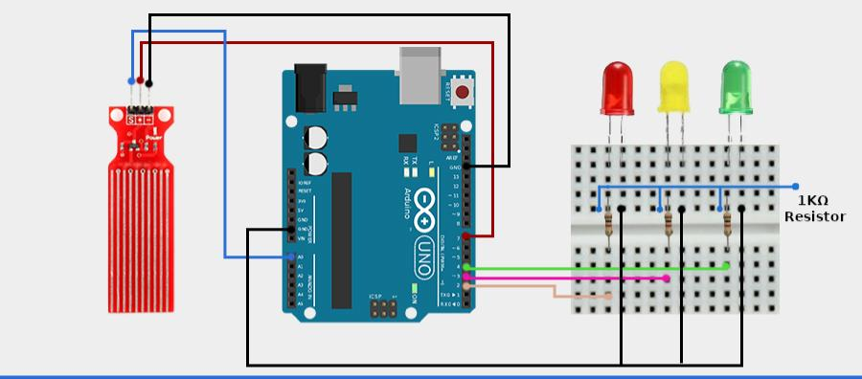**Circiut diagram for Smart water management:**

**3-D Representation for Smart Water Management:**

