EXP 7

1) SELECT dept_id

FROM department

MINUS

SELECT dept_id

FROM employees

WHERE job = 'stockclerk'

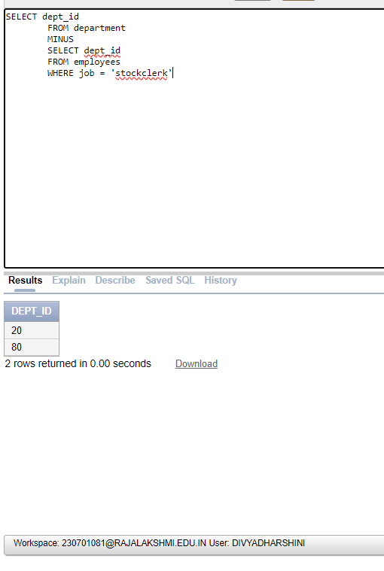

2) SELECT country_id,country_name

FROM countries

MINUS

SELECT l.country_id,c.country_name

FROM locations l, countries c

WHERE l.country_id = c.country_id;

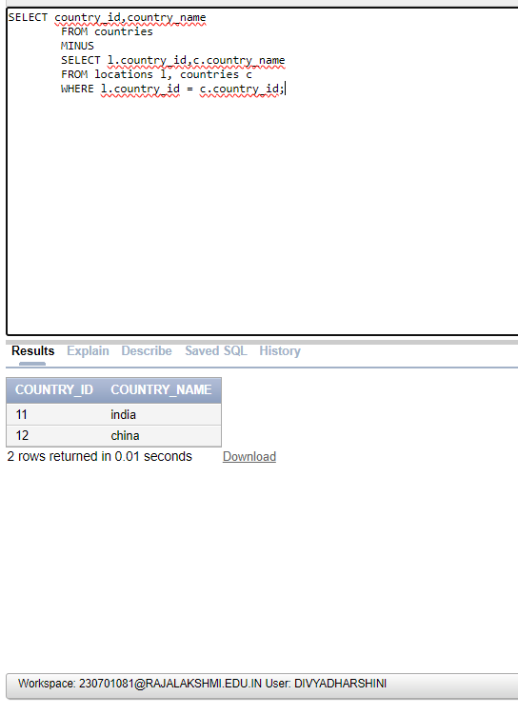

3) SELECT job_no, department_id

FROM employees

WHERE department_id = 10

UNION

SELECT job_no, department_id

FROM employees

WHERE department_id = 50

UNION

SELECT job_no, department_id

FROM employees

WHERE department_id = 20

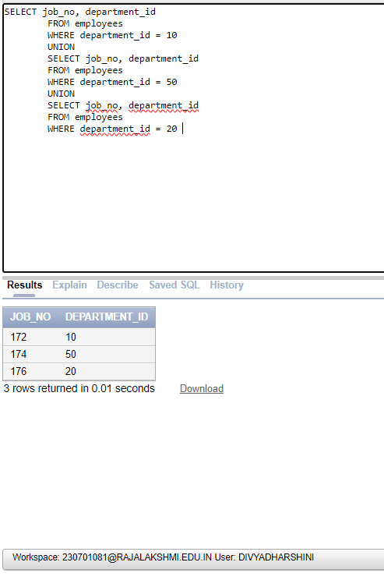

4) SELECT emp_id,job_no

FROM employees

INTERSECT

SELECT emp_id,job_no

FROM job;

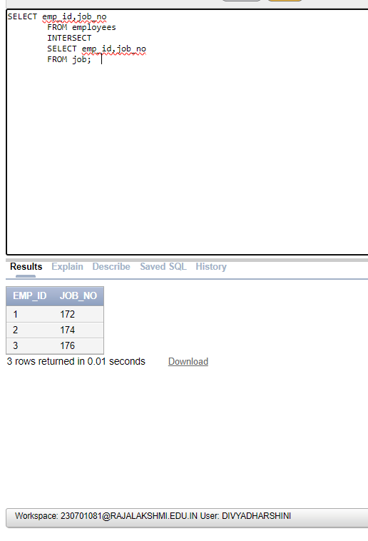

5) SELECT last_name,dept_id,TO_CHAR(null) as name

FROM employees

UNION

SELECT TO_CHAR(null),dept_id,dept_name

FROM department;

