OOPS LAB
Week 3
1)
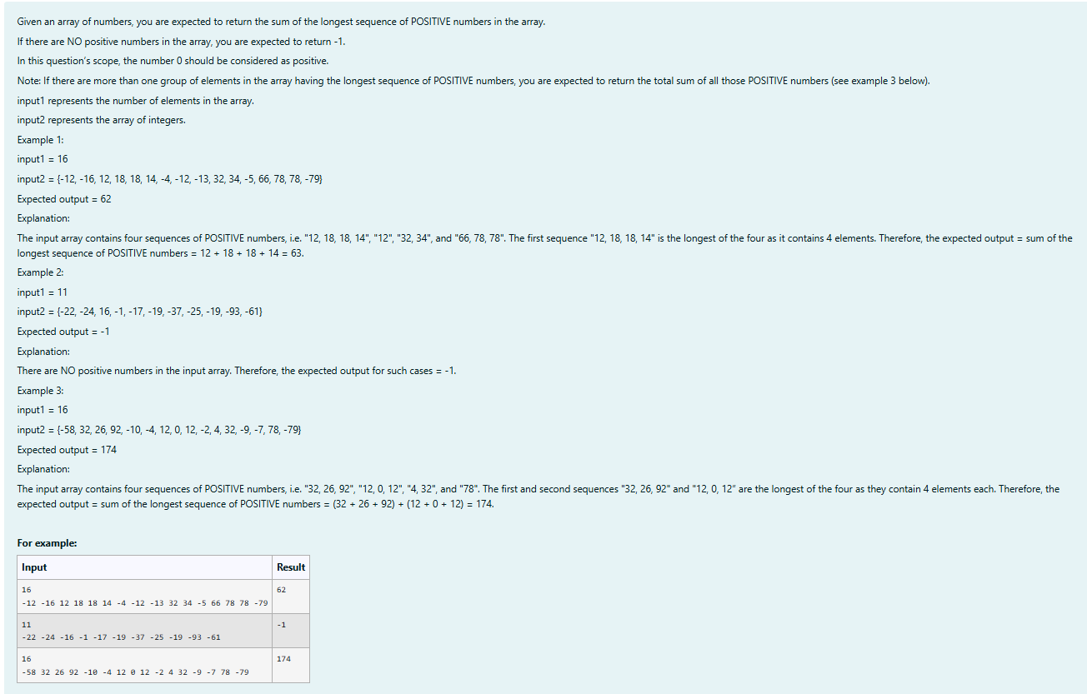
import java.util.Scanner;

public class LongestPositiveSequence {

public static void main(String[] args) {
Scanner sc = new Scanner(System.in);

int n = sc.nextInt();
int[] arr = new int[n];

for (int i = 0; i < n; i++) {
arr[i] = sc.nextInt();
}

int maxLen = 0, len = 0;
int maxSum = 0, sum = 0;
boolean hasPositive = false;

for (int i = 0; i < n; i++) {
if (arr[i] >= 0) {
hasPositive = true;
sum += arr[i];
len++;
} else {
if (len > maxLen) {
maxLen = len;
maxSum = sum;
} else if (len == maxLen) {
maxSum += sum;
}
sum = 0;
len = 0;
}
}

if (len > maxLen) {
maxSum = sum;
} else if (len == maxLen) {
maxSum += sum;
}

System.out.println(hasPositive ? maxSum : -1);

sc.close();
}
}
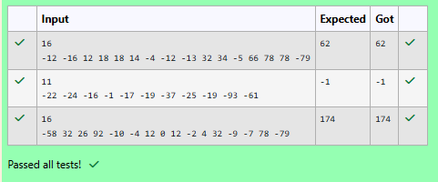
2)
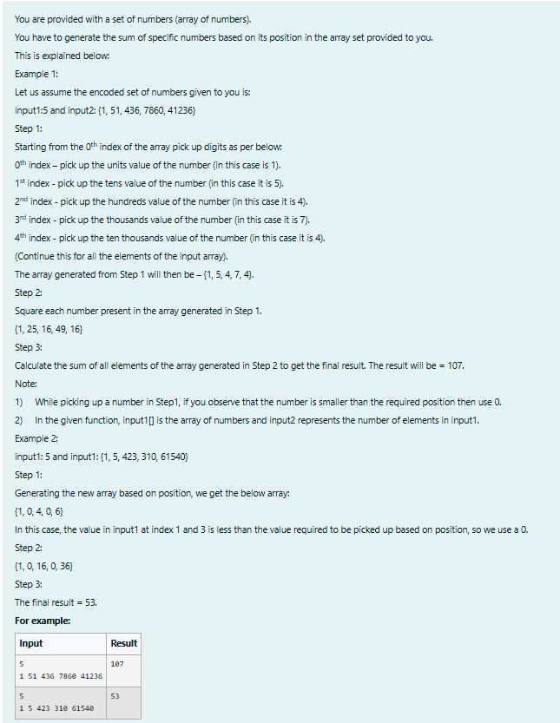
import java.util.Scanner;
public class ArraySum {
public static void main(String[] args) {
Scanner sc = new Scanner(System.in);
int n = sc.nextInt();
int[] input1 = new int[n];
for (int i = 0; i < n; i++) {
input1[i] = sc.nextInt();
}
int[] newArray = new int[n];
for (int i = 0; i < n; i++) {
int number = input1[i];
int digit = 0;
if (i == 0) {
digit = number % 10;
} else if (i == 1) {
digit = (number / 10) % 10;
} else if (i == 2) {
digit = (number / 100) % 10;
} else if (i == 3) {
digit = (number / 1000) % 10;
} else if (i == 4) {
digit = (number / 10000) % 10;
}

if (number < Math.pow(10, i)) {
digit = 0;
}

newArray[i] = digit;
}

for (int i = 0; i < n; i++) {
newArray[i] = newArray[i] * newArray[i];
}

int sum = 0;
for (int i = 0; i < n; i++) {
sum += newArray[i];
}

System.out.println(sum);

sc.close();
}
}

