OOPS LAB
Week 2
1)
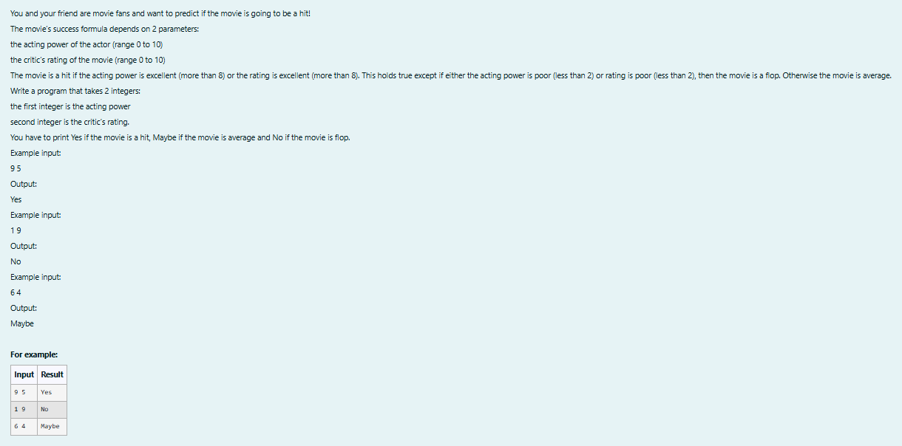
import java.util.Scanner;

class prog{
public static void main(String []args){
Scanner sc=new Scanner(System.in);
int a=sc.nextInt();
int r=sc.nextInt();
if(a>8 && r>2||a>2 && r>8){
System.out.println("Yes");
}
else if(a<=2 || r<=2){
System.out.println("No");
}
else{
System.out.println("Maybe");
}

}
}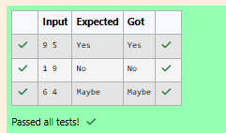
2)
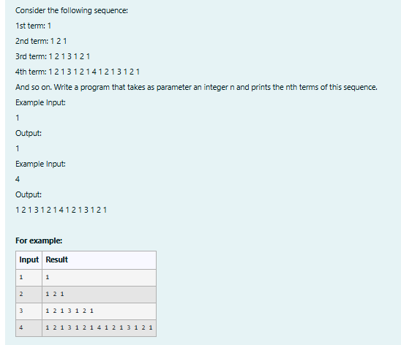
import java.util.Scanner;

public class prog {
public static String generateSequence(int n) {
if (n == 1) {
return "1";
}

String previousTerm = generateSequence(n - 1);
return previousTerm + " " + n + " " + previousTerm;
}

public static void main(String[] args) {
Scanner scanner = new Scanner(System.in);

int n = scanner.nextInt();
String result = generateSequence(n);
System.out.println(result);
scanner.close();
}
}
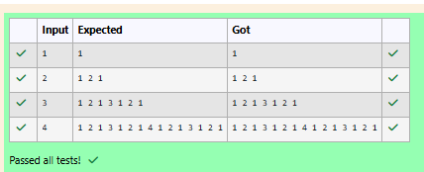
3)
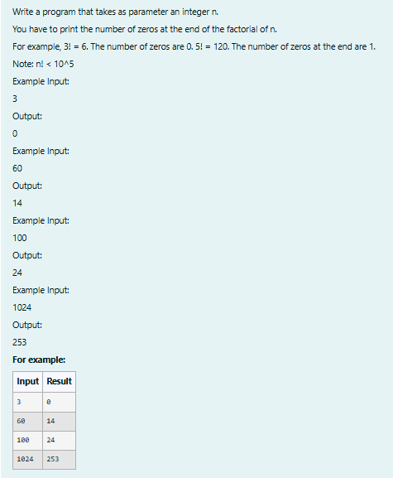
import java.util.Scanner;

class prog {
// Function to return trailing 0s in factorial of n
static int findTrailingZeros(int n) {
if (n < 0) // Negative Number Edge Case
return -1;

// Initialize result
int count = 0;

// Keep dividing n by powers of 5 and update count
for (int i = 5; n / i >= 1; i *= 5)
count += n / i;

return count;
}

// Driver Code
public static void main(String[] args) {
Scanner sc = new Scanner(System.in);

// Taking input

int n = sc.nextInt();

// Output the number of trailing zeros in n!
System.out.println(findTrailingZeros(n));
}
}
