OOPS LAB
Week 1
1)
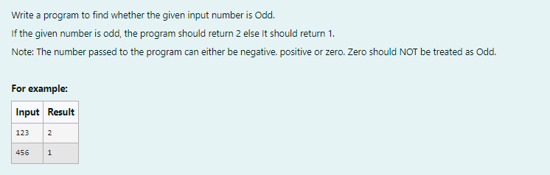
import java.util.*;
class prog{
public int isEven(int input1){
if(input1%2==0)
return 1;
else
return 2;
}
public static void main(String[]args){
Scanner o=new Scanner(System.in);
int input=o.nextInt();
prog obj=new prog();
int result=obj.isEven(input);
System.out.println(result);
}
}
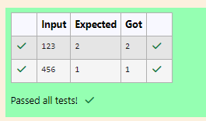
2)
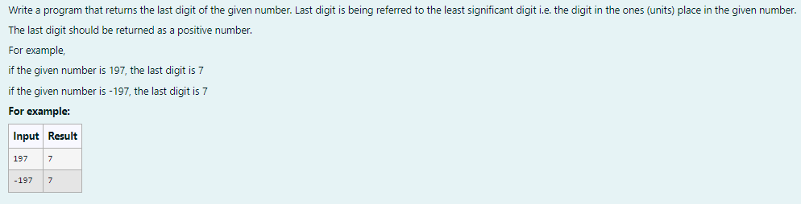
import java.util.*;
class prog{
public static void main(String [] args){
Scanner o=new Scanner(System.in);
int input=o.nextInt();
System.out.println(Math.abs(input%10));
}
}
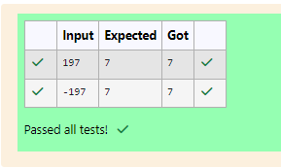

3)
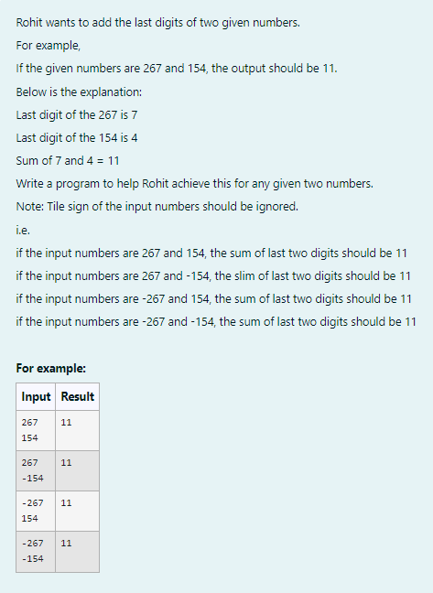
import java.util.*;
public class Sum{
public static void main(String[] args){
Scanner sc=new Scanner(System.in);
int n1=sc.nextInt();
int n2=sc.nextInt();
int d1=Math.abs(n1%10);
int d2=Math.abs(n2%10);
int sumd=d1+d2;
System.out.print(+sumd);
}
}
