IoT and Artificial Intelligence Integration: A Case Study

- Introduction

The rapid growth of the Internet of Things (IoT) has transformed the way devices communicate and share data. IoT connects physical devices such as sensors, actuators, smart appliances, and industrial machines to the internet, enabling real-time data collection and monitoring. However, IoT systems generate massive amounts of data that require intelligent processing.
Artificial Intelligence (AI) enhances IoT systems by enabling smart decision-making, automation, and predictive analytics. The integration of IoT and AI, often referred to as AIoT (Artificial Intelligence of Things), creates intelligent systems capable of learning, analyzing, and acting without human intervention.
This case study explores the integration of IoT and AI, its architecture, applications, benefits, challenges, and future scope.

- Overview of IoT and AI

  - Internet of Things (IoT)

IoT is a network of interconnected devices embedded with sensors, software, and communication modules. These devices collect and exchange data over the internet.
Key components:
- Sensors
- Microcontrollers (Arduino, Raspberry Pi)
- Communication protocols (Wi-Fi, Bluetooth, MQTT)
- Cloud storage

  - Artificial Intelligence (AI)

AI refers to systems that simulate human intelligence. It includes:
- Machine Learning (ML)
- Deep Learning
- Natural Language Processing (NLP)
- Computer Vision
AI enables systems to analyze patterns, predict outcomes, and make intelligent decisions.

3. Architecture of AIoT System
The integration of IoT and AI typically follows a layered architecture:

3.1 Device Layer

- Sensors collect data (temperature, motion, humidity, etc.)
- Actuators perform actions

3.2 Communication Layer

- Data transmitted via Wi-Fi, 5G, LoRa, etc.
- Protocols like MQTT and HTTP used

3.3 Data Processing Layer

- Data stored in cloud platforms
- AI algorithms process the data
- Machine learning models analyze patterns

3.4 Application Layer
- User interface (mobile/web app)
- Automated decision-making system
AI can be implemented:
- On Cloud (Cloud AI)
- On Edge Devices (Edge AI) for faster processing
The layered structure of AIoT is shown in Figure 1.

- Case Study Example: Smart Healthcare Monitoring System

Problem Statement

Traditional healthcare systems require continuous human monitoring. Delays in detecting abnormal health parameters can lead to serious complications.
IoT Implementation
- Wearable sensors measure heart rate, temperature, blood oxygen
- Data transmitted to cloud server

AI Integration
- Machine learning model analyzes health data
- Detects abnormal patterns
- Sends alerts automatically to doctor or family

Outcome
- Early disease detection
- Reduced hospital visits
- Improved patient safety

- Applications of AIoT

- Smart Homes
AI predicts user behavior and automates lighting, temperature, and security.

- Smart Agriculture
AI analyzes soil moisture and weather data for optimized irrigation.

- Industrial Automation
Predictive maintenance reduces machine downtime.

- Smart Cities
AI-based traffic management and waste management systems.

- Autonomous Vehicles
Real-time sensor data + AI decision-making.

6. Benefits of IoT and AI Integration
- Real-time intelligent decision making
- Predictive analytics
- Reduced human intervention
- Improved efficiency
- Cost reduction
- Enhanced accuracy

7. Challenges
- Data privacy and security risks
- High implementation cost
- Large data storage requirements
- Network latency issues
- Complexity of AI model training

8. Future Scope
- 5G-enabled AIoT systems
- Edge AI for faster response
- Integration with Blockchain for security
- Expansion in healthcare and smart cities
- Sustainable and energy-efficient AIoT systems
- AIoT will play a crucial role in Industry 5.0 and intelligent automation.

9. Conclusion
The integration of IoT and Artificial Intelligence creates powerful intelligent systems capable of real-time monitoring, predictive analysis, and automated decision-making. AI enhances the capabilities of IoT by transforming raw data into meaningful insights. Despite challenges like security and cost, AIoT has immense potential in healthcare, smart cities, agriculture, and industrial automation. The future of technology strongly depends on the intelligent collaboration between connected devices and AI systems.

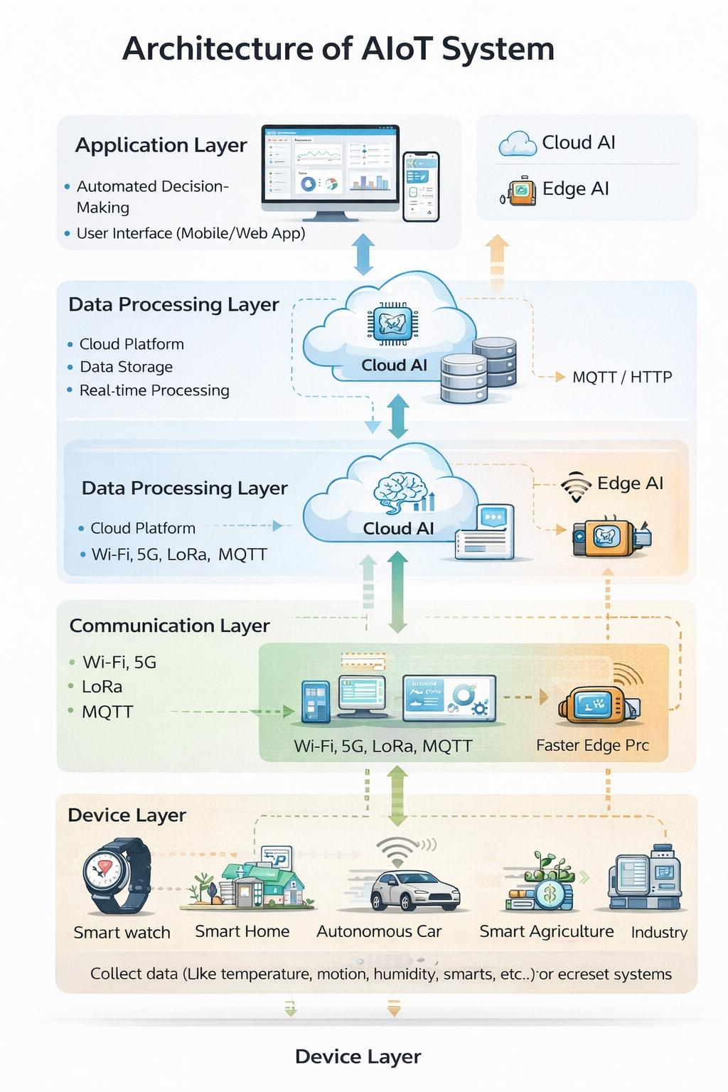
Figure 1: Architecture of AIoT System

10. References
- K. Ashton, “That ‘Internet of Things’ Thing,” RFID Journal, 2009.
- Gartner Research Reports on IoT & AI Integration.
- IEEE Papers on AIoT Systems (2020–2023).
- McKinsey Report on Artificial Intelligence Applications.
- ResearchGate publications on Smart Healthcare IoT.

