1. First, what is the problem?
The statement says:
One intentional issue I identified is data leakage during scaling. The notebook fits the scaler on the entire dataset before splitting into training and testing data. This means information from the future test period is used when calculating the scaling parameters. For a proper time-series pipeline, I would first split the data chronologically, fit the scaler only on the training data, and then use that same scaler to transform both training and test data.
We should never allow future/test data to influence how we prepare the training data.
For time-series data, this is especially important because the test data represents the future.
What does "scaling" mean?
Scaling means changing the numerical values of your data to a smaller, consistent range so that a machine-learning model can work with the features more effectively.
Notes: Scaling = putting numerical features onto a similar range.
Fitting the scaler = learning the minimum/maximum (or other statistics) needed for that transformation.
Example: 1. Imagine our holiday data looks like this
Suppose we have:
Date | Holiday | Sales
Jan 1 | New Year | 1,000
Feb 14 | Valentine's Day | 2,000
Mar 1 | None | 1,500
Apr 10 | Easter | 3,000
May 1 | Labor Day | 5,000

Let's say we're using Sales as a feature.
The values are:
1000
2000
1500
3000
5000
These numbers can be quite large, so we can scale them.
2) What calculation does MinMaxScaler do?
The formula is:
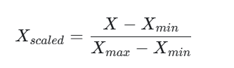
Python's MinMaxScaler performs this calculation.
Here:
Minimum = 1,000
Maximum = 5,000
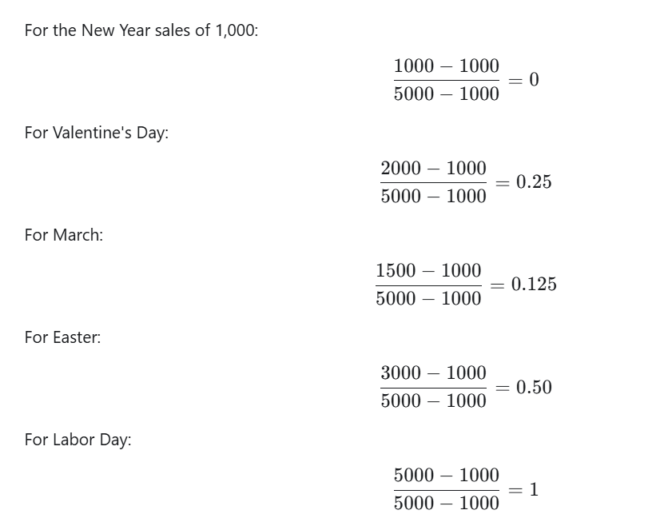
So we get:
Holiday | Sales | Scaled Sales
New Year | 1,000 | 0.000
Valentine's Day | 2,000 | 0.250
None | 1,500 | 0.125
Easter | 3,000 | 0.500
Labor Day | 5,000 | 1.000

So Pythong did all the calculations for us:

What does fit() actually do?
important for understanding your data-leakage question.
When you write:
scaler.fit(data)
Python looks at the data and learns the minimum and maximum.
For example:
Training data:
1000
2000
1500
3000
Python learns:
min = 1000
max = 3000
It remembers those numbers.
Then:
scaler.transform(data)
uses those learned numbers to scale the data.
4. What does fit_transform() mean?
This: scaler.fit_transform(data)
Is basically:
scaler.fit(data)
scaler.transform(data)
So:
FIT → learn min/max
TRANSFORM → use min/max to scale
data-leakage issue
Suppose your holiday dataset is a time series.
Imagine:
2019 ───── 2020 ───── 2021 ───── 2022
Training data Test data

If the code does this:
scaler = MinMaxScaler()

daily[feature_columns] = scaler.fit_transform(
daily[feature_columns]
)
This is where the problem can happen like: because we are doing
fit_transform(ALL DATA)
before the train/test split data.
so python looks at
2019
2020
2021
2022
and finds the minimum and maximum across everything.
That means the scaler has seen information from the future/test period.

Incorrect data pipeline:
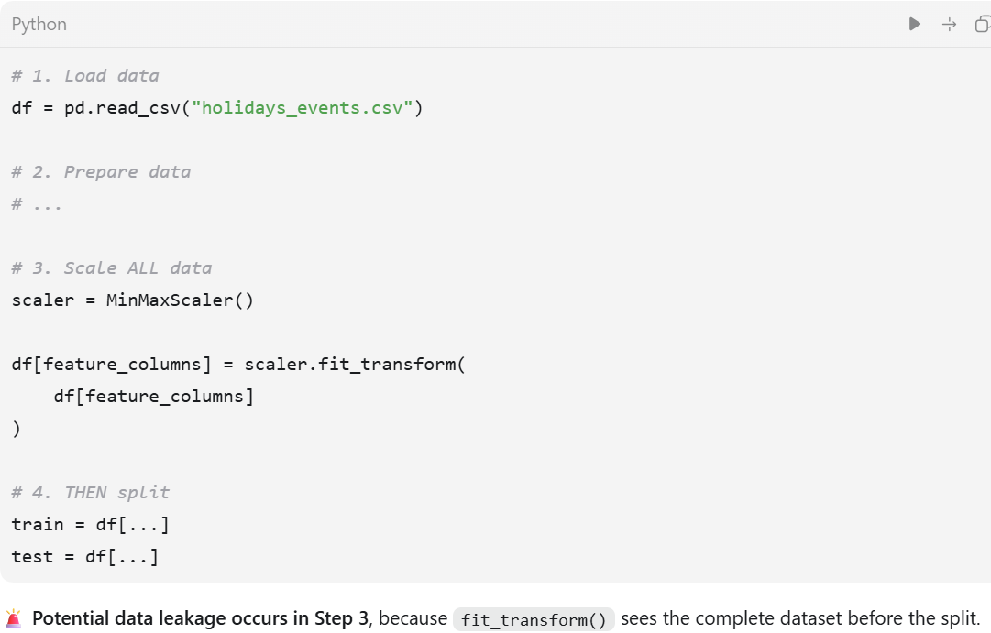

Correct pipeline is :
