**CSCI-6690 Master’s Project**

**University of New Haven**



**PART- 2**

# Electric Utilities Customer Account Management

**1- Project Objectives**

The main objective is to develop an android application to provide the customer utility services efficiently. It supports the Customers to view their bills, to pay their bills and they can raise a complaint instead of calling customer service. Customers need not call customer care for their history instead they can view in the application. There is also a news page where you can know the offers, information about power outages, storm and hurricane alerts. Application design includes the details of the customer of an electric company that mainly deals with distribution of power. This application is to provide an easy and efficient database that stores the information of employees and customers and how they are related to each other etc. The employee has his details stored such as his department, salary, position and his role etc. The customer has his details stored, equipment details and based on his consumption, billing is generated.

**2-Modules**

1.**Authentication and Security Module:**

Security and authentication module is main module which can provide security for entire processing of the system by using username, password, login, change password etc.

1. **Billing Module:**

**View bill:**

The customers can view the bill for the power consumption. This can be viewed by customer and the admin.

**Update bill:**

The bill payment can be updated by the admin (employee of the company) can access after the payment of bill.

**Pay bill:**

The customer can pay his bill through credit/debit card.

1. **Profile Module:**

The customer can view his profile, address, meter details etc,

1. **Complaint Module:**

The customer can raise the complaint what they have and the admin finds the problem and resolves the complaints and they will update the complaints which are given by the customer. The customers can give feedback to the electric utility company.

1. **Newsfeed Module:**

Where you can know the offers, information about power outages, storm and hurricane

alerts

**3-Software Requirements**

|  |  |
| --- | --- |
| **Operating System** | **:** Windows 10 |
| **Languages** | **:** JAVA |
| **Web Server** | **:** TOMCAT 9 |
| **Web Technologies** | **:** HTML, JavaScript. |
| **Back End** | **:** PL**/**SQL Server |
| **Database** | **:** Oracle 11G |
| **IDE/Workbench** | **:** My Eclipse |

**4-Hardware Requirements**

|  |  |
| --- | --- |
| **Processor** | **:** Intel i5 |
| **Hard Disk** | **:** 500 GB |
| **RAM** | **:** 8GB |

**5-System Design**

**5.1- Use Case Diagram**

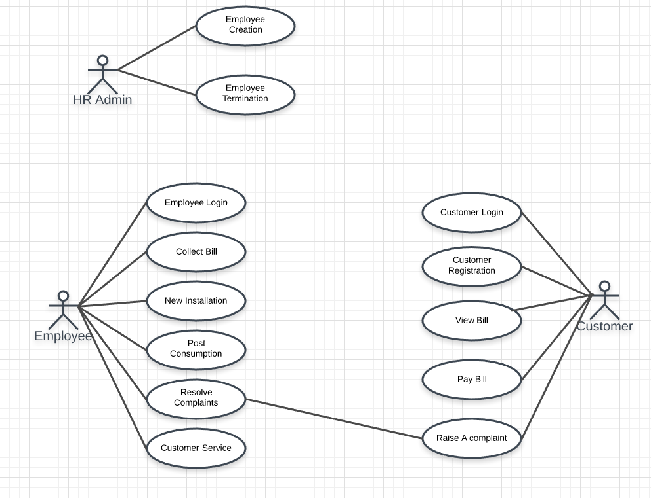

**5.2- Class Diagram**

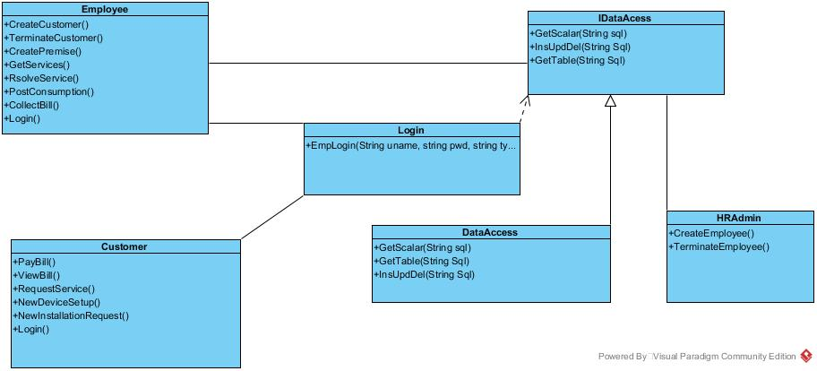

**5.3- E-R Diagram**

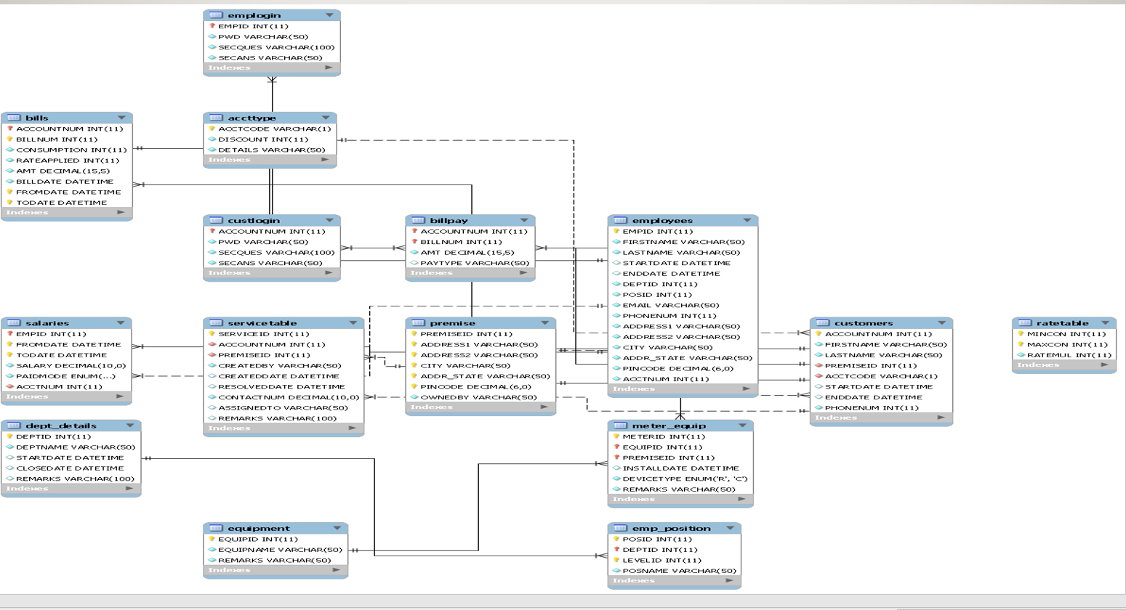

**5.4- Sequence Diagram**

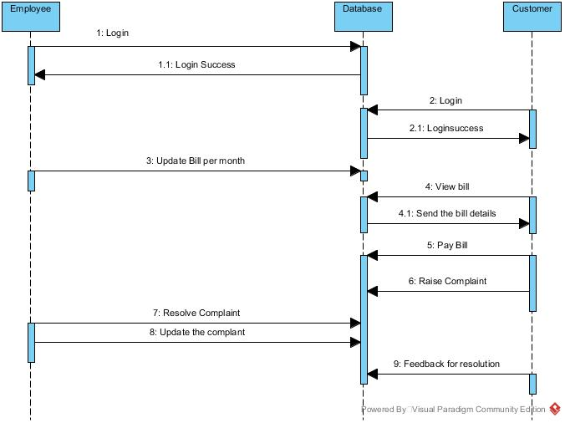

**6- Implementation**

Firstly, we will connect the java program with the real database we will use JDBC (Java Database Connectivity). It is an application interface program which encodes java statements into the query language which manages the database.

Secondly, we created a web application for the problem using the web application directory where it retrieves data from database or it allows the website users to it can send data to the database.

Then we need to use android studio an advanced build toolkit, to automate and manage the build process, while allowing you to define flexible custom build configurations. Each build configuration can define its own set of code and resources, while reusing the parts common to all versions of the app. Which is used to connect the computer codes and database with the android phones.

**7-DATABASE Tables**

**Account Type Table**

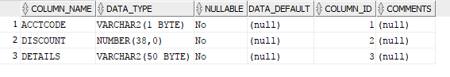

**Bills Table**

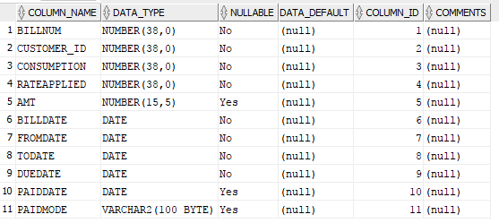

**Card Details Tables**

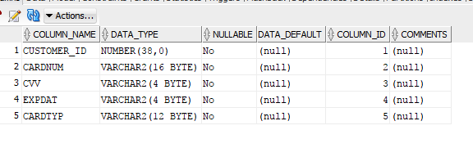

**Customer Login Table**

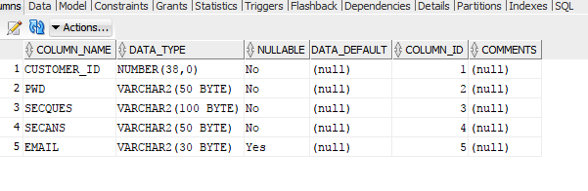

**Customers Table**

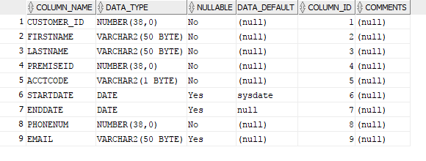

**Equipment Table**

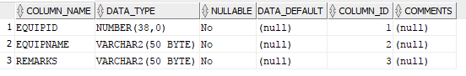

**Meter Equipment Table**

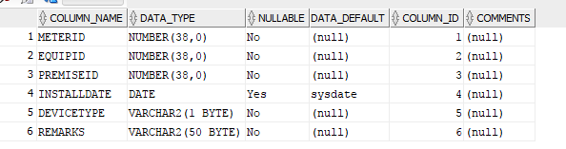

**News Feed Table**

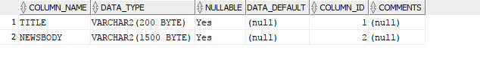

**Premise Table**

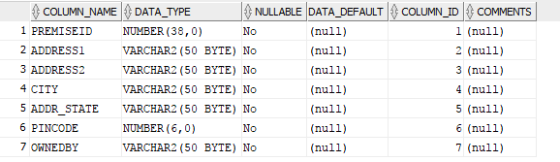

**Rate Table**

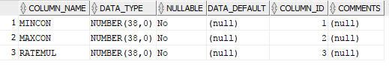

**Customer Service Table**

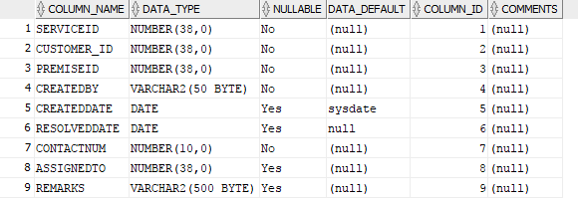

**8- OUTPUT Screenshots**

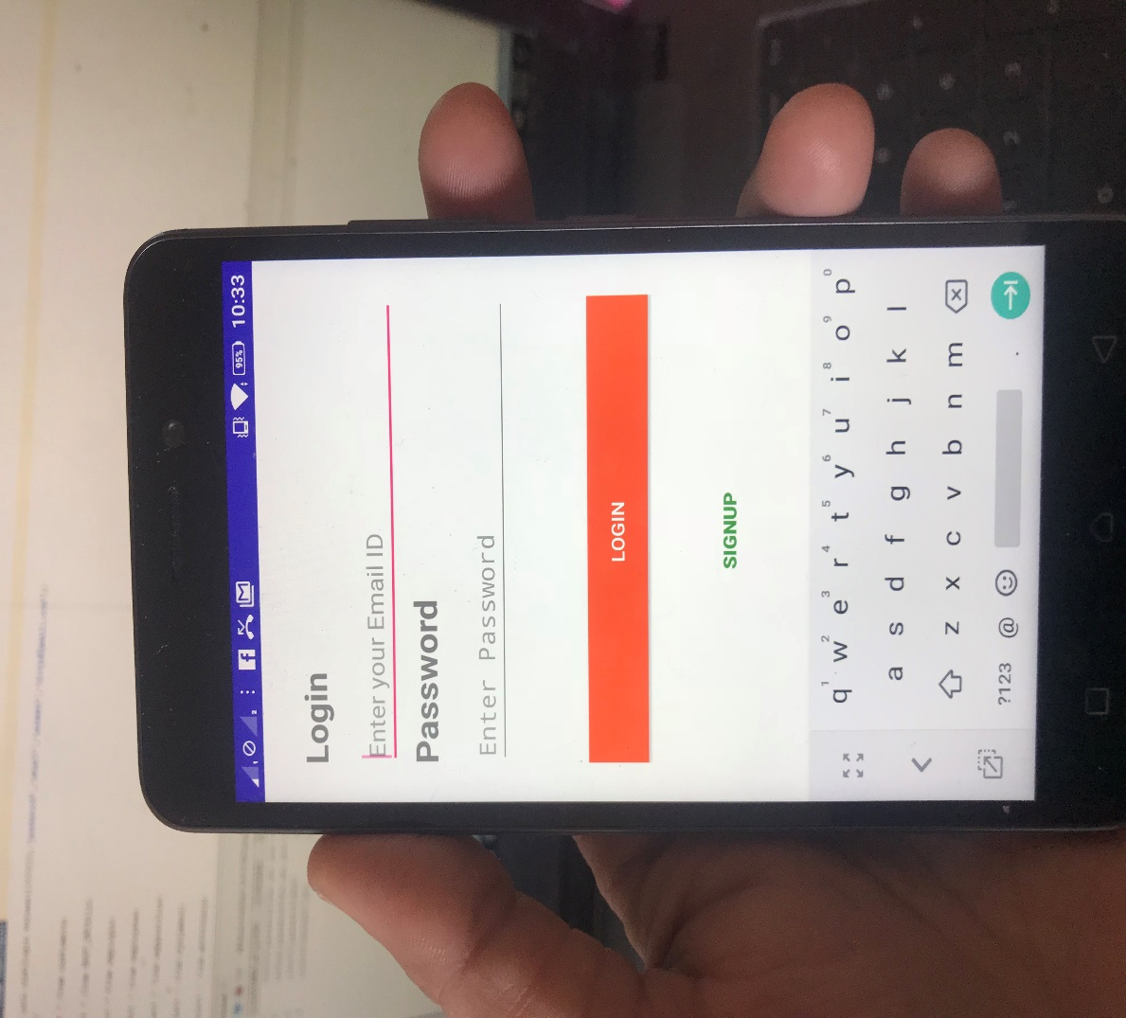

**Login page**

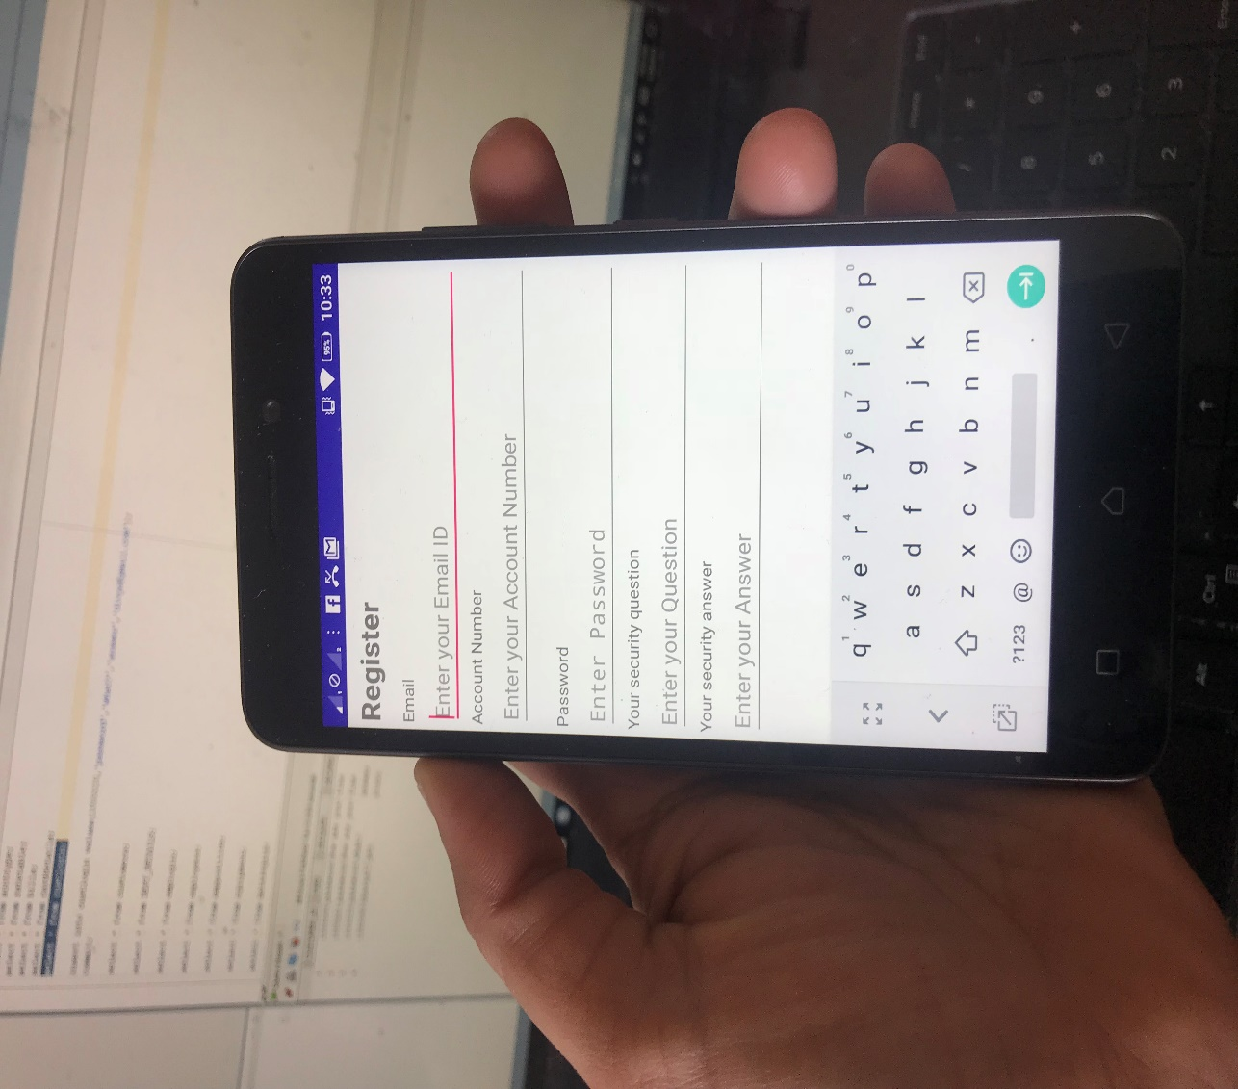

**Register Page**

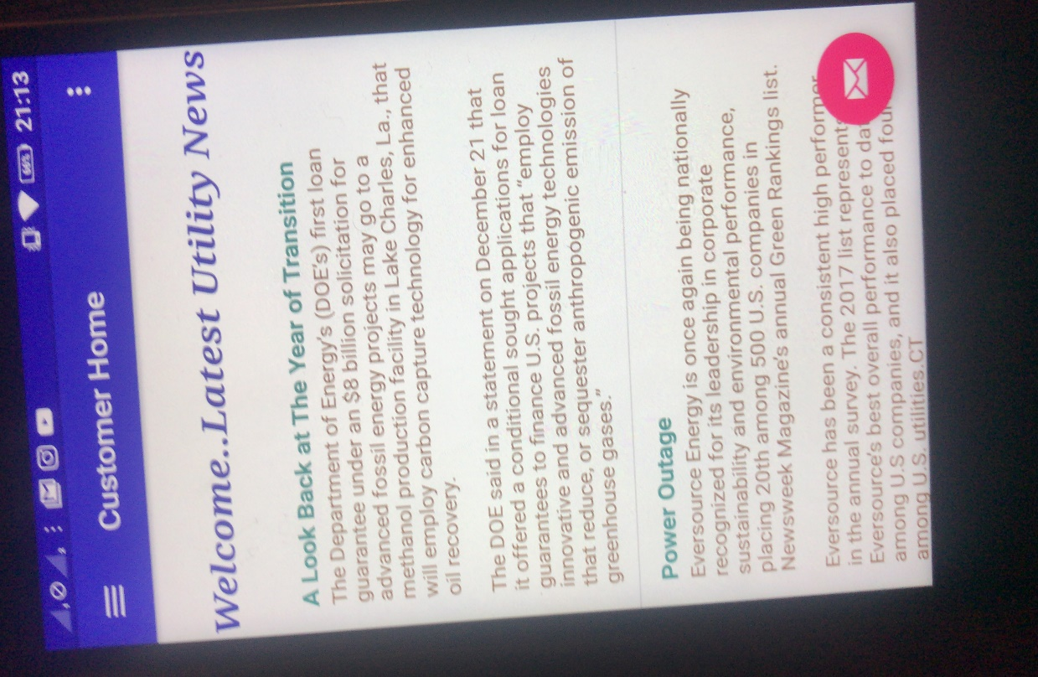

**Newsfeed Page**

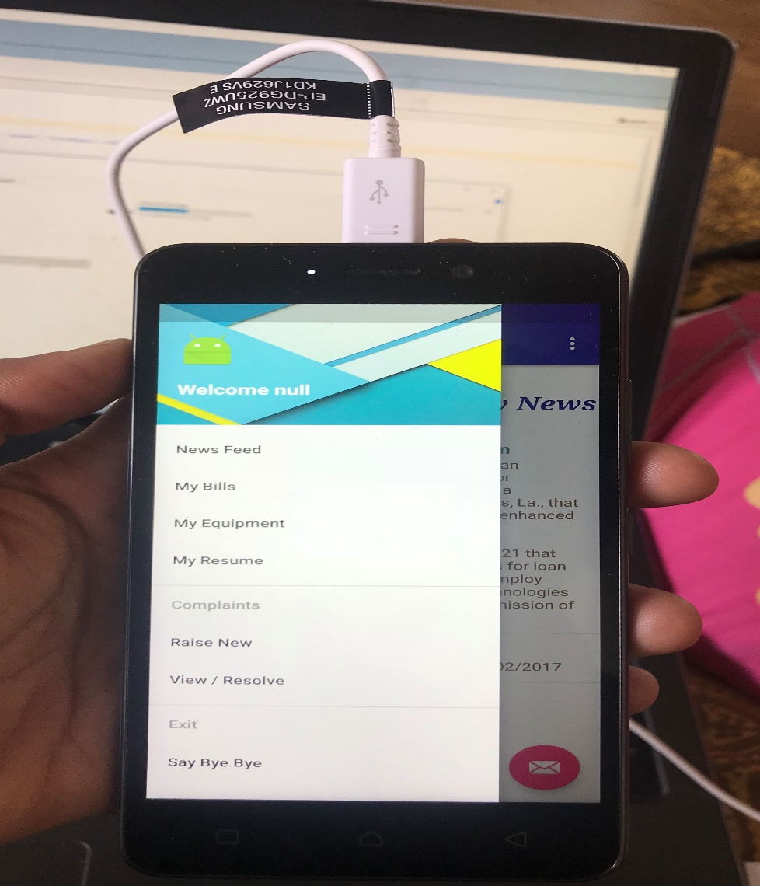

**Options Page**