1. AIM TO: Design DFA using simulator to accept odd number of a’s

INPUT:

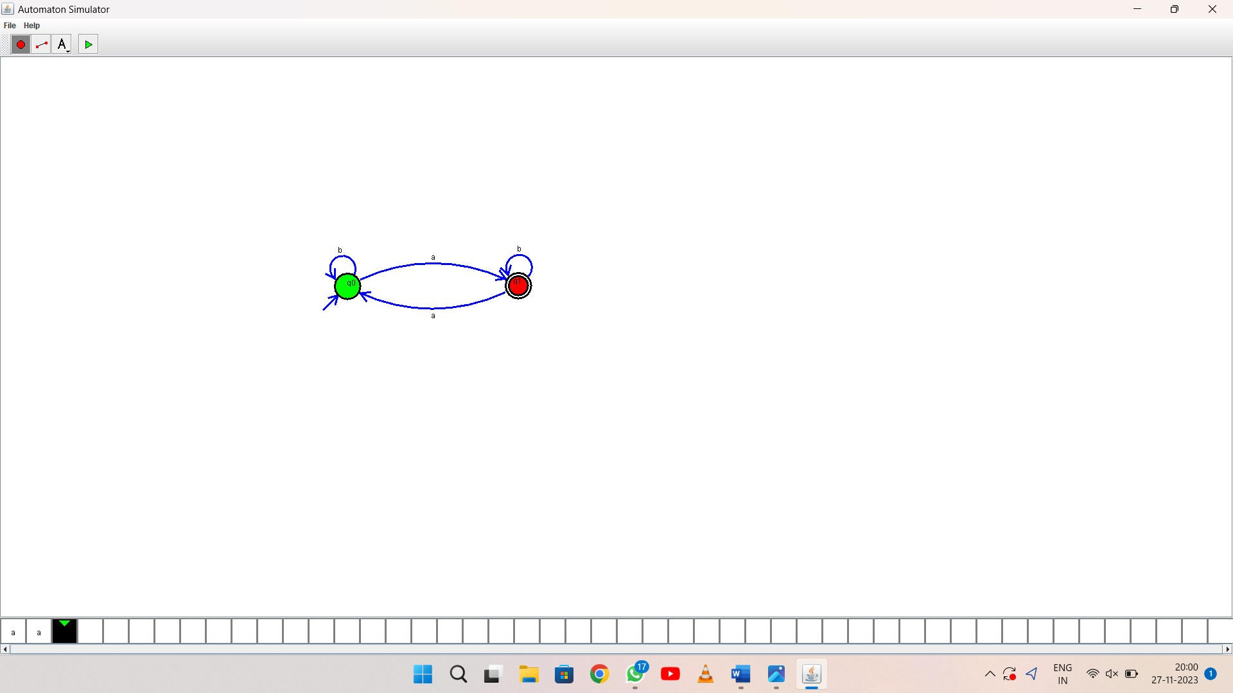

OUTPUT:

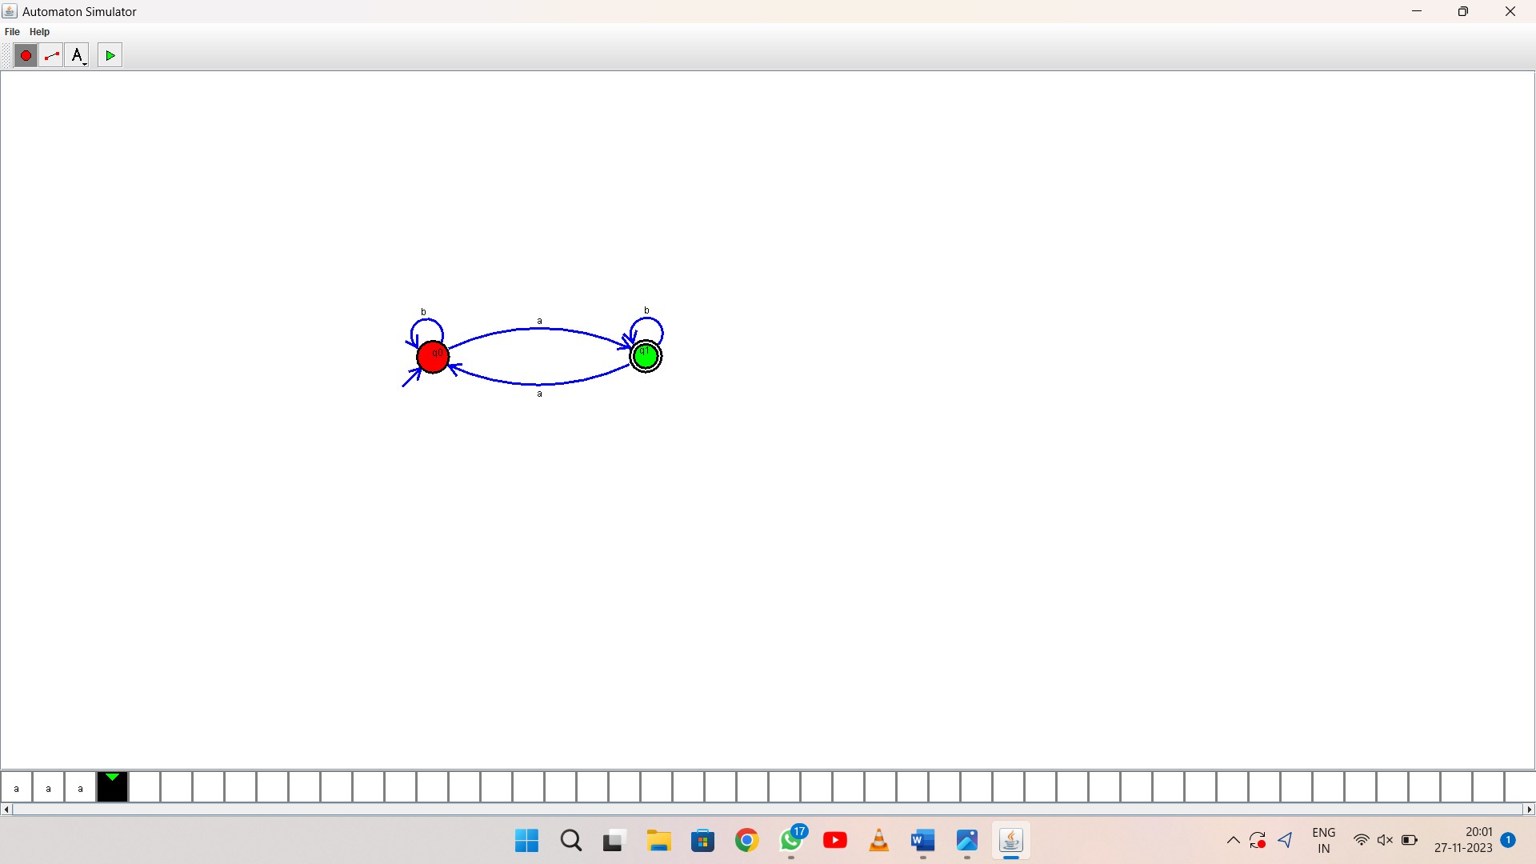

1. RESULT: thus Design DFA using simulator to accept odd number of a’s