1. AIM TO: Design DFA using simulator to accept the string having ‘ab’ as substring over the set {a,b}

INPUT:

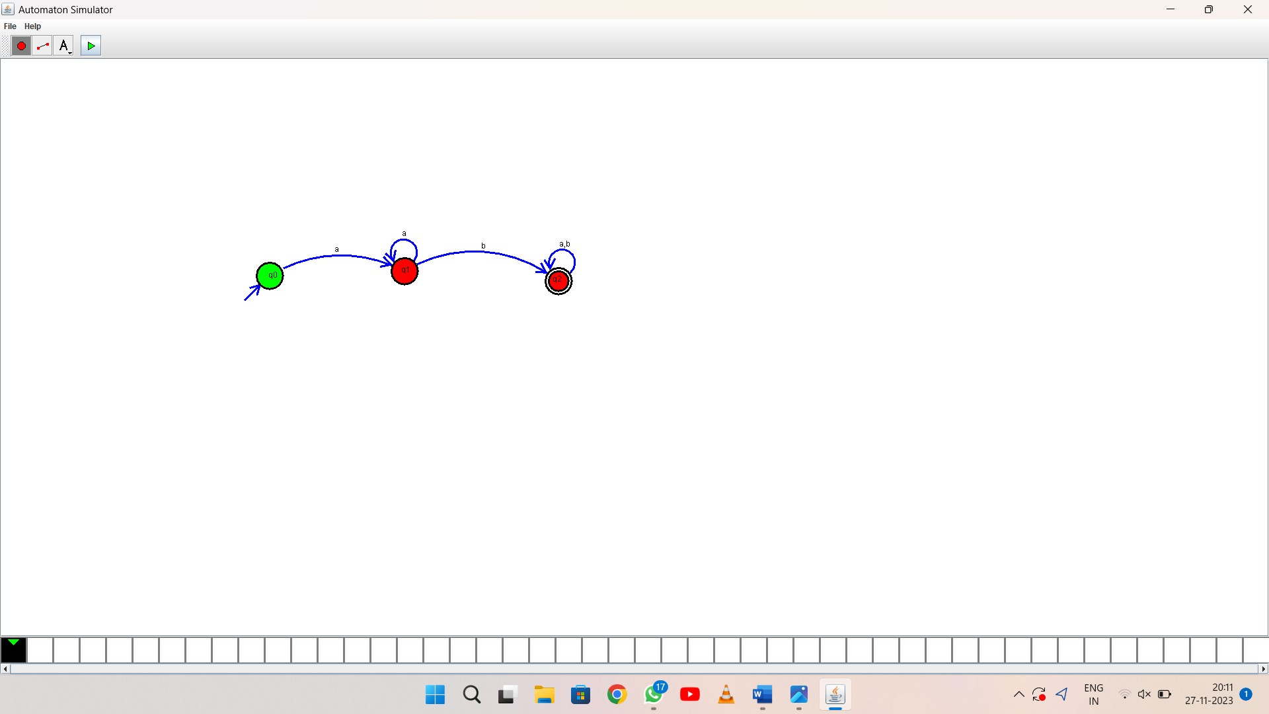

OUTPUT:

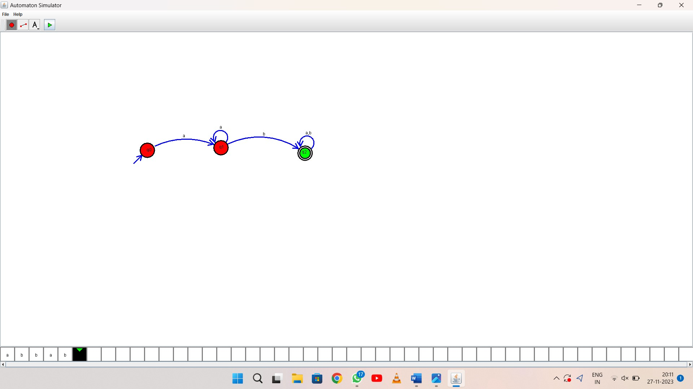

1. RESULT: thus Design DFA using simulator to accept the string having ‘ab’ as substring over the set {a,b}