1. AIM TO: Design DFA using simulator to accept the string start with a or b over the set {a,b}

INPUT: 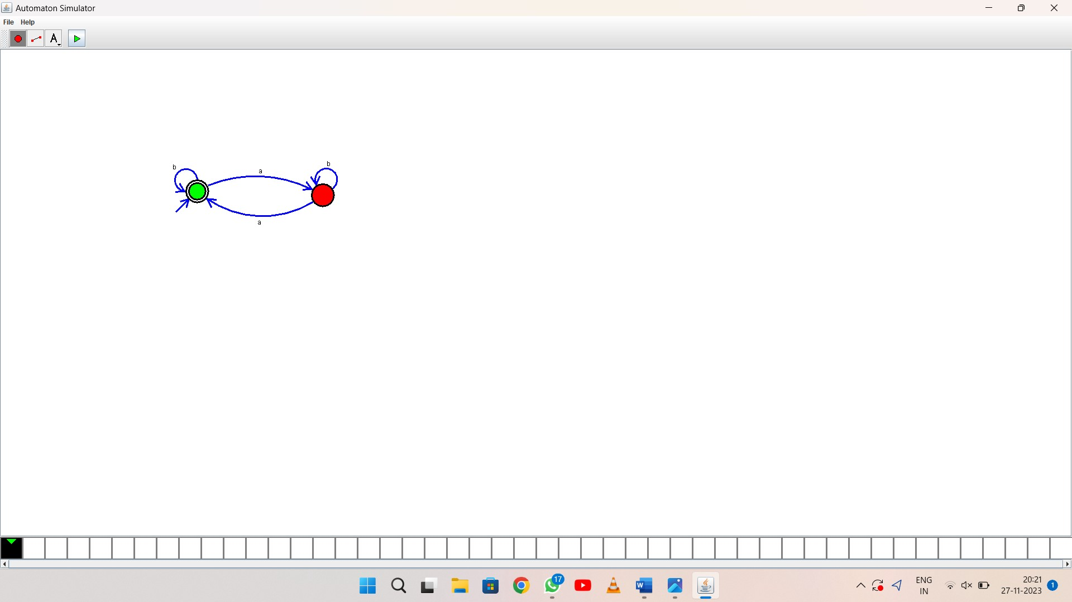

OUTPUT:

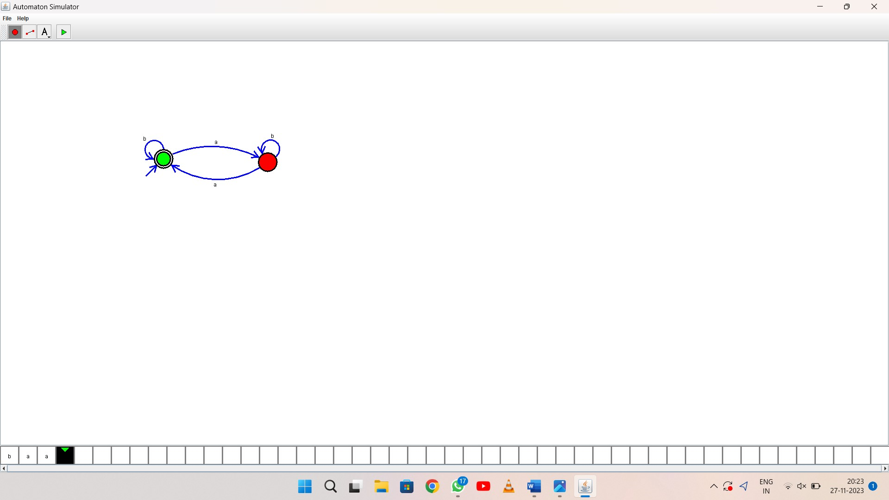

1. RESULT: thus Design DFA using simulator to accept the string start with a or b over the set {a,b}