BANNARI AMMAN INSTITUTE OF
TECHNOLOGY

Sathyamangalam, Erode – 638401
[ALUForge’26 – INTERNAL HACKATHON 2026]

8-BIT ARITHMETIC LOGIC UNIT (ALU)
& BUS INTERFACE

A Discrete TTL Logic Design with Registers, Adder/Subtractor & Bus Architecture

Submitted by

THE ALUchemists

DIVYA HARSHNI K
SAKTHIVEL V
BADRINATH A

Department of Electronics and Communication Engineering
September 2026

Table of Contents

- Abstract
2. Introduction
3. Problem Statement
4. Objectives
5. Components Used
6. Block Design & Architecture
7. Sub-Module Detailed Specifications
7.1 A-Register Module
7.2 B-Register Module
7.3 ALU Core Module
7.4 Clock Generator Module (1 Hz)
7.5 BUS Write & Read Module
8. Working Principle & Operational Steps
8.1 Bus Communication Protocol
8.2 Addition Sequence (A+B)
8.3 Subtraction Sequence (A−B)
9. Design Calculations
9.1 Astable Clock Frequency (555 Timer)
9.2 Bus Current Limit Calculation
10. Hardware Validation & Testing Results
11. Challenges Faced & Solutions
12. Applications & Future Scope
13. References

8-BIT ALU (COMPLETE ARCHITECTURE)

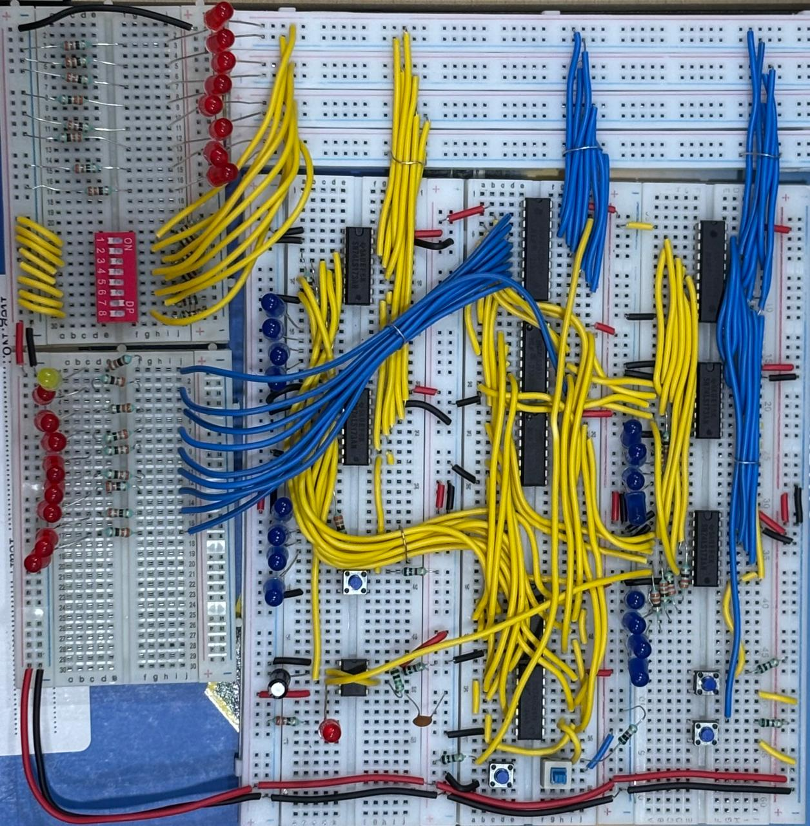

1. Abstract

This project details the hardware design and implementation of a discrete 8-bit Arithmetic Logic Unit (ALU) integrated with a shared 8-bit bidirectional data bus system. The circuit is designed using standard 74xx series Transistor-Transistor Logic (TTL) integrated circuits and a 555 timer clock reference, operating entirely without microcontrollers or programmable logic devices.
The design features an A-Register and B-Register (constructed with 4-bit D-type register IC SN74LS173ANs), an 8-bit binary full adder array (SN74LS283N), 2's complement subtraction logic (SN74HC86N XOR gates), and octal tri-state bus transceivers (SN74HCT245N). The ALU performs 8-bit addition (A+B) and subtraction (A−B) controlled via a DPDT switch. The functional breadboard prototype demonstrates synchronized data transfers, register storage, 2's complement arithmetic, and tri-state bus isolation.
Keywords: 8-bit ALU, TTL Logic, 74LS173, 74LS283, 74HC86, Tri-state Bus, 2's Complement, Breadboard Computer.

2. Introduction
In digital processing architecture, the Arithmetic Logic Unit (ALU) and system registers form the computational backbone. Understanding microarchitecture requires direct hardware-level experience with signal propagation, timing synchronization, and bus arbitration.

This project implements an 8-bit TTL-based ALU and register system based on classic computer architecture principles (inspired by Ben Eater’s SAP-1 design). Operating over a shared 8-bit bidirectional bus, data can be written manually via DIP switches, transferred into storage registers (A-Reg, B-Reg), processed through arithmetic logic, and read back onto the central bus. System timing is governed by an integrated 1 Hz astable 555 timer.

3. Problem Statement
Design and construct a modular, discrete 8-bit Arithmetic Logic Unit (ALU) system operating over a shared 8-bit bidirectional bus using DIP TTL ICs, under the following constraints:
- No microcontrollers, microprocessors, or FPGAs may be used.
- Data transfers must occur over a shared 8-bit bus with tri-state line isolation.
- The system must include positive-edge-triggered 8-bit storage registers (A and B).
- The ALU must perform 8-bit Addition (A+B) and 2's Complement Subtraction (A−B) with carry output.
- Timing must be driven by an integrated 1 Hz clock generator.

4. Objectives
- Build a 1 Hz clock reference using an IC 555 timer in astable mode.
- Implement an 8-bit shared bidirectional bus interface with DIP switches for manual data loading.
- Construct 8-bit edge-triggered registers (A-Register and B-Register) using SN74LS173 D-flip-flops.
- Implement arithmetic operations using 74LS283 binary adders and 74HC86 XOR logic gates.
- Control data flow using active-low enable lines (A-IN, A-OUT, B-IN, ALU-OUT, ADD/SUB) to prevent bus contention.
- Verify performance on breadboards and document hardware debugging procedures.

5. Components Used

The complete bill of materials is based on the supplied project content. The compact table below follows the visual style of the reference document while keeping each entry readable.

S.N | Part / IC | Qty | Role in the Circuit
1 | IC SN74LS173AN | 4 | 4-bit D-type register with 3-state outputs (2 ICs per 8-bit Register: A & B).
2 | IC SN74HCT245N | 2 | Octal bidirectional transceivers for tri-state bus interfacing (A-Reg & ALU OUT).
3 | IC SN74LS283N | 2 | 4-bit binary full adders cascaded for 8-bit addition.
4 | IC SN74HC86N | 2 | Quad 2-input XOR gates for bitwise inversion during subtraction.
5 | IC NE555P | 1 | Timer IC configured as 1 Hz astable clock generator.
6 | DIP Switch (8-bit) | 1 | Manual 8-bit bus write data entry interface.
7 | DPDT Switch | 1 | Operation selection switch (Logic 0: ADD, Logic 1: SUB).
8 | Push Buttons | 4 | Control line triggers (A-IN, A-OUT, B-IN, ALU-OUT).
9 | LEDs (Red, Blue, Yellow, Green) | 35 | Status indicators (16 Blue for Regs, 17 Red for ALU/Bus, 1 Yellow CLK, 1 Green Carry).
10 | Resistors (330Ω, 1kΩ, 1.2kΩ, 100kΩ) | 47 | LED current limiting, pull-up/pull-downs, and timing network.
11 | Capacitors (1µF, 0.1µF) | 2 | 1µF timing capacitor for 555 timer and 0.1µF decoupling capacitor.

6. Block Design & Architecture
The system is centered on a common 8-bit data BUS. Manual data is written using the 8-bit DIP switch and transferred to the A-Register or B-Register using the corresponding input control. The A operand and the XOR-conditioned B operand are processed by the cascaded 74LS283 adders. The arithmetic result is passed through the 74245 bus driver and returned to the common bus when ALU-OUT is enabled.

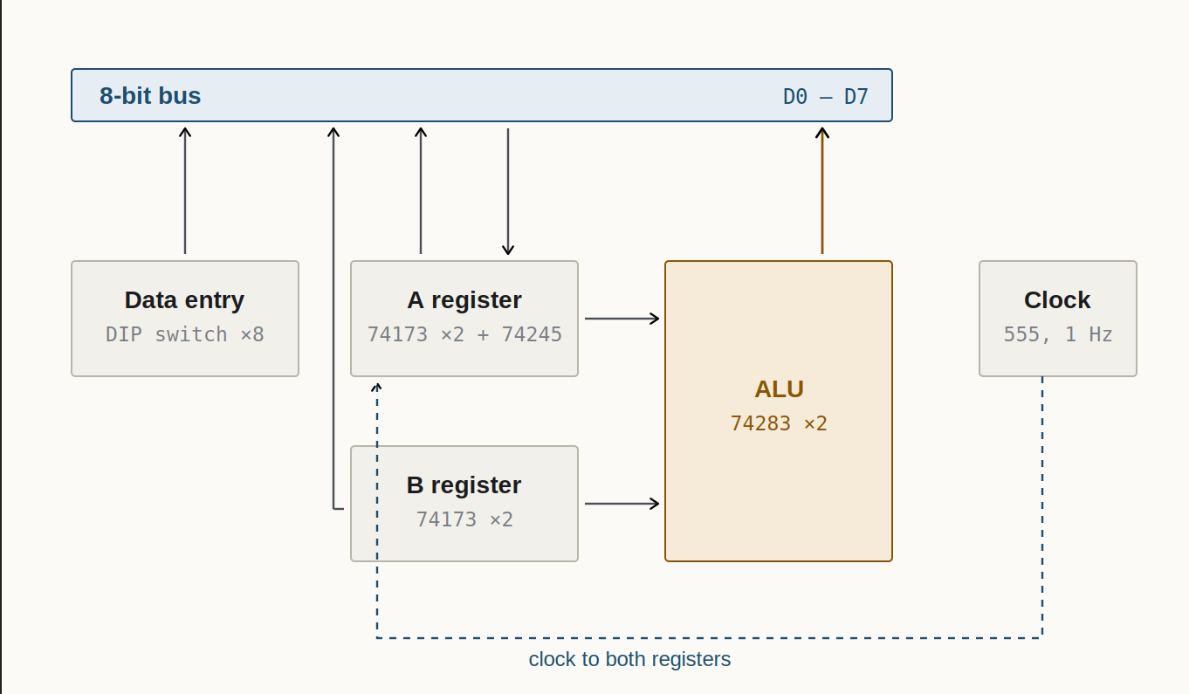

7. Sub-Module Detailed Specifications

7.1 A-Register Module
Stores the primary operand (A). It receives data from the bus on the positive edge of the clock when A-IN is active and can output its contents back onto the bus via A-OUT.
Components: 2 × SN74LS173AN (4-bit D-type registers, giving 8-bit storage); 1 × SN74HCT245N octal tri-state buffer; 2 push buttons for A-IN and A-OUT [Active Low]; 8 blue LEDs for stored-data visualization; 330 Ω / 1 kΩ resistors for LED current limiting and pull-ups.

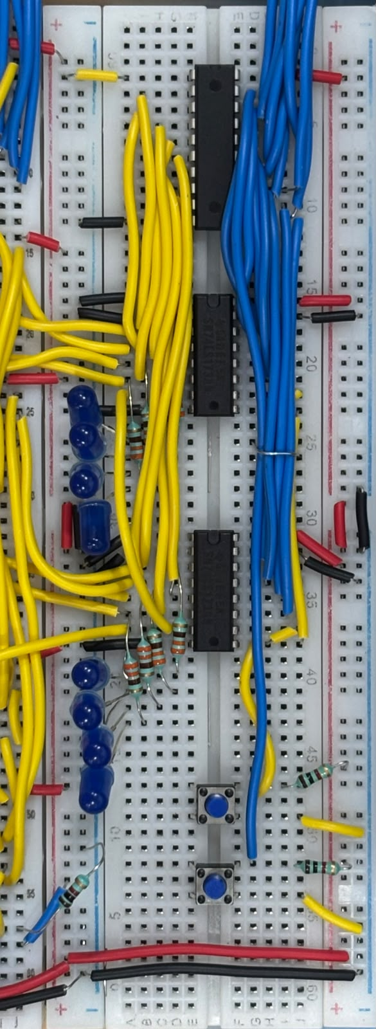

7.2 B-Register Module
Stores the secondary operand (B). It receives data from the bus when B-IN is active. Unlike the A-Register, its outputs feed directly into the ALU XOR logic array rather than back onto the bus.
Components: 2 × SN74LS173AN; 1 push button for B-IN [Active Low]; 8 blue LEDs for stored-data visualization; 330 Ω / 1 kΩ resistors for LED current limiting and pull-up.

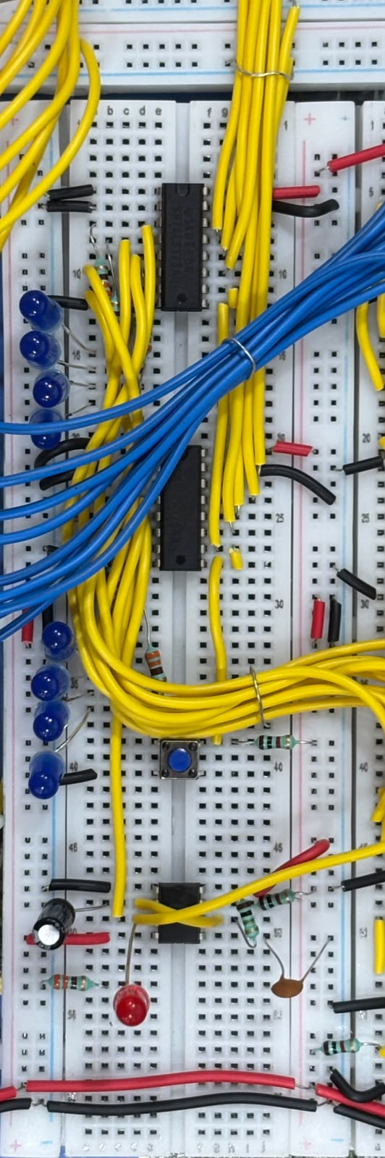

7.3 ALU Core Module
Computes A+B or A−B. Addition uses 74LS283 full adders directly. Subtraction utilizes 2's complement logic by inverting input B using XOR gates and setting Carry-In C₀=1.
Components: 2 × SN74LS283N 4-bit binary full adders; 2 × SN74HC86N quad XOR gates; 1 × SN74HCT245N tri-state output buffer for ALU-OUT; 1 × DPDT switch for ADD/SUB selection; 8 red result LEDs and 1 green carry flag LED.

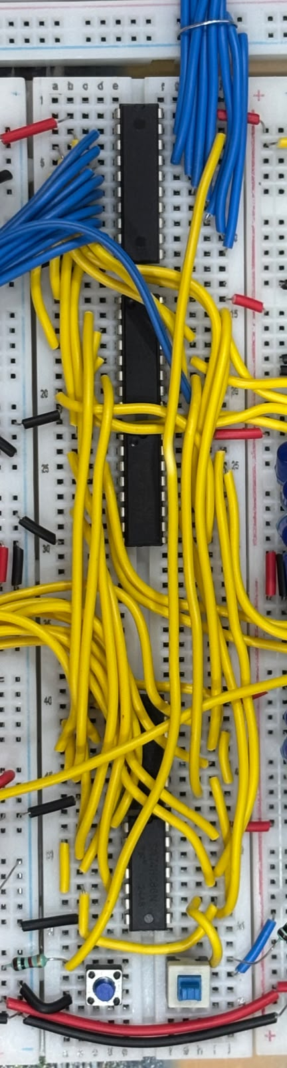
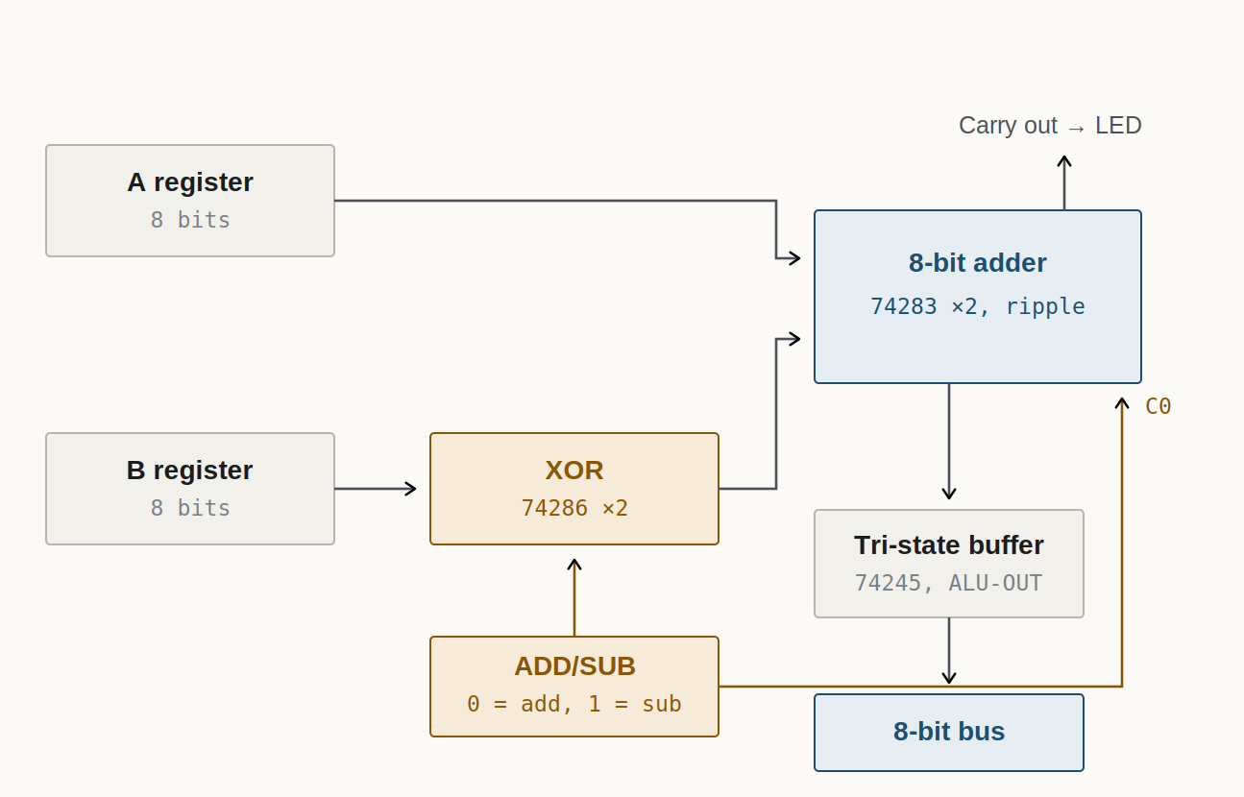

7.4 Clock Generator Module (1 Hz)
Generates system timing pulses using an IC NE555P timer configured as an astable multivibrator. The supplied design uses an LED for clock-pulse visualization and a timing network of R₁ = 1 kΩ, R₂ = 100 kΩ, and C₁ = 1 μF.
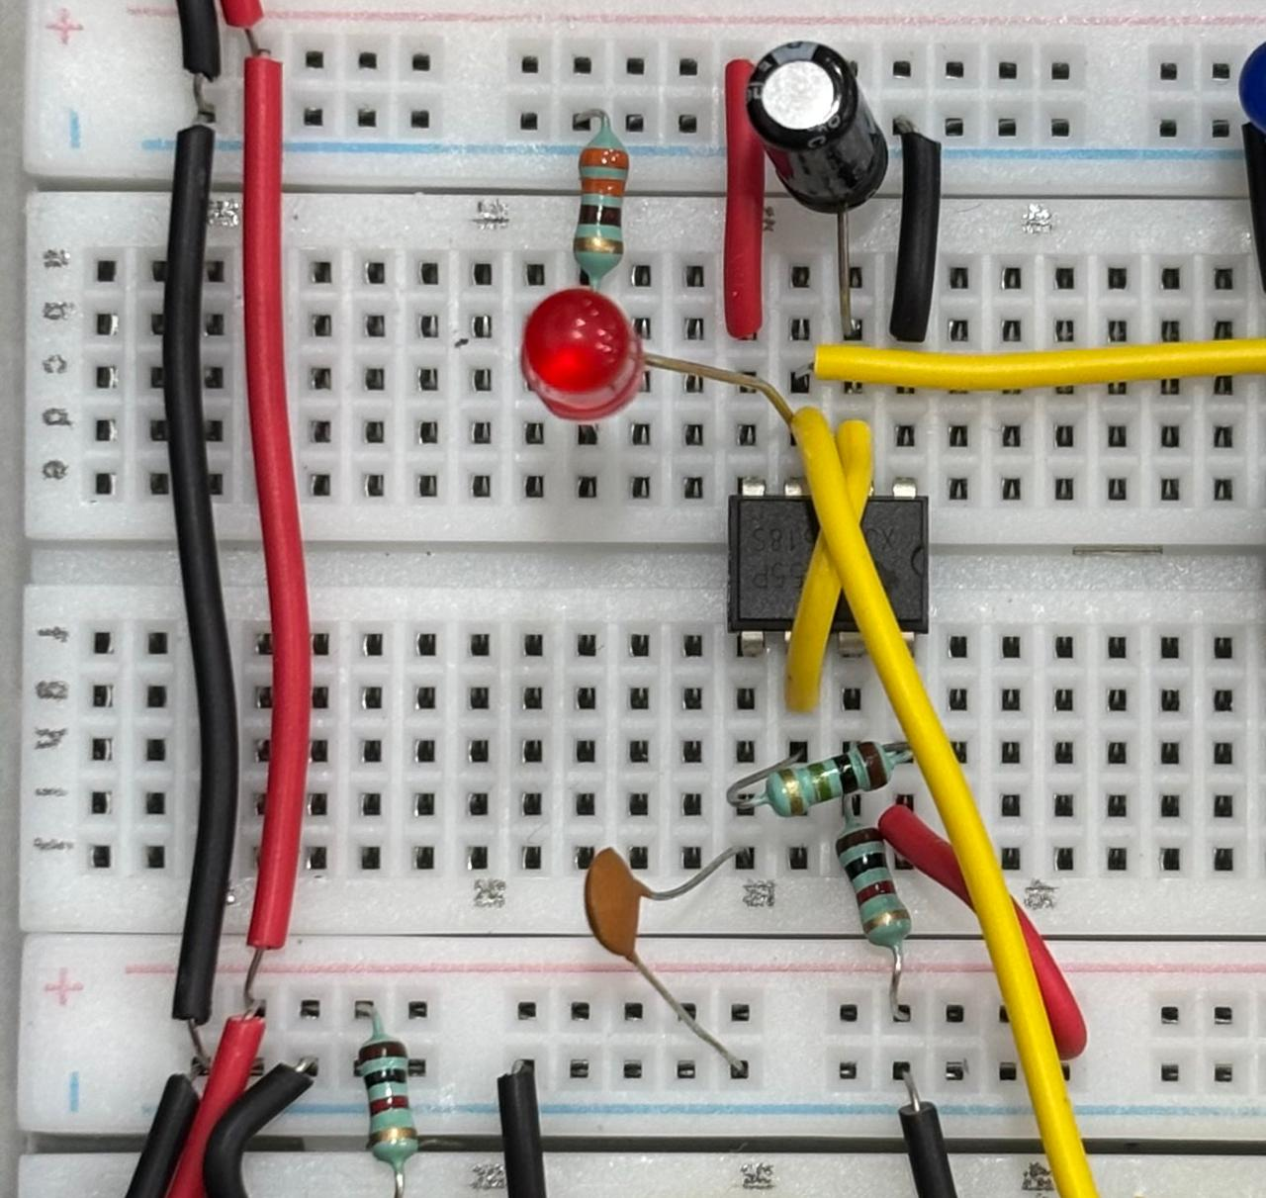

7.5 BUS Write & Read Module
Allows manual data entry to the shared 8-bit bus lines. The module uses one 8-bit DIP switch as the manual byte input interface, eight red LEDs as bus-line status monitors, and eight 1.2 kΩ resistors as bus-line pull-downs.
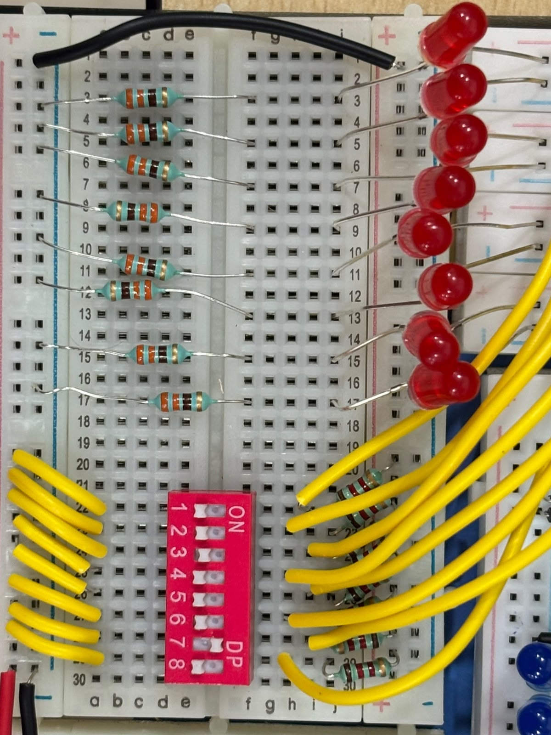

8. Working Principle & Operational Steps

8.1 Bus Communication Protocol
All modules share the 8-bit bus. Data is asserted onto the bus by activating tri-state outputs (such as A-OUT, ALU-OUT, or input DIP switches). Target registers load bus data on the rising edge of the 1 Hz clock when their load line (A-IN or B-IN) is pulled low.

8.2 Addition Sequence (A+B)
- Set DIP switches to operand A value.
- Assert A-IN control line; A loads into A-Register on the next clock pulse.
- Set DIP switches to operand B value.
- Assert B-IN control line; B loads into B-Register on the next clock pulse.
- Set DPDT switch to ADD mode (Logic 0).
- The 74LS283 adders compute A+B+0. Assert ALU-OUT to output the sum to the bus.

8.3 Subtraction Sequence (A−B)
Load A into A-Register and B into B-Register following steps 1–4 above.
- Set DPDT switch to SUB mode (Logic 1).
- Logic 1 on the XOR inputs inverts operand B (B̅).
- Logic 1 is also fed to Carry-In (C₀=1) of the first 74LS283 adder.
- The sum calculated is A+B̅+1, which represents A−B in 2's complement arithmetic.

9. Hardware Validation & Testing Results
Module / Function | Test Procedure | Observed Outcome | Status
Clock | Measured clock signal across yellow LED | Stable ~1 Hz pulse generated | PASS
BUS Data Entry | Set DIP switch pattern 10101010 | All 8 bus indicator LEDs illuminated correctly | PASS
A-Register Load | Loaded 00001111 with A-IN enabled | Data captured successfully on posedge clock | PASS
B-Register Load | Loaded 00000011 with B-IN enabled | Data stored into B-Register | PASS
ALU Addition | Computed 15+3 in ADD mode | Bus output displayed 00010010 (18) | PASS
ALU Subtraction | Computed 15−3 in SUB mode | Bus output displayed 00001100 (12) | PASS
Overflow / Carry | Computed 255+1 in ADD mode | Bus displayed 00000000, Green Carry LED lit | PASS

10. Challenges Faced & Solutions
Floating Bus Lines
Problem: Unconnected bus lines floated to uncertain voltage levels, causing erratic register loading.
Solution: Installed 1.2 kΩ pull-down resistors on all 8 bus lines to tie floating states reliably to Ground.
Push Button Switch Bounce
Problem: Mechanical switch bounce caused multiple clock cycles during manual control line triggering.
Solution: Added 0.1 μF debouncing capacitors across control push-button switches.
Bus Contention
Problem: Accidentally enabling multiple tri-state outputs simultaneously created short-circuit currents on bus lines.
Solution: Implemented interlocking manual procedures and tri-state control lines.

11. Applications & Future Scope
Educational Platform: Serves as a hands-on physical model for teaching CPU microarchitecture, instruction cycles, and bus management.
Modular Computer Design: Can be expanded into a complete 8-bit SAP-1 computer by adding a Program Counter (PC), RAM module, and EEPROM instruction decoder.

12.Pin Diagram ICSN74HC86N

IC SN74LS173AN IC SN74HCT245
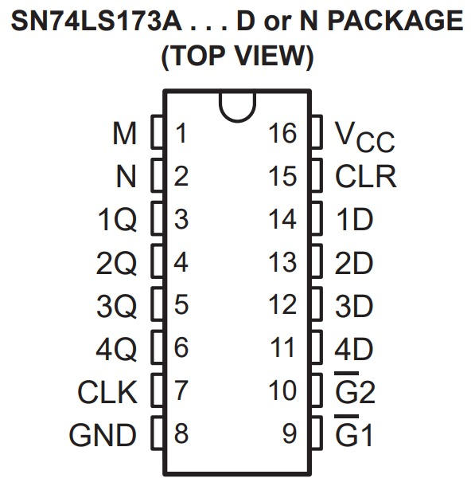
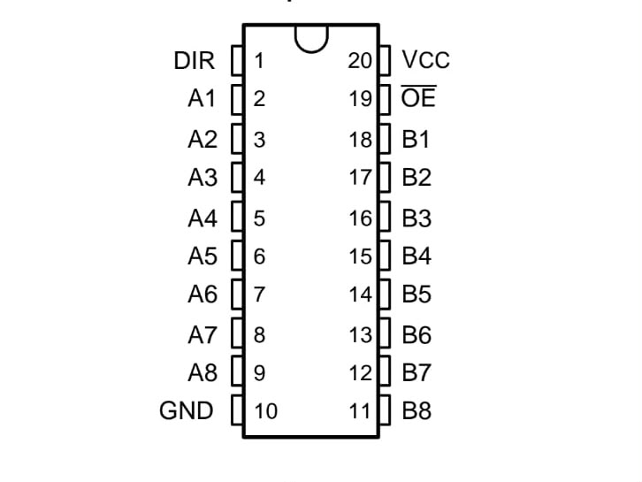

IC SN74LS283N ICSN74HC86N

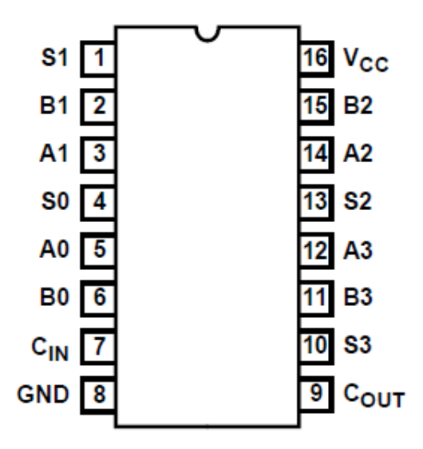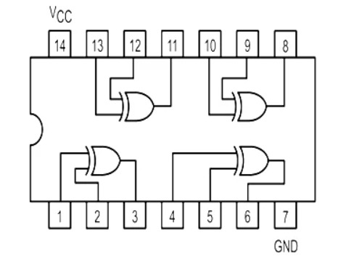

12. References
- Ben Eater, "Building an 8-bit breadboard computer – ALU design," Online Documentation & Video Series. URL: eater.net/8bit/alu.
- Texas Instruments, SN74LS173A 4-Bit D-Type Registers with 3-State Outputs Datasheet.
- Texas Instruments, SN74LS283 4-Bit Binary Full Adders Datasheet.
- Texas Instruments, SN74HCT245 Octal Bus Transceivers Datasheet.

