Part A: Concept Application (40%)
Project: Personal Finance Calculator

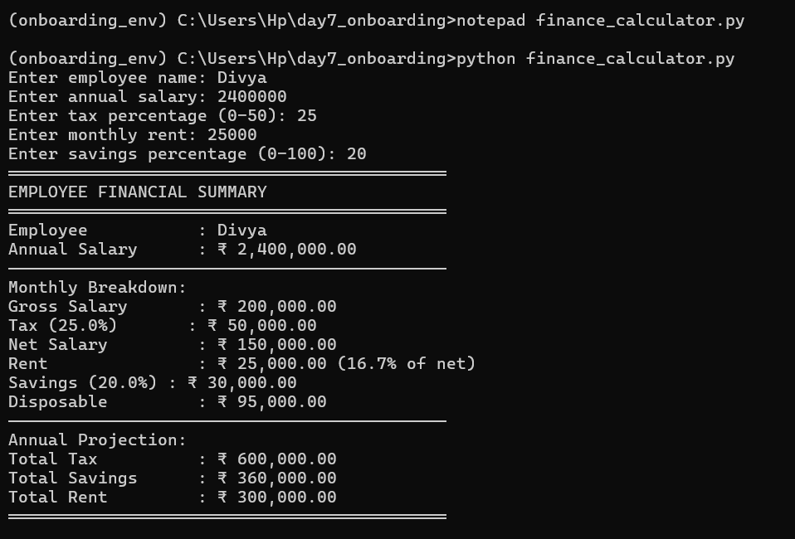
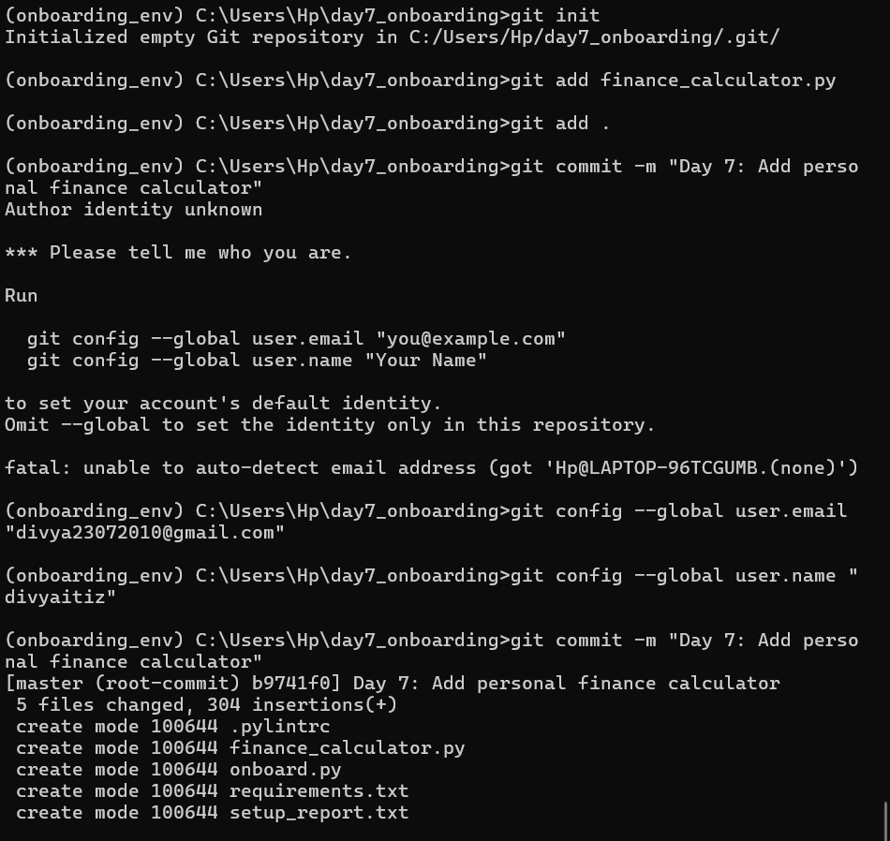
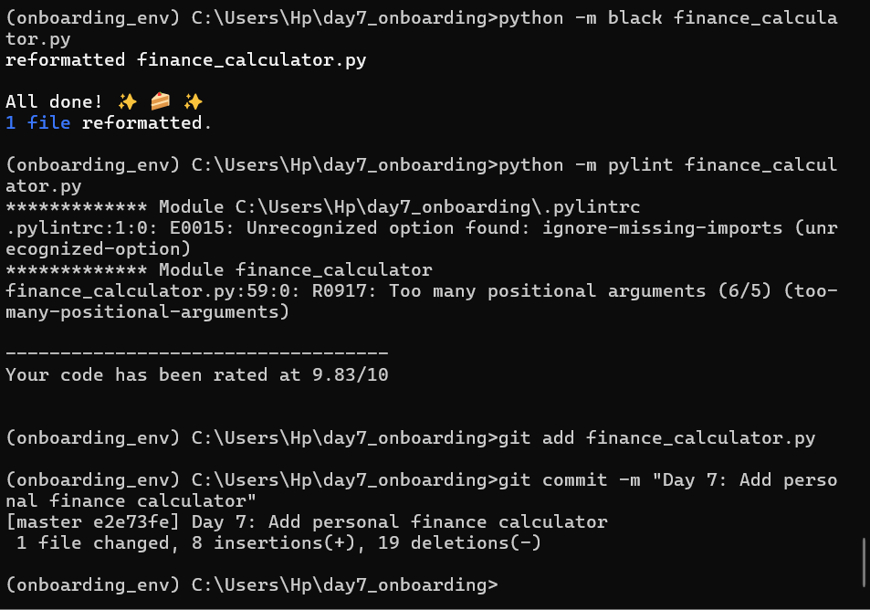
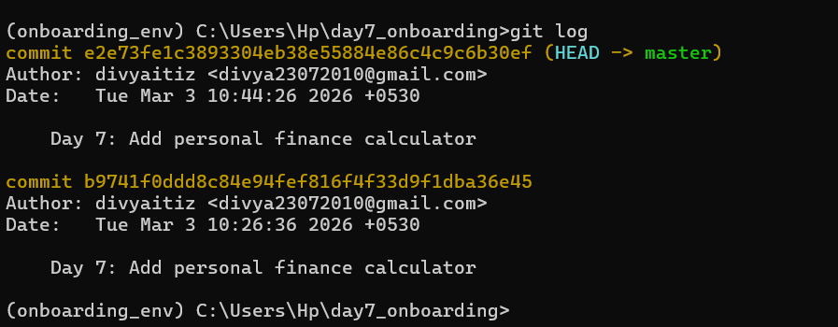

Part B: Stretch Problem (30%)
Extend with Indian Number Formatting & Comparison

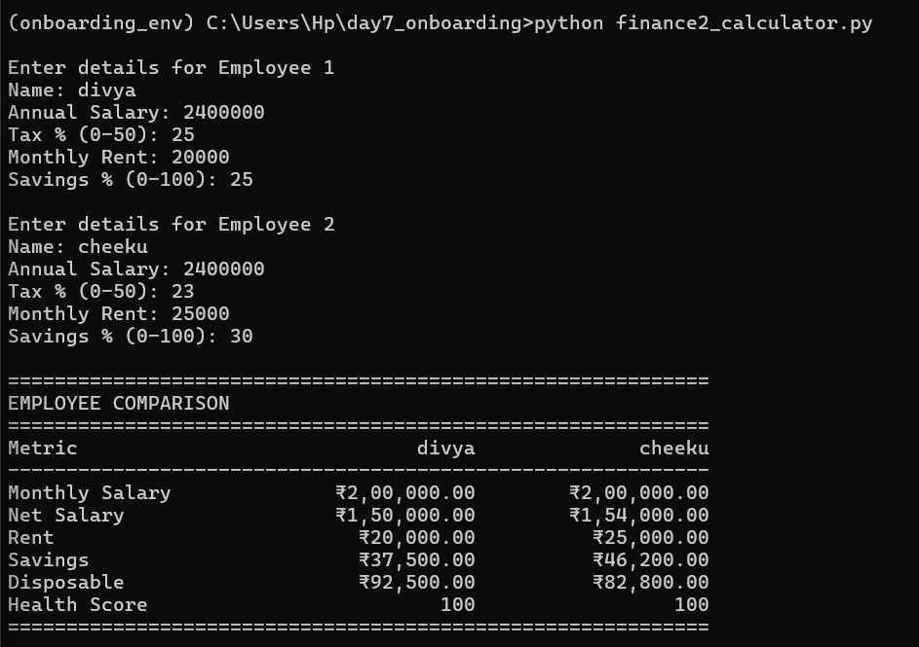
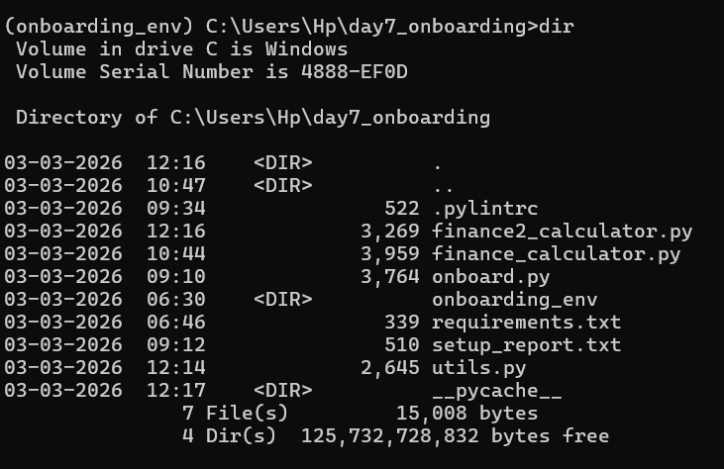

Q1: Conceptual — Data types deep dive
Explain the output of EACH line without running the code. Then verify by running:
print(type(True)) - True is of type bool, which is a subclass of int.
print(isinstance(True, int)) - In Python, bool inherits from int, so this returns True.
print(True + True + False) - Internally: True = 1, False = 0 → 1 + 1 + 0 = 2
print(int(3.99)) - int() truncates the decimal part (does NOT round).
print(bool("False")) - Any non-empty string is truthy, regardless of content.
print(bool("")) - Empty string is falsy.
print(0.1 + 0.2 == 0.3) - Due to floating-point precision errors, result is actually:
0.30000000000000004
print("5" + "3") - String concatenation, not arithmetic.
print(5 + 3) – integer addition
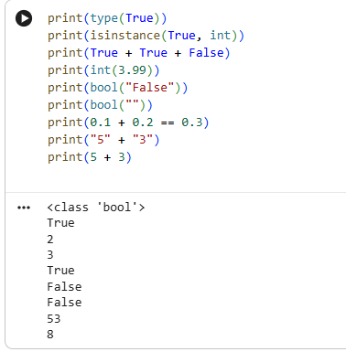

Q2: Coding —Builda type analyzer function

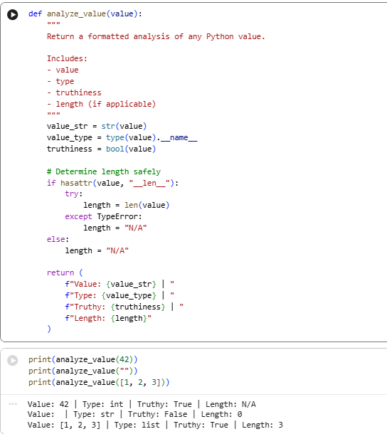

Q3: Debug —Findandfix 4bugs
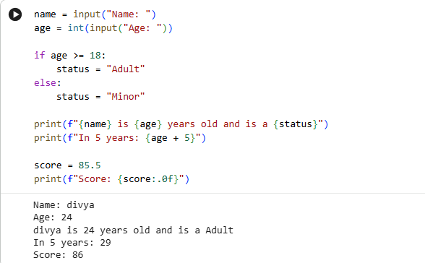
Issues in given code
- age is taken as string → must convert to int
- Comparison age >= 18 fails (string vs int)
- age + 5 causes error (string + int)
- Invalid format specifier {score:.0} → should be {score:.0f}

Part D: AI-Augmented Task (10%)
Task: Use AI to generate a comprehensive type conversion reference

Generate a Python type conversion matrix showing what happens when you convert between int, float, str, bool, list, and tuple. Include:
- Valid conversions with examples
- Invalid conversions and the exact error raised
- Edge cases (empty values, None, nested structures, unusual strings)
- Notes explaining why each conversion behaves that way
Present it as a clear table.

1. Exact Prompt Used
Generate a Python type conversion matrix showing what happens when you convert between int, float, str, bool, list, and tuple. Include:
- Valid conversions with examples
- Invalid conversions and the exact error raised
- Edge cases (empty values, None, nested structures, unusual strings)
- Notes explaining why each conversion behaves that way
Present it as a clear table.

2. Summary of Tested Conversions (Key Findings)
✔ Correct AI Outputs (Mostly Accurate)
- int("10") → 10
- float("3.14") → 3.14
- str(123) → "123"
- bool(0) → False, bool(1) → True
- list("abc") → ['a', 'b', 'c']
- tuple([1,2]) → (1,2)
⚠️ Partially Correct / Missed Nuances
- bool("False") → True
→ AI often misses that any non-empty string is True
- int(3.99) → 3
→ Correct but AI sometimes incorrectly says “rounds”
- list(123)
→ ❌ Error: 'int' object is not iterable
→ AI sometimes forgets to mention iterability requirement
❌ Incorrect / Missing Edge Cases
- int("") → ❌ ValueError
- float("") → ❌ ValueError
- int("10.5") → ❌ ValueError (not automatically cast)
- tuple(5) → ❌ TypeError
- list(None) → ❌ TypeError

3. Critical Evaluation (≈170 words)
The AI-generated type conversion matrix was broadly accurate for common conversions, particularly straightforward cases such as int("10"), float("3.14"), and iterable transformations like list("abc"). However, it lacked rigor in handling edge cases and frequently oversimplified behaviors. For example, it often failed to emphasize that bool("False") evaluates to True, which is a common conceptual pitfall. Additionally, it occasionally misrepresented truncation (int(3.99)) as rounding, indicating a gap in precision.
Error handling coverage was inconsistent. While some invalid conversions were identified, the AI did not systematically explain why operations like list(123) or tuple(None) fail—specifically the requirement for iterability. It also omitted several important failure cases such as int("") and int("10.5"), which raise ValueError.
To improve, the AI output should include a stricter taxonomy of errors (TypeError vs ValueError), explicitly document iterability constraints, and add more boundary inputs (empty strings, None, mixed-type collections). A more formal matrix with categorized rules would significantly enhance clarity and reliability.

