Part A: Concept Application (40%)
Project: Build a "New Developer Onboarding Kit"
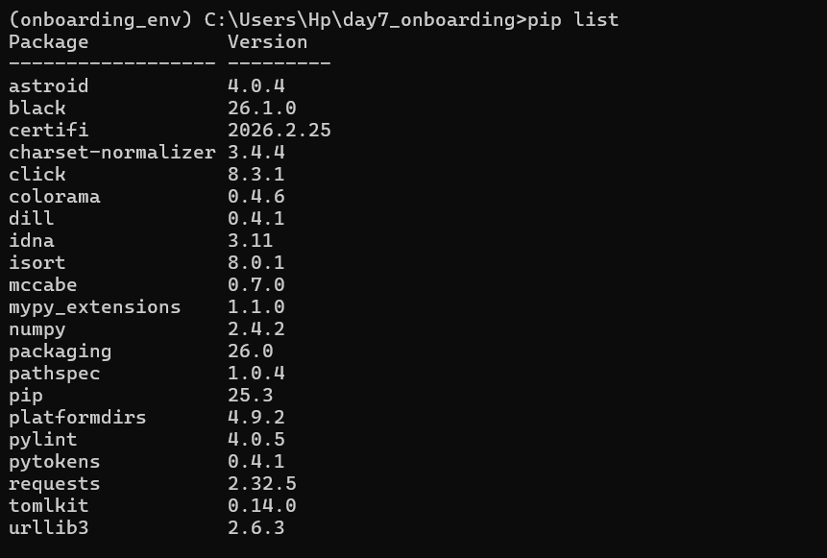
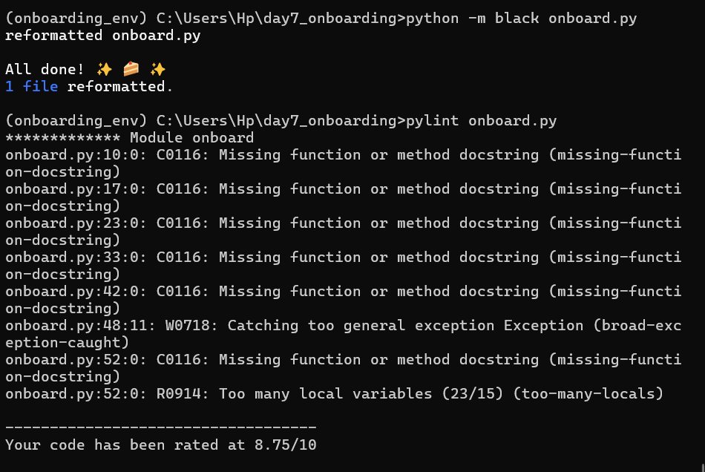
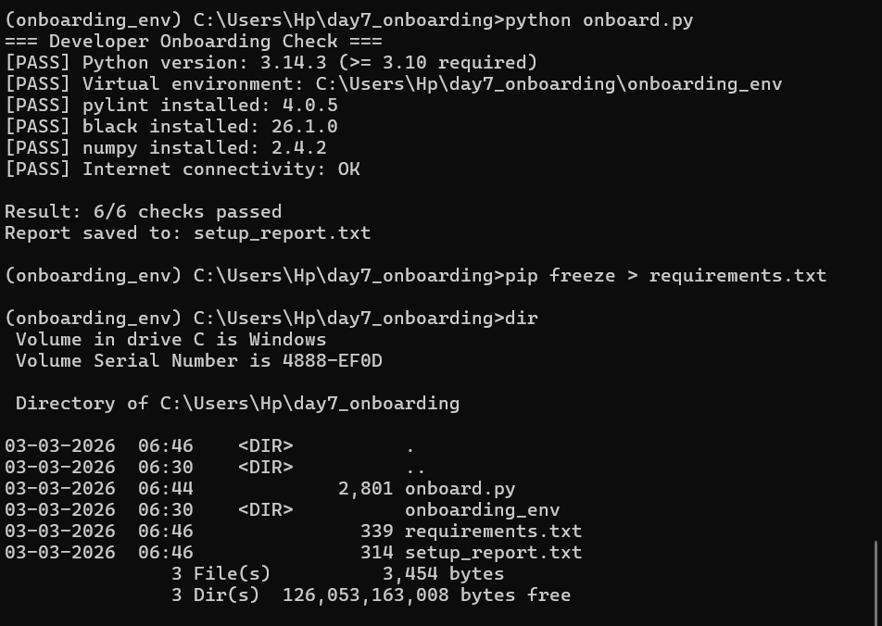

Part B: Stretch Problem (30%)
Extend the Onboarding Script with Advanced Features
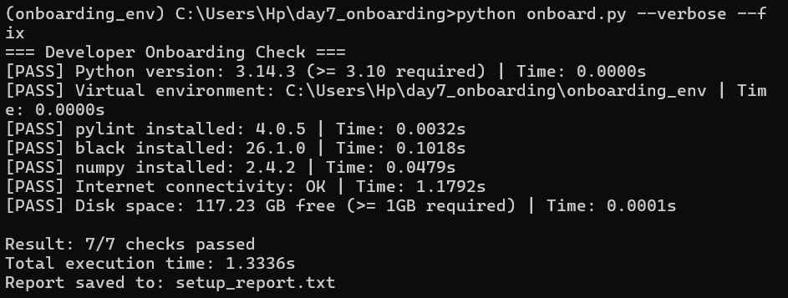
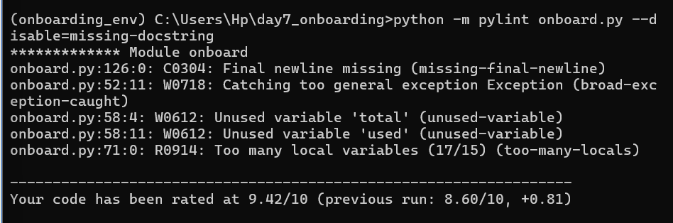

Part C: Interview Ready

Q1: Conceptual — Virtual Environments
A Python virtual environment is an isolated workspace that contains its own Python interpreter and installed packages, separate from the system-wide setup. Developers use them to avoid dependency conflicts between projects and to ensure reproducibility across machines. Without a virtual environment, installing packages globally can lead to version clashes or breaking other projects. A good analogy is having separate kitchens for different cuisines—each one has its own ingredients and tools, so recipes don’t interfere with each other.

Q2: Coding — Issues + Fixed Code
🔎 The 5 Issues
- Multiple imports on one line → violates style guidelines (import os, sys, json)
- Unused imports → os and json are never used
- Function naming not snake_case → checkVersion() should be check_version()
- Incorrect version logic → condition allows Python 3.12 but fails for 3.10 (requirement unclear, but logic is inconsistent)
- Unused variable → temp = 42 serves no purpose

✅ Corrected Code (Pylint-friendly ≥ 8/10)

import sys

def check_version():
"""Check if Python version is >= 3.11."""
version = sys.version_info
if version >= (3, 11):
return "Good"
return "Bad"

def main():
"""Main execution function."""
result = check_version()
print("Version status:", result)

if __name__ == "__main__":
main()

Q3: Debug / Analyze — numpy not found
Cause 1: Installed in different Python environment
- The developer installed numpy globally, but is running code inside a virtual environment (or vice versa)
Diagnostic:
python -m pip list

Cause 2: Wrong Python interpreter
- pip and python point to different installations
Diagnostic:
where python
where pip

Cause 3: Virtual environment not activated
- numpy is installed inside the venv, but the venv isn’t active when running the script
Diagnostic:
echo %VIRTUAL_ENV%
(If empty → venv is not active)

Part D: AI-Augmented Task (10%)
Task: Use ChatGPT/Claude to generate a comprehensive .pylintrc configuration file
Prompt –
Generate a .pylintrc configuration file suitable for a beginner-friendly Python AI/ML project.
The config should:
- Not be overly strict (avoid discouraging beginners)
- Allow common data science practices (like shorter variable names such as x, y)
- Disable overly pedantic warnings (like missing docstrings initially)
- Keep important checks (errors, unused imports, syntax issues)
- Set a reasonable max line length (100–120)
- Ensure code readability and maintainability
- Be compatible with Python 3.10+
Provide a clean, well-commented .pylintrc file.

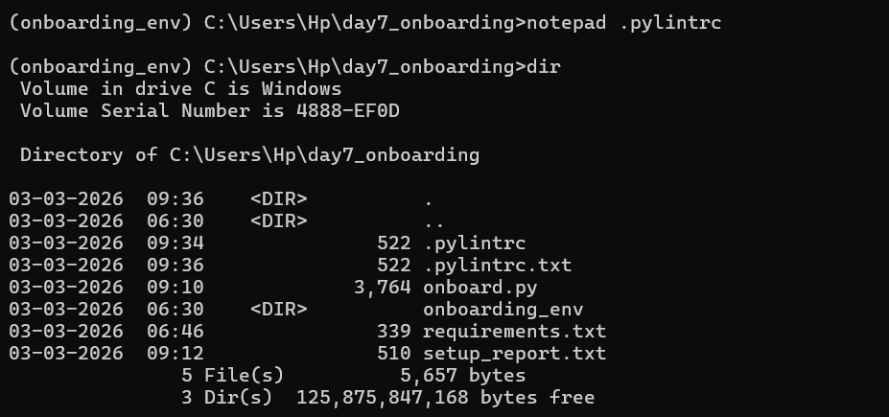

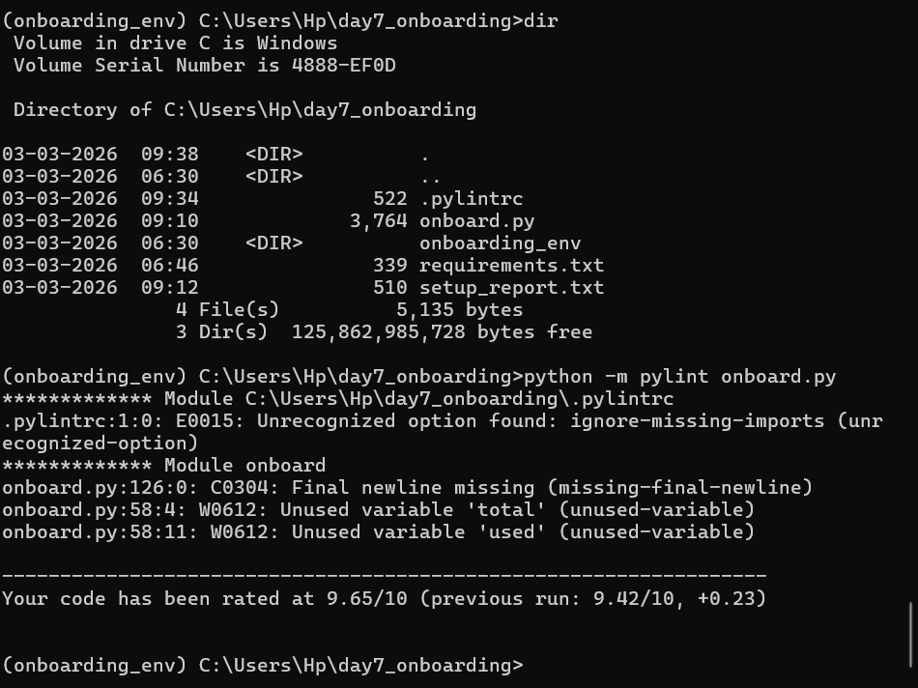

Write a critical evaluation (150-200 words): What did the AI get right? What would you change? Did it include any rules that are too strict or too lenient for beginners?

The generated .pylintrc configuration achieves a sensible balance between enforcing code quality and remaining approachable for beginners. It correctly disables docstring-related warnings, which can otherwise overwhelm new developers who are still focusing on core programming concepts. Allowing flexible naming conventions is also appropriate for AI/ML workflows, where short variable names like x, y, and df are common. The increased line length limit further supports readability in data-heavy scripts.
However, there are areas that could be improved. The inclusion of unsupported or incorrect options (such as ignore-missing-imports) indicates a lack of full alignment with Pylint’s configuration standards, which could confuse beginners. Additionally, disabling warnings like broad-except may be too lenient, as it encourages poor error-handling practices. Some complexity-related limits are also relatively relaxed, which might allow inefficient or hard-to-maintain code structures to pass unnoticed.
Overall, the configuration is well-suited for an introductory environment but would benefit from minor corrections and a gradual tightening of rules as the developer gains experience.

