ADITYA MAVLE

Mobile: 76204 69531 [adityamavle@gmail.com](mailto:adityamavle@gmail.com) https://in.linkedin.com/in/aditya-mavle-702591218

# OBJECTIVE

To start a journey into Data Science, Machine Learning and AI with strong knowledge and right mindset

# EXTRA-

## EDUCATION

### Pune Institute of Computer Technology

2020 – 2024, First Year CGPA: 9.95 , Second Year CGPA: 8.23 BE, E&TC, Data Science (Hon.)

### HSC ( 2018-2020): 80% Rajiv Gandhi E-learning, Pune

**ICSE ( 2008-2018) : 92 %, The Bishop’s School, Camp, Pune**

# CURRICULAR

## WORK EXPERIENCE

1. Inter District Cricket tournament U-16

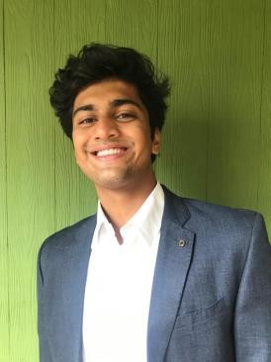

1. TEDex PICT Volunteer(Curation and Content team) Shortlisting, Interviewing and on-boarding of Guest Speakers

Article Writing

1. PISB: Part of the event organizing team of PICT IEEE Credenz 21’s event DataWiz,a DataScience and ML competition
2. PCSB(Pune CSI Student Branch): Part of the marketing team for Xenia 21.
3. Part of the Concepts team in the annual flagship event of PICT impetus and concepts

# HOBBIES

Experimenting with new technologies

Reading psychology Books Playing Cricket

Working out

### PrimeNumerics Consulting Inc.

Jan-2022-May-2022

Analyzing Electronic Health Records for patient profiling and assessment using NLP

### College Projects:

* Building a backup system to store files in a chunked manner and maintained tags about its contents using natural language processing and CV
* Building a website of a Directory and Search Engine for NGO portals
* Built a Home Energy Management System using Raspberry PI

### Personal Projects:

* Using ViTransformers for organ image segmentation and diagnosis of diseases through images
* Financial Document Understanding using BERT
* Document Analyzing for Sensitive Information using Abstractive Summarization and Keyword Extraction

**SKILLS**

* Python
* Pandas, Scikit-Learn
* OpenCV
* TensorFlow
* BERT
* NLP
* Object Oriented Programming
* C++
* Data Structures and Algorithms