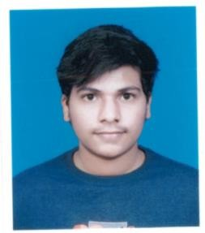Sameer Somkuwar

04/06/2002, Nagpur, Maharashtra, India. 9130193523

[sameer.som.2002@gmail.com](mailto:sample@sample.com)

# EDUCATION

*2018 - S.S.C.* **S.t Joseph’s Convent School, Fetri, Nagpur.**

**Percentage- 71.8**

*2020 –H.S.C.* **Taiwade Jr. College, Nagpur.**

**Percentage- 78.15**

*2020- UG* **Pune Institute of Computer Technology**

**(2nd year)GPA- 8.9**

# SKILLS AND QUALIFICATIONS

## Programming

* C++
* C(Basics)
* SQL(Basics)
* Python (Basics)
* HTML(Basics)
* Database Management System (Basics)
* Data Structures and Algorithms
* Over 50+ questions on Codeforces (user- ssomkuwar)
* 1 star in Codechef (1251) (user- sameer_246)

## Languages

*Native tongue* Hindi

*Basics* English, Marathi