TURBOJET DIGITAL TWIN — DASHBOARD
UX & Aesthetic Review
Prepared for: engineering / scientist end-users of the physics-informed health-monitoring dashboard
Scope: front-end aesthetics and interaction design only — the 3D engine model itself is out of scope for this review.
21 July 2026

Executive Summary
The dashboard’s overall visual direction — dark instrumentation panels, monospaced numerals, restrained health-band coloring — is the right register for a physics-informed engine health monitor and should be kept. This review looks specifically at how well the interface serves the people who will actually use it during real analysis work: engineers and scientists reading these values repeatedly, not a one-time audience seeing it in a demo.
Eight specific issues are documented below, each with a problem statement, why it matters for this specific audience, an illustration of the issue and the fix, and a concrete recommendation. They range from a genuine data-correctness defect (Issue 1) to interaction-efficiency gaps (Issues 5–6) to visual polish (Issues 4, 7, 8).
PRIORITY AT A GLANCE
# | Issue | Why it ranks here | Effort
1 | Unlabeled dual-axis trend chart | Actively misleads a reader trying to take a value off the chart | Low
2 | No uncertainty shown outside one panel | Health Index numbers are trusted more than their real precision supports | Low
3 | No baseline reference on sparklines | Forces mental math the UI already has the data to do for you | Low
4 | Decorative motion competes with monitoring | Constant motion pulls attention during long monitoring sessions | Low
5 | No keyboard / precise cycle control | Mouse-only dragging is imprecise for repeat, careful analysis | Medium
6 | No jump-to-anomaly control | Manual scrubbing through 250 cycles to find a threshold crossing is slow | Medium
7 | Inconsistent numeric precision | Small added parsing effort, repeated hundreds of times per session | Low
8 | Amber/orange bands hard to tell apart for some users | Color-only cues fail a portion of any real user base | Low

ISSUE 1 · Unlabeled Dual-Axis Trend Chart
PROBLEM
The Degradation Trends chart plots Health Index and Remaining Useful Life (RUL) as two lines sharing one set of axes. HI is normalized to 0–1 and its axis is labeled. RUL is independently normalized to its own maximum so it fits the same visual band — but no second axis is drawn or labeled anywhere on the chart.
WHY IT MATTERS FOR SCIENTIST USERS
A domain expert reading this chart will naturally try to read an actual value off the dashed RUL line — "the line is at about 0.6, so RUL is around..." — and there is no way to do that correctly, because the height carries no declared units. An unlabeled second series is worse than omitting it entirely: it invites a wrong reading with full visual confidence, in a chart whose entire purpose is to support a maintenance decision.
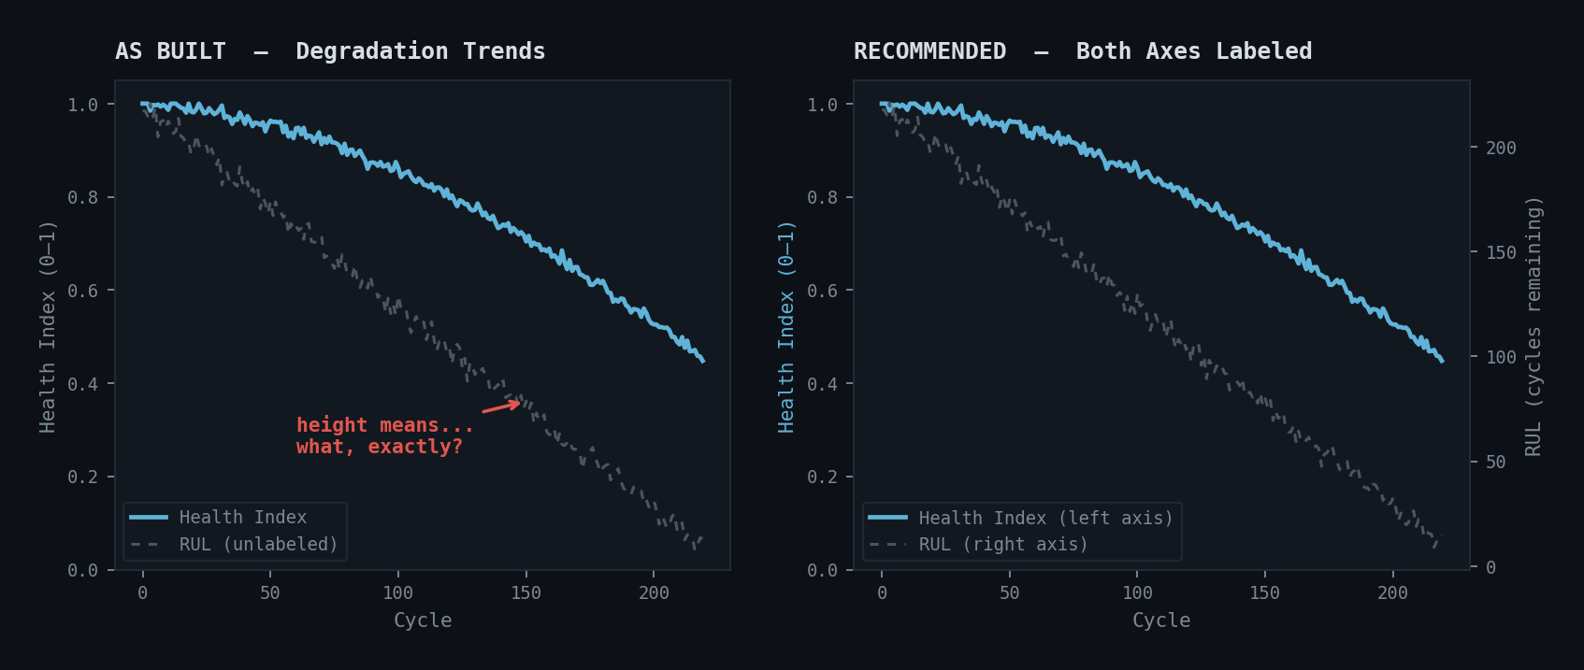
Left: current chart with an unlabeled second series. Right: the same data with a properly labeled right-hand axis in its native units (cycles).
RECOMMENDATION
Add a right-hand y-axis with its own tick labels in cycles, a distinct axis label color matching the RUL line, and keep both series’ units visible in the legend (e.g. "Health Index (0–1, left axis)" / "RUL (cycles, right axis)").

ISSUE 2 · Point Estimates Shown Without Uncertainty
PROBLEM
The dashboard already computes a confidence percentage and a sigma value for RUL predictions, but this is confined to a single Confidence panel. Every other Health Index number — compressor, combustor, turbine, and Overall Health Index — is displayed as a single value with no visible error band.
WHY IT MATTERS FOR SCIENTIST USERS
A scientist’s first instinct on seeing "HI: 0.83" is to ask whether a 0.02 dip from the previous cycle is a real trend or noise inside the measurement’s own uncertainty. Without a visible band, that question can only be answered by digging into raw data outside the dashboard — defeating the purpose of a monitoring UI built specifically for this audience.
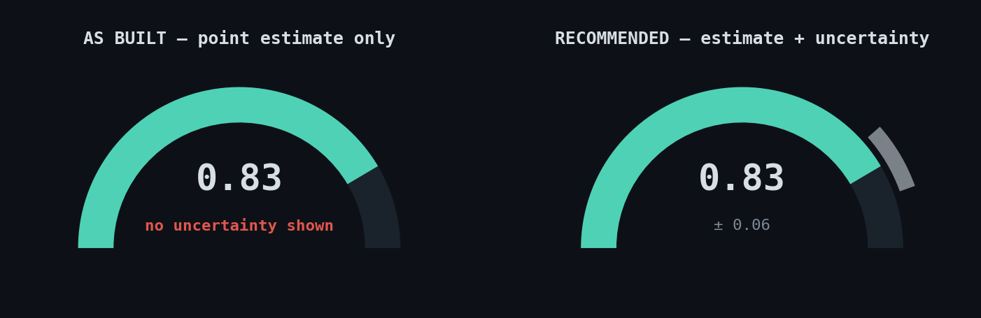
Left: a gauge showing only a point value. Right: the same gauge with its uncertainty band rendered as a shaded arc segment, and the value expressed as a range.
RECOMMENDATION
Extend the existing sigma/confidence calculation to every HI gauge: render a shaded uncertainty wedge on the arc itself, and append a "±" value next to every headline number, not just in the Confidence panel.

ISSUE 3 · No Baseline Reference in Sparklines
PROBLEM
Every Health Index is defined relative to a per-engine healthy baseline (the rolling average of each engine’s first 10–15% of cycles, per the project’s own physics spec). The sparklines throughout the dashboard show the raw trend shape only — the baseline value itself is never drawn on the chart.
WHY IT MATTERS FOR SCIENTIST USERS
The question a scientist actually has isn’t "what shape is this line" — it’s "how far off the healthy baseline are we right now." Right now that requires cross-referencing a separate number and doing the subtraction mentally, for every gauge, every time. A chart element that already has the baseline value in memory should just draw it.
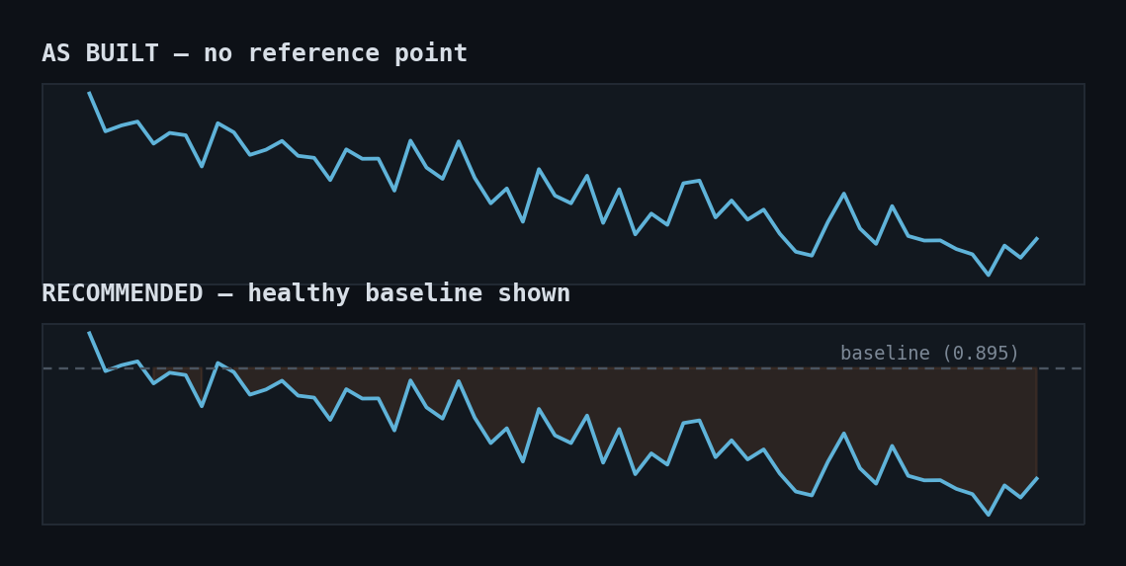
Top: sparkline with no reference point. Bottom: the same trend with a faint baseline line and the degradation-from-baseline area shaded.
RECOMMENDATION
Draw a faint dashed horizontal line at each engine’s stored baseline value on every HI sparkline, labeled once with its numeric value, and optionally shade the gap between the current trend and that line.

ISSUE 4 · Decorative Motion Competes with Monitoring
PROBLEM
Several chrome elements animate continuously or glow on interaction regardless of whether any underlying data changed: the topbar logo mark spins on a permanent loop, hover states add a glow ring, and the component info card carries a drop-shadow-plus-blur treatment.
WHY IT MATTERS FOR SCIENTIST USERS
This is fine for a two-minute pitch demo. It is a real cost for someone whose job is to watch this screen for extended periods: constant motion in peripheral vision competes for attention with the one thing that should draw the eye, which is a value actually changing or a threshold actually being crossed. Motion should be a signal, not ambient decoration.
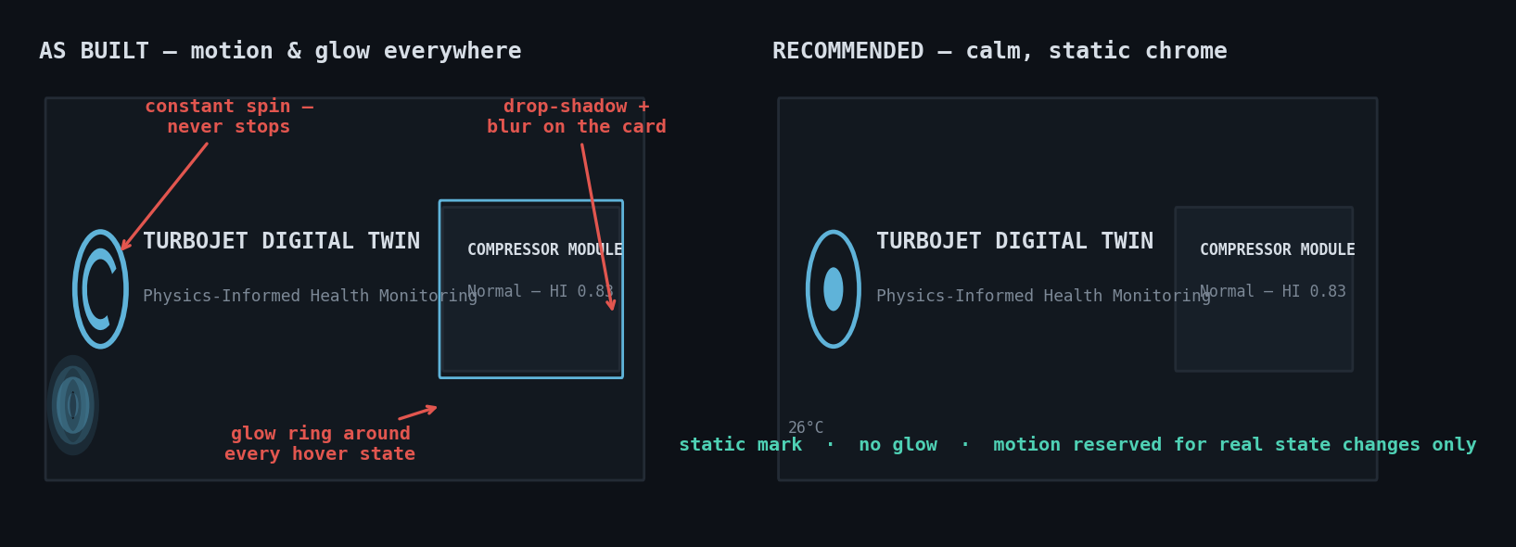
Left: current chrome with three sources of constant motion/glow highlighted. Right: the same layout with motion reserved only for genuine state changes.
RECOMMENDATION
Make the logo mark static (or tie its motion to actual engine-running state). Remove ambient glow/blur from hover and card treatments; keep a single, consistent elevation style (one shadow token) used sparingly, and reserve animation for value transitions and band crossings.

ISSUE 5 · No Keyboard or Precise Cycle Control
PROBLEM
The only way to move between cycles is dragging the 52px flight-cycle tape with a mouse. There is no way to type a specific cycle number or step by keyboard.
WHY IT MATTERS FOR SCIENTIST USERS
First-time viewers rarely need to land exactly on cycle 187; repeat users comparing a specific cycle against a written report or a colleague’s note do, constantly. Precise navigation is exactly the kind of feature that separates a tool built for a one-time demo from one built for people who will actually use it every day.
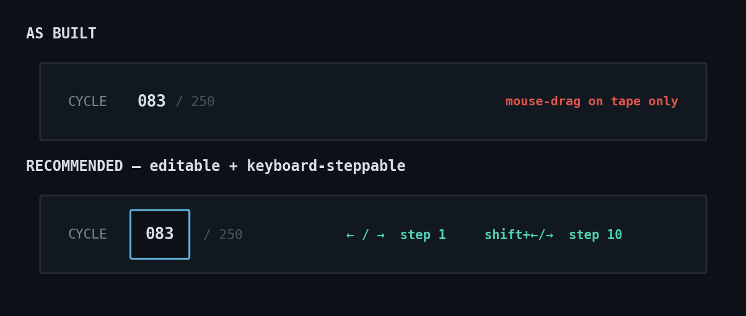
Top: current cycle readout, mouse-drag only. Bottom: an editable cycle field with keyboard step hints (←/→ for ±1, shift+←/→ for ±10).
RECOMMENDATION
Make the cycle number in the topbar an editable field (type-and-enter to jump), and bind arrow keys to step ±1 cycle, shift+arrow to step ±10, matching common lab-instrument and video-scrubber conventions.

ISSUE 6 · No "Jump to Next Anomaly" Control
PROBLEM
Finding where Overall Health Index first crosses from Normal into Warning (or further) requires manually scrubbing through as many as 250 cycles one at a time — there is no shortcut to the next or previous threshold crossing.
WHY IT MATTERS FOR SCIENTIST USERS
Auditing a run for exactly this kind of transition is one of the most common real analysis tasks this tool will be used for. A manual scrub across hundreds of cycles to find it is the single biggest efficiency gap in the current interaction model — and closing it is also the clearest signal that the tool was designed around how domain experts actually work, not just around what looks good in a walkthrough.
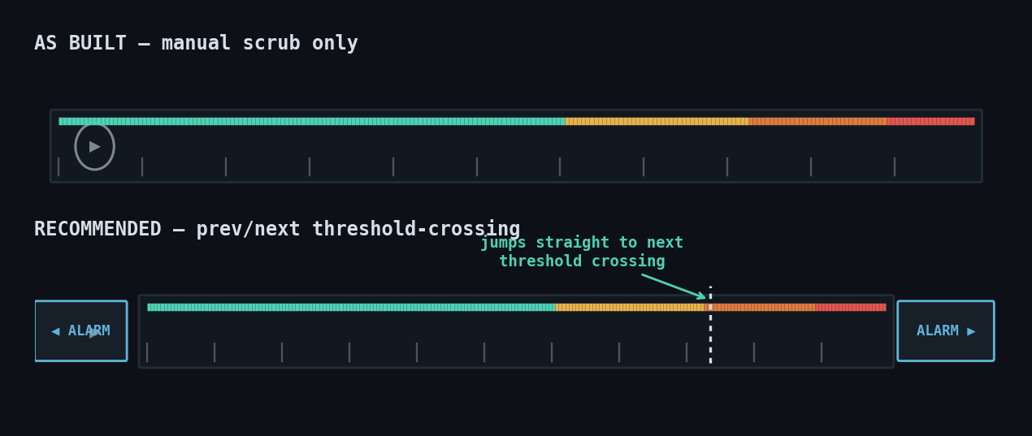
Top: manual scrub only. Bottom: prev/next buttons that jump directly to the nearest health-band threshold crossing, with the target cycle marked on the tape.
RECOMMENDATION
Add "◀ Prev" / "Next ▶" controls next to the play button that jump the cycle pointer to the nearest earlier/later band transition, using the same band-crossing data already computed for the tape’s color coding.

ISSUE 7 · Inconsistent Numeric Precision
PROBLEM
The same unit type is displayed at different decimal precision in different panels — for example, isentropic efficiency (η) appears at three decimal places in one panel and effectively two elsewhere; pressures mix kPa-scale and implicit Pa-scale figures.
WHY IT MATTERS FOR SCIENTIST USERS
This is a small thing multiplied by a large number of readings per session. Every time the precision convention changes, a reader has to briefly re-calibrate what level of significance to assign the trailing digits. A fixed convention per unit type removes that friction entirely, at near-zero implementation cost.
Quantity | As built | Recommended
η (isentropic efficiency) | 0.885 in one panel, 0.87 in another | Always 3 dp — 0.885
π (pressure ratio) | 10.72 / 11.2 (mixed) | Always 2 dp — 10.72
Temperatures (K) | 647 K / 647.3 K (mixed) | Always 0 dp — 647 K
Pressures | 226 kPa / 226000 Pa (mixed scale) | Always kPa, 0 dp — 226 kPa
Health Index | 0.83 / 0.830 (mixed) | Always 2 dp — 0.83

RECOMMENDATION
Fix precision per unit type once, in one shared formatting helper, and use it everywhere that unit type appears.

ISSUE 8 · Warning/Alarm Band Colors Are Close Under Color-Vision Deficiency
PROBLEM
The health-band palette runs teal → amber → orange → red. Amber and orange are close in hue and differ mainly by lightness, which is the dimension most compressed under red-green color vision deficiency (deuteranopia), affecting roughly 5–8% of men.
WHY IT MATTERS FOR SCIENTIST USERS
An engineering team of any size will very likely include at least one person with some degree of red-green color vision deficiency. For a tool where color encodes an aircraft engine’s health band, that is not a cosmetic detail — every place a status dot appears, it should never be the only cue distinguishing Warning from Alarm.
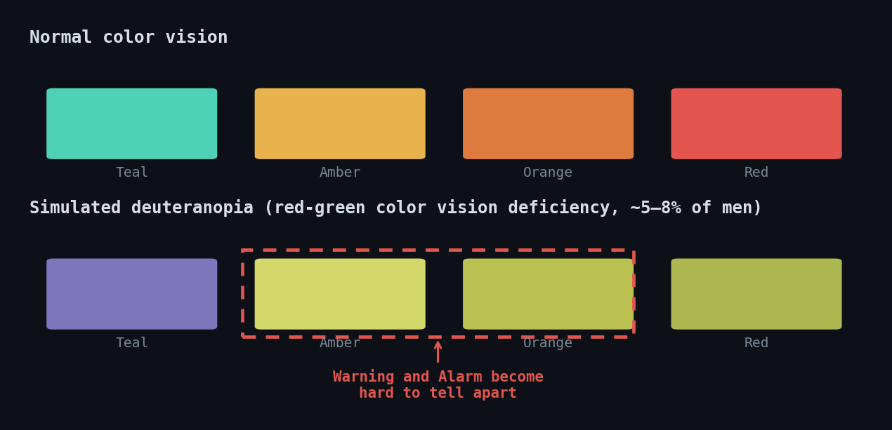
Top: the four band colors under normal vision. Bottom: the same colors under a simulated deuteranopia transform — Warning and Alarm become difficult to separate.
RECOMMENDATION
Widen the hue separation between the Warning and Alarm colors (push amber warmer / orange redder, or shift one toward a distinct hue rather than a lightness step), and audit every status dot in the interface to confirm a text label is always visible alongside it, never color alone.

