Obesity Analysis and Prediction Using Machine Learning
[Author Name]
School of Computer Science and Engineering
Lovely Professional University
Phagwara, Punjab, India
Registration No. [Registration Number]

Abstract—Obesity is a major public-health concern, and its prevalence differs by year, location and population group. This paper analyses 20,369 cleaned records of adult obesity prevalence from the US Behavioral Risk Factor Surveillance System (2011 to 2025; 55 locations and 27 demographic groups) and carries out five machine-learning tasks. Simple linear regression estimates the trend over time, multiple linear regression predicts prevalence from year, location and demographic group, and decision tree, logistic regression and K-nearest neighbours (KNN) classify records as High (30% or above) or Lower prevalence. Prevalence rose by about 0.53 percentage points a year, but year alone explained only 10.2% of the variance (R-squared 0.10, RMSE 6.99). Adding location and demographic variables raised R-squared to 0.75 and cut RMSE to 3.67. For classification, logistic regression was best (accuracy 0.870, F1 0.896, AUC 0.938), closely followed by KNN (accuracy 0.861, F1 0.890); the decision tree had the highest recall (0.978) but many false alarms (accuracy 0.724). Demographic and geographic characteristics are therefore strong predictors of obesity prevalence, although the random split and the fixed 30% cut-off limit how far the results generalise.
Keywords—obesity prevalence, BRFSS, linear regression, logistic regression, decision tree, K-nearest neighbours, classification

Introduction
Obesity is one of the most important public-health problems of the present day. It is linked to type 2 diabetes, heart disease and several cancers, and it raises health-care costs [2], [3]. Obesity is commonly defined as a body mass index (BMI) of 30 kg/m² or more. In the United States the share of adults with obesity differs a great deal between states and between groups defined by age, sex, education, income and race or ethnicity, and it has changed over time. Surveillance data such as the Behavioral Risk Factor Surveillance System (BRFSS) record these differences and are published openly [1].
Understanding how obesity prevalence changes with time, place and population group helps health departments decide where to focus programmes. This paper therefore asks: using state-level survey data from 2011 to 2025, how far can the level of adult obesity be predicted from the year, the US state and the demographic group, and can records be sorted into High and Lower prevalence? Five objectives are addressed: (i) to predict the level of obesity from the number of years and determine the trend; (ii) to predict obesity from several variables, namely year, US state and demographic group; (iii) to categorise the prevalence of obesity into High and Lower using demographic and geographic data; (iv) to forecast the likelihood that a record falls into the High or Lower category using the same characteristics; and (v) to categorise prevalence by comparing demographic and geographic records with identical data.
Each objective is matched to one method: simple linear regression, multiple linear regression, a decision tree, logistic regression and K-nearest neighbours (KNN), respectively. The contributions are (i) a cleaned dataset of 20,369 prevalence records; (ii) an exploratory analysis of trend, state and demographic differences; and (iii) a side-by-side comparison of the five models using standard regression and classification metrics. The study covers published prevalence percentages for groups of adults only; individual-level prediction, causes of obesity and forecasts beyond 2025 are out of scope.

Dataset
Source. The data come from the Nutrition, Physical Activity, and Obesity dataset of the US Centers for Disease Control and Prevention (CDC), which is built from the Behavioral Risk Factor Surveillance System telephone survey [1]. The file holds 118,580 rows and 33 columns covering several questions about obesity, overweight, physical activity and fruit and vegetable intake. Obesity in BRFSS is based on BMI calculated from self-reported height and weight.
Variables. Only the question “Percent of adults aged 18 years and older who have obesity” was used, which gives 23,100 records. Five columns were kept: YearStart (the survey year), LocationDesc (the state or territory), StratificationCategory1 (the type of demographic split), Stratification1 (the specific group) and Data_Value (the obesity prevalence in per cent, which is the quantity to be predicted).
Coverage. Records cover 2011 to 2025 (15 years) and 55 locations: the 50 states, the District of Columbia, Guam, Puerto Rico, the Virgin Islands and a national figure. Each location and year is reported for a total and for 27 demographic groups in five categories (age, education, income, sex and race or ethnicity), as summarised in Table I. The word state is used for all locations for brevity.
TABLE I
Records by demographic category after cleaning
Category | Records | Mean (%) | High (%)
Income | 5,613 | 32.35 | 65.5
Age (years) | 4,812 | 30.86 | 57.3
Race/Ethnicity | 4,330 | 30.97 | 60.3
Education | 3,208 | 31.70 | 65.1
Sex | 1,604 | 31.14 | 59.7
Total | 802 | 31.15 | 60.7
All records | 20,369 | 31.46 | 61.8
ª High means a prevalence of 30% or more; the last column is the share of records in each category that are High.

Methodology
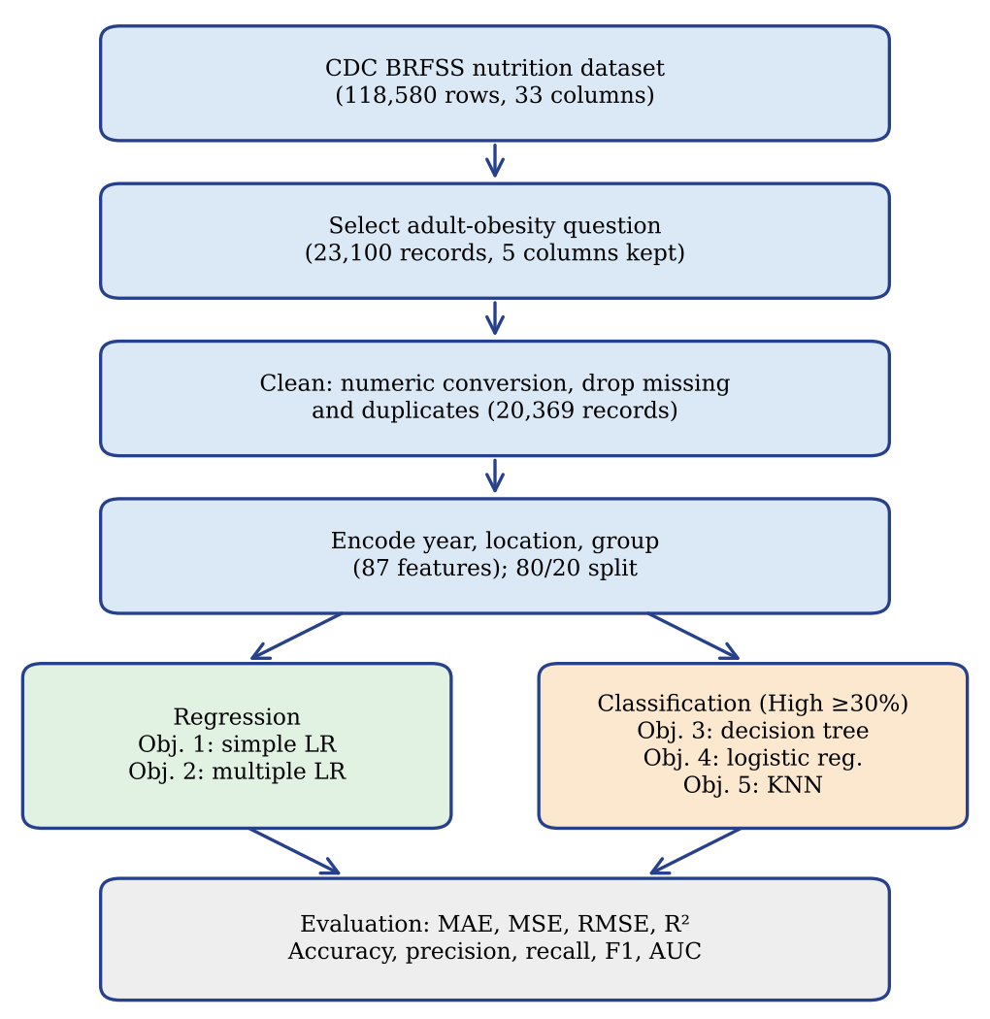
Fig. 1. Overview of the methodology.

Data cleaning and preparation
The dataset was loaded with pandas [5] and filtered to the adult-obesity question. Data_Value was converted to a number, and records with no value were removed. This dropped 2,731 records (11.8%), and no duplicate rows were found, leaving 20,369 records. The cleaned file was saved for reuse. Exploratory statistics and plots were produced with NumPy, Matplotlib and seaborn [6]–[8].

Feature encoding and data split
The inputs are the year (numeric) and three categorical variables: location, demographic category and demographic group. The categorical variables were one-hot encoded with the first level of each dropped, giving 87 input columns (1 year, 54 location, 5 category and 27 group columns). The first level dropped is the reference, so a coefficient shows the difference from that level (Alabama for locations). The data were split at random into 80% for training (16,295 records) and 20% for testing (4,074 records) with a fixed random seed of 42. For classification the split was stratified by class, and all inputs were standardised using the training set only [4].

Targets and category definition
For regression the target is the prevalence itself. For classification a record is High if its prevalence is 30% or more and Lower otherwise. The 30% cut-off matches the BMI threshold used to define obesity and gives 12,578 High records (61.8%) and 7,791 Lower records (38.2%). The test set has 4,074 records, of which 2,516 (61.8%) are High. A classifier that always answered High would therefore score an accuracy of 0.618, which is the level to beat.

Models and objectives
Table II links each objective to its model. Simple linear regression fits the prevalence ŷ to the year only, and multiple linear regression adds the encoded location and demographic columns [9]:
ŷ = β₀ + β₁·year + Σ βⱼdⱼ (1)
where dⱼ are the one-hot columns and β the coefficients fitted by ordinary least squares; simple regression keeps only the β₁ term. The decision tree [11] splits records on the encoded features using the Gini impurity and was limited to a depth of 5 to reduce over-fitting. Logistic regression [10] gives the probability of the High class as
P = 1 / (1 + e^{−(β₀ + β·x)}) (2)
where x is the vector of standardised features; records with P of 0.5 or more are labelled High. KNN [12] labels a record by the majority class of its k = 5 closest training records, using the Euclidean distance
d(a, b) = √ Σ(aₖ − bₖ)² (3)
so records with the same state, group and similar year lie close together and share a label.
TABLE II
Objectives and the models used
No. | Objective (short form) | Task | Model
1 | Prevalence from year; trend | Regression | Simple LR
2 | Prevalence from year, state, group | Regression | Multiple LR
3 | Classify as High or Lower | Classification | Decision tree
4 | Probability of High or Lower | Classification | Logistic reg.
5 | Classify by similar identical records | Classification | KNN (k = 5)
ª LR = linear regression.

Exploratory Analysis
Trend. The mean prevalence rose from 27.74% in 2011 to 34.30% in 2025 (Fig. 2). Growth was steady until 2020 (32.41%), jumped in 2021 (34.03%) and then stayed between 34.01% and 34.41%. The curve for the Total group alone follows the same shape (27.59% in 2011 and 33.69% in 2025). The correlation between year and prevalence over all records is 0.31, which is positive but modest because most variation lies between places and groups rather than between years.
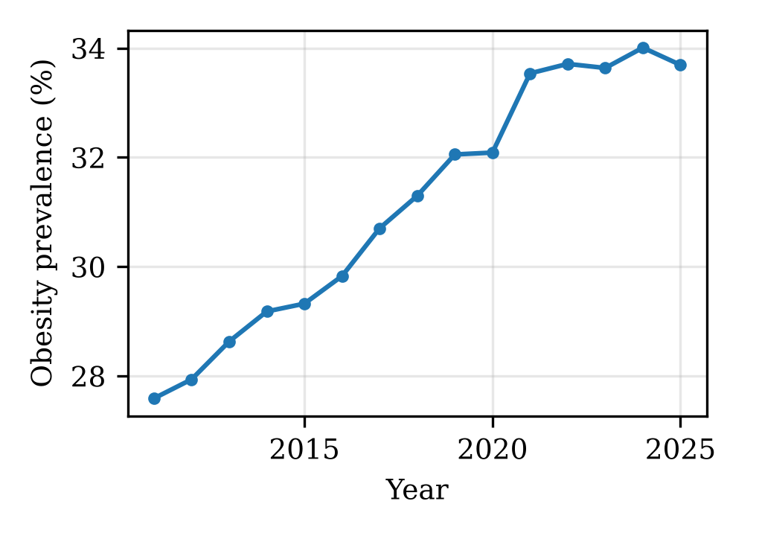
Fig. 2. Mean adult obesity prevalence by year, Total group, 2011–2025.
Distribution. Prevalence averages 31.46% (standard deviation 7.48, median 31.90%) and ranges from 0.9% to 71.1%; half of the records lie between 27.3% and 36.3% (Fig. 3). The 30% cut-off falls on the left of the main mass, so 61.8% of records are High.
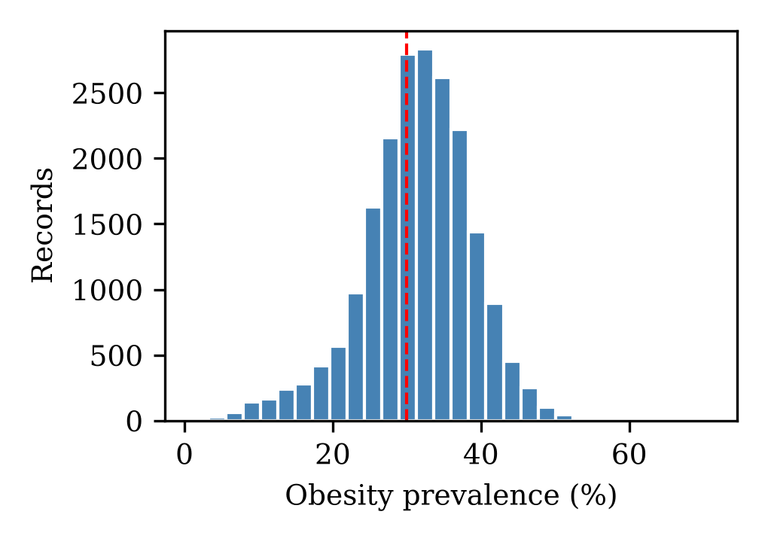
Fig. 3. Distribution of obesity prevalence; the dashed line marks the 30% cut-off.
States. Among the states, West Virginia (38.03%), Mississippi (37.88%), Louisiana, Alabama and Arkansas (all between 36.58% and 36.64%) have the highest mean prevalence. Colorado (23.79%), the District of Columbia (25.16%), Hawaii, Massachusetts and California have the lowest (Fig. 4). The gap between the highest and lowest state is about 14.2 percentage points, larger than the 6.6 points of growth over the 15 years.
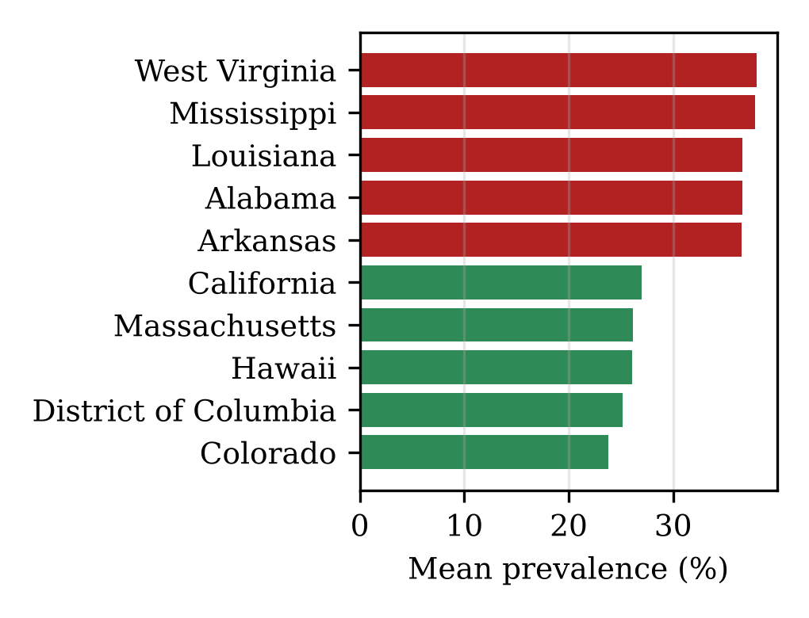
Fig. 4. Five lowest and five highest states by mean prevalence, 2011–2025.
Demographic groups. Group means differ more than category means (Fig. 5 and Table I). Prevalence is highest among Native Hawaiian or Pacific Islander adults (41.27%), Non-Hispanic Black adults (38.85%) and American Indian or Alaska Native adults (37.68%), and lowest among Non-Hispanic Asian adults (11.89%) and those aged 18 to 24 (18.63%). Adults with less than high-school education average 34.84% against 25.59% for college graduates, and those earning under $15,000 average 35.93% against 29.37% for those earning $75,000 or more. Females (31.33%) and males (30.95%) are close. Prevalence peaks at ages 45 to 54 (37.15%).
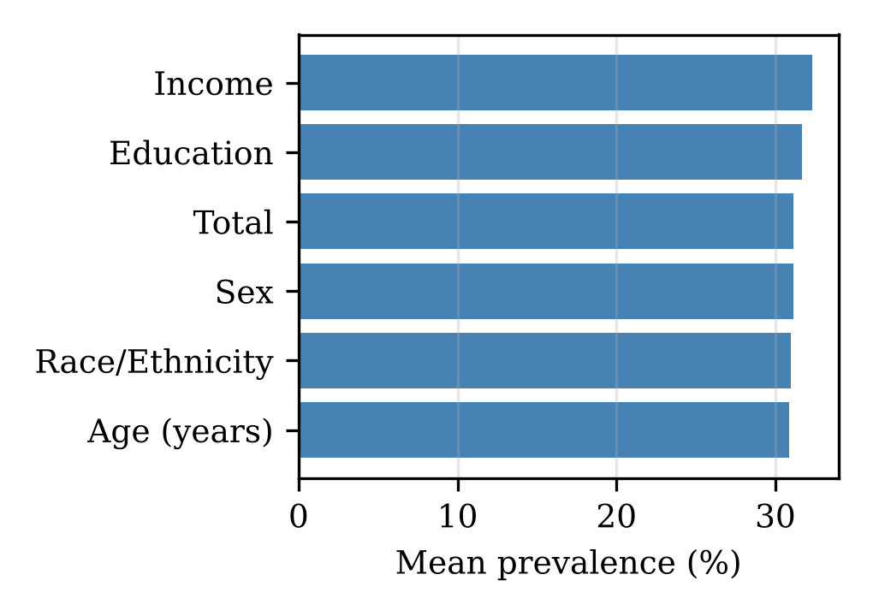
Fig. 5. Mean prevalence by demographic category.

Models and Results
Regression is scored with the mean absolute error (MAE), the mean squared error (MSE), its square root (RMSE) and the coefficient of determination R-squared [9],
R² = 1 − Σ(yᵢ − ŷᵢ)² / Σ(yᵢ − ȳ)² (4)
where yᵢ is the actual and ŷᵢ the predicted prevalence and ȳ the mean actual prevalence; a value of 0 means no better than predicting the mean. MAE and RMSE are in percentage points. Classification is scored with accuracy, precision = TP/(TP + FP), recall = TP/(TP + FN), where TP, FP and FN are the true positives, false positives and false negatives, their harmonic mean
F1 = 2 × precision × recall / (precision + recall) (5)
and the area under the receiver operating characteristic curve (AUC), which measures how well predicted probabilities rank High records above Lower ones (0.5 is guessing). High is the positive class. All scores are on the held-out test set.

Regression of obesity prevalence
Objective 1: trend from year. The simple model gives a slope of 0.530 percentage points per year (intercept -1037.4), so prevalence rose by about half a point a year over 2011 to 2025. The fit is weak, however: R-squared is 0.102, meaning that year explains about 10% of the variation, and the RMSE is 6.99 points (Table III, Fig. 6). The predictions lie in a narrow band because a single year gives the same estimate for every state and group. The trend is real but year alone is a poor predictor, since much of the spread comes from place and population group.
Objective 2: year, state and group. With year, state and group together the model explains 75.3% of the variation. MAE falls from 5.23 to 2.51, RMSE from 6.99 to 3.67 and R-squared rises from 0.10 to 0.75 (Fig. 7). The year coefficient stays near 0.54 points a year, so the trend is unchanged but now sits on top of place and group effects. An average error of about 2.51 points is small next to the 7.48-point spread of the data.
TABLE III
Regression results on the test set (n = 4,074)
Model | MAE | MSE | RMSE | R²
Simple LR (year only) | 5.23 | 48.90 | 6.99 | 0.102
Multiple LR (87 inputs) | 2.51 | 13.43 | 3.67 | 0.753
ª The better model on every metric is in bold. MAE and RMSE are in percentage points; MSE is in squared points.
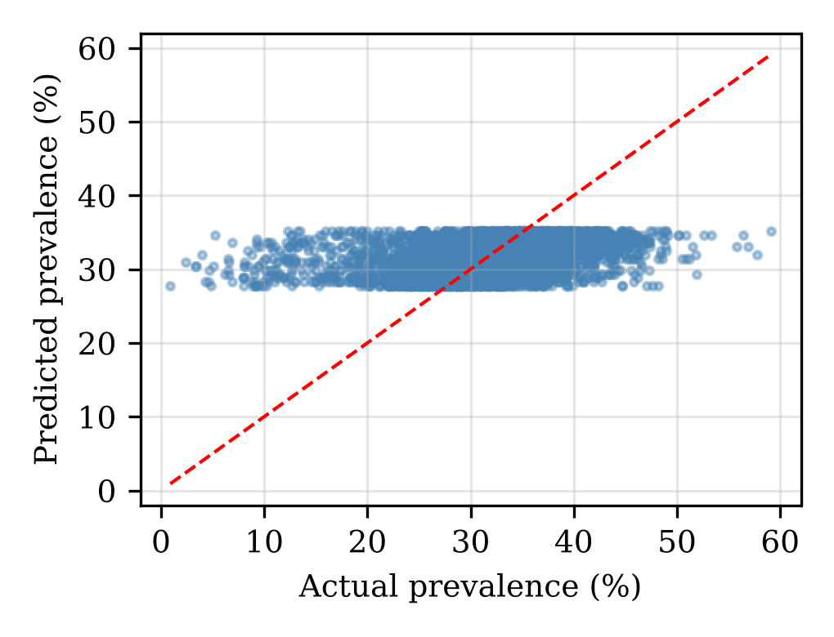
Fig. 6. Simple linear regression: actual against predicted prevalence (dashed line = perfect fit).
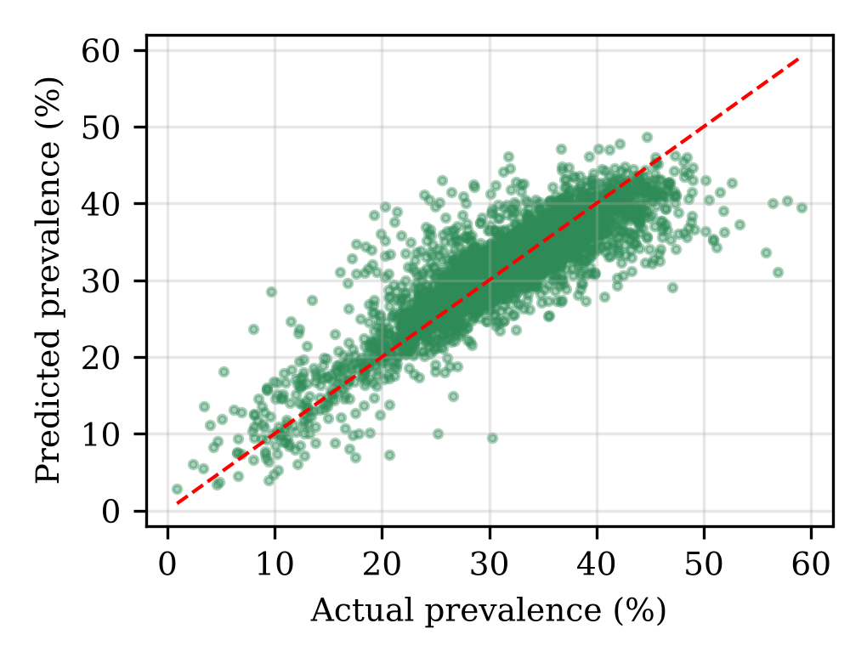
Fig. 7. Multiple linear regression: actual against predicted prevalence.
Table IV lists the largest coefficients of the multiple model. Relative to the reference levels, the biggest increases belong to Native Hawaiian or Pacific Islander (+11.8), Non-Hispanic Black (+6.6) and the 45 to 54 age group (+5.7); the biggest decreases belong to Non-Hispanic Asian (−19.7), ages 18 to 24 (−12.9) and Colorado (−12.3). Because category and group columns overlap and Alabama is the reference state, single coefficients should be read as ordering information and not as exact effects.
TABLE IV
Largest coefficients of the multiple regression
Input (dummy variable) | Coef. | Type
NH Hawaiian/Pacific Islander | +11.85 | Group
Non-Hispanic Black | +6.61 | Group
Age 45 – 54 | +5.72 | Group
NH American Indian/Alaska Native | +5.58 | Group
Non-Hispanic Asian | −19.67 | Group
Age 18 – 24 | −12.88 | Group
Colorado | −12.28 | State
District of Columbia | −10.67 | State
Hawaii | −10.33 | State
ª Coefficients are in percentage points relative to the dropped reference level of each variable; NH = Non-Hispanic.

Classification into High and Lower prevalence
Objective 3: decision tree. All three classifiers beat the always-High rate of 0.618 (Table V, Fig. 8). The decision tree reached an accuracy of 0.724 and an F1 of 0.814. Its recall of 0.978 is the highest of the three, but it is obtained by predicting High for 86.6% of the test records, so its precision is only 0.697 and its AUC is the lowest (0.747). A tree of depth 5 cannot isolate the many separate state and group combinations in 87 sparse inputs and falls back on a few broad splits.
Objective 4: logistic regression. Logistic regression gave the best result on every metric except recall: accuracy 0.870, precision 0.882, recall 0.911, F1 0.896 and AUC 0.938. The AUC means that a randomly chosen High record gets a higher probability than a randomly chosen Lower record about 94% of the time. Because the output is a probability, it can also be used to rank records or to move the 0.5 threshold, for example to favour recall.
Objective 5: KNN on identical records. KNN with five neighbours was very close to logistic regression (accuracy 0.861, F1 0.890, AUC 0.929), which shows that records with identical state and group, from neighbouring years, carry a good deal of information about the class. It trailed logistic regression by 0.9 points of accuracy and needs the whole training set at prediction time. Part of its strength may come from the random split, which places the same state and group in both the training and test sets in other years.
TABLE V
Classification results on the test set (n = 4,074)
Model | Acc. | Prec. | Rec. | F1 | AUC
Decision tree | 0.724 | 0.697 | 0.978 | 0.814 | 0.747
Logistic regression | 0.870 | 0.882 | 0.911 | 0.896 | 0.938
KNN (k = 5) | 0.861 | 0.873 | 0.907 | 0.890 | 0.929
ª Acc. = accuracy; Prec. = precision; Rec. = recall. The best model by F1 and AUC is in bold. An always-High classifier would score an accuracy of 0.618.
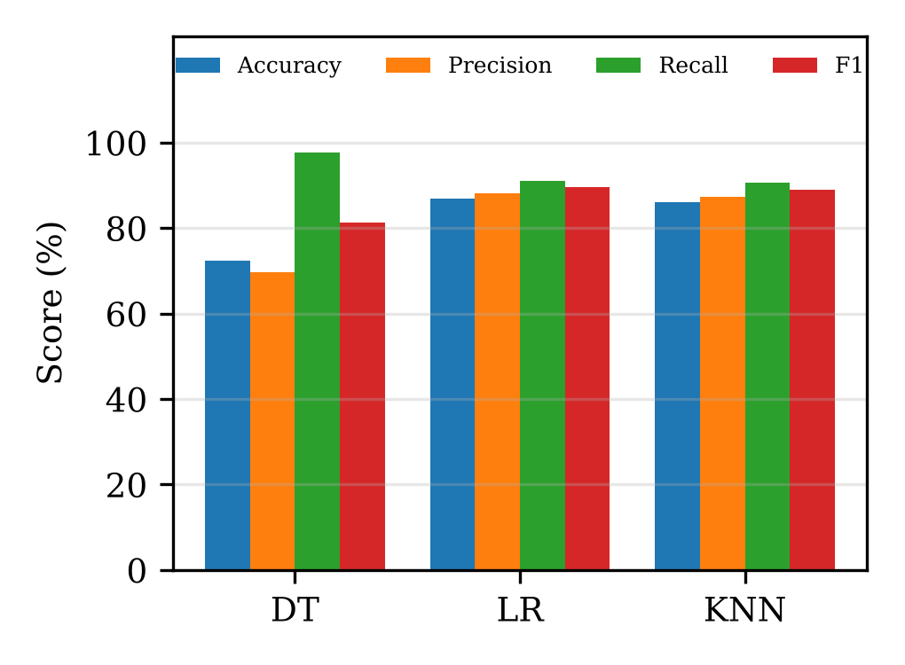
Fig. 8. Accuracy, precision, recall and F1 of the three classifiers (DT = decision tree, LR = logistic regression).
Table VI gives the confusion matrices (Fig. 9). Logistic regression makes 306 false alarms and misses 224 High records. The decision tree misses only 56 High records but labels 1,067 of the 1,558 Lower records as High, a specificity of just 0.32 against 0.80 for logistic regression and 0.79 for KNN. Which model is preferred therefore depends on the cost of each error: the tree suits a screening task where no High area may be missed, while logistic regression gives the better balance.
TABLE VI
Confusion matrices on the test set
Model | TN | FP | FN | TP | Spec.
Decision tree | 491 | 1,067 | 56 | 2,460 | 0.32
Logistic regression | 1,252 | 306 | 224 | 2,292 | 0.80
KNN (k = 5) | 1,226 | 332 | 234 | 2,282 | 0.79
ª TN = true negatives (Lower correctly found); FP = false positives; FN = false negatives; TP = true positives (High correctly found); Spec. = specificity = TN/(TN + FP).
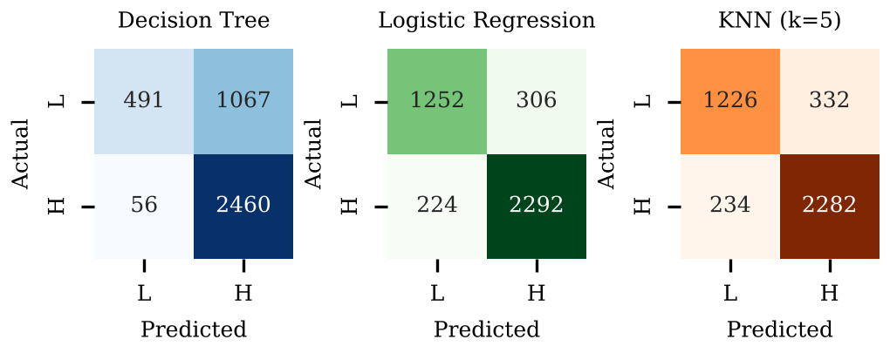
Fig. 9. Confusion matrices on the test set (L = Lower, H = High); left to right: decision tree, logistic regression, KNN.

Discussion
Taken together, the results show that where and who matter more than when. Year alone leaves about 90% of the variation unexplained, yet adding state and demographic group raises R-squared to 0.75. The same inputs let logistic regression separate High from Lower records with an AUC of 0.94. The linear and logistic models are additive in their inputs, which suits a problem where a state effect and a group effect add together, and this probably explains why they beat the shallow tree. The slope of 0.53 points a year describes the whole period on average; the yearly means rise quickly until 2021 and then level off, so extending the straight line into later years would probably over-state future prevalence.

Conclusion
This work cleaned 20,369 adult-obesity prevalence records from the BRFSS for 2011 to 2025 and tested five models against five objectives. (i) Simple linear regression found a rise of about 0.53 percentage points a year, but with R-squared of only 0.10. (ii) Multiple linear regression using year, state and demographic group reached R-squared of 0.75 and an RMSE of 3.67 points. (iii) The decision tree sorted records into High and Lower with an accuracy of 0.724 and very high recall, at the cost of many false alarms. (iv) Logistic regression was the best classifier (accuracy 0.870, F1 0.896, AUC 0.938) and gives probabilities as well as labels. (v) KNN, which compares records with identical demographic and geographic values, came close (accuracy 0.861, F1 0.890). Demographic and geographic characteristics are strong predictors of obesity prevalence, and the results are best used to identify groups and states that need attention.
Limitations. The data are published percentages for groups, not individuals, and BMI is self-reported; the test set was drawn at random from all years, so the scores show how well the models fill in missing combinations of state, group and year, and not how well they forecast later years; the 30% cut-off is fixed and records with small samples are noisy, although the sample sizes and confidence limits supplied in the data were not used; the tree depth and the number of neighbours were fixed and not tuned; a single split gives no confidence intervals; one-hot coefficients are relative to reference levels and overlap between category and group columns; and the models show association, not causation.
Future scope. Evaluate by time, training on earlier years and testing on later ones; add cross-validation and tuning of tree depth and k; test random forests and gradient boosting and interaction terms between state and group; weight records by sample size; use the physical-activity and diet questions in the same dataset as extra predictors; and apply time-series methods such as ARIMA or Prophet to forecast the trend [13].

Acknowledgment
The author thanks the faculty guide, [Guide Name], and [Institution Name] for the opportunity, and the US Centers for Disease Control and Prevention for making the data openly available.

References
- Centers for Disease Control and Prevention, “Nutrition, Physical Activity, and Obesity: Behavioral Risk Factor Surveillance System,” Data.CDC.gov. [Online]. Available: https://data.cdc.gov/Nutrition-Physical-Activity-and-Obesity/Nutrition-Physical-Activity-and-Obesity-Behavioral/hn4x-zwk7
- World Health Organization, “Obesity and overweight,” Fact sheet. [Online]. Available: https://www.who.int/news-room/fact-sheets/detail/obesity-and-overweight
- Centers for Disease Control and Prevention, “Adult obesity facts.” [Online]. Available: https://www.cdc.gov/obesity/adult-obesity-facts/index.html
- F. Pedregosa et al., “Scikit-learn: Machine learning in Python,” J. Mach. Learn. Res., vol. 12, pp. 2825–2830, 2011.
- W. McKinney, “Data structures for statistical computing in Python,” in Proc. 9th Python Sci. Conf., 2010, pp. 56–61.
- C. R. Harris et al., “Array programming with NumPy,” Nature, vol. 585, pp. 357–362, 2020.
- J. D. Hunter, “Matplotlib: A 2D graphics environment,” Comput. Sci. Eng., vol. 9, no. 3, pp. 90–95, 2007.
- M. L. Waskom, “seaborn: Statistical data visualization,” J. Open Source Softw., vol. 6, no. 60, p. 3021, 2021.
- G. James, D. Witten, T. Hastie, and R. Tibshirani, An Introduction to Statistical Learning, 2nd ed. New York, NY, USA: Springer, 2021.
- D. W. Hosmer, S. Lemeshow, and R. X. Sturdivant, Applied Logistic Regression, 3rd ed. Hoboken, NJ, USA: Wiley, 2013.
- L. Breiman, J. Friedman, R. Olshen, and C. Stone, Classification and Regression Trees. Belmont, CA, USA: Wadsworth, 1984.
- T. Cover and P. Hart, “Nearest neighbor pattern classification,” IEEE Trans. Inf. Theory, vol. 13, no. 1, pp. 21–27, 1967.
- R. J. Hyndman and G. Athanasopoulos, Forecasting: Principles and Practice, 3rd ed. Melbourne, Australia: OTexts, 2021. [Online]. Available: https://otexts.com/fpp3/

