Implementing Automated CI/CD Pipelines for ACEest Fitness & Gym
Name: Divya Kadam
Student ID: 2024TM93659
Course: DevOps
University: BITS WILP
Submission Date: 04/04/2026

Project Repository
Primary implementation repository for the CI/CD pipeline:
https://github.com/divyakadam282002/aceest-gym-ci-cd-pipeline

Executive Summary
This report presents the implementation of an automated CI/CD workflow for the ACEest Fitness & Gym API using Flask, Docker containerization, Jenkins build validation, and GitHub Actions automation. The solution ensures consistent execution environments, automated testing, and reproducible build validation aligned with modern DevOps practices.

Problem Statement and Objectives
The objective of this assignment is to establish a structured DevOps workflow that ensures application integrity, environment consistency, and automated validation of application functionality. This includes integrating version control, containerized deployment, automated testing, and CI/CD pipeline execution to demonstrate an industry-aligned development lifecycle.

Application Implementation
The ACEest Fitness & Gym API was developed using the Flask framework. The application exposes service endpoints and was executed successfully inside a Docker container environment and validated through browser access using localhost.
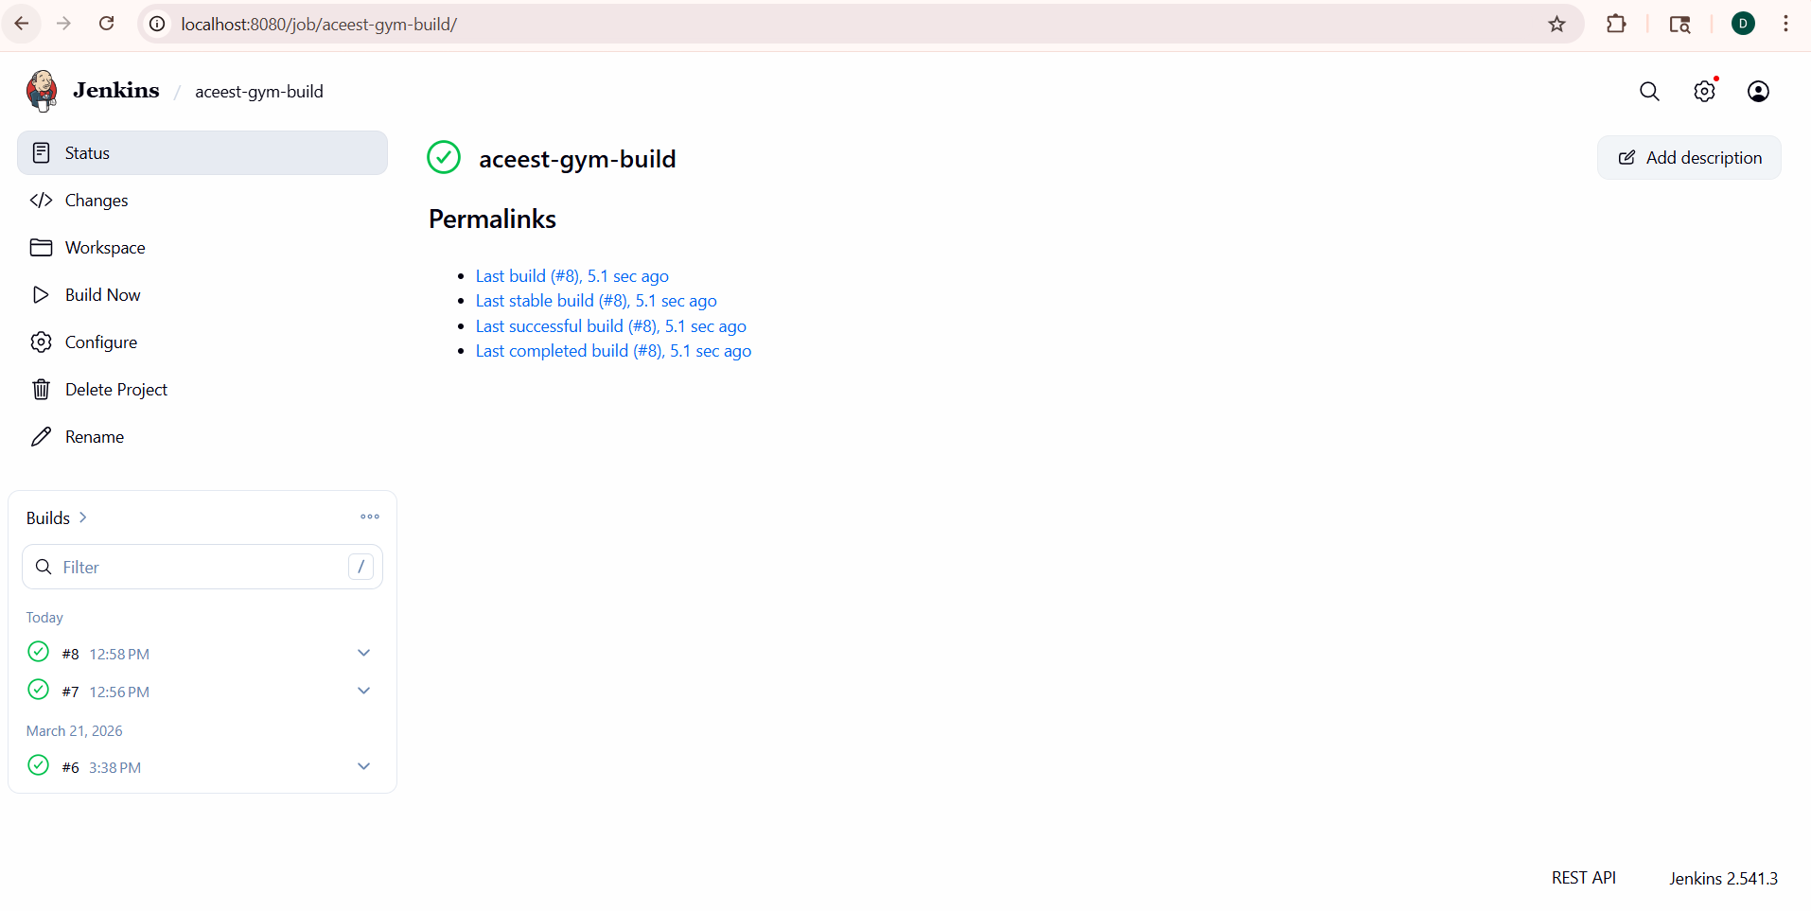
Fig‑1: ACEest Fitness & Gym API running successfully on localhost:5001

Containerization Using Docker
Docker was used to package the application and its dependencies into a portable runtime environment ensuring consistent execution behaviour across systems. The containerized application executed successfully through mapped host ports.
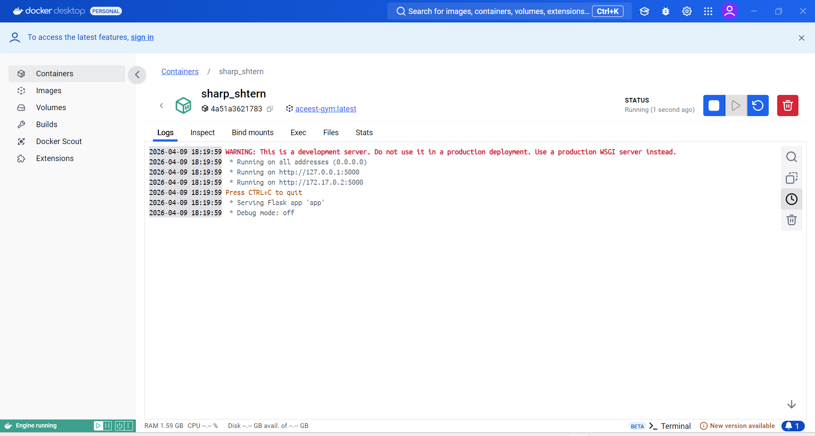
Fig‑2: Docker container running ACEest Fitness & Gym API successfully

Jenkins Build and Quality Gate Validation
A Jenkins job was configured to retrieve source code from the GitHub repository and perform automated build validation. Successful pipeline execution confirms integration readiness and validates the clean build environment.
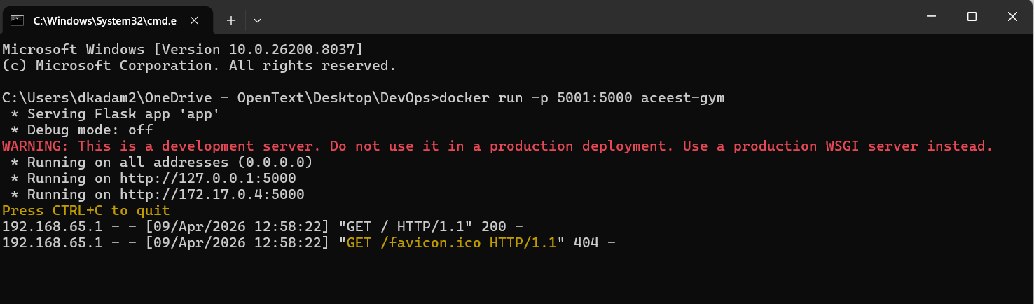
Fig‑3: Jenkins job showing successful build execution

GitHub Actions Continuous Integration
GitHub Actions workflow automation validates repository updates by executing automated test and build steps whenever code changes are pushed. This ensures early detection of issues and maintains pipeline stability.
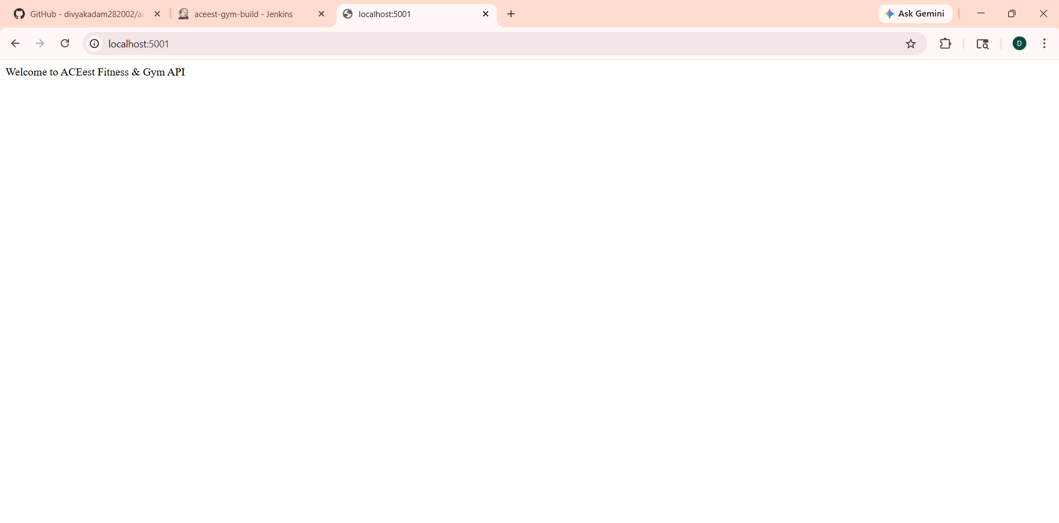
Fig‑4: GitHub Actions workflow showing successful CI pipeline execution

Tools and Technologies Used
Tool | Purpose
Flask | Backend API development
Docker | Containerization and environment consistency
GitHub | Version control and repository hosting
GitHub Actions | Automated CI pipeline execution
Jenkins | Build validation and pipeline verification
Pytest | Automated application testing

CI/CD Pipeline Architecture Overview
Developer Code → GitHub Repository → GitHub Actions CI Workflow → Docker Image Build → Jenkins Build Validation → Application Execution

Conclusion
The implemented solution demonstrates a complete DevOps CI/CD workflow integrating version control, automated testing, containerized deployment, Jenkins build validation, and GitHub Actions automation. This pipeline ensures reliability, reproducibility, and continuous validation of application functionality.

