**CS5224 Cloud Computing Assignment 1**

**Name: Maddi Kamal Divya  
Student ID: A0178511E**

1. What is Cloud Foundry software in the context of cloud?

Ans. Cloud foundry is free, open source platform as a service Paas, developed by vmware on which developers can build, test, deploy, run and scale applications.

Cloud Foundry has defined a new type of platform that allows to write software in any language and deploy it to organization’s datacenter, on - site via VMWare's vSphere or OpenStack, or off - site on top of a public cloud. So, the users are locked into a single framework or a provider. Cloud Foundry uses container- based architecture to provide own isolated view of system resources and limit the resource usage.

2. In which way does Cloud Foundry help us when developing and updating web applications using boilerplates such as Node.js Boilerplate? (1 mark)

Ans. A boilerplate is a container for an application and its associated runtime environment and predefined services So, boilerplate is usually generic and can be included with minimal changes required. Boilerplate code is efficient and is easy to use.

In cloud foundry, node.js can set up a development environment, deploy an app locally and on the cloud, and then integrate a database service to the app.  All of the tools and services are ready to be used and the environment guides how to use it.

3. How does Cloud Foundry software determine dependencies for the application which is

uploaded/pushed by a user via the Cloud Foundry command line interface (CLI)? (1

mark)

Ans. When deploying applications via Cloud Foundry manifest.yml and package.json sets the deployment parameters and helps to resolve the dependencies. App dependencies like databases, messaging queue are delivered as services. Services can be bind or unbind to an app.

4. What is the use of VCAP_SERVICES environment variable in IBM Bluemix applications? (1 mark)

Ans. The VCAP_SERVICES environment variable contains information that is required to interact with an IBM Cloud service instance. When a service instance is binding to an application, the fields in this environment variable are set. A running application reads these environment variables after a service is bound to extract the required name-value pairs.

5. Hands-on exercise Example 1 demonstrated a simple example of using a web application

to output the result of an SQL script using Node.js. In the example, we output the whole

database table into the web interface. **Modify the Node.JS** code such that the output

contains **only the first three fields** of the database table, and, push the updated app to

cloud. (include necessary screenshots including the web page) (1 mark)

Ans. As the number of rows is not mentioned, I extracted the first three fields from the entire table (all rows).

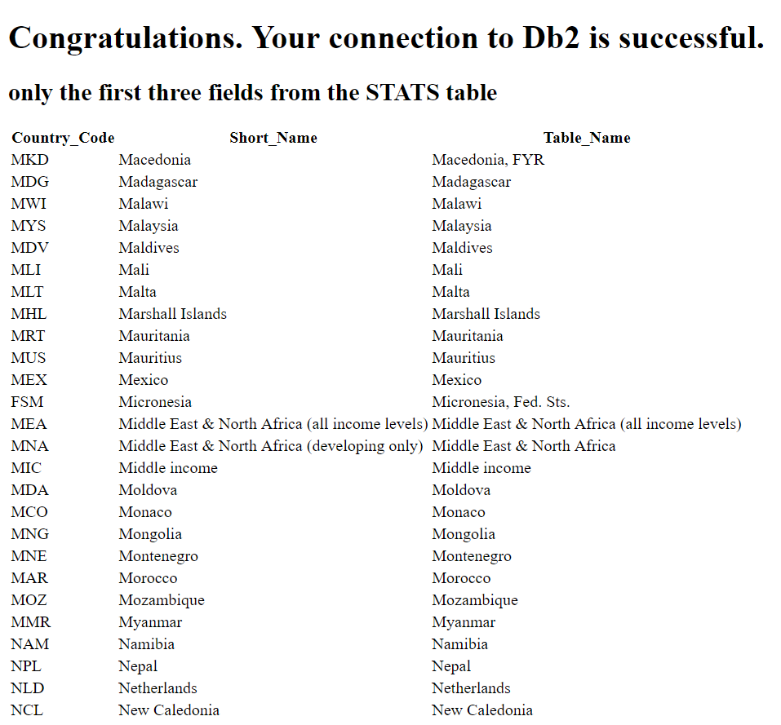

6. Hands-on exercise Example 2 demonstrated a simple example of using Bluemix Personality Insights. Modify the app.js of Example 2 such that the output is **word count** **for input text**. (Hint: output the “word_count” field of the json you get from Personality Insights). View this demo (https://personality-insights-demo.ng.bluemix.net/) for assistant. (include necessary screenshots including the web page) (2 mark)

Ans. Below screenshots shows that Obama speech text file is uploaded, and the word count is “6535”.

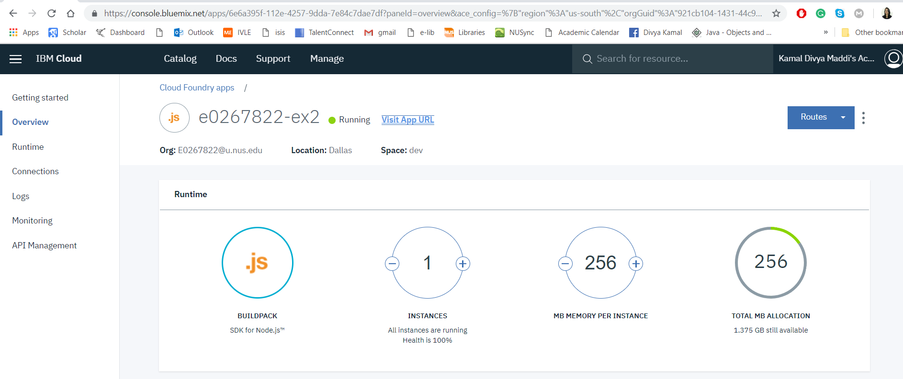

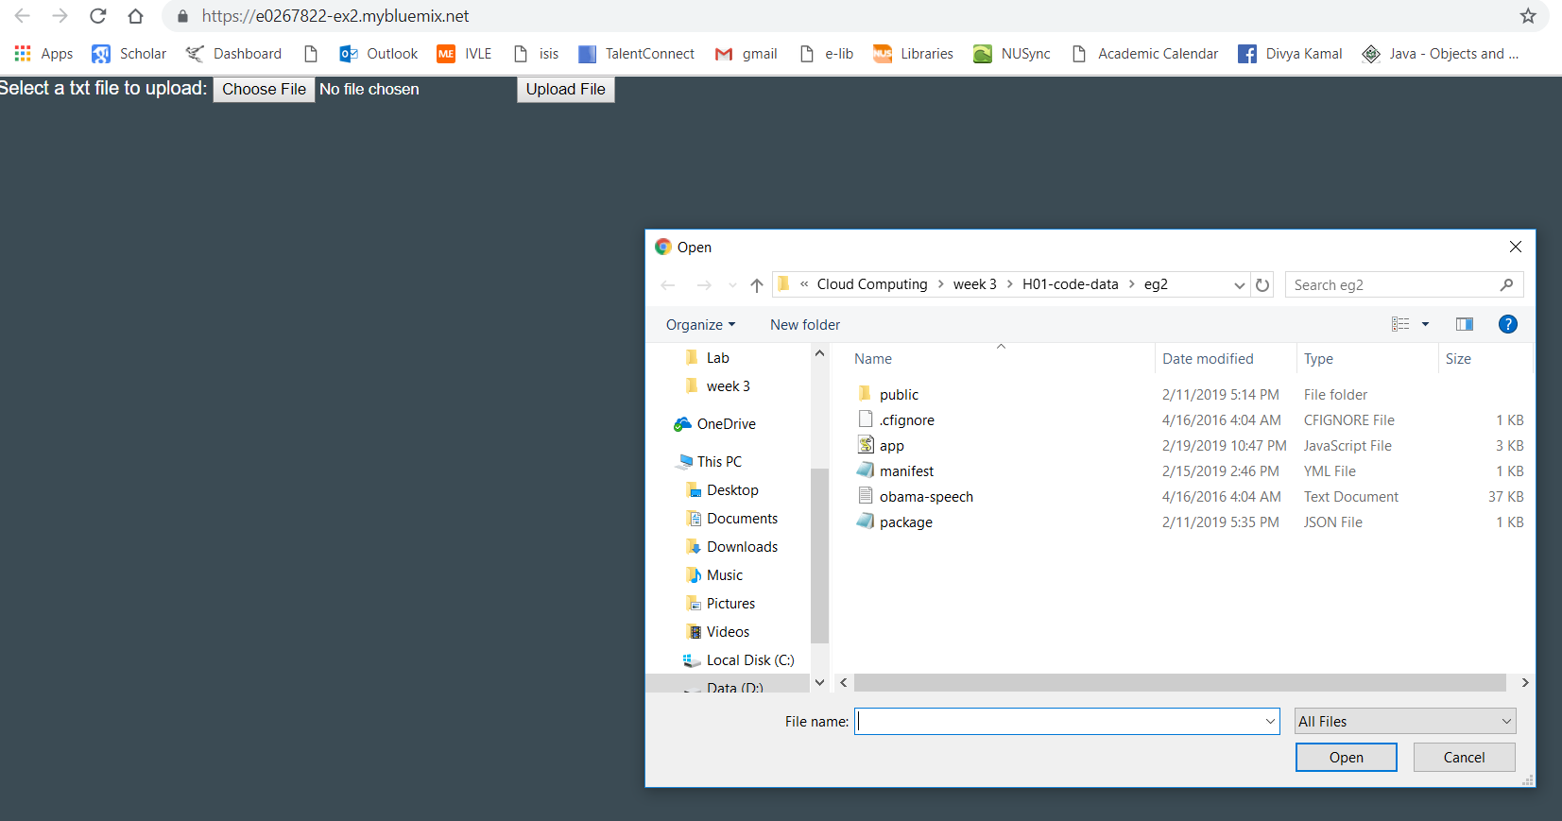

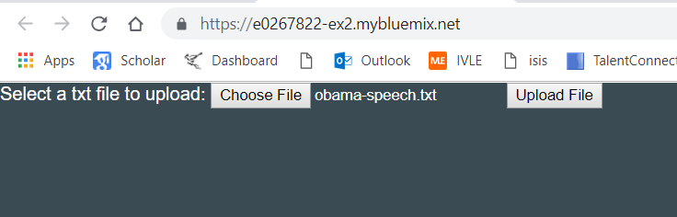

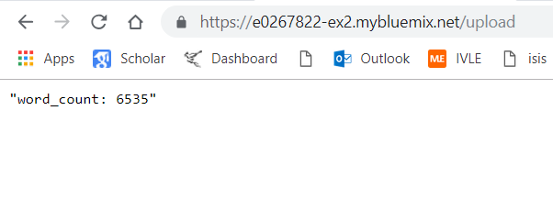

7. Download the test-db.csv (contains data of students in a school) from the course web

page. Upload the test-db.csv file as a new table in the same database you created in

**Example 1** in the hands-on exercise. (please include screenshots) (1 marks)

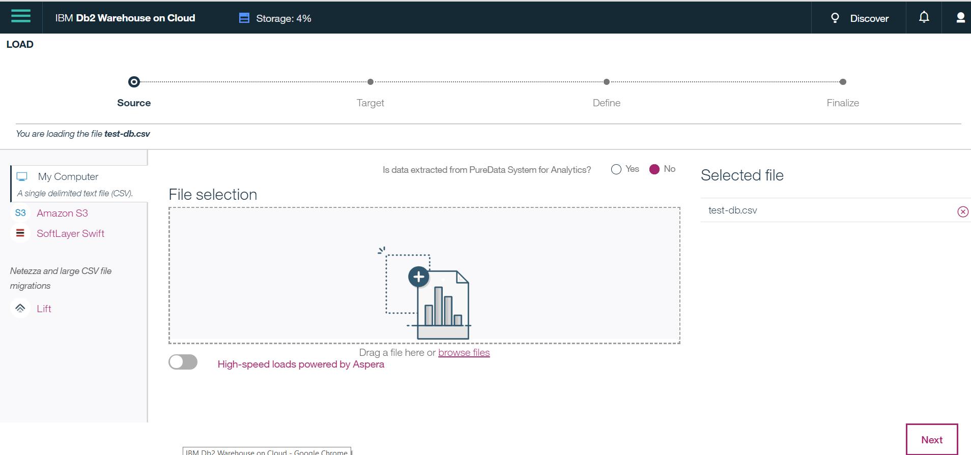

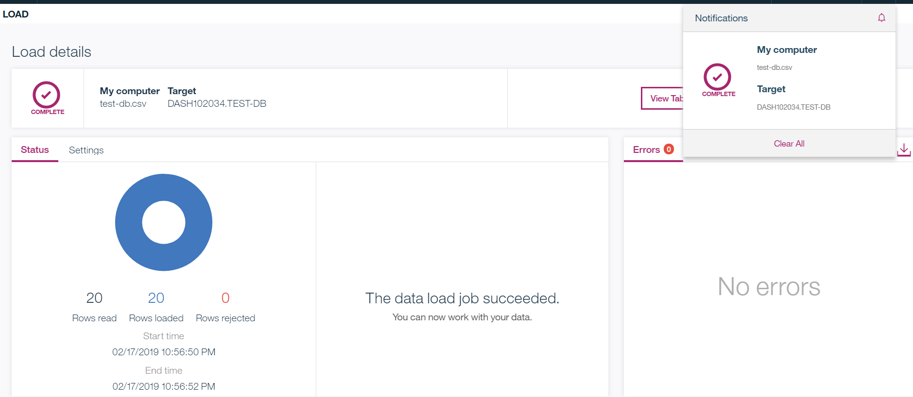

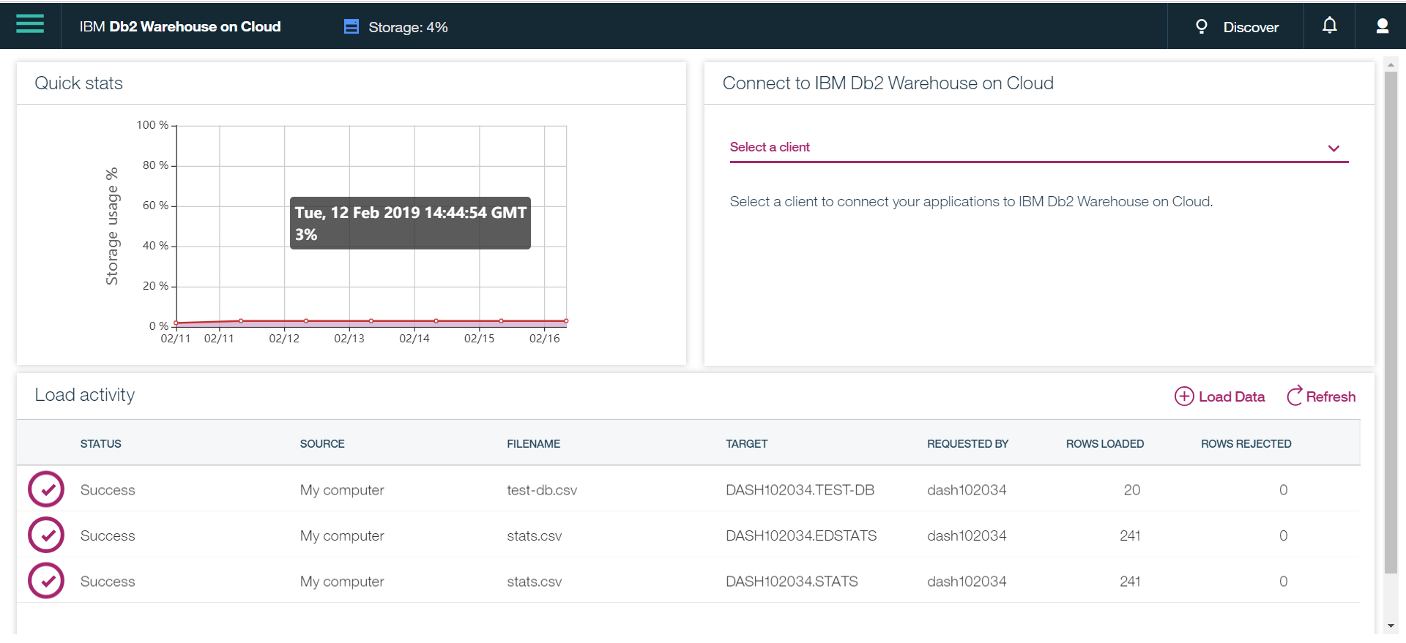

8. Using an R script, draw the class distribution bar chart, where x-axis denotes the class and

y-axis denote the number of students. (please include screenshots) (1 marks)

Ans. There are 4 students in Class 6, 5 students in Class 7, 4 students in Class 8, 7 students in Class 9. Below bar chart depicts the same.

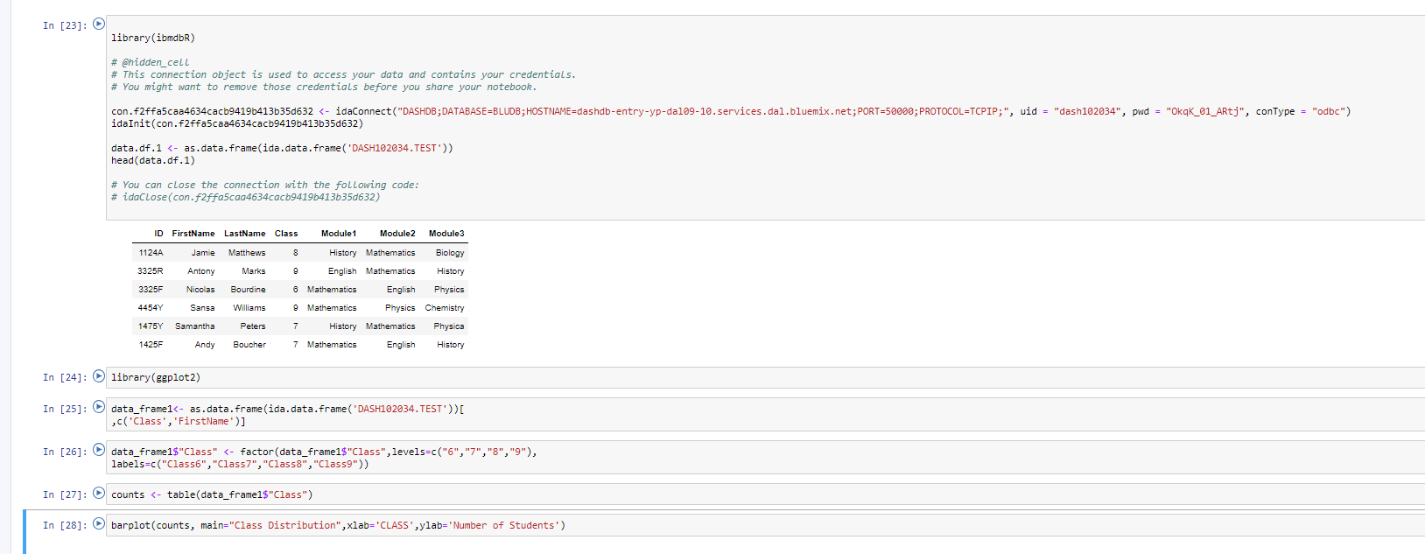

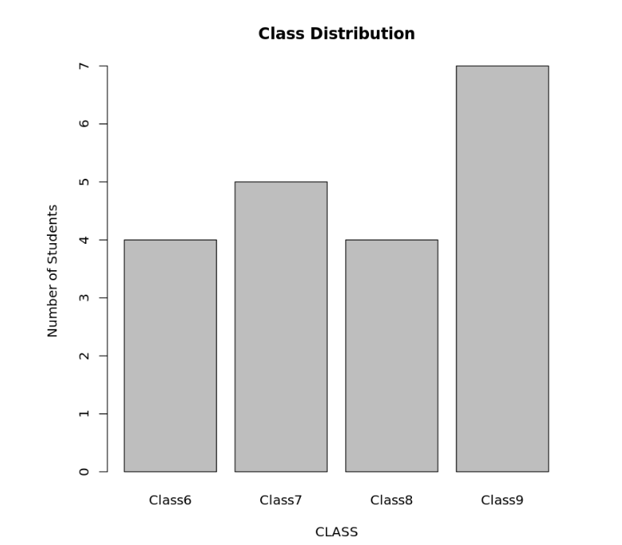

9. Using an SQL script, find the number of students that are in grade 9 and studying history.

(please include screenshots) (1 marks)

Ans. There are 4 students from class 9 studying history which can be seen in result set

