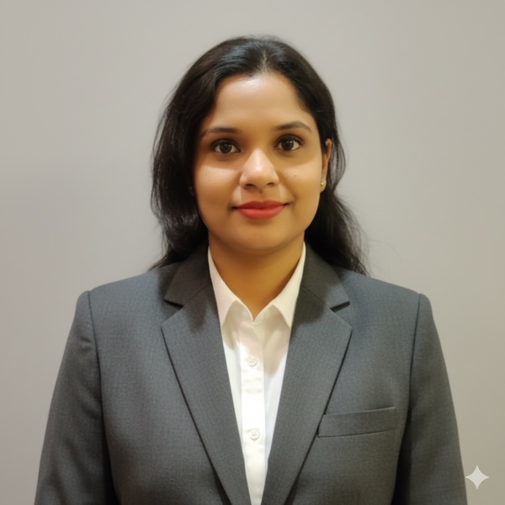 | Divya Kodukula  TECHNICAL PROGRAM MANAGER | SCRUM LEAD | AUTOMATION & DEVOPS SME  divyakodukula1991@gmail.com | +91 8095014314 | Bengaluru, India  github.com/divyakodu | www.linkedin.com/in/divya-kodukula-5b7a4584

PROFESSIONAL SUMMARY
- Automation & DevOps Expert: Expert in Test Automation, CI/CD, and DevOps practices across API, frontend, and backend systems with 8.6 years of relevant experience.
- Program & Agile Leadership: Agile practitioner with a dual focus on people development and technical delivery excellence. Proven as Scrum Master/Lead driving cross-team coordination, delivery discipline, and program execution.
- Atlassian Ecosystem Specialist: Experienced in Atlassian backend monitoring, Jira frontend administration, Jira Align, and Jira automation/standardization, ensuring platform stability and process efficiency while identifying and communicating risks and mitigations.
- Modern Technology & GenAI Focus: Proficient in Python. Skilled in leveraging Generative AI and Agentic AI (Google ADK, FastAPI, Streamlit) for technical delivery, automation, and productivity tool development.
- Strategic Alignment: Passionate about aligning teams, technology, and strategy to deliver business value, including identifying and implementing process improvements that help teams scale.
CORE SKILLS
Programming | Python, SQL, Windows, PowerShell, Linux Scripting
GenAI & Agentic AI | LLM and AI, Google ADK (Agent Development Kit), GPT, Gemini, FastAPI, Streamlit, Copilot Studio
Cloud | AWS, Azure
Program Strategy & Tools | Jira Align, Jira, Planview, Program Strategy & Roadmap Planning
Automation & Testing | Selenium, Robot Framework, Karate Framework, UI Testing, API Testing
Data Warehousing & NoSQL | SAP Hana, BigQuery, MongoDB, Postgres, Neo4j
Governance & Reporting | Reporting & Data Visualization
Leadership | Team Leadership & Management, Budget Oversight & Financial Planning, Coaching & Career Development, Partnership & Stakeholder Management, Executive Presentation
PROFESSIONAL EXPERIENCE
Program Manager, Scrum Lead & Technical SME Sep 2024 - Present
HCLTech - Dell
- Lead and mentor a team of 5 members, fostering collaboration and alignment with organizational goals while driving programs to successful landing.
- Operate as Scrum Lead/Scrum Master, coordinating with multiple cross-functional teams to manage program execution through design, development, test, and deploy, ensuring delivery discipline.
- Specialize in Atlassian backend monitoring, Jira frontend administration, Jira Align, and Jira Standardization/automation, delivering builds, source control and branch management, while identifying and communicating risks and mitigations to ensure platform stability and process efficiency.
- Maximize team performance and business impact by identifying, developing, and implementing process improvements that help teams scale.
- Explored and integrated Generative AI capabilities to enhance automation, testing efficiency, and program management, developing internal applications and Proof-of-Concepts (POCs) for productivity tools using Streamlit, FastAPI, and Milvus.
Test Automation Lead & Technical SME Sep 2022 - Sep 2024
UST Global - Dell
- Assumed dual role of Scrum Master and Technical Lead, guiding and leading a team of 5 members, driving project execution through strong ownership and accountability in an Agile/Kanban development environment.
- Spearheaded and executed comprehensive testing efforts across 4 functional areas and over 60 APIs, developing UT and functional test plans for complex applications and executing end-to-end use cases.
- Developed custom testing frameworks using Python for specialized test cases and various automations in Linux and Windows environments.
- Practiced TDD methodologies, CI/CD framework, and Agile/DevOps methodologies, utilizing automation tools like Selenium, Robot Framework, and Karate Framework.
- Explored and integrated GenAI capabilities to enhance automation beyond traditional database-related tech stacks.
Test Engineer Jan 2014 - Jan 2017, May 2021 - Sep 2022 — career break Jan 2017 - Apr 2021
Trueblue, Accenture
- Performed UI, backend, and database testing using automation tools: Selenium, Robot Framework, Karate Framework.
- Developed monitoring dashboard using BigQuery and Looker. Utilized SAP HANA for reporting and testing purposes.
- Developed and executed test plans and test cases to ensure comprehensive test coverage.
- Collaborated with development teams to identify and resolve software defects, improving overall product quality.
EDUCATION
- B.Tech, Information Technology — JNTUK, Kakinada (7.2 CGPA, 2013)
COURSES
- Program Management (LinkedIn)
- Agentic AI (Coursera)
- AI in Program Management (LinkedIn)
AWARDS
- HCLTech - Excellence Award (2024)

