3RD JUNE, 2026

MONGODB CRUD OPERATIONS CODE
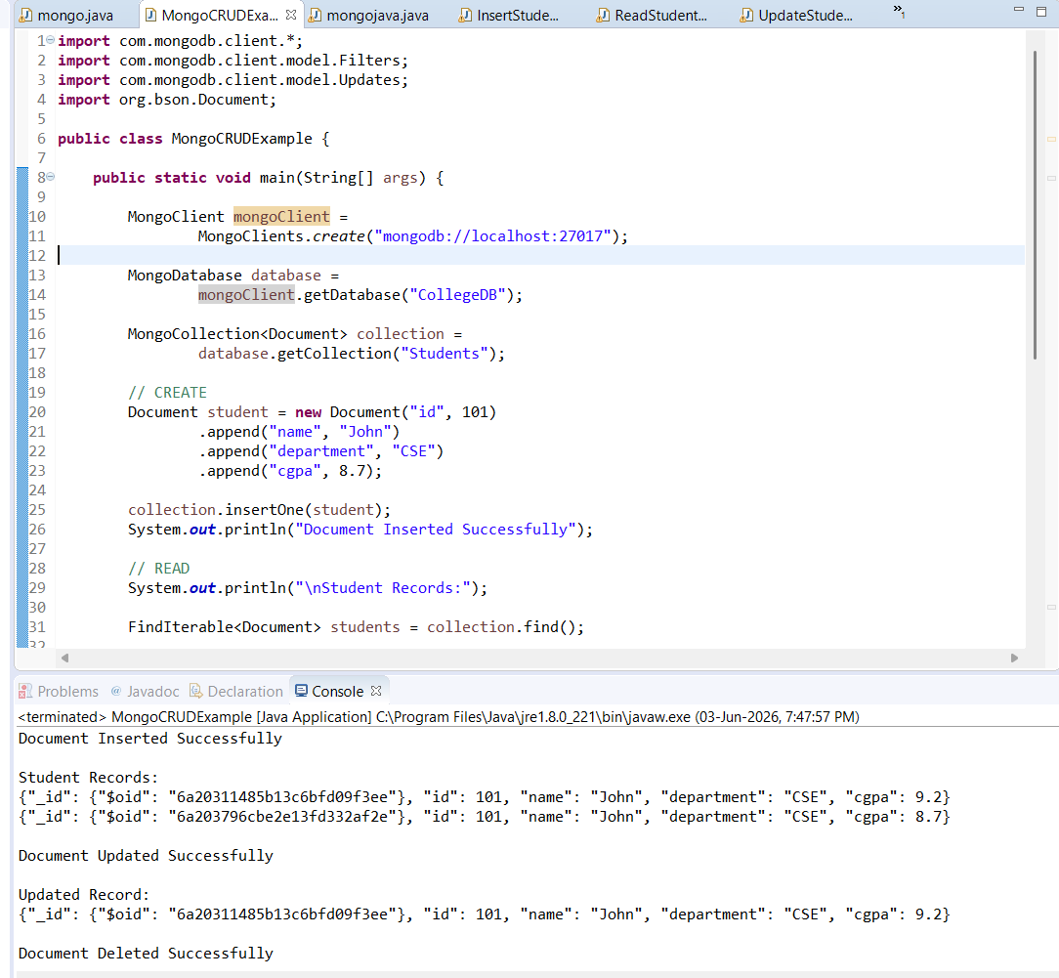

INSERT STUDENT CODE
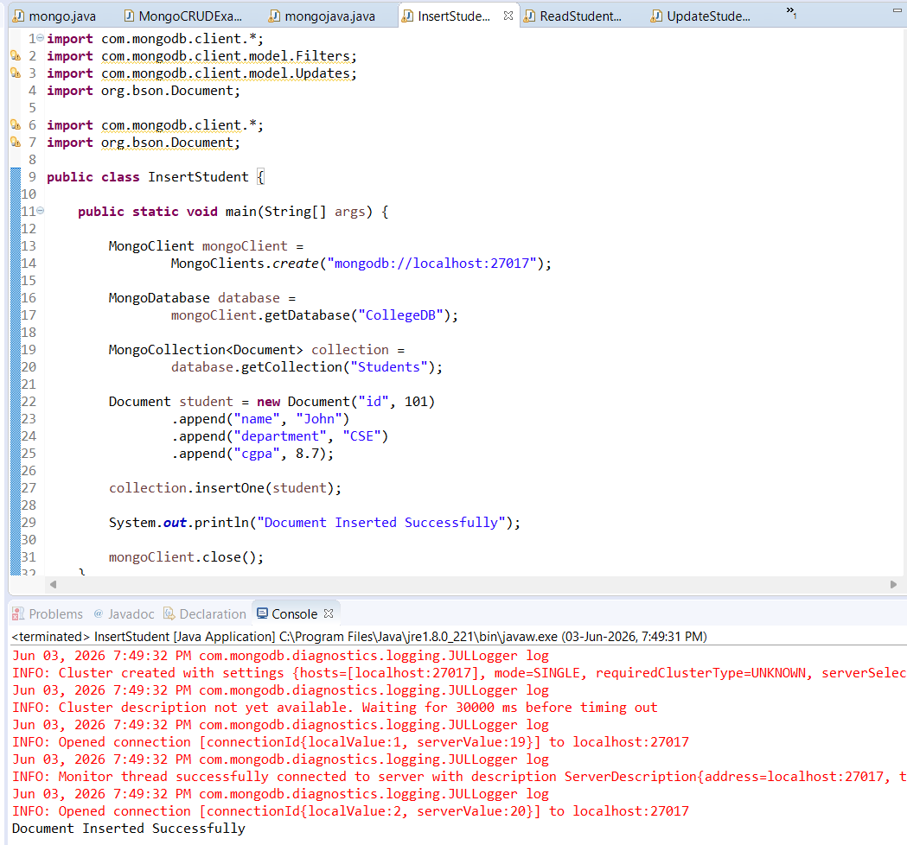

READ STUDENT CODE
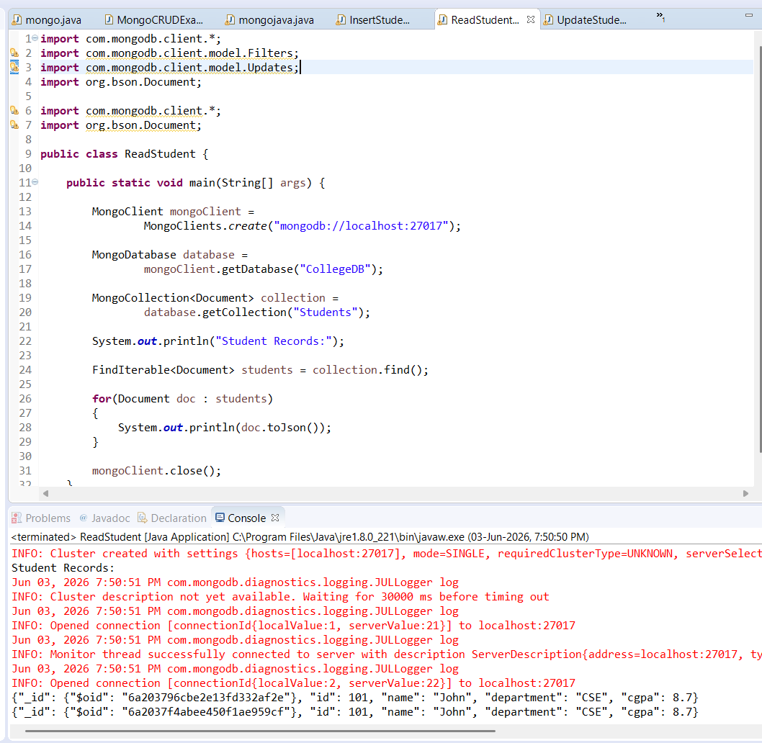

UPDATE STUDENT CODE
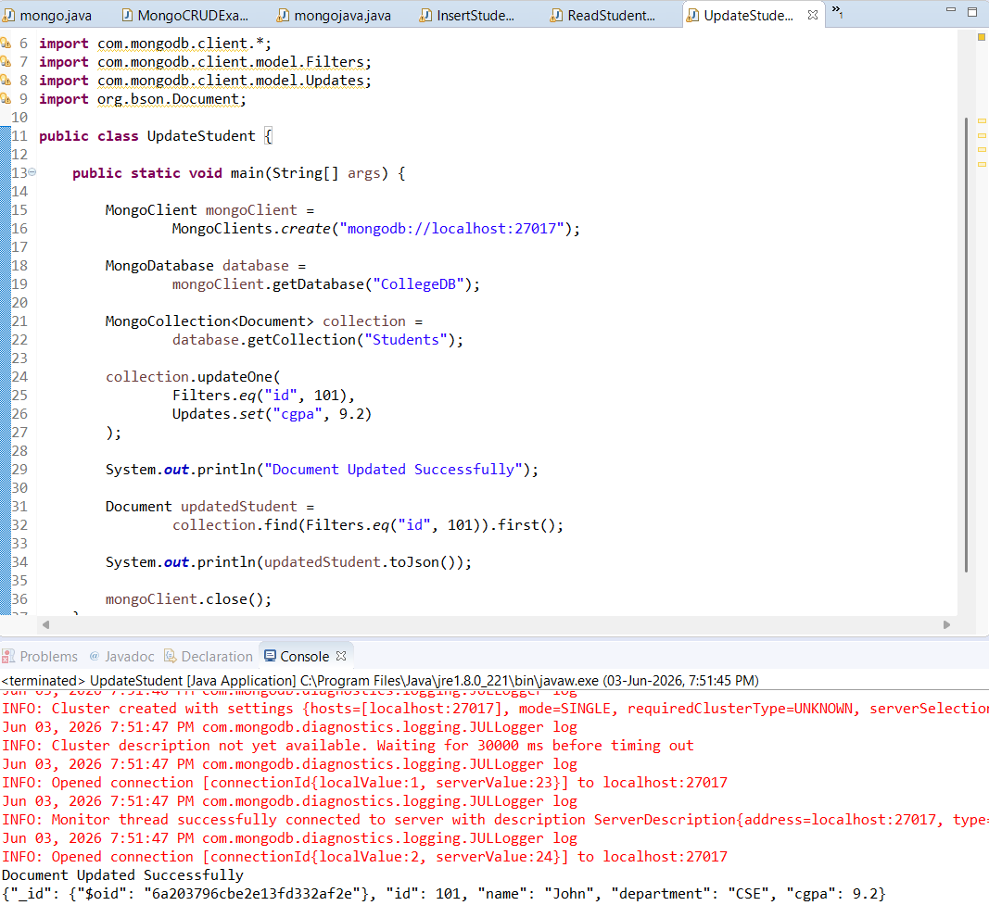

DELETE STUDENT CODE
