EMPLOYEE PERFORMANCE ANALYSIS

INTERNSHIP TASK – 07
Name: DIVYA DHARSHINI K
Department: B.E.CSE(AI&ML)
College: DMI College Of Engineering
Date: 18.06.2026

ABSTRACT
This project focuses on analyzing employee performance, productivity and satisfaction using data analytics techniques. The employee dataset was collected and processed using Python in Jupyter Notebook. Statistical analysis, visualization, trend analysis, correlation analysis, hypothesis testing, and employee segmentation were performed to understand workplace patterns and employee behavior. The results provide meaningful insights that can support employee management and decision-making.

- INTRODUCTION

- Employee performance, productivity and satisfaction play an important role in organizational growth. Understanding employee behavior helps improve productivity, workplace environment, and employee retention.
- This project analyzes employee-related factors such as salary, performance score, work hours, training hours, satisfaction score, and resignation status using data analysis techniques.
- Employee data analysis helps organizations understand workforce behavior, improve employee satisfaction, enhance productivity, and support better decision-making through data-driven insights.

- OBJECTIVE
The objectives of this project are:
• To understand employee performance patterns
• To analyze employee satisfaction levels
• To identify relationships between workplace factors
• To perform statistical and trend analysis
• To segment employees based on performance levels
• To generate business insights from the dataset

- DATASET DESCRIPTION
Dataset Name:
Employee Performance and Productivity Dataset
Total Records Used:
10,000

Dataset Attributes:

• Employee ID
• Department
• Gender
• Age
• Job Title
• Hire Date
• Years At Company
• Education Level
• Performance Score
• Monthly Salary
• Work Hours Per Week
• Projects Handled
• Overtime Hours
• Sick Days
• Remote Work Frequency
• Team Size
• Training Hours
• Promotions
• Employee Satisfaction Score
• Resigned

- TOOLS AND TECHNOLOGIES USED
Programming Language:
Python
Platform:
Jupyter Notebook
Libraries:
• Pandas
• NumPy
• Matplotlib
• Seaborn
• SciPy
Version Control:
GitHub

- METHODOLOGY
Phase 1 – Data Understanding
- Dataset loading
- Data cleaning
- Missing value checking
- Duplicate removal
Phase 2 – Statistical Analysis
- Mean
- Median
- Standard Deviation
- Quartiles
- Percentiles

Phase 3 – Trend Investigation
- Department vs Satisfaction
- Team Size vs Performance
- Job Title vs Satisfaction
- Experience vs Salary Growth
- Training vs Performance

Phase 4 – Correlation Analysis
- Training Hours vs Performance
- Work Hours vs Satisfaction
- Team Size vs Performance
- Salary vs Satisfaction

Phase 5 – Hypothesis Testing
Method Used:
T-Test
Hypothesis:
H0:
Overtime does not affect employee satisfaction.
H1:
Overtime affects employee satisfaction.
Result:
P-value = 0.4107
Conclusion:
No statistically significant relationship was identified.
Phase 6 – Employee Segmentation
Categories:
• High Performer
• Medium Performer
• Low Performer

- RESULTS AND DISCUSSION
The analysis identified employee trends across departments and job roles. Correlation analysis highlighted relationships among training, performance, and salary. Trend analysis showed employee behavior patterns. Hypothesis testing indicated that overtime did not significantly impact satisfaction within the selected dataset.

- BUSINESS INSIGHTS
• Employee performance is influenced by training, work hours, and experience
• Employee satisfaction varies across departments and salary levels
• Overtime did not show a significant impact on employee satisfaction
• Low performer groups showed lower satisfaction levels
• Training and employee engagement support better workforce outcomes

- CONCLUSION
This project successfully analyzed employee performance and satisfaction using statistical and visualization techniques. Employee behavior patterns and workplace trends were identified through data exploration and testing. The findings can support organizations in improving employee management and making better workforce decisions.

- FUTURE SCOPE
• Apply machine learning models
• Build employee prediction systems
• Develop interactive dashboards
• Analyze real-time employee data

10. REFERENCES
• Python Documentation
• Pandas Documentation
• Matplotlib Documentation
• Jupyter Notebook Documentation

GITHUB REPOSITORY LINK:
https://github.com/divyakumaravel15/Employee-Performance-Analysis.git

Appendix
Appendix A: Dataset Overview
Code
df.head()

df.info()

Output

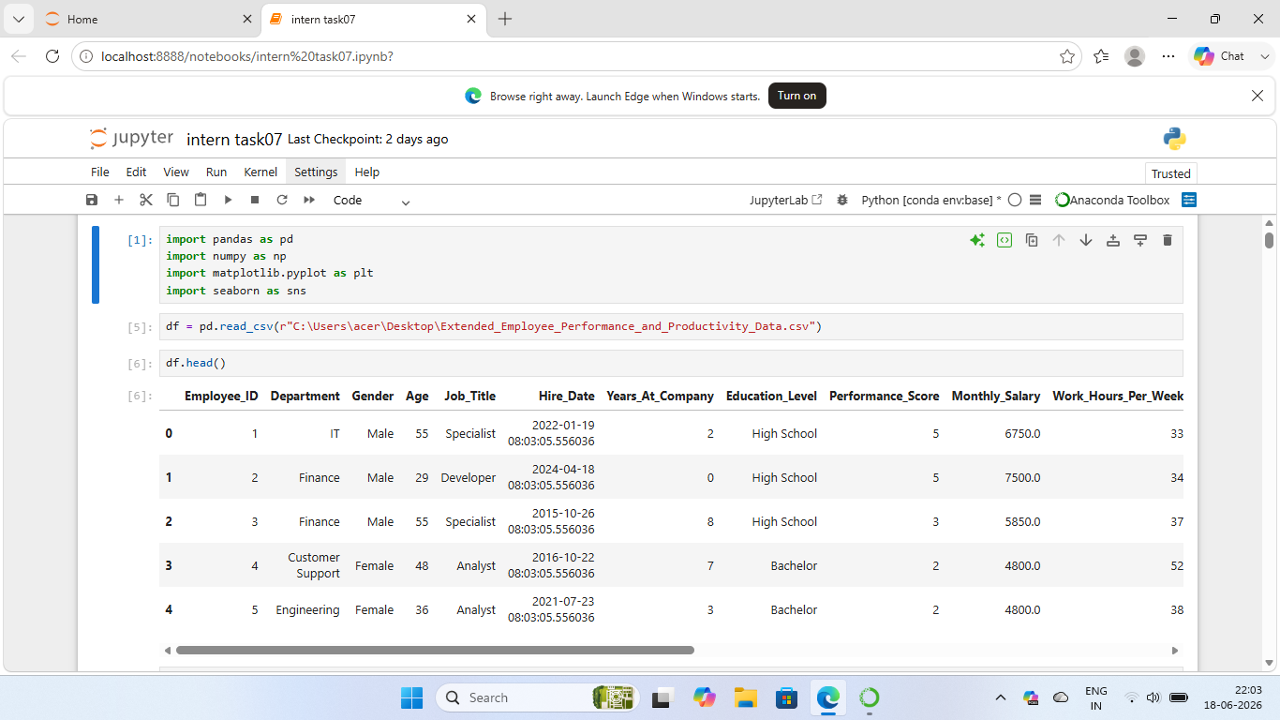
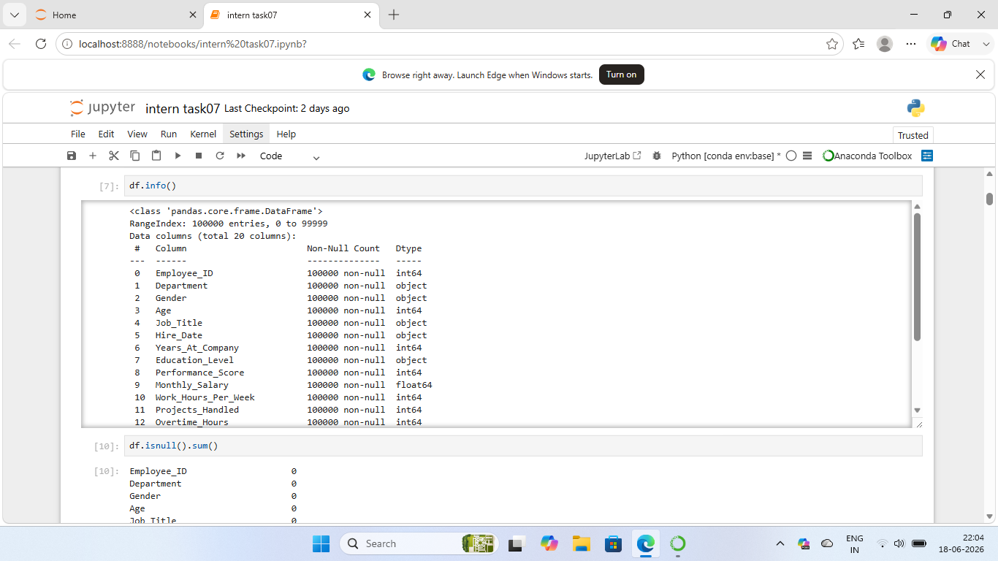
Figure A1: Dataset overview showing employee records and feature information.

Appendix B: Trend Analysis

Code

trend = df.groupby("Years_At_Company")["Monthly_Salary"].mean()
trend.plot(kind="line")
plt.title("Years At Company vs Salary Growth")
plt.show()

Output
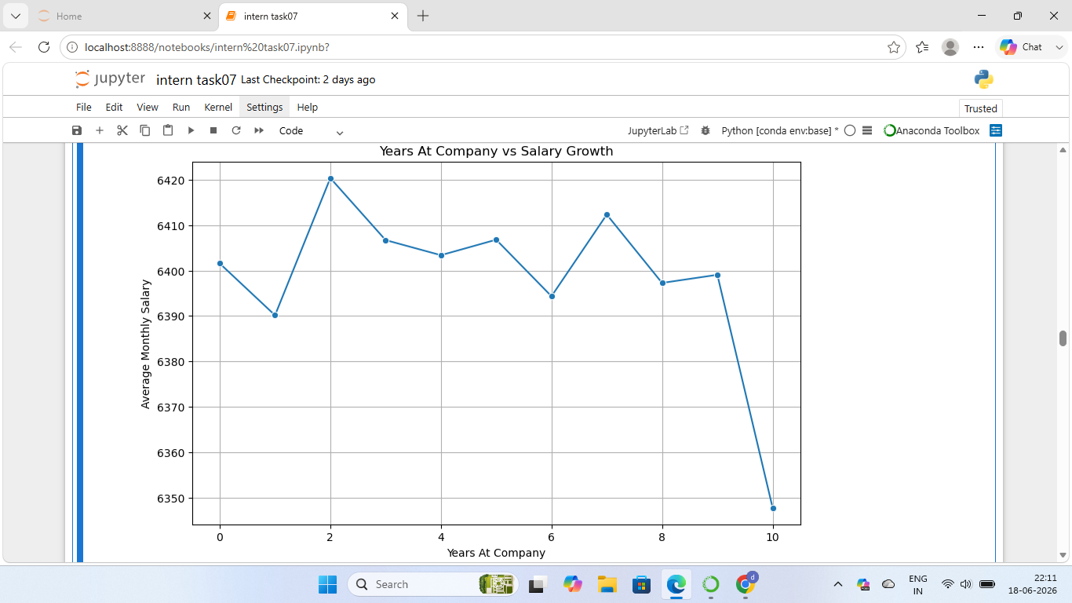
Figure B1: Trend analysis showing salary growth based on years at company.

Appendix C: Correlation Analysis
Code
corr = df[
[
"Training_Hours",
"Performance_Score",
"Monthly_Salary",
"Employee_Satisfaction_Score"
]
].corr()

sns.heatmap(
corr,
annot=True
)

plt.title(
"Correlation Heatmap"
)

plt.show()
Output
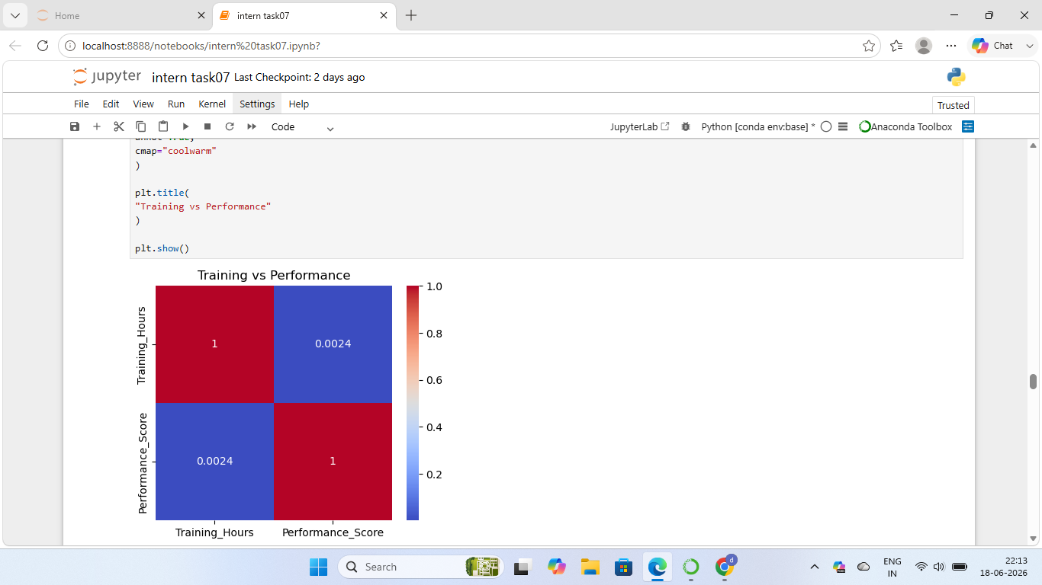

Figure C1: Correlation matrix showing relationships among employee variables.

Appendix D: Hypothesis Testing (T-Test)
Code
from scipy.stats import ttest_ind
low = df[df["Overtime_Hours"] < 10] ["Employee_Satisfaction_Score"]
high = df[df["Overtime_Hours"] >= 10] ["Employee_Satisfaction_Score"]
t_stat, p_value = ttest_ind(low, high)
print("T Statistic:", t_stat)
print("P Value:", p_value)
Output
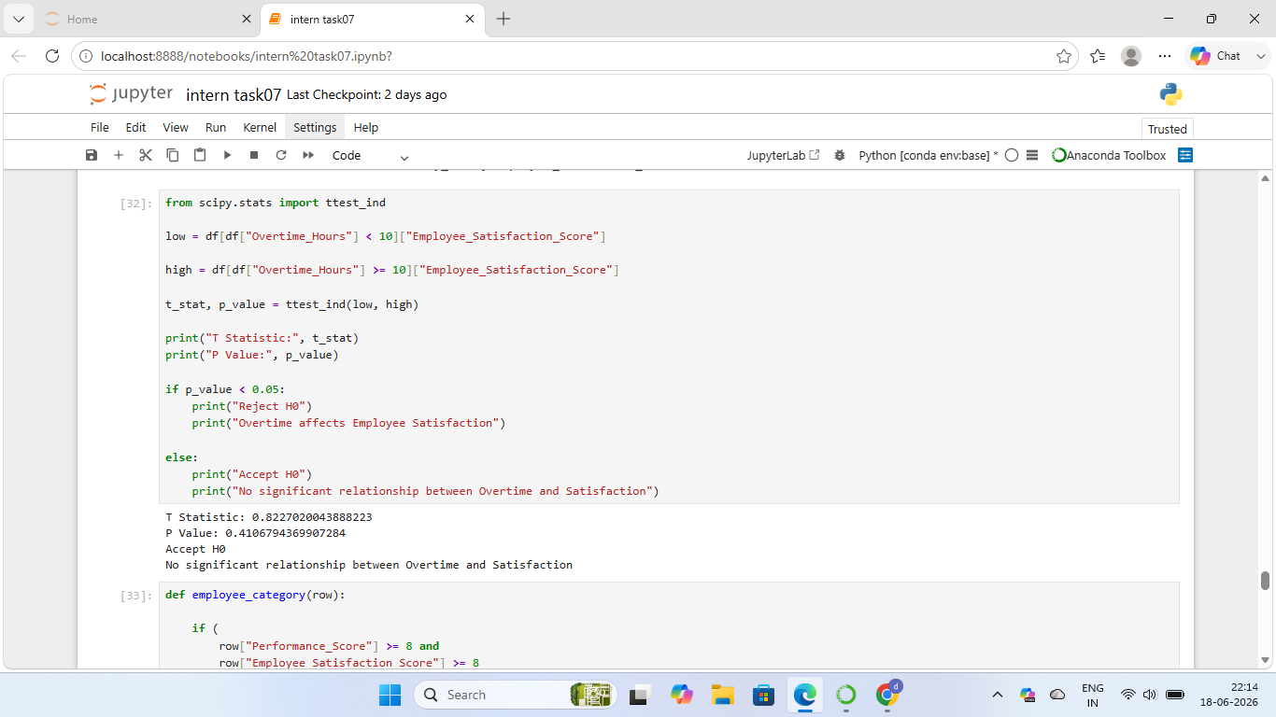
Example Output:
T Statistic: 0.8227
P Value: 0.4107
Accept H0
No significant relationship between Overtime and Satisfaction
Figure D1: T-Test result showing relationship between overtime hours and employee satisfaction.

Appendix E: Employee Segmentation
Code
sns.countplot(
x="Employee_Category",
data=df
)
plt.show()
Output

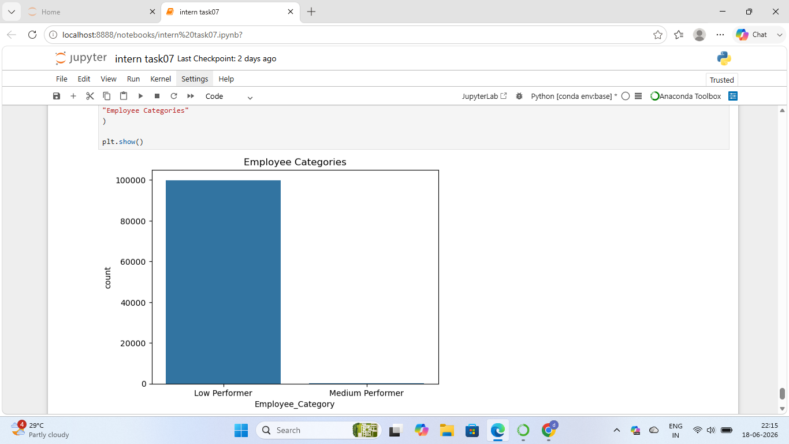

Figure E1: Employee segmentation showing High, Medium, and Low Performer groups.

