Digital Document Verification System (DDVS)
Software Engineering Practical Submission — Lab 03

Experiment Number: Lab 03 | Experiment Title: Class Identification, Classification & Class Diagram
Project Title: Digital Document Verification System (DDVS) | Team Size: 4 Members
Project Team Members: 1. Divya Kumari  2. Divyanshi Jaiswal  3. Divyanshi Khemani  4. Divyanshu Gupta | Course / Subject: B.Tech Computer Science & Engineering  Software Engineering Laboratory
Submission Target: Moodle Practical Submission | Source Baseline: IEEE SRS for DDVS v1.0 (August 2026)

1. Objective
To systematically identify the object-oriented classes strictly from the Software Requirements Specification (SRS) of the Digital Document Verification System (DDVS), classify them into strong, weak/dependent, and specialized classes, define their attributes and operations supported by the SRS, establish structural associations with well-justified multiplicities, and construct a standardized three-compartment UML Class Diagram.
2. Relevant Theory
What is a Class and an Object?
• Class: A class is a blueprint, prototype, or abstract template that defines the shared variables (attributes), behaviors (methods), and business constraints of a category of domain entities.
• Object: An object is a concrete, runtime instance of a class that encapsulates a specific state (attribute values) and exhibits the behaviors defined by its class.
Attributes and Methods:
• Attributes: Named data elements that represent the properties or current state of an object (e.g., status, email).
• Methods (Operations): Functions or procedural services that an object provides to inspect or modify its internal state or collaborate with other objects (e.g., login, registerDocument, computeHash).
Strong vs. Weak / Dependent Entity Classification:
• Strong Entity / Class: A class that possesses an independent existence and a primary identifier that does not depend on the primary key of another entity.
• Weak / Dependent Entity / Class: In formal database and conceptual modeling, a weak entity cannot be uniquely identified by its own attributes alone and relies on an identifying owner entity's primary key.
• Important Distinction: Having a foreign key does not automatically make an entity weak. For example, in DDVS, Document records are associated with an IssuingOrganization, but Document possesses its own unique verification ID (FR-16), making it an independent strong entity rather than a weak entity.
3. SRS-Based Project Details
In accordance with SRS Appendix B (Analysis Models), six core domain classes are explicitly identified for the DDVS project:
Class Name | SRS Category | Entity Classification | SRS Traceability Reference
User | Core User Account | Strong Entity (Superclass) | Section 2.3, FR-01 to FR-06, FR-10 to FR-12
IssuingOrganization | Authorized Issuer | Specialization (Subclass of User) | Section 2.3, FR-07, FR-08, FR-13 to FR-21
Administrator | System Governance | Specialization (Subclass of User) | Section 2.3, FR-09, FR-43 to FR-49
Document | Issued Credential Record | Strong Entity (Core Domain) | Section 2.2, FR-13 to FR-21, FR-26 to FR-31
VerificationRequest | Transient Query Session | Transactional Boundary Class | Section 4.3, FR-22 to FR-25, FR-30
VerificationLog | Audit Trail Record | Dependent Audit Entity | Section 4.5, FR-36 to FR-42, Section 6.1

3.1 Specification of Attributes and Operations
The attributes and operations for each class are grounded in the functional requirements of the SRS. Where programming language types (e.g., String, Boolean, DateTime) or visibilities are specified, they represent [Design Assumption] choices necessary to produce standard UML notation, as primitive data types are Not specified in the SRS.
Class | Attributes (SRS-Grounded) | Methods / Operations (SRS-Grounded)
User | - userId: String [Design Assumption]  - name: String (FR-01)  - email: String (FR-01, FR-02)  - passwordHash: String (FR-04)  - role: String (Section 2.3)  - isActive: Boolean (FR-46)  - createdAt: DateTime [Design Assumption] | + register(): Boolean (FR-01)  + login(credentials): Boolean (FR-05)  + logout(): void (FR-10)  + changePassword(old, new): Boolean (FR-12)  + viewVerificationHistory(): List (FR-39)
IssuingOrganization | - orgId: String [Design Assumption]  - orgName: String (Section 2.3)  - orgType: String (Section 2.3)  - approvalStatus: String (Pending/Approved) (FR-07)  - approvedAt: DateTime (FR-44)  - contactEmail: String [Design Assumption] | + submitRegistrationRequest(): Boolean (FR-07)  + registerDocument(meta, file): Document (FR-13)  + viewIssuedDocuments(): List (FR-19)  + revokeDocument(docId, reason): Boolean (FR-29)
Administrator | - adminLevel: String [Design Assumption]  - department: String [Design Assumption]  - lastLogin: DateTime [Design Assumption] | + approveOrganization(orgId): Boolean (FR-44)  + rejectOrganization(orgId, reason): Boolean (FR-44)  + manageUser(userId, action): Boolean (FR-45, FR-46)  + manageDocument(docId, action): Boolean (FR-47, FR-48)  + viewAllVerificationLogs(filter): List (FR-40, FR-42)
Document | - documentId: String (Unique ID; FR-16)  - documentType: String (FR-13)  - recipientName: String (FR-13)  - issueDate: DateTime (FR-13)  - storedHash: String (SHA-256; FR-15)  - qrCodeData: String (FR-17)  - status: String (Active/Revoked; FR-29)  - registeredByOrgId: String (FR-18) | + getMetadata(): DocumentInfo (FR-27)  + computeHash(file): String (FR-15, FR-32)  + updateStatus(newStatus): Boolean (FR-29, FR-48)  + getVerificationUrl(): String [Design Assumption]
VerificationRequest | - requestId: String [Design Assumption]  - submissionType: String (ID/QR/File; FR-22–24)  - submittedDocId: String (FR-22)  - submittedFile: Object (FR-24)  - requestTimestamp: DateTime (FR-38)  - clientIpAddress: String [Design Assumption]  - submittedByUserId: String (Optional; FR-30, FR-39) | + validateInput(): Boolean (FR-25)  + extractVerificationId(): String (FR-23)  + initiateVerification(): VerificationLog (Section 4.3)
VerificationLog | - logId: String [Design Assumption]  - verificationId: String (FR-38)  - timestamp: DateTime (FR-38)  - verificationMethod: String (ID/QR/File; FR-38)  - resultStatus: String (Verified/Invalid/NotFound/Tampered; FR-38)  - performedByUserId: String (FR-39)  - hashCompared: Boolean (FR-38)  - remarks: String [Design Assumption] | + recordLog(): Boolean (FR-36, FR-37)  + getLogDetails(): LogEntry (FR-39, FR-40)  + exportLog(): String [Design Assumption]

4. UML Class Diagram
The standardized UML Class Diagram models the six SRS classes, their three-compartment definitions, generalization (inheritance) hierarchies, and associations with explicitly justified multiplicities:

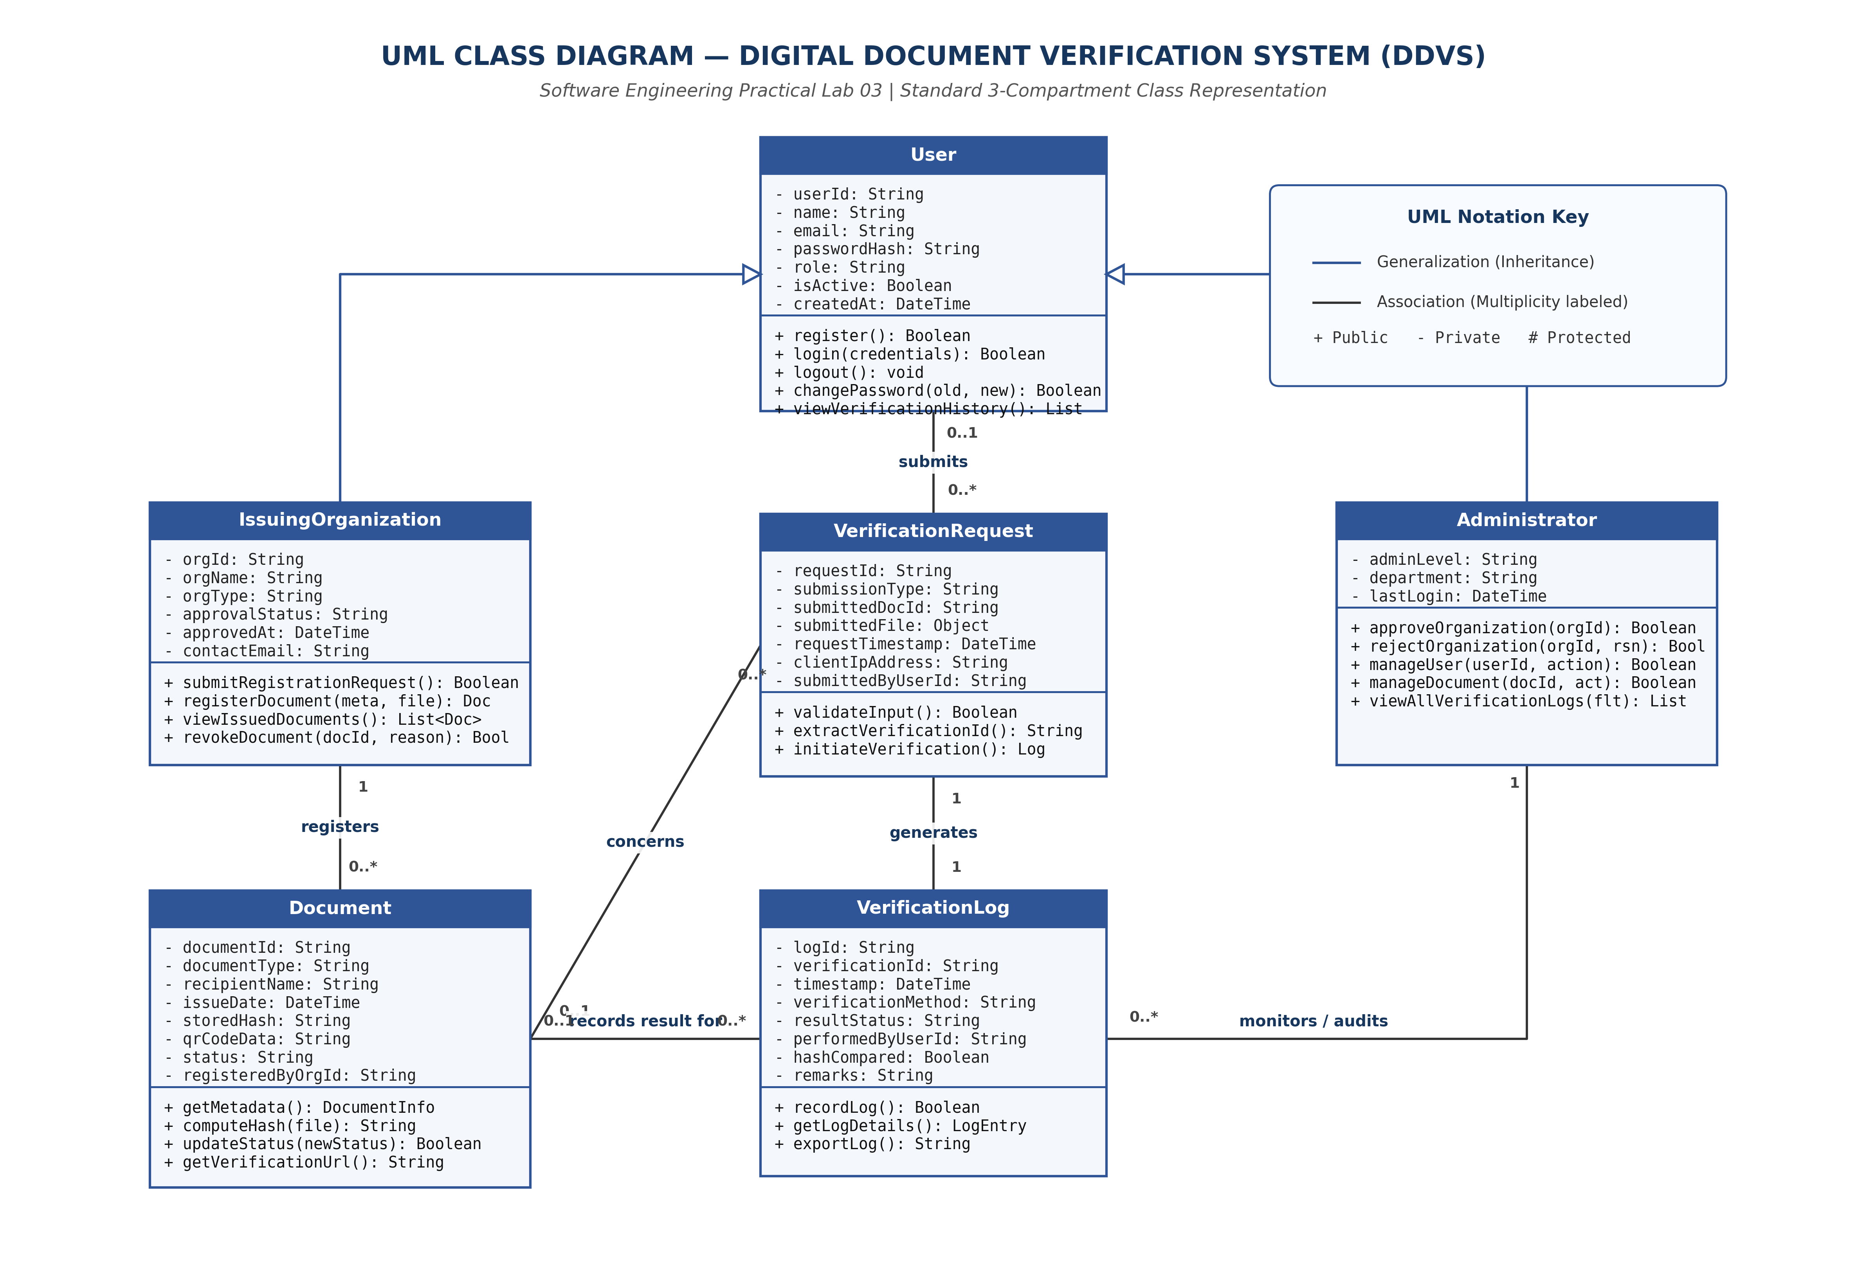
Figure 3.1: Standard UML Class Diagram for Digital Document Verification System (DDVS)
4.1 Structural Relationships and Multiplicity Justification
1. Generalization (Inheritance):
• IssuingOrganization —► User: Specialization of User. Inherits core account identity and credentials while adding organizational profile and issuance methods.
• Administrator —► User: Specialization of User. Inherits identity while adding approval and system governance operations.
2. Association (Multiplicities):
• IssuingOrganization [1] ——— registers ——— [0..*] Document: Exactly one issuing organization registers zero or many documents. Each document is tied to exactly one issuer (FR-18).
• User [0..1] ——— submits ——— [0..*] VerificationRequest: A user may submit zero or more verification requests. Multiplicity is 0..1 on the User end because unauthenticated guest verification is explicitly permitted by FR-30.
• VerificationRequest [0..*] ——— concerns ——— [0..1] Document: A verification request targets at most one document record (0 if record is Not Found).
• VerificationRequest [1] ——— generates ——— [1] VerificationLog: Each verification attempt generates exactly one immutable audit log entry (FR-37).
• Document [0..1] ——— referenced in ——— [0..*] VerificationLog: A registered document may be verified multiple times; non-existent ID queries reference 0 documents.
• Administrator [1] ——— audits ——— [0..*] VerificationLog: Administrators inspect and filter system-wide verification logs (FR-40, FR-42).
5. Result and Conclusion
Result:
All six classes specified in the SRS were systematically identified, classified, and fully defined with attributes and operations traceable to functional requirements. A complete UML Class Diagram was created and embedded above.
Conclusion:
The class diagram establishes a robust, highly cohesive, and loosely coupled structural blueprint for the Digital Document Verification System. By accurately modeling user inheritance, separating transient verification requests from permanent audit logs, and maintaining strict fidelity to the SRS, the design provides an authoritative foundation for subsequent behavioral modeling.

