Digital Document Verification System (DDVS)
Software Engineering Practical Submission — Lab 04

Experiment Number: Lab 04 | Experiment Title: Activity Diagram for Document Verification Workflow
Project Title: Digital Document Verification System (DDVS) | Team Size: 4 Members
Project Team Members: 1. Divya Kumari  2. Divyanshi Jaiswal  3. Divyanshi Khemani  4. Divyanshu Gupta | Course / Subject: B.Tech Computer Science & Engineering  Software Engineering Laboratory
Submission Target: Moodle Practical Submission | Source Baseline: IEEE SRS for DDVS v1.0 (August 2026)

1. Objective
To model the step-by-step procedural control flow of document verification in the Digital Document Verification System (DDVS) using a partitioned UML Activity Diagram with swimlanes, accurately representing multi-channel input handling, decision branching (record lookup, hash comparison bypass, and status checking), the four SRS-defined outcomes (Not Found, Tampered, Invalid, Verified), and guaranteed verification audit logging.
2. Relevant Theory
• Activity Diagram: A behavioral UML diagram that models procedural logic, business workflows, and operational steps over time.
• Initial Node (●): Entry point of control flow.
• Action Node (Rounded Rectangle): An atomic computational step (e.g., Query Document Store, Compute SHA-256 Hash).
• Decision & Merge Nodes (Diamonds ◇): Evaluates runtime guard conditions ([condition]) to select alternative paths, or re-converges branches.
• Activity Final Node (⦿): Terminates the activity flow.
• Swimlanes (Partitions): Divides actions based on organizational responsibility (Verifier vs. DDVS System).
3. SRS-Based Project Details
The verification workflow is strictly derived from SRS Sections 4.3, 4.4, and Appendix B:
1. Submission Channels: Verifiers can submit an alphanumeric Verification ID (FR-22), scan a QR code (FR-23), or upload a PDF document (FR-24).
2. Record Lookup: System queries the document store. If no record is found, display 'Not Found' (FR-26).
3. Hash Check Applicability: If a document file was uploaded, compute its SHA-256 hash and compare with the stored hash (FR-33). If the hash does not match, display 'Tampered' (FR-28, FR-34). If no file was uploaded (ID or QR only), the hash comparison is bypassed without forcing an artificial file upload (FR-26, FR-27).
4. Status Evaluation: If record is revoked or invalid, display 'Invalid' (FR-29). Otherwise, display 'Verified' (FR-27).
5. Audit Logging: Every attempt is logged in the verification log store before displaying the verdict (FR-36, FR-37, FR-38).
4. Verification Decision Table
Rule # | Record Found? | File Uploaded? | Hash Matches? | Status Flag | System Verdict & Action
R1 | No | N/A | N/A | N/A | Log attempt as 'Not Found' ──► Display 'Not Found' (FR-26)
R2 | Yes | Yes | No (Mismatch) | Any | Log attempt as 'Tampered' ──► Display 'Tampered' Warning (FR-28, FR-34)
R3 | Yes | Yes | Yes (Match) | Revoked/Invalid | Log attempt as 'Invalid' ──► Display 'Invalid / Revoked' (FR-29)
R4 | Yes | Yes | Yes (Match) | Active | Log attempt as 'Verified' ──► Display 'Verified' + Metadata (FR-27)
R5 | Yes | No (ID/QR) | Bypassed | Revoked/Invalid | Log attempt as 'Invalid' ──► Display 'Invalid / Revoked' (FR-29)
R6 | Yes | No (ID/QR) | Bypassed | Active | Log attempt as 'Verified' ──► Display 'Verified' + Metadata (FR-27)

5. UML Activity Diagram

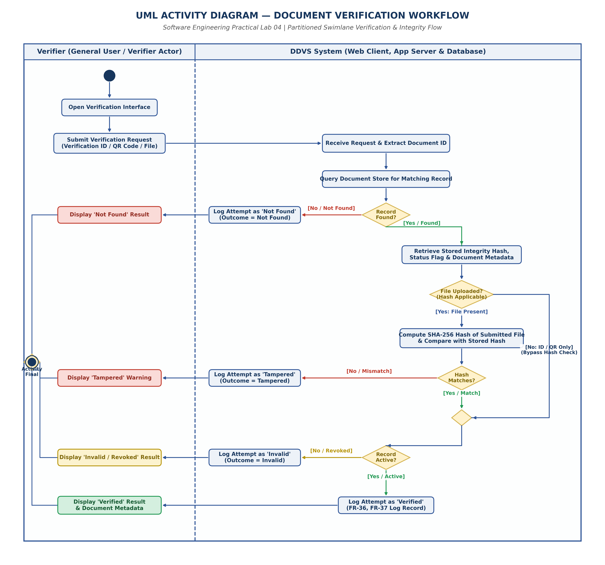
Figure 4.1: Partitioned UML Activity Diagram for Document Verification Workflow
6. Result and Conclusion
Result:
The complete document verification workflow was modeled using a partitioned UML Activity Diagram with swimlanes. All decision points, bypass pathways, and outcome classifications were verified against SRS requirements.
Conclusion:
The activity diagram demonstrates a robust procedural design. By separating verifier actions from system operations, handling diverse input channels without forcing mandatory file uploads, and ensuring guaranteed audit logging, the workflow meets all functional and safety requirements defined in the SRS.

