Digital Document Verification System (DDVS)
Software Engineering Practical Submission — Lab 05

Experiment Number: Lab 05 | Experiment Title: Data Flow Diagrams (Context Level 0 & Level 1 DFD)
Project Title: Digital Document Verification System (DDVS) | Team Size: 4 Members
Project Team Members: 1. Divya Kumari  2. Divyanshi Jaiswal  3. Divyanshi Khemani  4. Divyanshu Gupta | Course / Subject: B.Tech Computer Science & Engineering  Software Engineering Laboratory
Submission Target: Moodle Practical Submission | Source Baseline: IEEE SRS for DDVS v1.0 (August 2026)

1. Objective
To represent the functional flow and transformation of data within the Digital Document Verification System (DDVS) by constructing a Context Diagram (Level 0 DFD) defining external entity boundaries, a decomposed Level 1 DFD isolating the four SRS-defined processes and three data stores, and verifying flow conservation through a formal DFD Balancing Matrix.
2. Relevant Theory
• Data Flow Diagram (DFD): A structured analysis technique that models how data passes through a system, gets transformed by processes, and is stored in data stores.
• External Entity: A person, department, or external system that supplies input or receives output (Verifier, Issuing Organization, Administrator).
• Process: A functional transformation of input data into output data (e.g., 1.0 Manage Accounts, 3.0 Verify Document).
• Data Store: A repository of data at rest within persistent storage (D1 User Store, D2 Document Store, D3 Verification Log Store).
• DFD Balancing: The principle that all data flows crossing the system boundary in the Level 0 diagram must be strictly preserved in the Level 1 decomposition.
3. SRS-Based Project Details
Strictly adhering to SRS Appendix B (Analysis Models), the DFD architecture comprises:
• External Entities: Verifier, Issuing Organization, Administrator.
• Level 1 Processes: 1.0 Manage Accounts, 2.0 Register Document, 3.0 Verify Document, 4.0 Maintain Verification Log.
• Data Stores: D1 User Store, D2 Document Store, D3 Verification Log Store.
• Syntactic Rules Enforced: Entities interact only with processes; entities never access data stores directly.
4. Context Diagram (Level 0 DFD)

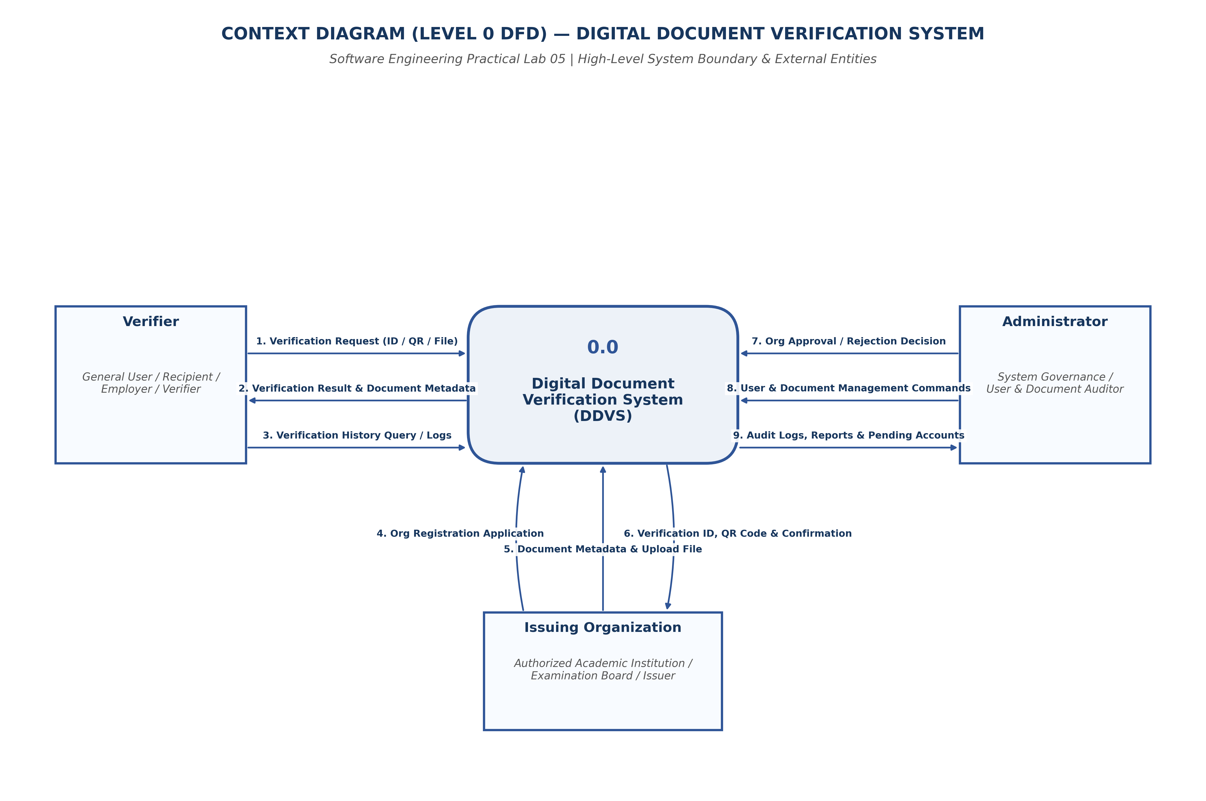
Figure 5.1: Context Diagram (Level 0 DFD) — System Boundary & External Entities
5. Level 1 Data Flow Diagram

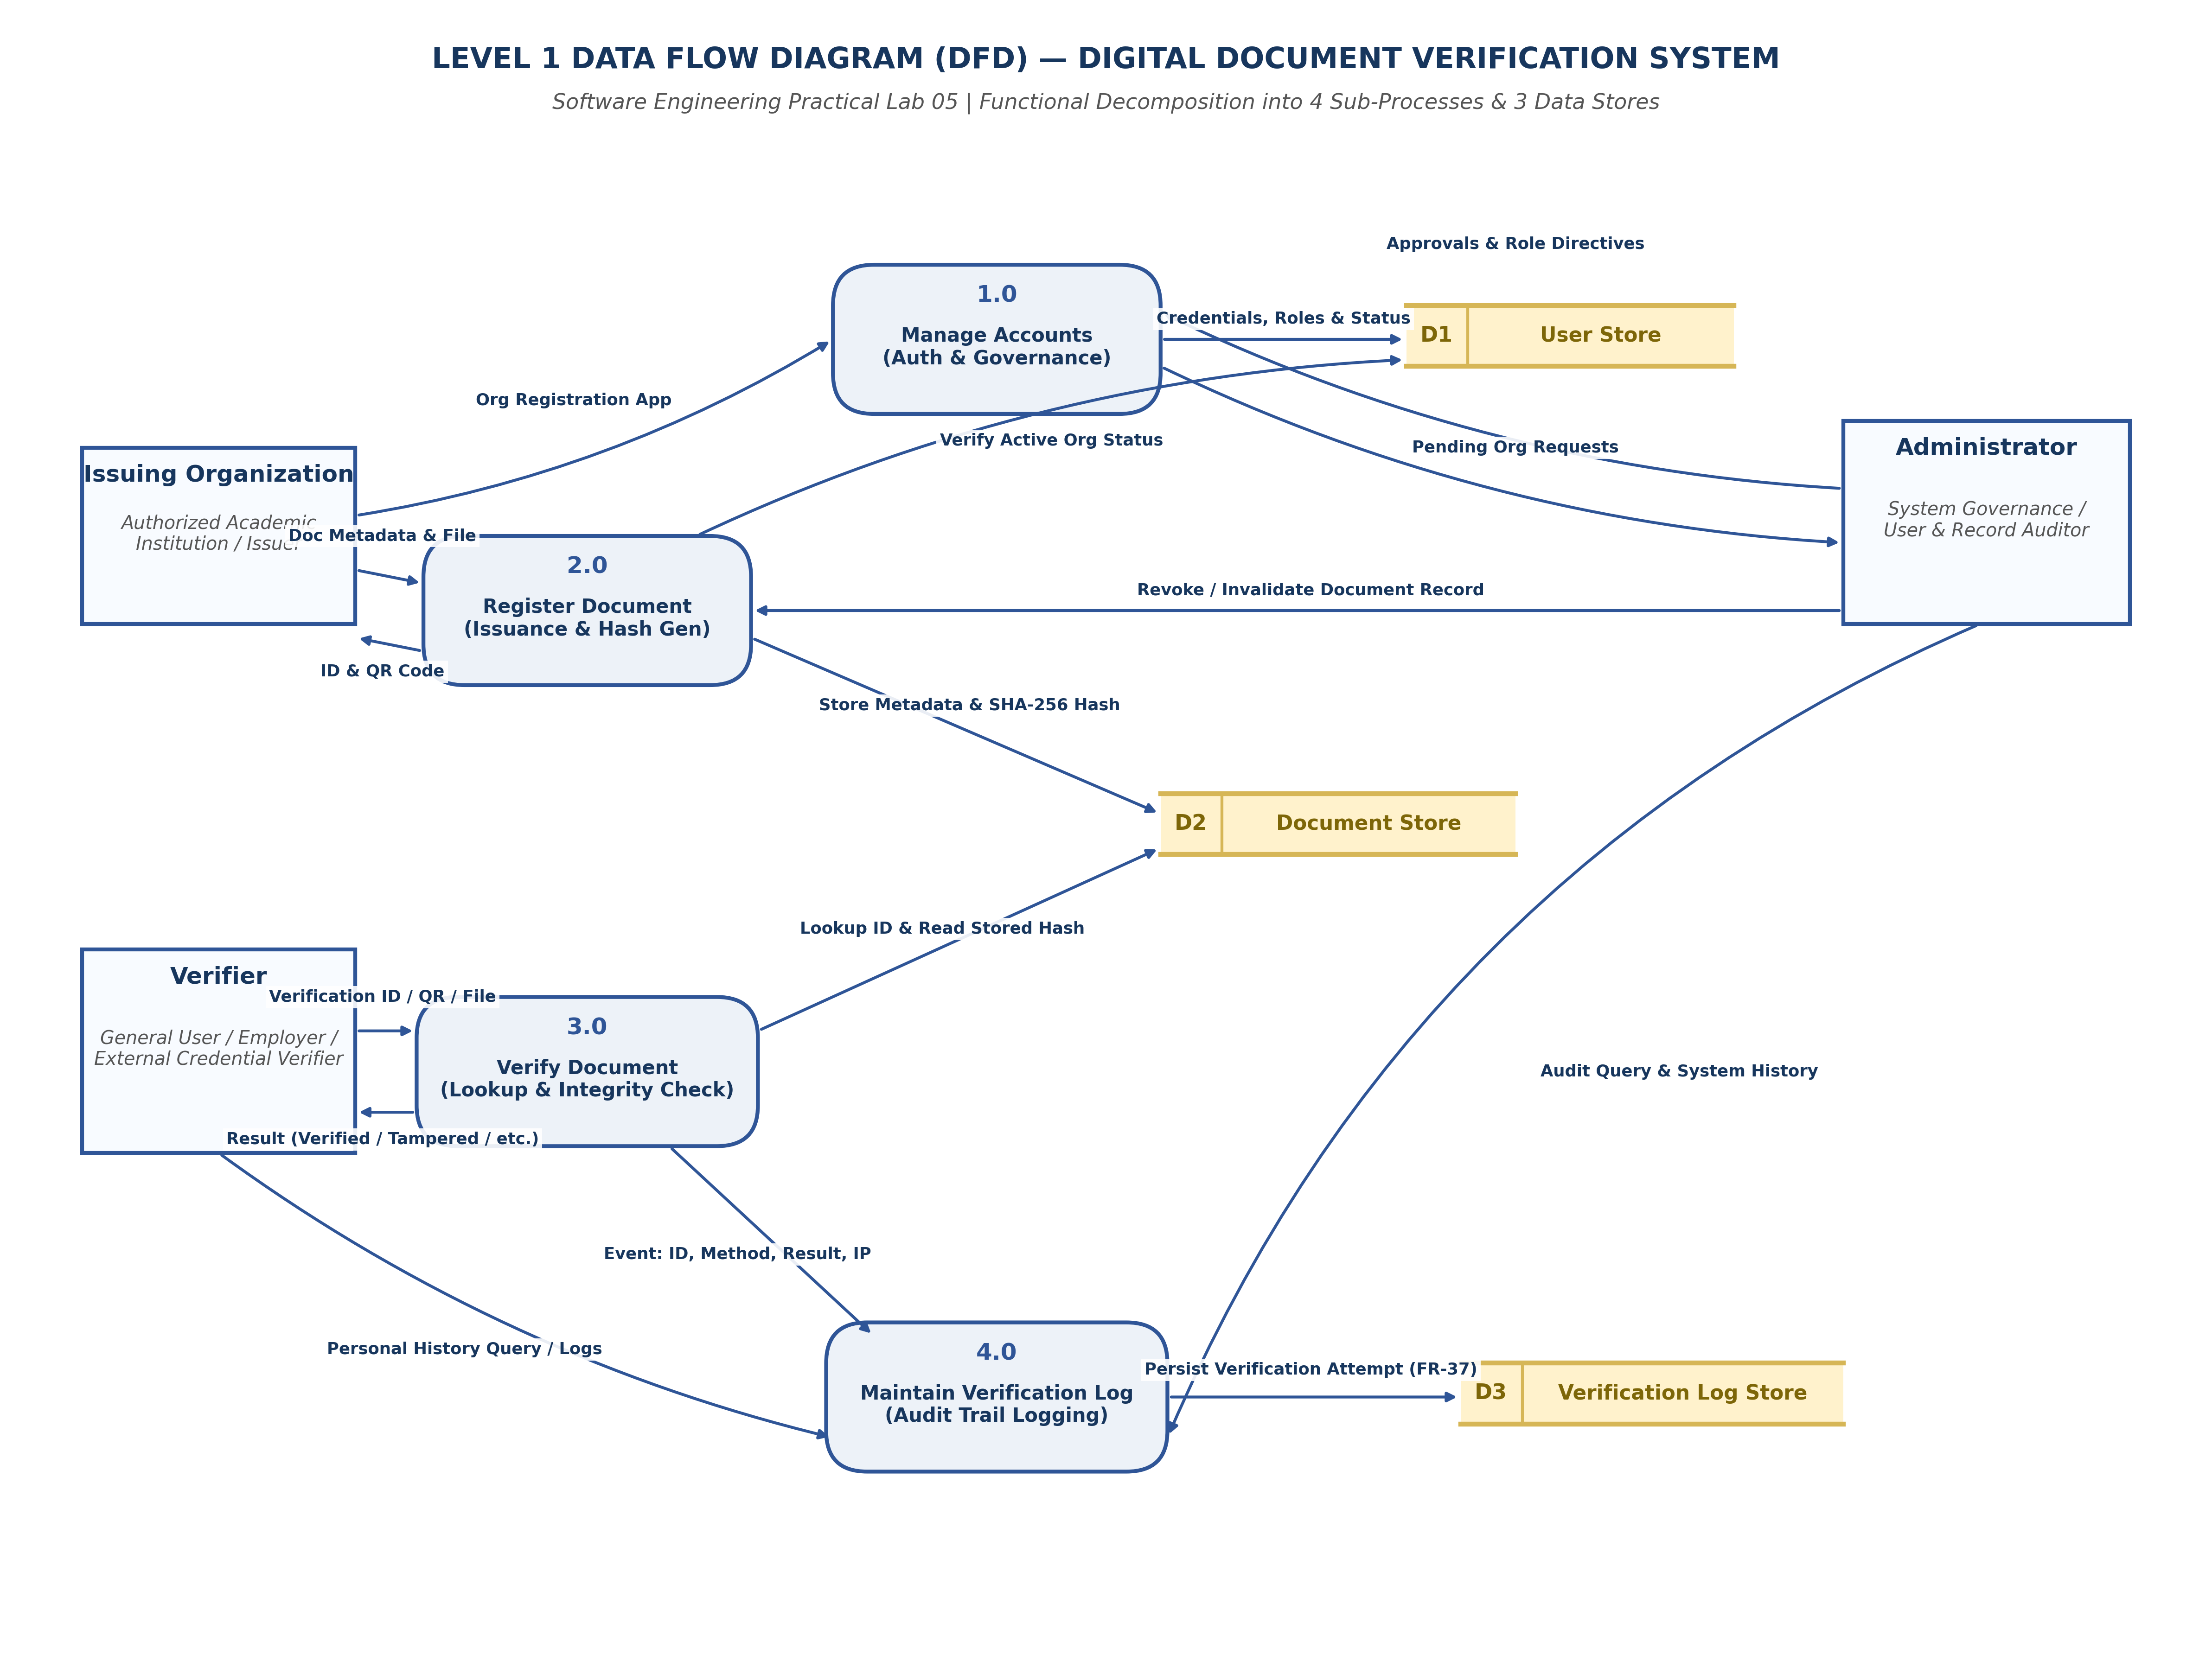
Figure 5.2: Decomposed Level 1 DFD — 4 Processes & 3 Data Stores
6. DFD Balancing Matrix
External Entity | Net Flow at Level 0 | Direction | Matched Sub-Process at Level 1 | Balanced?
Verifier | Verification Request (ID/QR/File) | Inflow | 3.0 Verify Document | YES (Conserved)
Verifier | Verification Result & Metadata | Outflow | 3.0 Verify Document | YES (Conserved)
Issuing Organization | Org Registration Request | Inflow | 1.0 Manage Accounts | YES (Conserved)
Issuing Organization | Doc Metadata & File / ID & QR | Bidirectional | 2.0 Register Document | YES (Conserved)
Administrator | Approvals, Directives / Logs & Reports | Bidirectional | 1.0 Manage Accounts & 4.0 Maintain Log | YES (Conserved)

7. Result and Conclusion
Result:
The data flow architecture was developed at both Context (Level 0) and Level 1 abstraction tiers. All flows were verified for strict consistency and mathematical balancing.
Conclusion:
The DFD models prove clean separation of concerns and high functional cohesion. By mediating all data store interactions through structured business processes, the system eliminates unauthorized direct data access and enforces referential integrity.

