Digital Document Verification System (DDVS)
Software Engineering Practical Submission — Lab 06

Experiment Number: Lab 06 | Experiment Title: UML Sequence Diagram for Document Verification
Project Title: Digital Document Verification System (DDVS) | Team Size: 4 Members
Project Team Members: 1. Divya Kumari  2. Divyanshi Jaiswal  3. Divyanshi Khemani  4. Divyanshu Gupta | Course / Subject: B.Tech Computer Science & Engineering  Software Engineering Laboratory
Submission Target: Moodle Practical Submission | Source Baseline: IEEE SRS for DDVS v1.0 (August 2026)

1. Objective
To represent the dynamic, chronological message exchanges and architectural interactions among DDVS participants (Verifier, Web Client, Application Server, and Database) during the document verification workflow, utilizing standard UML 'alt' combined fragments to model alternative outcome scenarios and guaranteed audit logging.
2. Relevant Theory
• Sequence Diagram: An interaction diagram that depicts how objects communicate over time, emphasizing message sequencing.
• Lifeline: Vertical dashed line representing the timeline of a participating classifier.
• Actor: External user initiating interaction (Verifier).
• Activation Bar: Vertical rectangle indicating execution of an active focus of control.
• Synchronous Call (──►): Sender blocks until receiving response or acknowledgement.
• Return Message (< - - -): Returns control or data to the invoking caller.
• Combined Fragment (alt): An interaction frame used to represent mutually exclusive alternative execution branches.
3. SRS-Based Project Details
In accordance with SRS Section 2.1 and Appendix B, the four exact architectural participants are:
1. Verifier (Actor): End-user submitting credentials for verification.
2. Web Client («boundary»): Browser frontend capturing inputs and rendering UI.
3. Application Server («control»): Central business logic tier executing hash checks and status evaluation.
4. Database («entity»): Relational storage executing ACID-compliant reads and audit writes.
The 'alt' fragment models four mutually exclusive outcome paths:
• Case 1: Record Not Found in Database ──► Log attempt ──► Return HTTP 404 (FR-26)
• Case 2: File Uploaded & Hash Mismatch ──► Log attempt ──► Return HTTP 200 'Tampered' (FR-28, FR-34)
• Case 3: Record Revoked or Inactive ──► Log attempt ──► Return HTTP 200 'Invalid' (FR-29)
• Case 4: Record Active & Hash Matches / Bypassed ──► Log attempt ──► Return HTTP 200 'Verified' + Metadata (FR-27)
4. UML Sequence Diagram

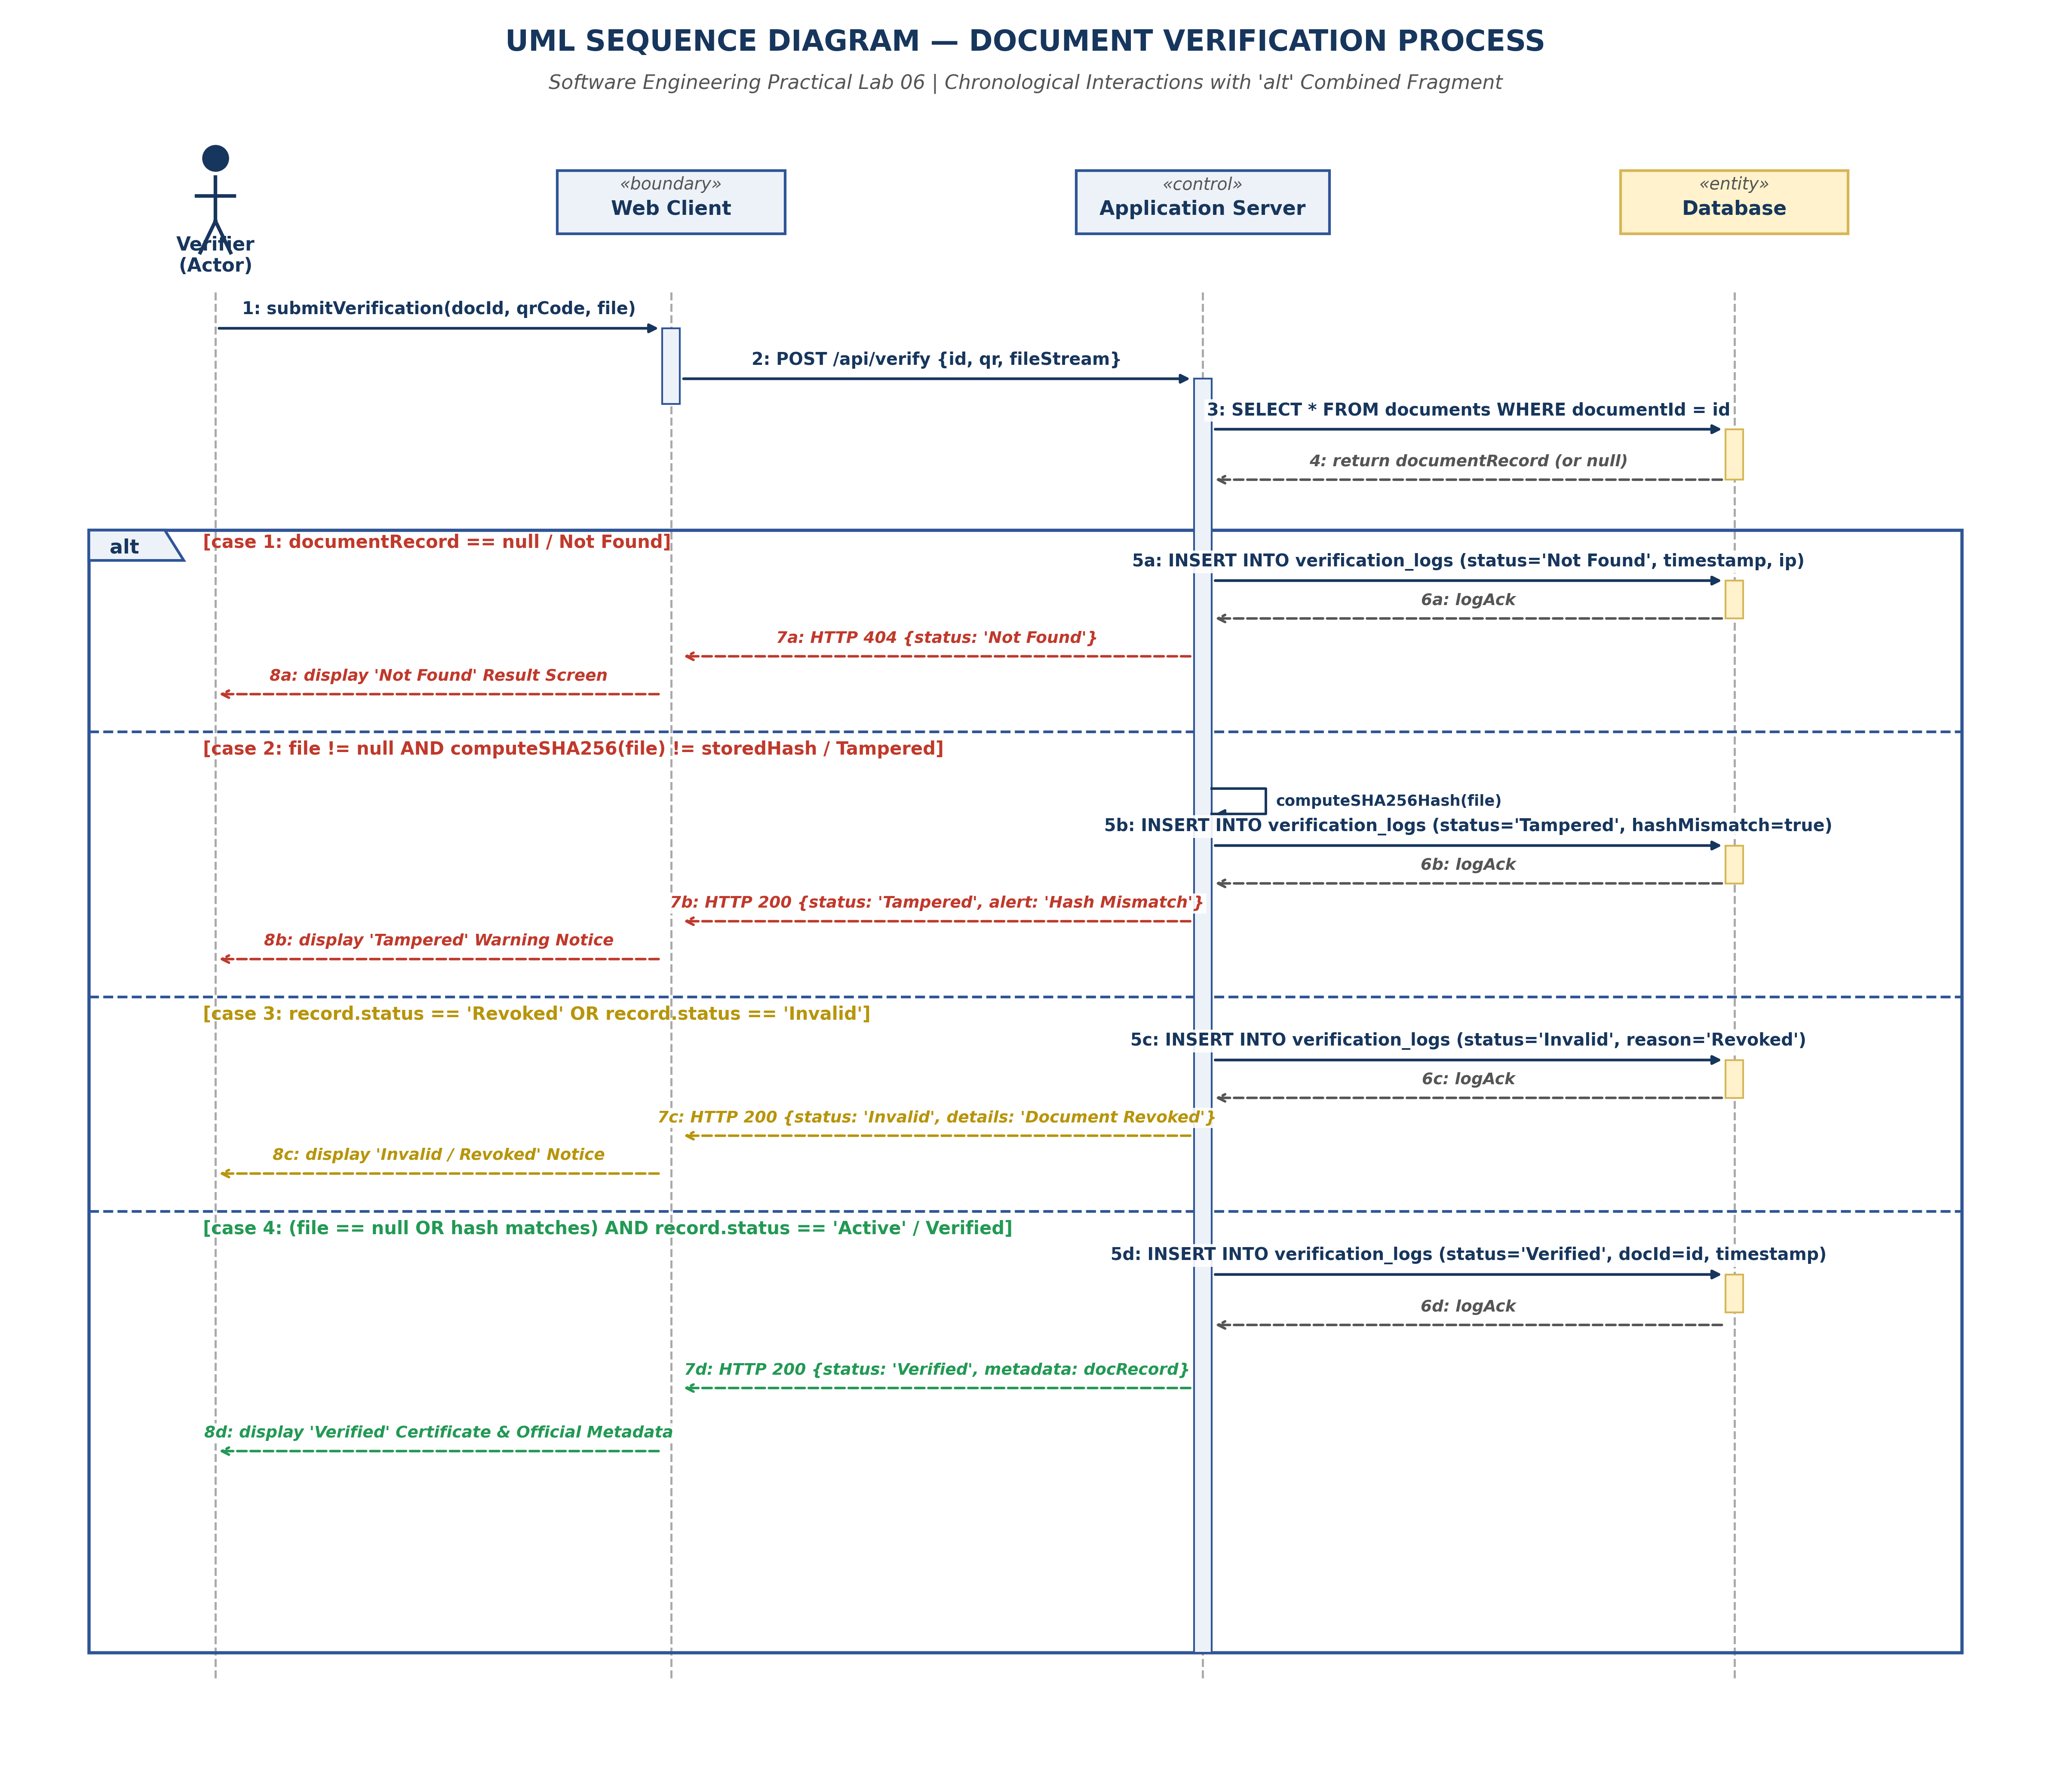
Figure 6.1: UML Sequence Diagram with 'alt' Combined Fragment for Document Verification
5. Result and Conclusion
Result:
A complete UML Sequence Diagram was constructed adhering to the four SRS-defined participants, with standard synchronous calls, return flows, activation bars, and an 'alt' fragment covering all four verification outcomes.
Conclusion:
The sequence diagram establishes clear temporal ordering across presentation, control, and persistence tiers. By enforcing synchronous database audit insertion before client response delivery, the interaction model guarantees zero audit log loss.

