Digital Document Verification System (DDVS)
Software Engineering Practical Submission — Lab 07

Experiment Number: Lab 07 | Experiment Title: UML State Machine Diagram for Verification Request
Project Title: Digital Document Verification System (DDVS) | Team Size: 4 Members
Project Team Members: 1. Divya Kumari  2. Divyanshi Jaiswal  3. Divyanshi Khemani  4. Divyanshu Gupta | Course / Subject: B.Tech Computer Science & Engineering  Software Engineering Laboratory
Submission Target: Moodle Practical Submission | Source Baseline: IEEE SRS for DDVS v1.0 (August 2026)

1. Objective
To model the dynamic, event-driven state transitions of a document verification request within the Digital Document Verification System (DDVS) using a standardized UML State Machine Diagram, establishing formal operational states, deterministic guard conditions, discrete outcome classifications, and consolidated audit ledger finalization.
2. Relevant Theory
• State Machine Diagram: A behavioral diagram that models the discrete states an entity transitions through in response to events.
• State: A condition or phase in the lifecycle of an object during which it satisfies certain conditions or performs activities.
• Transition (trigger [guard] / action): Movement from a source state to a target state triggered by an event, conditioned on a boolean guard, and executing an atomic action.
• Initial Pseudostate (●) & Final State (⦿): Entry and exit points of the state machine.
• Crucial Distinction: Document Entity Lifecycle (Draft ──► Active ──► Revoked) is a persistent entity state, whereas Verification Request Lifecycle is a transient transaction state machine.
3. SRS-Based Project Details
The Verification Request State Machine models the transient lifecycle of a single verification transaction:
1. States: Idle / AwaitingInput ──► RequestReceived ──► RecordLookup ──► IntegrityChecking (or bypassed) ──► StatusEvaluation.
2. Terminal Outcome States: NotFound (FR-26), Tampered (FR-28), Invalid (FR-29), Verified (FR-27).
3. Consolidation: All outcome states transition to 'Logged & Terminated' where audit persistence occurs (FR-37) before session closure.
4. State Transition Table
Current State | Trigger / Event | Guard Condition | Next State | Action Executed
Idle / AwaitingInput | submitVerification() | [validPayload] | RequestReceived | extractID(); parsePayload()
RequestReceived | executeDBQuery() | None | RecordLookup | queryByDocumentId()
RecordLookup | dbResponseReceived | [recordNotFound] | NotFound | setOutcome('Not Found')
RecordLookup | dbResponseReceived | [recordFound && fileUploaded] | IntegrityChecking | readBytes(); computeSHA256()
IntegrityChecking | hashComputed | [hashMismatch] | Tampered | logSecurityAlert(); setOutcome('Tampered')

5. UML State Machine Diagram

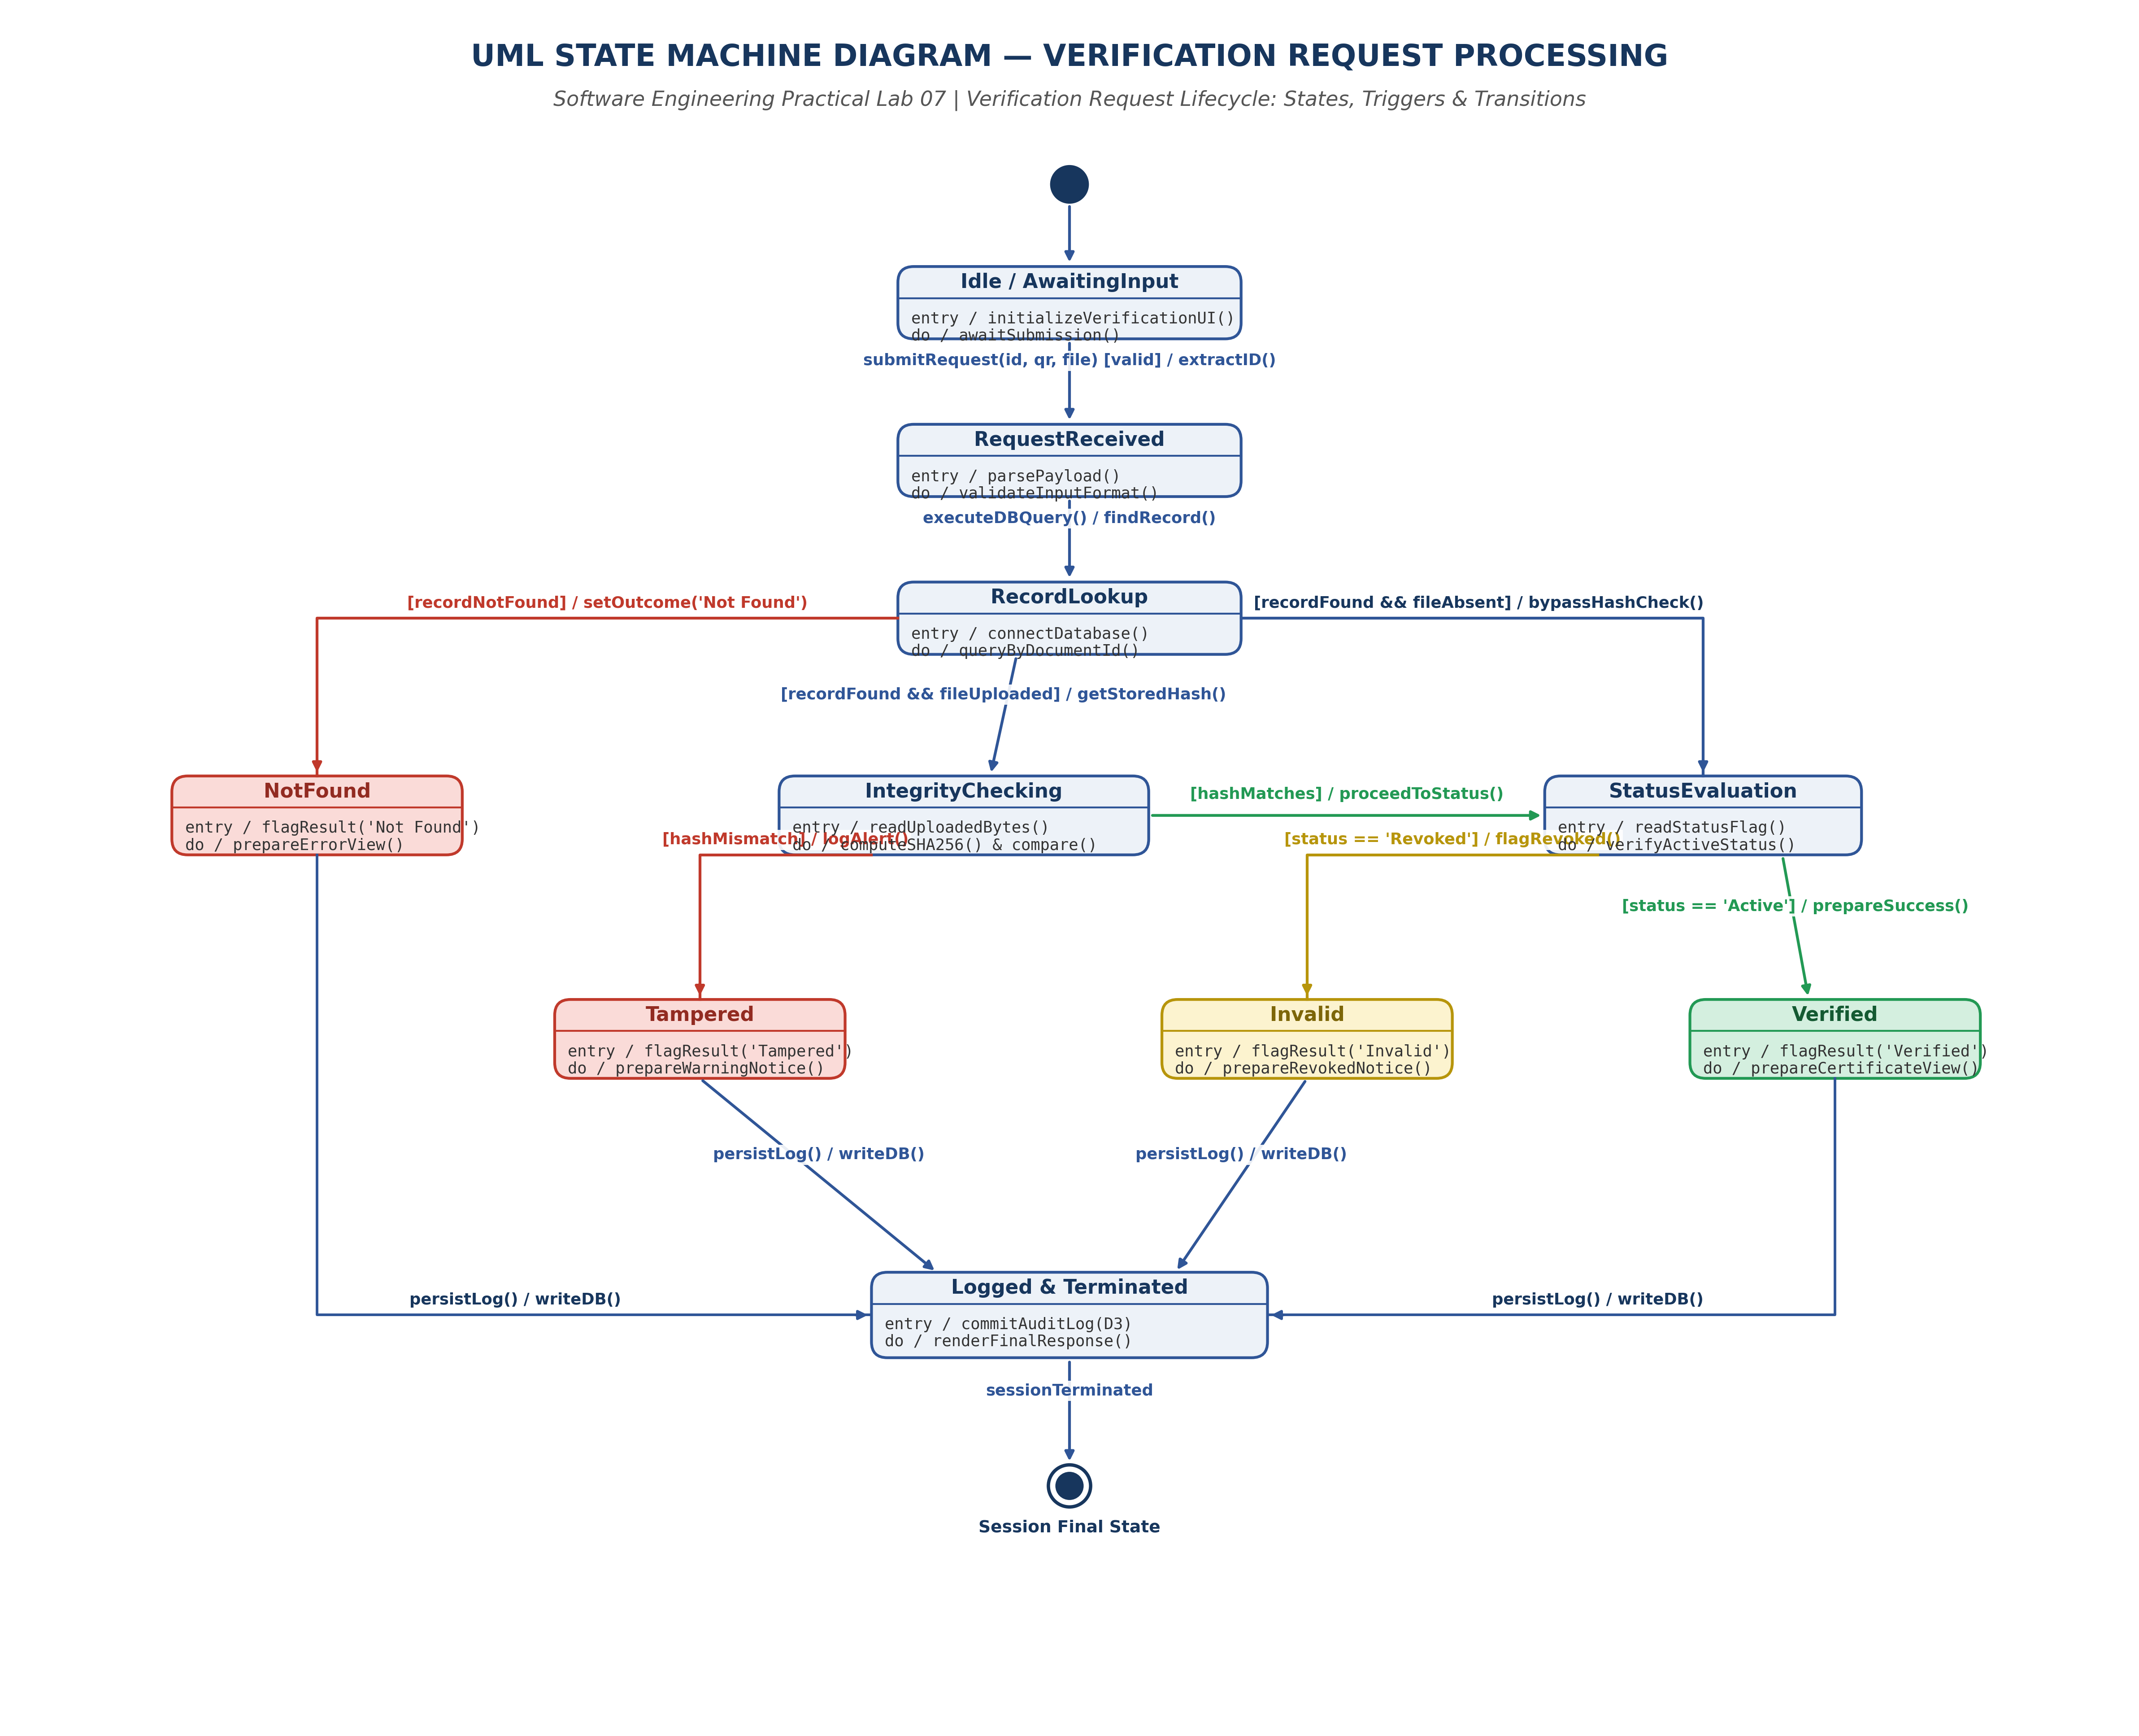
Figure 7.1: UML State Machine Diagram for Verification Request Processing Lifecycle
6. Result and Conclusion
Result:
The reactive state transitions of the DDVS verification request were formally modeled using a UML State Machine Diagram supported by a deterministic state transition table.
Conclusion:
The state machine diagram guarantees mathematical determinism across all decision forks. By consolidating terminal outcome states into an audit logging phase prior to termination, the model guarantees 100% compliance with audit trail requirements.

