Digital Document Verification System (DDVS)
Software Engineering Practical Submission — Lab 08

Experiment Number: Lab 08 | Experiment Title: UML Component Diagram for Logical Software Architecture
Project Title: Digital Document Verification System (DDVS) | Team Size: 4 Members
Project Team Members: 1. Divya Kumari  2. Divyanshi Jaiswal  3. Divyanshi Khemani  4. Divyanshu Gupta | Course / Subject: B.Tech Computer Science & Engineering  Software Engineering Laboratory
Submission Target: Moodle Practical Submission | Source Baseline: IEEE SRS for DDVS v1.0 (August 2026)

1. Objective
To design and model the high-level logical component architecture of the Digital Document Verification System (DDVS) using a standardized UML Component Diagram, identifying seven decoupled logical components across three architectural tiers, formalizing provided and required interfaces, and evaluating subsystem dependencies.
2. Relevant Theory
• Component Diagram: A structural diagram that models the organization, interfaces, and dependencies of software subsystems.
• Component («component»): A modular, deployable unit of software that encapsulates its internal implementation behind interfaces.
• Provided Interface: A service exposed by a component to its environment.
• Required Interface: A service that a component requires from another component to execute its responsibilities.
• Dependency («use»): A dashed directed line indicating runtime coupling between components or interfaces.
3. SRS-Based Project Details
In accordance with SRS Section 2.1 (Product Perspective) and Section 3.3 (Software Interfaces), the seven logical components are:
1. User Interface / Web Client: Presentation Tier component rendering portals for Verifiers, Issuers, and Administrators.
2. Account Management: Handles user authentication, credential hashing, and RBAC (IAccountService).
3. Document Registration: Orchestrates metadata ingestion and ID/QR generation (IRegistrationService).
4. Document Verification: Coordinates query dispatching and verdict synthesis (IVerificationService).
5. Integrity Hash Processing: Pure stateless utility executing SHA-256 hash digests (IHashService).
6. Verification Log Management: Manages immutable audit logs and history queries (ILogService).
7. Data Persistence / Database Access: Encapsulates SQL queries and connection pools (IDataAccess).
Important Note: These are logical components, not framework-specific implementations. Proprietary frameworks are Not specified in the SRS.
4. Component Responsibility & Interface Summary
Component Name | Tier | Provided Interface | Required Interface
User Interface / Web Client | Presentation | IWebUI | IAccountService, IRegistrationService, IVerificationService, ILogService
Account Management | Business Logic | IAccountService | IDataAccess
Document Registration | Business Logic | IRegistrationService | IHashService, IDataAccess
Document Verification | Business Logic | IVerificationService | IHashService, ILogService, IDataAccess
Integrity Hash Processing | Business Logic | IHashService | None (Stateless Utility)
Verification Log Management | Business Logic | ILogService | IDataAccess
Data Persistence / DB Access | Persistence | IDataAccess | Relational DBMS Connection

5. UML Component Diagram

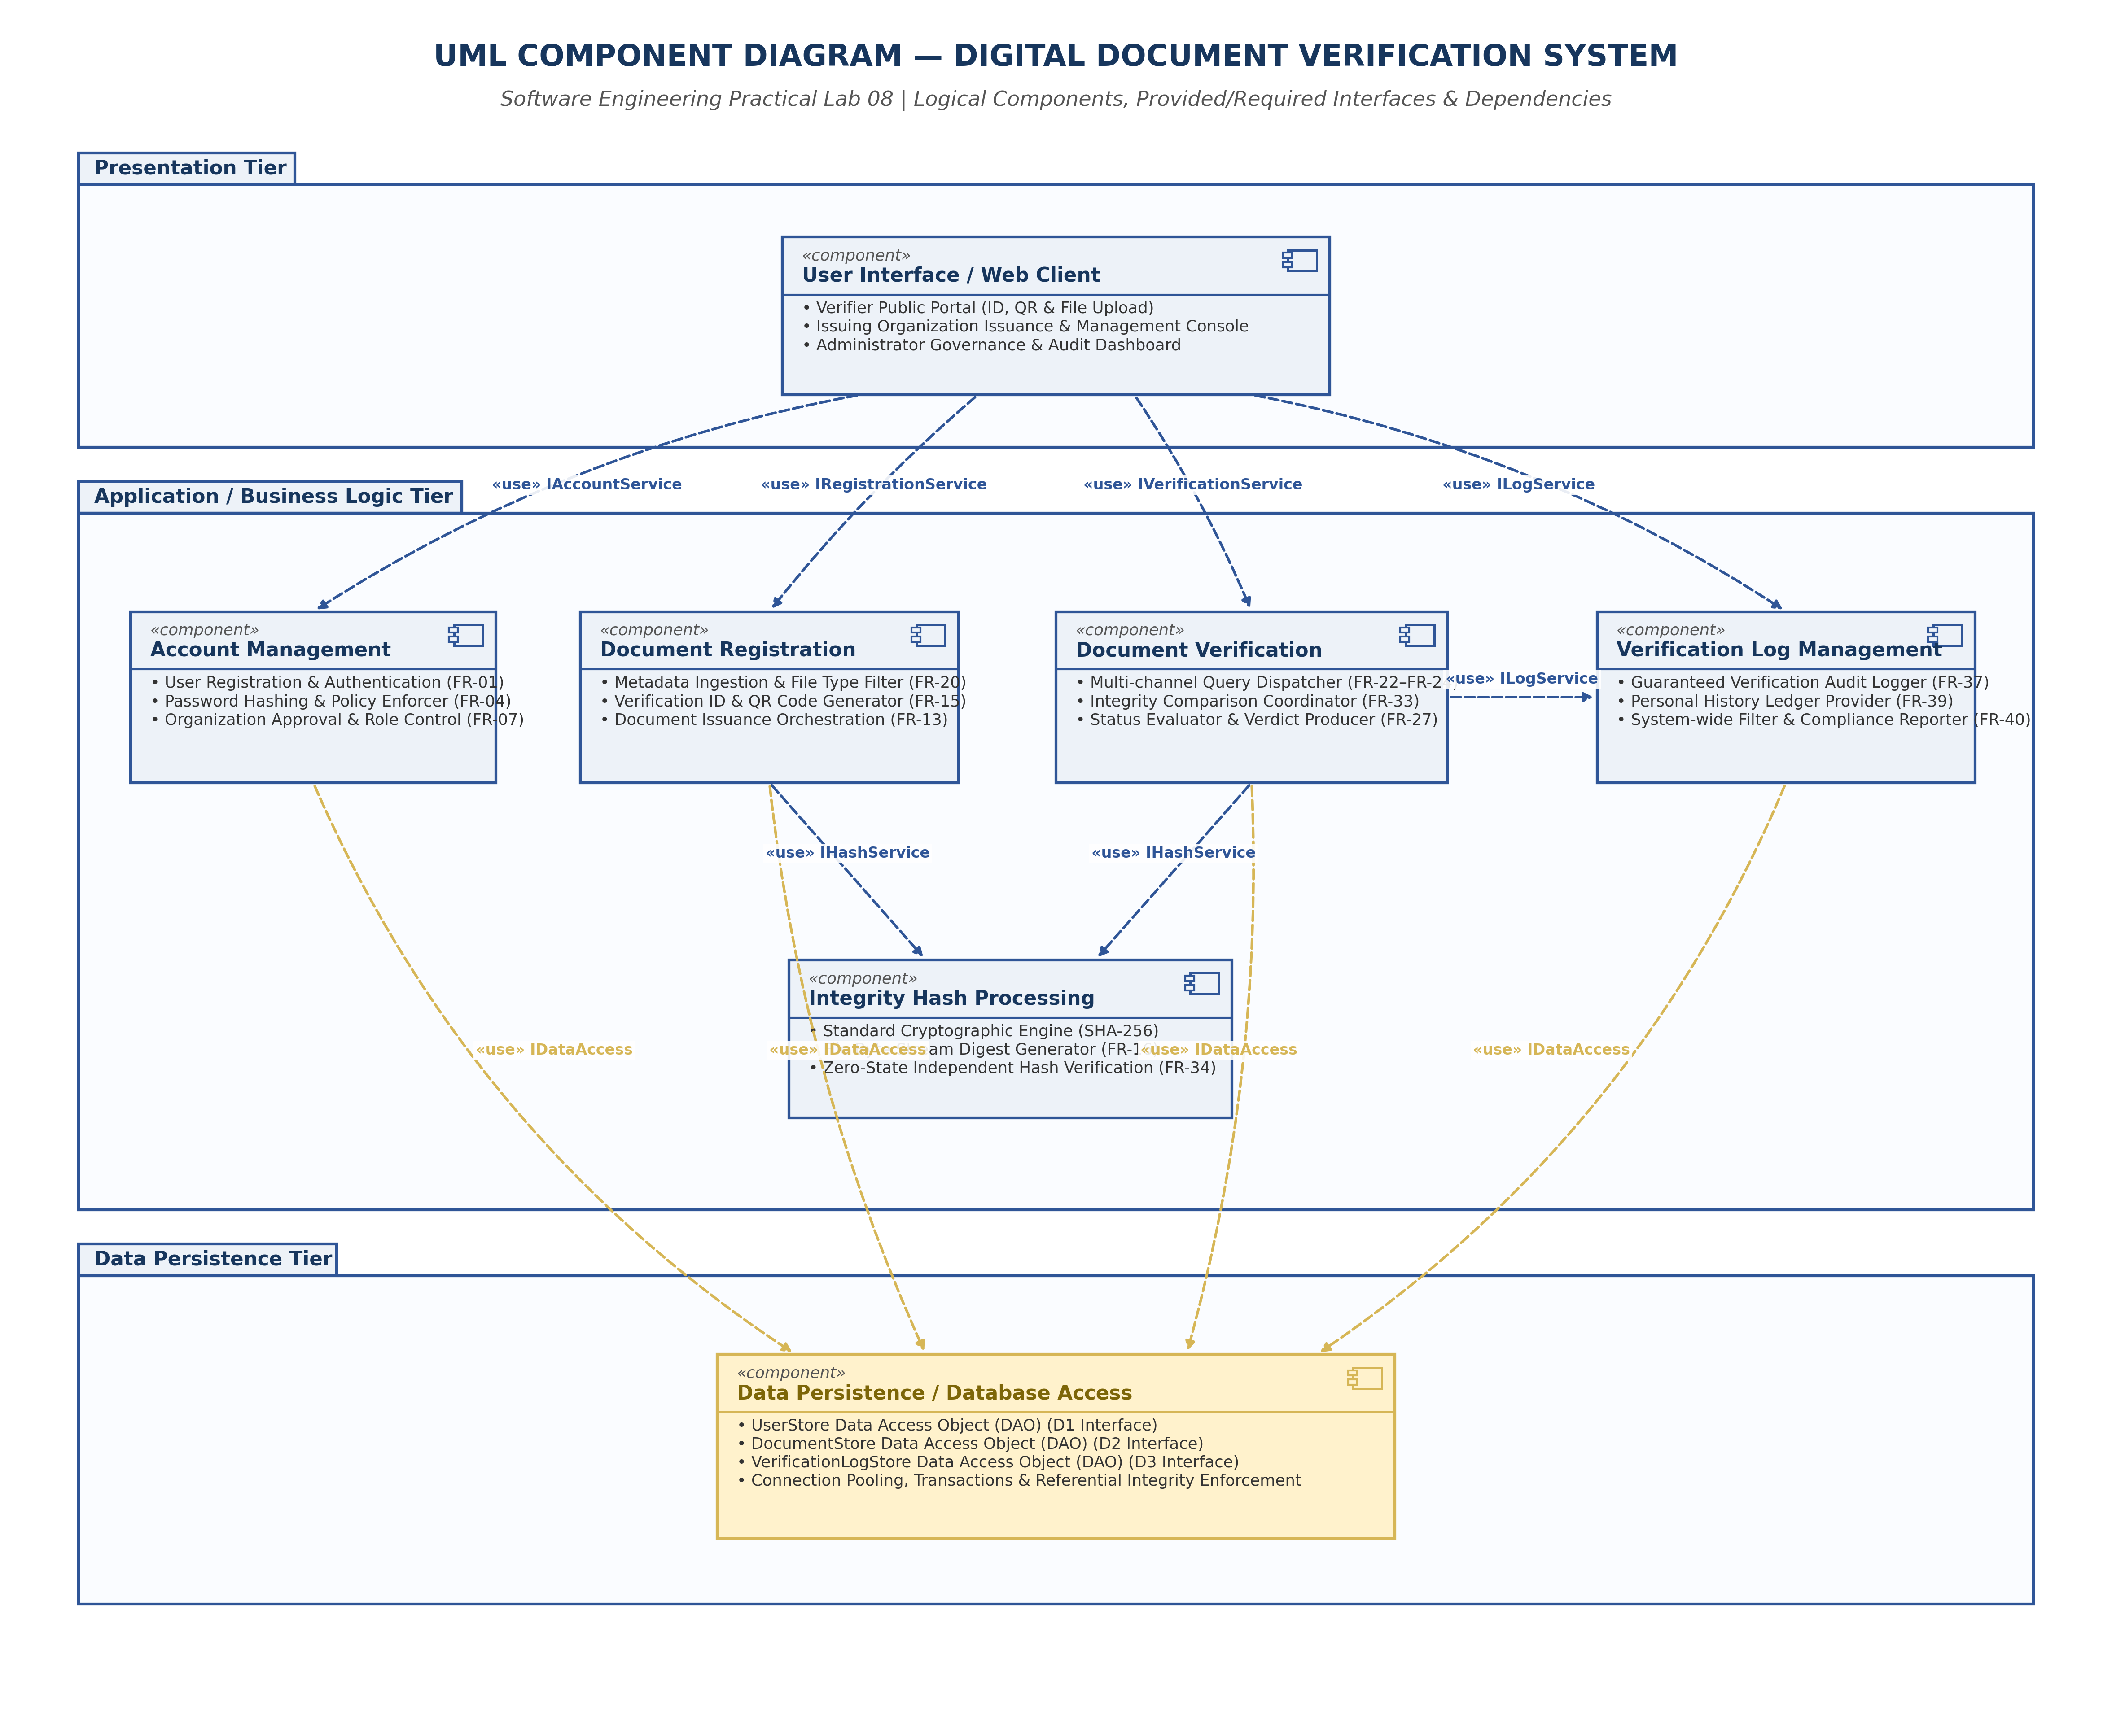
Figure 8.1: UML Component Diagram for DDVS Logical Architecture
6. Result and Conclusion
Result:
The modular logical architecture of DDVS was designed and represented using a UML Component Diagram across three standard tiers, defining seven discrete components and six formal interface contracts.
Conclusion:
The component diagram enforces the Dependency Inversion Principle (DIP). By mediating all persistence interactions through the IDataAccess interface and isolating cryptographic calculations into a stateless utility, the architecture achieves high modularity and maintainability.

