Digital Document Verification System (DDVS)
Software Engineering Practical Submission — Lab 09

Experiment Number: Lab 09 | Experiment Title: Software Design Analysis Report
Project Title: Digital Document Verification System (DDVS) | Team Size: 4 Members
Project Team Members: 1. Divya Kumari  2. Divyanshi Jaiswal  3. Divyanshi Khemani  4. Divyanshu Gupta | Course / Subject: B.Tech Computer Science & Engineering  Software Engineering Laboratory
Submission Target: Moodle Practical Submission | Source Baseline: IEEE SRS for DDVS v1.0 (August 2026)

1. Objective
To conduct an in-depth software design analysis of the Digital Document Verification System (DDVS), evaluating its three-tier architecture, modular decomposition, functional cohesion, loose coupling, non-functional quality attributes (maintainability, scalability, reliability, and security), and architectural constraints in accordance with established Software Engineering principles.
2. Architectural Overview and Three-Tier Structure
The DDVS design is structured around a classic Three-Tier Logical Architecture:
• Tier 1: Presentation Tier (Web Client): Encapsulates user interaction, form input capture, camera QR decoding, and dynamic feedback rendering. Maintains no direct database connectivity.
• Tier 2: Business Logic Tier (Application Server): Encapsulates user authentication, document issuance pipelines, SHA-256 cryptographic hash computation, and verification verdict evaluation. Communicates over HTTPS (TLS 1.3).
• Tier 3: Data Persistence Tier: Relational database housing User Store (D1), Document Store (D2), and Verification Log Store (D3), enforcing referential integrity and ACID semantics.
3. 3-Tier Logical Architecture Diagram

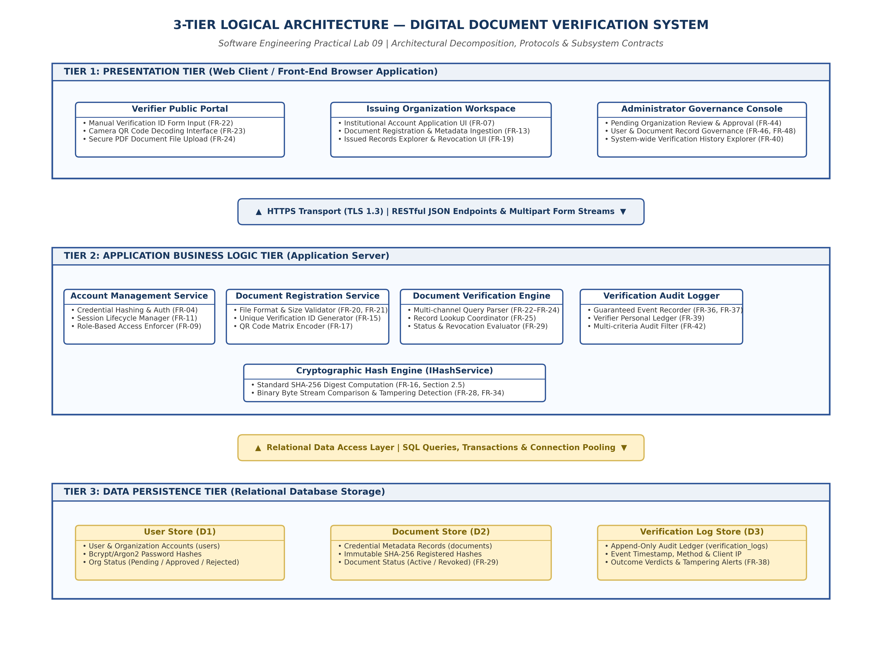
Figure 9.1: 3-Tier Logical Architecture for Digital Document Verification System
4. Evaluation of Software Engineering Principles
• Modularity: System responsibilities are divided across seven logical modules. Presentation changes do not affect backend services, and cryptographic changes do not affect database schemas.
• Cohesion: Modules exhibit high Functional Cohesion. Account Management deals strictly with credentials and identity; Integrity Hash Processing is a pure mathematical calculation engine with zero side effects.
• Coupling: Content and Common coupling are entirely eliminated (no shared mutable memory). Subsystems communicate strictly via Data and Stamp Coupling through defined interfaces (IDataAccess, IHashService).
• Maintainability: Separation of concerns allows independent refactoring, automated testing, and algorithm replacement.
• Scalability: Application Server is stateless, enabling horizontal scaling behind a load balancer. Relational indexing on documentId supports high read throughput.
• Reliability & Security: Deterministic verification outcomes, guaranteed audit logging, bcrypt password hashing, and role-based access control.
5. Design Limitations and Engineering Roadmap
Design Limitation | Architectural Root Cause | Proposed Engineering Roadmap
Centralized Database Trust | Relational DB is single point of trust; root DB admins could alter records. | Anchor document hashes into a consortium Blockchain/Distributed Ledger.
Binary File Upload Overhead | Storing large files (up to 10 MB; FR-21) in DB causes severe I/O bottlenecks. | Offload files to cloud Object Storage (S3/GCS); store only URI references in DB.
No Printed Paper OCR | Cryptographic hash works only on original digital byte streams. | Integrate Optical Character Recognition (OCR) pipeline for printed documents.

6. Result and Conclusion
Result:
A comprehensive design analysis of DDVS was completed, evaluating the logical architecture, modular decomposition, cohesion, coupling, and software quality attributes.
Conclusion:
The analysis validates that the DDVS architectural design adheres to core Software Engineering quality benchmarks. Its three-tier separation, high functional cohesion, loose interface coupling, and multi-layered security establish a maintainable and scalable baseline.

