Digital Document Verification System (DDVS)
Software Engineering Practical Submission — Lab 10

Experiment Number: Lab 10 | Experiment Title: Software Metrics and Complexity Analysis
Project Title: Digital Document Verification System (DDVS) | Team Size: 4 Members
Project Team Members: 1. Divya Kumari  2. Divyanshi Jaiswal  3. Divyanshi Khemani  4. Divyanshu Gupta | Course / Subject: B.Tech Computer Science & Engineering  Software Engineering Laboratory
Submission Target: Moodle Practical Submission | Source Baseline: IEEE SRS for DDVS v1.0 (August 2026)

1. Objective
To quantitatively evaluate the architectural and algorithmic complexity of the Digital Document Verification System (DDVS) by constructing a formal Control Flow Graph (CFG), calculating McCabe's Cyclomatic Complexity, conducting an honest design-stage Lines of Code (LOC) analysis, and computing the Chidamber & Kemerer (CK) Object-Oriented Metrics Suite.
2. Relevant Theory
• Software Measurement: Quantifies software attributes to predict fault-proneness, test effort, and maintainability.
• Product Metrics: Quantifies artifact characteristics (e.g., Cyclomatic Complexity, LOC, CK metrics).
• McCabe Cyclomatic Complexity V(G): Measures linearly independent paths through a control flow graph:
Formula 1: V(G) = E - N + 2P (Edges - Nodes + 2 * Components)
Formula 2: V(G) = Pdec + 1 (Predicate Decision Nodes + 1)
• Chidamber & Kemerer (CK) Suite: WMC (Weighted Methods/Class), DIT (Depth of Inheritance Tree), NOC (Number of Children), CBO (Coupling Between Objects), RFC (Response for a Class), LCOM (Lack of Cohesion in Methods).
3. Control Flow Graph & Cyclomatic Complexity
The verification workflow was mapped to a formal Control Flow Graph G = (N, E):
• Total Nodes (N) = 14
• Total Edges (E) = 17
• Connected Components (P) = 1
• Predicate Nodes (Pdec) = 4 (Node 3: Record Found?, Node 6: File Uploaded?, Node 8: Hash Matches?, Node 11: Status Active?)
Calculation:
• Formula 1: V(G) = 17 - 14 + 2(1) = 5
• Formula 2: V(G) = 4 + 1 = 5
Basis Paths (Test Paths Required for 100% Coverage):
1. Path 1: 1 ──► 2 ──► 3 ──► 4 ──► 14 (Record Not Found)
2. Path 2: 1 ──► 2 ──► 3 ──► 5 ──► 6 ──► 7 ──► 8 ──► 9 ──► 14 (File Uploaded, Hash Mismatch / Tampered)
3. Path 3: 1 ──► 2 ──► 3 ──► 5 ──► 6 ──► 7 ──► 8 ──► 10 ──► 11 ──► 12 ──► 14 (File Uploaded, Hash Match, Revoked / Invalid)
4. Path 4: 1 ──► 2 ──► 3 ──► 5 ──► 6 ──► 7 ──► 8 ──► 10 ──► 11 ──► 13 ──► 14 (File Uploaded, Hash Match, Active / Verified)
5. Path 5: 1 ──► 2 ──► 3 ──► 5 ──► 6 ──► 10 ──► 11 ──► 13 ──► 14 (ID/QR Only, Hash Bypassed, Active / Verified)
Interpretation: V(G) = 5 falls in the low-complexity band (1–10), proving the verification algorithm is concise, robust, and highly testable.
4. Control Flow Graph Diagram

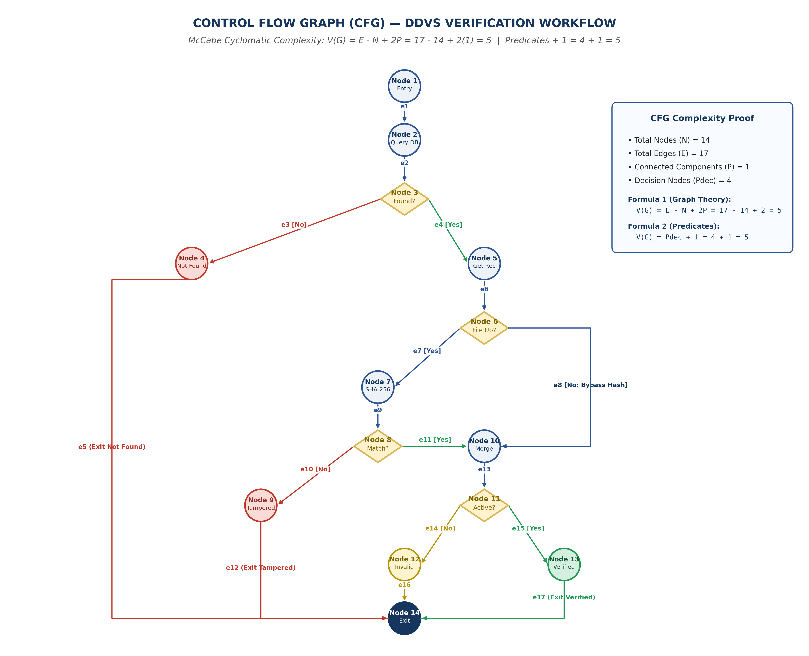
Figure 10.1: Control Flow Graph (CFG) for DDVS Verification Workflow
5. Honest LOC and Object-Oriented Metrics Analysis
Academic Integrity Note: Because DDVS is at the architectural design stage, physical source code has not yet been authored. Actual LOC cannot yet be measured directly. Below are Design-Stage Estimations alongside calculated CK metrics from Lab 03:
Class Name | WMC | DIT | NOC | CBO | Estimated SLOC
User | 5 | 0 | 2 | 2 | 100 – 150 SLOC
IssuingOrganization | 4 | 1 | 0 | 2 | 100 – 140 SLOC
Administrator | 5 | 1 | 0 | 2 | 100 – 150 SLOC
Document | 4 | 0 | 0 | 3 | 100 – 140 SLOC
VerificationRequest | 3 | 0 | 0 | 3 | 60 – 90 SLOC
VerificationLog | 3 | 0 | 0 | 3 | 60 – 90 SLOC
Core Domain Total | 24 | 1 (max) | 2 (max) | 2.5 (mean) | 520 – 760 SLOC (est.)

6. Result and Conclusion
Result:
McCabe's Cyclomatic Complexity was derived as V(G) = 5 with five basis paths. Design-stage LOC and CK metrics confirm shallow inheritance (DIT = 1), low coupling (mean CBO = 2.5), and focused class methods (WMC = 3 to 5).
Conclusion:
The complexity analysis demonstrates that DDVS possesses high structural quality, low algorithmic risk, and high testability. The architectural baseline provides a solid, maintainable foundation for subsequent physical implementation.

