DESIGN AND REALIZATION OF A VIRTUAL CIRCUIT NETWORK THROUGH FRAME RELAY TECHNOLOGY

A CAPSTONE PROJECT REPORT

Submitted in the partial fulfilment for the Course of

CSA 0764 - COMPUTER NETWORKS FOR A GAME SERVER

to the award of the degree of BACHELOR OF ENGINEERING IN
ELECTRONICS AND COMMUNICATIONS ENGINEEERING
COMPUTER SCIENCE AND ENGINEERING
ARTIFICIAL INTELLIGENCE AND DATA SCIENCE
Submitted by

V S AVINASH (192512017)
B SANTHOSH KUMAR (192511053)
DIVYALAKSHMI B (192524204)

Under the Supervision of
Dr SENTHIL K
Dr RAJARAM P


SIMATS ENGINEERING
Saveetha Institute of Medical and Technical Sciences Chennai-602105
December 2025



SIMATS ENGINEERING
Saveetha Institute of Medical and Technical Sciences Chennai-602105

DECLARATION

We, V.S.AVINASH , B.SANTHOSH KUMAR & DIVYALAKSHMI B of the department of ELECTRONICS AND COMMUNICATIONS ENGINEERING , COMPUTER SCIENCE AND ENGINEERING & ARTIFICIAL INTELLIGENCE AND DATA SCIENCE Saveetha Institute of Medical and Technical Sciences, Saveetha University, Chennai, hereby declare that the Capstone Project Work entitled ‘Design and Realization of a Virtual Circuit Network Through Frame Relay Technology’ is the result of our own bonafide efforts. To the best of our knowledge, the work presented herein is original, accurate, and has been carried out in accordance with principles of engineering ethics.

Place: Chennai
Date: 26.12.2025

Signature of the Students with Names



SIMATS ENGINEERING
Saveetha Institute of Medical and Technical Sciences Chennai-602105

BONAFIDE CERTIFICATE

This is to certify that the Capstone Project entitled “Design and Realization of a Virtual Circuit Network Through Frame Relay Technology” has been carried out by V.S.AVINASH , B. SANTHOSH KUMAR & DIVYALAKSHMI B under the supervision of Dr SENTHIL K & Dr RAJARAM P and is submitted in partial fulfilment of the requirements for the current semester of the B.E ELECTRONCS AND COMMUNICTIONS ENGINEERING , COMPUTER SCIENCE AND ENGINEERING & ARTIFICIAL INTELLIGENCE AND DATA SCIENCE program at Saveetha Institute of Medical and Technical Sciences, Chennai.

SIGNATURE SIGNATURE
Dr MAGESH KUMAR S Dr SENTHIL K & Dr RAJARAM P
Program Director Professor
Department of CS-DS Department of CSE
Saveetha School of Engineering Saveetha School of Engineering
SIMATS SIMATS

Submitted for the Project work Viva-Voce held on 26.12.2025
.

INTERNAL EXAMINER EXTERNAL EXAMINER

ACKNOWLEDGEMENT

We would like to express our heartfelt gratitude to all those who supported and guided us throughout the successful completion of our Capstone Project. We are deeply thankful to our respected Founder and Chancellor, Dr. N.M. Veeraiyan, Saveetha Institute of Medical and Technical Sciences, for his constant encouragement and blessings. We also express our sincere thanks to our Pro-Chancellor, Dr. Deepak Nallaswamy Veeraiyan, and our Vice-Chancellor, Dr. Ashwani Kumar, for their visionary leadership and moral support during the course of this project.

We are truly grateful to our Director, Dr. Ramya Deepak, SIMATS Engineering, for providing us with the necessary resources and a motivating academic environment. Our special thanks to our Principal, Dr. B. Ramesh for granting us access to the institute’s facilities and encouraging us throughout the process. We sincerely thank our Head of the Department, Dr. S. Magesh Kumar for his continuous support, valuable guidance, and constant motivation.

We are especially indebted to our guide, Dr. SENTHIL K for his creative suggestions, consistent feedback, and unwavering support during each stage of the project. We also express our gratitude to the Project Coordinators, Review Panel Members (Internal and External), and the entire faculty team for their constructive feedback and valuable inputs that helped improve the quality of our work. Finally, we thank all faculty members, lab technicians, our parents, and friends for their continuous encouragement and support.

Signature With Student Name

ABSTRACT

Virtual circuit networks play an important role in wide area communication by establishing logical paths before actual data transmission takes place. Frame Relay is a packet-switched wide area network technology that operates based on this virtual circuit concept, using Permanent Virtual Circuits (PVCs) to enable efficient and predictable data transfer. Although Frame Relay is considered a legacy technology, it remains significant in understanding the fundamental principles behind modern virtual networking techniques.
The primary objective of this capstone project is to design and realize a virtual circuit network using Frame Relay technology in a simulated environment. The project involves the creation of a network topology consisting of three routers, three personal computers, and a Frame Relay cloud using Cisco Packet Tracer. Logical connections between routers are established through DLCI mappings without direct physical router-to-router links. Proper IP addressing, gateway configuration, and routing mechanisms are implemented to ensure seamless communication between end devices.
The successful implementation of the network demonstrates effective data transfer between PCs through the Frame Relay cloud. Connectivity is verified using network diagnostic tools such as ping, confirming the reliability of the configured virtual circuits. This project enhances understanding of WAN technologies, virtual circuit concepts, and practical network configuration, serving as a strong foundation for advanced networking studies and real-world applications.

TABLE OF CONTENTS

S.NO | TITLE | PAGE NO
1 | CHAPTER 1: INTRODUCTION
1.1 | Background Information: | 8
1.2 | Project Objectives | 8
1.3 | Significance of the project | 9
1.4 | Scope of the project | 9
1.5 | Methodology Overview | 9
2 | CHAPTER:2 PROBLEM IDENTIFICATION AND  ANALYSIS
2.1 | Description of the Problem | 10
2.2 | Evidence of the Problem | 10
2.3 | Stakeholders | 11
2.4 | Supporting Data and Research | 11
2.5 | Problem Analysis Summary | 12
3 | CHAPTER:3 SOLUTION DESIGN AND IMPLEMENTATION
3.1 | Development and Design Process | 13
3.2 | Tools and Technologies Used | 13
3.3 | Solution Overview | 14
3.4 | Engineering Standards Applied | 15
3.5 | Solution Justification | 15
4 | CHAPTER:4 RESULTS AND RECOMMENDATIONS
4.1 | Evaluation of Results | 16
4.2 | Challenges Encountered | 17
4.3 | Possible Improvements | 18
4.4 | Recommendations | 18

5 | CHAPTER:5 REFLECTION ON LEARNING AND PERSONAL DEVELOPMENT
5.1 | Key Learning Outcomes | 19
5.2 | Challenges Encountered and Overcome | 20
5.3 | Application of Engineering Standards | 20
5.4 | Insights into the Industry | 20
5.5 | Conclusion of Personal Development | 21
6 | CHAPTER:6 CONCLUSION | 22
7 | REFERENCES | 23
8 | APPENDICES | 25

LIST OF FIGURES

SNO | TITLE | PAGE NO
1 | Figure 1: Frame Relay Virtual Circuit Network Topology | 15
2 | Figure 2: Frame Relay Cloud PVC and DLCI Configuration | 15
3 | Figure 3: Successful End-to-End Connectivity Test Using Ping | 17
4 | Figure 4.1: Frame Relay PVC Status on Router Interface-show frame-relay pvc | 18
5 | Figure 4.2: Frame Relay PVC Status on Router Interface-show ip interface | 19
6 | Figure A1: Frame Relay Virtual Circuit Network Topology | 25
7 | Figure A2: Frame Relay Cloud PVC Mapping | 26
8 | Figure A2.1: Frame Relay Cloud DLCI Mapping | 26
9 | Figure A3: Router Serial Interface and DLCI Configuration | 27
10 | Figure A4: PC IP Address and Default Gateway Configuration | 27
11 | Figure A5: End-to-End Connectivity Verification Using Ping | 28
12 | Figure A6: Frame Relay PVC Status on Router Interface | 28

CHAPTER 1
INTRODUCTION

1.1 Background Information
In modern communication systems, computer networks play a critical role in enabling data exchange across geographically distributed locations. As network usage increased, the need for efficient and reliable wide area network (WAN) technologies became essential. Virtual circuit–based networks emerged as a solution to provide organized and predictable data transmission by establishing a logical path before actual communication begins.
Frame Relay is a packet-switched WAN technology that operates on the concept of virtual circuits. It uses Permanent Virtual Circuits (PVCs) to create logical connections between network devices without requiring dedicated physical links. Frame Relay minimizes transmission delays by eliminating extensive error-checking mechanisms at intermediate nodes and relying on higher-layer protocols for reliability. Although it is considered a legacy technology today, Frame Relay remains an important topic for academic study as it clearly demonstrates the working principles of virtual circuit networks, which form the foundation for modern technologies such as MPLS.
This project focuses on the design and realization of a virtual circuit network using Frame Relay technology in a simulated environment. The network is implemented using Cisco Packet Tracer and demonstrates communication between multiple end devices through routers connected via a Frame Relay cloud, without direct router-to-router physical connections.

1.2 Project Objectives
The primary objectives of this capstone project are:
- To understand the working principles of virtual circuit networks.
- To study Frame Relay technology and its role in WAN communication.
- To design a Frame Relay–based network topology using multiple routers and PCs.
- To configure Permanent Virtual Circuits (PVCs) using DLCI mappings.
- To establish successful end-to-end communication between PCs through logical connections.
- To analyze the performance and functionality of the implemented network using connectivity tests.

1.3 Significance of the Project
This project is significant from both academic and practical perspectives. It provides a clear understanding of virtual circuit concepts, which are essential for learning advanced networking technologies. By implementing Frame Relay in a simulated environment, the project bridges the gap between theoretical knowledge and practical network design.
The project also enhances understanding of WAN technologies, routing concepts, and logical network connections. These concepts are fundamental for students pursuing careers in networking, telecommunications, and IT infrastructure management. Additionally, the project serves as a foundation for understanding modern virtual networking technologies used in enterprise networks.

1.4 Scope of the Project
The scope of this project is limited to the design, configuration, and simulation of a Frame Relay–based virtual circuit network using Cisco Packet Tracer. The project includes:
- Design of a network with three routers, three PCs, and a Frame Relay cloud.
- Configuration of IP addressing, gateways, and routing mechanisms.
- Logical interconnection of routers using Permanent Virtual Circuits.
- Verification of data transfer between end devices.
The project does not include real-time hardware implementation, advanced traffic management techniques, or security configurations such as encryption and firewall policies.

1.5 Methodology Overview
The methodology adopted for this project involves the following steps:
- Studying the theoretical concepts of virtual circuits and Frame Relay technology.
- Designing a suitable network topology based on project requirements.
- Configuring routers, PCs, and the Frame Relay cloud in Cisco Packet Tracer.
- Assigning IP addresses, gateways, and DLCI mappings.
- Implementing routing to enable communication between different networks.
- Testing and verifying connectivity using diagnostic tools such as ping.
- Analyzing the results to ensure successful realization of the virtual circuit network.
CHAPTER 2
PROBLEM IDENTIFICATION AND ANALYSIS

2.1 Description of the Problem
Wide Area Networks (WANs) are designed to facilitate communication between devices located at different geographical locations. Traditional WAN implementations often rely on dedicated point-to-point links between routers. While this approach ensures reliable communication, it significantly increases infrastructure cost, complexity, and maintenance effort, especially as the number of network nodes increases.
The major problem addressed in this project is the need for an efficient communication mechanism that enables multiple routers to communicate without direct physical connections between them. Establishing such connectivity using shared infrastructure while maintaining reliability and logical separation of data traffic presents a key networking challenge.
Frame Relay technology provides a solution by enabling virtual circuit–based communication. However, improper configuration of virtual circuits, incorrect DLCI mapping, lack of routing information, or gateway misconfiguration can result in communication failure. This project identifies and analyzes these challenges by designing a Frame Relay virtual circuit network and resolving connectivity issues through proper configuration and testing.

2.2 Evidence of the Problem
In real-world enterprise environments, organizations often require scalable WAN solutions that minimize operational costs while supporting reliable communication between branch offices. Point-to-point leased lines are expensive and inefficient when multiple locations must be interconnected.
Studies on legacy WAN technologies show that shared network infrastructures with logical connectivity significantly reduce costs and improve scalability. Frame Relay addresses this requirement by allowing multiple Permanent Virtual Circuits to operate over a single physical interface. However, without correct configuration, issues such as packet loss, unreachable destinations, and routing failures commonly occur.
During the initial stages of network simulation in this project, communication between PCs resulted in destination unreachable errors. These issues highlighted the importance of proper DLCI assignment, correct IP addressing, and accurate routing configuration. Resolving these issues provided practical evidence of the challenges associated with virtual circuit network implementation.

2.3 Stakeholders
The stakeholders affected by the problem addressed in this project include:
- Network Administrators: Responsible for designing, configuring, and maintaining WAN infrastructures using virtual circuit technologies.
- Organizations and Enterprises: Require cost-effective and scalable communication solutions between geographically distributed offices.
- Internet Service Providers (ISPs): Utilize virtual circuit–based technologies to deliver WAN services efficiently.
- Academic Institutions and Students: Use Frame Relay networks as educational tools to understand fundamental WAN concepts and virtual circuit operation.
Each stakeholder benefits from a clear understanding of virtual circuit design, logical connectivity, and WAN optimization strategies.

2.4 Supporting Data and Research
Research on WAN communication highlights the effectiveness of virtual circuit–based technologies in reducing bandwidth wastage and infrastructure cost. Frame Relay has historically been adopted by enterprises due to its ability to support multiple logical connections over a single physical interface.
Academic literature emphasizes that proper configuration of DLCIs, routing protocols, and gateway settings is critical for successful Frame Relay implementation. Simulation-based studies further demonstrate that logical connectivity must be supported by accurate routing tables to ensure end-to-end communication.
The results obtained from this project align with these findings. Connectivity tests confirmed that communication between PCs was successful only after correct configuration of Permanent Virtual Circuits and routing paths. This validates the theoretical concepts of virtual circuits and reinforces their practical significance in WAN design.

2.5 Problem Analysis Summary
The analysis clearly shows that the core challenge lies not in physical connectivity but in logical network configuration. Frame Relay virtual circuits provide an efficient solution for WAN communication; however, their success depends heavily on correct planning, configuration, and verification.
This project demonstrates that issues such as unreachable destinations and routing failures can be resolved by applying proper networking principles. The insights gained from this analysis form the foundation for the solution design and implementation discussed in the next chapter.

CHAPTER 3
SOLUTION DESIGN AND IMPLEMENTATION

3.1 Development and Design Process
The solution for the identified problem was developed using a systematic network design approach. Initially, the requirements of the virtual circuit network were analyzed, focusing on enabling communication between multiple end devices without direct physical connections between routers. Based on these requirements, a suitable network topology was designed using Frame Relay technology.
The design process involved selecting appropriate devices, defining logical connections through Permanent Virtual Circuits, and planning IP addressing schemes. A simulated environment was chosen to implement and test the design, ensuring that the network behavior could be observed and analyzed without the need for physical hardware.

3.2 Tools and Technologies Used
The following tools and technologies were used for the implementation of the project:
- Cisco Packet Tracer: Used to simulate the network topology and configure devices.
- Frame Relay Technology: Implemented to establish virtual circuits between routers.
- Routers: Used to route data between different network segments.
- Personal Computers (PCs): Acted as end devices for data transmission and reception.
- IP Addressing and Routing: Used to ensure proper data forwarding across the network.
- Command Line Interface (CLI): Used for configuring routers and verifying network status.

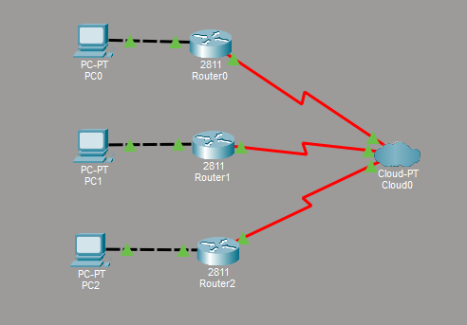
Figure 1: Frame Relay Virtual Circuit Network Topology

3.3 Solution Overview
The implemented solution consists of three routers connected logically through a Frame Relay cloud, with each router connected to a local PC. Instead of using direct physical links between routers, Permanent Virtual Circuits are established using Data Link Connection Identifiers (DLCIs).
Each router is assigned a serial interface connected to the Frame Relay cloud and a Fast Ethernet interface connected to a PC. IP addresses are assigned to all interfaces, and each PC is configured with a default gateway pointing to its respective router. Static routing is implemented to ensure that each router can reach the networks connected to other routers.
This configuration enables seamless communication between PCs through the Frame Relay network, demonstrating the effectiveness of virtual circuit–based communication.
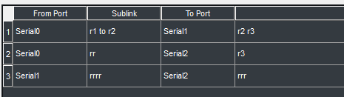
Figure 2: Frame Relay Cloud PVC and DLCI Configuration

3.4 Engineering Standards Applied
The project follows established engineering standards and best practices in network design and implementation, including:
- IEEE 802 Standards: Used as a reference for Ethernet-based local area network communication.
- ITU-T Frame Relay Standards: Followed for the implementation of Frame Relay virtual circuits and DLCI mappings.
- IP Networking Standards (RFCs): Applied for IP addressing and routing configuration.
- Cisco Networking Guidelines: Followed for device configuration and simulation practices.
These standards ensure interoperability, reliability, and structured implementation of the network.

3.5 Solution Justification
The application of engineering standards plays a crucial role in the success of the project. Adhering to Frame Relay and IP networking standards ensures accurate logical connectivity and proper data flow across the network. The use of static routing provides simplicity and control over packet forwarding in the simulated environment.By eliminating direct physical router-to-router connections and relying on virtual circuits, the solution effectively addresses the problem of cost and complexity in WAN design. The successful data transfer between PCs validates the design choices and confirms the practicality of the implemented solution.

CHAPTER 4
RESULTS AND RECOMMENDATIONS

4.1 Evaluation of Results
The implemented Frame Relay virtual circuit network was tested to evaluate its effectiveness in addressing the identified problem. Connectivity tests were performed using the ping command between PCs connected to different routers. Successful packet transmission confirmed that data was correctly routed through the Frame Relay cloud using Permanent Virtual Circuits.
The results demonstrated that the logical connections established using DLCI mappings enabled reliable end-to-end communication without direct physical router-to-router links. Once proper IP addressing, routing configuration, and gateway settings were applied, destination unreachable errors were eliminated. This confirms that the designed network met the project objectives and functioned as intended.
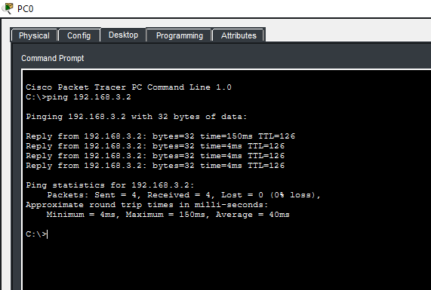
Figure 3: Successful End-to-End Connectivity Test Using Ping

4.2 Challenges Encountered
Several challenges were encountered during the implementation phase of the project. Initial configuration attempts resulted in connectivity failures due to incorrect DLCI assignments and missing routing information. Misconfiguration of default gateways on PCs also caused communication issues.
These challenges were resolved through systematic troubleshooting, including verification of interface status, Frame Relay PVC status, routing tables, and IP configurations. Diagnostic commands such as “show frame-relay pvc” and “show ip route” were used to identify and correct errors. Overcoming these challenges enhanced understanding of Frame Relay operation and network troubleshooting techniques.
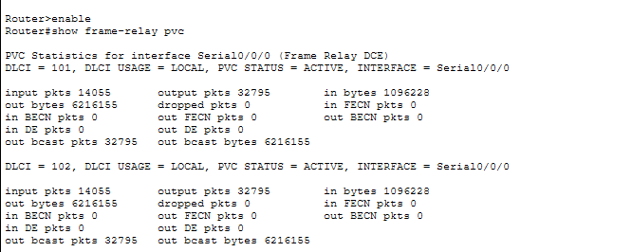
Figure 4.1: Frame Relay PVC Status on Router Interface-show frame-relay PVC

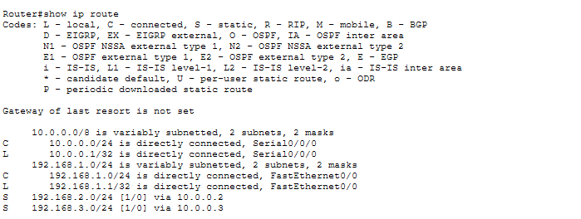
Figure 4.2: Frame Relay PVC Status on Router Interface-show ip interface

4.3 Possible Improvements
Although the implemented solution successfully demonstrates virtual circuit communication, there are areas for potential improvement. The current network uses static routing, which may not scale efficiently for larger networks. Implementing dynamic routing protocols such as RIP or OSPF could improve scalability and adaptability.
Additionally, performance metrics such as delay, throughput, and packet loss were not analyzed in detail. Future enhancements could include traffic analysis and Quality of Service (QoS) mechanisms to evaluate network performance under varying load conditions.

4.4 Recommendations
Based on the results obtained, the following recommendations are proposed:
- Implement dynamic routing protocols to enhance scalability and flexibility.
- Analyze network performance parameters for deeper evaluation.
- Extend the network topology to include additional routers and end devices.
- Compare Frame Relay performance with modern WAN technologies such as MPLS.
These recommendations provide opportunities for further research and development in virtual circuit–based networking.

CHAPTER 5
REFLECTION ON LEARNING AND PERSONAL DEVELOPMENT

This capstone project provided valuable academic, technical, and professional learning experiences. The process of designing and implementing a virtual circuit network using Frame Relay technology enhanced both theoretical understanding and practical skills, contributing significantly to overall personal and professional development.

5.1 Key Learning Outcomes

5.1.1 Academic Knowledge
Through this project, core networking concepts such as virtual circuits, wide area networks, and packet-switched communication were applied in a practical context. Studying Frame Relay technology deepened understanding of legacy WAN protocols and their relevance to modern networking concepts like MPLS. The project strengthened knowledge of IP addressing, routing, and logical network design principles.

5.1.2 Technical Skills
The project helped develop strong technical skills related to network simulation and configuration. Practical experience was gained in using Cisco Packet Tracer, configuring routers through the command line interface, assigning DLCIs, and implementing routing mechanisms. Troubleshooting techniques were improved through the identification and resolution of connectivity issues, enhancing hands-on networking competence.

5.1.3 Problem-Solving and Critical Thinking
Several technical challenges were encountered during the implementation of the project, including routing failures and destination unreachable errors. These issues required analytical thinking and systematic troubleshooting. By verifying configurations step by step, logical reasoning and problem-solving skills were significantly enhanced.

5.2 Challenges Encountered and Overcome

5.2.1 Personal and Professional Growth
The complexity of the network configuration initially presented difficulties, leading to moments of uncertainty. However, overcoming these challenges improved confidence and resilience. The experience fostered patience, attention to detail, and the ability to learn from mistakes, which are essential qualities in professional engineering practice.

5.2.2 Collaboration and Communication
Regular interaction with the project supervisor provided guidance and constructive feedback, improving communication skills. Although the project was individually implemented, discussions with peers helped clarify concepts and troubleshoot issues. This experience emphasized the importance of clear communication and knowledge sharing in technical environments.

5.3 Application of Engineering Standards
Engineering standards and best practices were consistently applied throughout the project. Frame Relay and IP networking standards guided the configuration of virtual circuits and routing mechanisms. Following these standards ensured logical consistency, interoperability, and reliable network performance, reinforcing the importance of structured engineering approaches.

5.4 Insights into the Industry
The project offered insights into real-world networking practices, particularly in the design and management of WANs. Understanding how virtual circuits reduce infrastructure cost and complexity provided a realistic view of enterprise network design. The project also highlighted the importance of documentation, testing, and troubleshooting in professional networking environments.

5.5 Conclusion of Personal Development
Overall, this capstone project significantly contributed to personal and professional development. It strengthened technical expertise, improved problem-solving abilities, and enhanced understanding of industry-relevant networking concepts. The experience has prepared the student for future academic pursuits and professional roles in networking and communication technology.

CHAPTER 6
CONCLUSION

This capstone project successfully demonstrated the design and realization of a virtual circuit network using Frame Relay technology. The primary objective of enabling end-to-end communication between multiple PCs without direct physical router-to-router connections was achieved through the implementation of Permanent Virtual Circuits and appropriate routing mechanisms.
The project highlighted the effectiveness of Frame Relay as a virtual circuit–based WAN technology by establishing logical connectivity over a shared network infrastructure. Proper configuration of IP addressing, DLCI mappings, gateways, and routing ensured reliable data transfer across the network. Connectivity tests confirmed the successful operation of the designed network, validating both theoretical concepts and practical implementation.
Although Frame Relay is considered a legacy technology, the concepts explored in this project remain relevant for understanding modern networking solutions. The project provided valuable insights into WAN design, logical network configuration, and troubleshooting techniques. Overall, the successful implementation and analysis of the virtual circuit network demonstrate the significance of structured network design and the continued relevance of virtual circuit principles in communication engineering
REFERENCES

- Xin, Y., Sasidharam, S., Wang, C. & Cevik, M., 2024. Taming Imbalance and Complexity in WAN Traffic Engineering. arXiv preprint arXiv:2412.17248. Available at: https://arxiv.org/abs/2412.17248.
- Xu, Z., Yan, F.Y., Singh, R., Chiu, J.T., Rush, A.M. & Yu, M., 2022. Teal: Learning-Accelerated Optimization of WAN Traffic Engineering. arXiv preprint. Available at: https://arxiv.org/abs/2210.13763.
- Rahman, S., Ahmed, T., Huynh, M., Tornatore, M. & Mukherjee, B., 2018. Auto-Scaling Network Resources using Machine Learning to Improve QoS and Reduce Cost. arXiv preprint. Available at: https://arxiv.org/abs/1808.02975.
- Troia, S., Sapienza, F., Vare, L. & Maier, G., 2021. On Deep Reinforcement Learning for Traffic Engineering in SD-WAN. IEEE Journal on Selected Areas in Communications (JSAC). Available at: https://doi.org/10.1109/JSAC.2020.3041385.
- Alsolami, F.A., Qureshi, H.K. & Khan, M.W., 2025. Analysis of SD-WAN Architectures and Techniques for Efficient Traffic Control under Transmission Constraints. Sensors, 25(20), p.6317. Available at: https://www.mdpi.com/1424-8220/25/20/6317.
- Routing and QoS Policy Optimization in SD-WAN, 2022. arXiv preprint. Available at: https://arxiv.org/abs/2209.12515 .
- Alharbi, A., Alenezi, M. & Khan, F., 2024. Reliable Path Prediction using Intelligent Reinforcement Learning in Software-Defined Networks. Journal of King Saud University – Computer and Information Sciences. Available at: https://doi.org/10.1016/j.jksuci.2024.102006
- Lu, J., Tang, C., Ma, W. and Xing, W., 2025. Graph-based reinforcement learning for software-defined networking traffic engineering. Journal of King Saud University – Computer and Information Sciences. Available at: https://doi.org/10.1007/s44443-025-00133-zSpringer Nature Link.
- Akharchaf, Y. and Gao, G., 2025. Enhancing traffic engineering with AI: Comparative analysis of MPLS, SD-WAN, and SRv6. International Journal of Research and Innovation in Social Science, 9(11), pp.331-349. Available at: https://doi.org/10.47772/IJRISS.2025.91100027.
- Pei, X., Sun, P., Hu, Y., Li, D., Chen, B. and Tian, L., 2024. Enabling efficient routing for traffic engineering in SDN with deep reinforcement learning. Computer Networks, 241, p.110220. Available at: https://doi.org/10.1016/j.comnet.2024.110220.
- Masood, M., et al., 2025. Enhanced optimisation of MPLS network traffic using a novel adjustable Bat algorithm with loudness optimizer. Results in Engineering, 20, p.104774. Available at: https://doi.org/10.1016/j.rineng.2025.104774.
- Silalahi, L.M., Amaada, V., Setiyo Budiyanto, I.U.V. Simanjuntak and Rochendi, A.D., 2024. Implementation of auto failover on SD-WAN technology with BGP routing method on Fortigate routers. International Journal of Electronics and Telecommunications, 70(1), pp.5-11. Available at: https://doi.org/10.24425/ijet.2024.149540.

Appendices

Appendix A: Network Topology Diagram

This appendix presents the complete network topology designed for the project “Design and Realization of a Virtual Circuit Network through Frame Relay Technology.” The topology consists of three routers, three personal computers, and a Frame Relay cloud. Each router is connected to a PC through a Fast Ethernet interface, while logical connectivity between routers is achieved using Permanent Virtual Circuits (PVCs).

The topology clearly demonstrates the absence of direct physical router-to-router connections and highlights the use of virtual circuits for WAN communication.

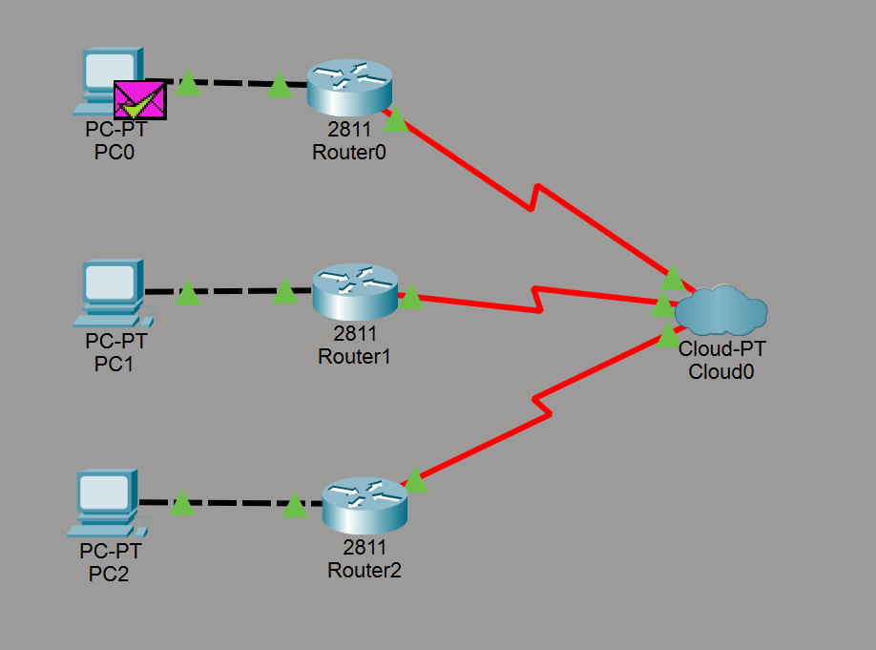
Figure A1: Frame Relay Virtual Circuit Network Topology

Appendix B: Frame Relay Cloud PVC Configuration

This appendix includes the configuration of the Frame Relay cloud used to establish Permanent Virtual Circuits between routers. The cloud is configured with appropriate Data Link Connection Identifiers (DLCIs) to enable logical connectivity between all routers.

Proper DLCI mapping ensures accurate data forwarding and successful communication across the virtual circuit network.

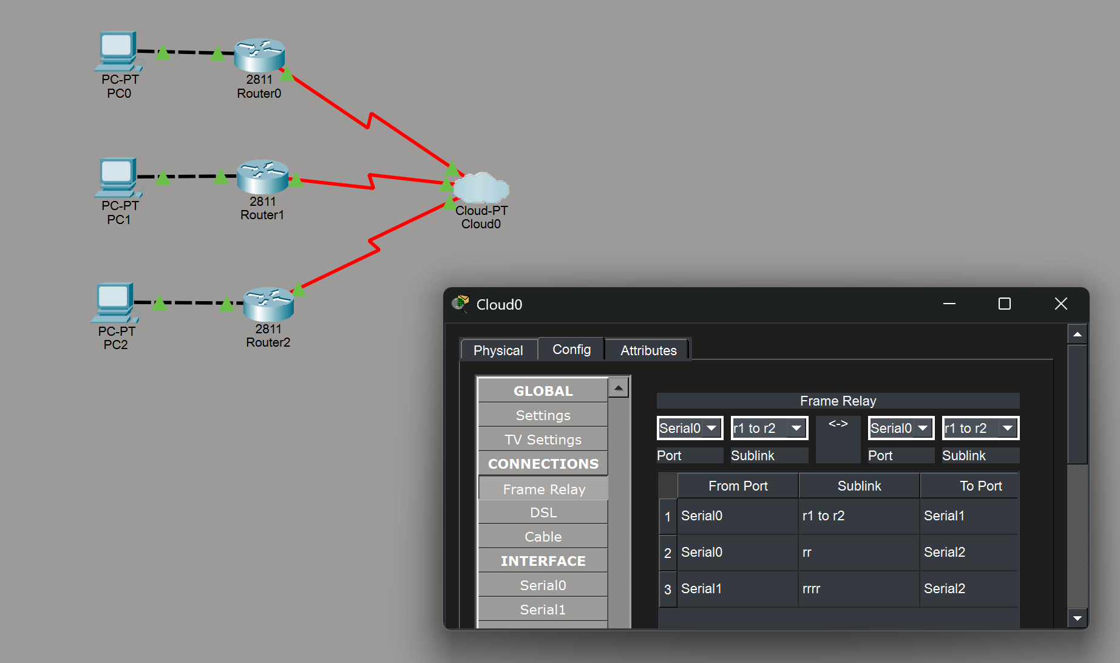
Figure A2: Frame Relay Cloud PVC Mapping

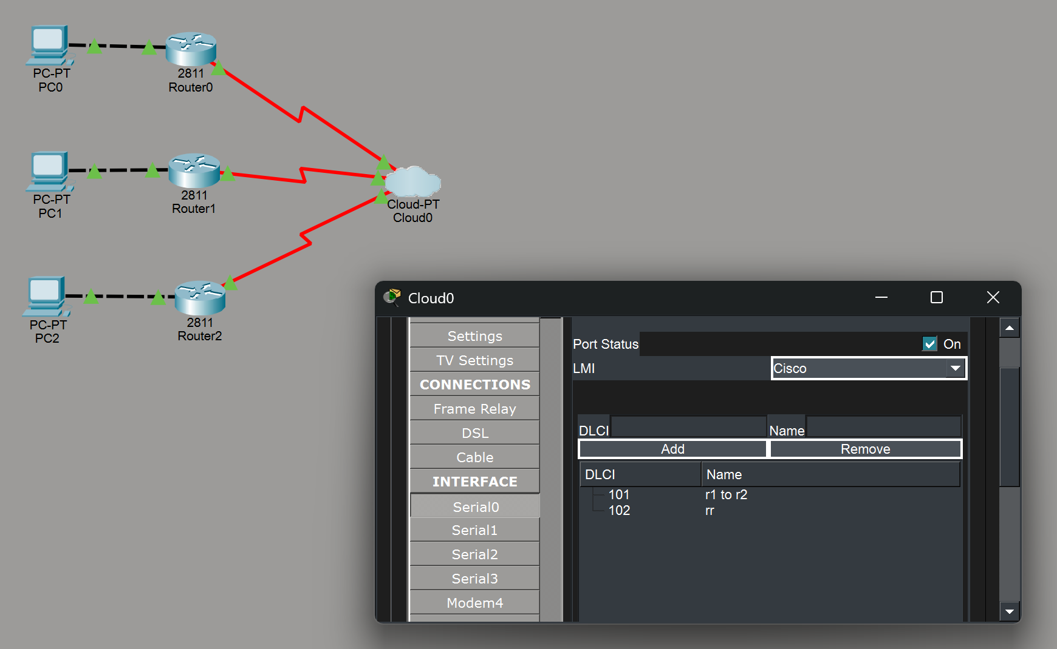
Figure A2.1: Frame Relay Cloud DLCI Mapping

Appendix C: Router Interface and DLCI Configuration

This appendix presents the router-side configuration required to connect to the Frame Relay cloud. Each router is configured with a serial interface, assigned an IP address, and mapped with the corresponding DLCIs. Static routing is also configured to allow inter-network communication.

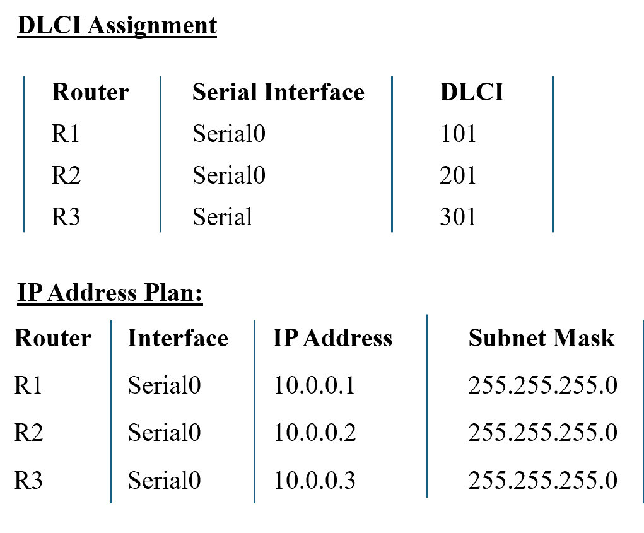
Figure A3: Router Serial Interface and DLCI Configuration

Appendix D: PC IP Address and Gateway Configuration

This appendix shows the configuration details of the PCs connected to each router. Each PC is assigned an IP address within its local network and configured with a default gateway pointing to the router interface.

Correct IP and gateway configuration is essential for end-to-end data transmission.

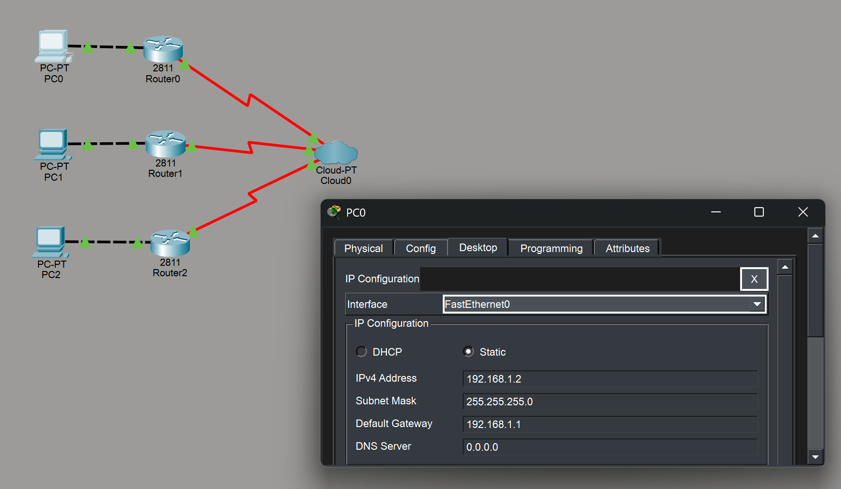
Figure A4: PC IP Address and Default Gateway Configuration

Appendix E: Connectivity Test Results

This appendix contains screenshots of connectivity testing performed to verify the successful operation of the virtual circuit network. Ping commands executed between PCs demonstrate reliable end-to-end communication through the Frame Relay cloud.

Successful ping replies confirm that the virtual circuits and routing configurations are functioning correctly.

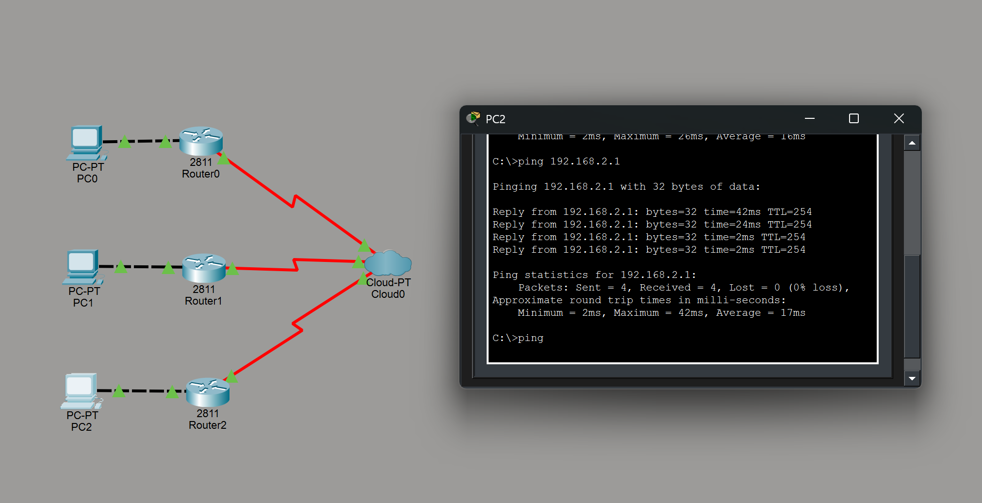
Figure A5: End-to-End Connectivity Verification Using Ping

Appendix F: Frame Relay PVC Status Verification

This appendix presents router CLI output showing the status of configured Permanent Virtual Circuits. The show frame-relay pvc command confirms that all PVCs are active and operational.

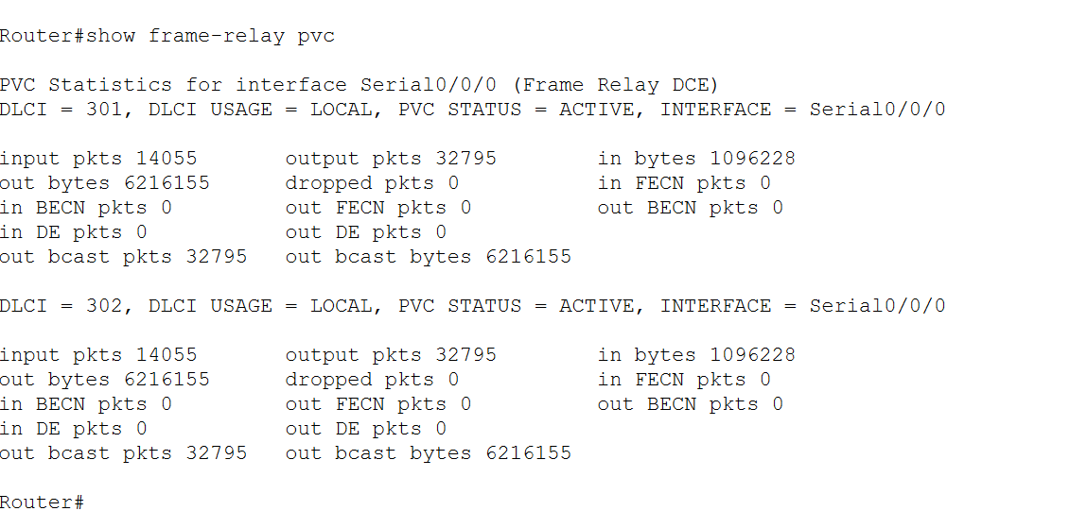
Figure A6: Frame Relay PVC Status on Router Interface

