|  |
| --- |
|  |
| Coursera Capstone IBM Applied Datascience |
| Restaurant Types in Toronto Compared to New York |
|  |
| **Divya Lakshmi Narasimhan** |
|  |

**INTRODUCTION**

Restaurant is one of the thriving businesses all over the world. Everyone needs to eat and eating in restaurants and updating in social media like Instagram, Facebook etc. became one of the most trending lifestyle nowadays. People started trying different cuisines according to their mood and likings. Dinning outside became favourite pass time for lot of bloggers and youtubers. As a result there are so many restaurants available in major city like New york and Toronto. Lot of people are migrating to different Countries nowadays because of work or any other reasons. The very first thing people check before migrating or travelling is for the availability of their cuisine or the restaurants that serve food restrictions.

**BUSINESS PROBLEM**

Here we are going to take two major cities New york USA, Toronto Canada where there is lot of immigrants and tourism place and we are going to compare the cuisines of their restaurants and check what are the cuisines that available in New York which is not available in Toronto. It even helps to answer the question for the cuisine which is missing in the particular city?

**TARGETED AUIDIENCE OF THIS PROJECT**

Target audiences for this project does not limit to the people who wants to immigrate or travel to Toronto but anyone who is interested to know about the diversity of food available in Toronto and New york and anyone who is looking to open a restaurant in either of Toronto or New york can use this project to find what type of cuisine is not available in the respective cities and what kind of new cuisine they can bring to the cities to attract more people.

**DATA**

To solve this we need the following data.

* The latitude and longitude of Toronto Canada
* The latitude and longitude of New york USA
* The restaurants available in both the cities
* The cuisine type of each restaurant in both the cities.
* Map for each city pointing the restaurants along with their cuisine type

**SOURCE OF METHODS AND DATA TO EXECUTE THEM**

We use Python Geocoder package to find the latitude and longitude for each city by passing the name and abbreviations in the input. We then use Nominatim to get the latitude and longitude of the respected cities.

We use Foursquare API to get the available restaurants in the particular location along with the category of their cuisine for each restaurant in both the cities. In the request we then pass the categoryId=4d4b7105d754a06374d81259 as one of the parameter to fetch the category column in the response. In this particular case this id represents the id of the food. So it fetches all the cuisines under the food category. We are searching with the key word of ‘restaurants’ in the query to get all the restaurants of the specific area.

We are using the Folium map to display the map for the respective restaurant in each city. We are using a blue marker to display all the restaurants on the specific city. On click of the city it will display the corresponding cuisine name. It can even be fast food or even Indian restaurant this name can be anything provided by the restaurant.

Then we are using a Data visualization tool called ‘Bar’ to display each cuisine and their respective number of restaurants in New york and Toronto. Using Data visualization tool is helpful for the user or the business to understand the output even better.

**METHODOLOGY AND EXPLORATORY OF DATA ANALYSIS**

At the first step we get the latitude and longitude of Toronto, ON. We got the geographical coordinate of Toronto are 43.6534817, -79.3839347.

Now we need to call the Foursquare API to get the restaurants that are available in the corresponding coordinate. For this we are creating the request object and use the get method passing the client id, client secret code, access token, version, and limit of records to be fetched, radius, and search query in our case it is restaurants. Then we are passing a special category id to tell the API that we need the category type in our response, if we are not passing the category id then we will not get the category of restaurant in our response. Foursquare API has different variety of category id listed in <https://developer.foursquare.com/docs/build-with-foursquare/categories/> for further information about the categories. We then get a json as a response with list of all the restaurants. We can use pythons json_normalize method to convert json into a dataframe.

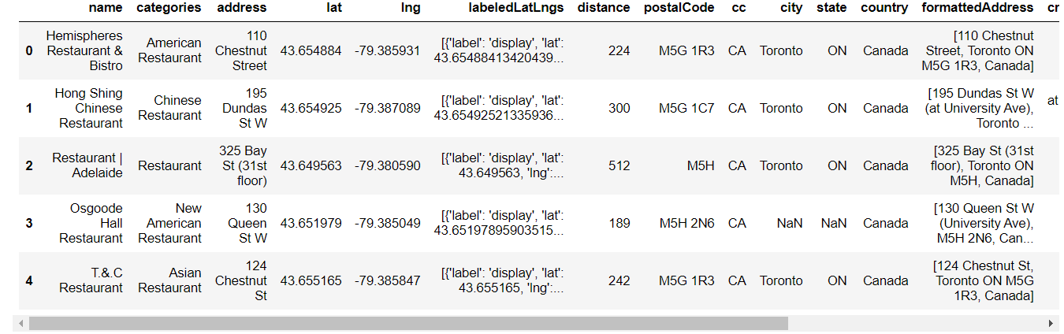

We then pass the dataframe into Folium map get all the values displayed into a map.

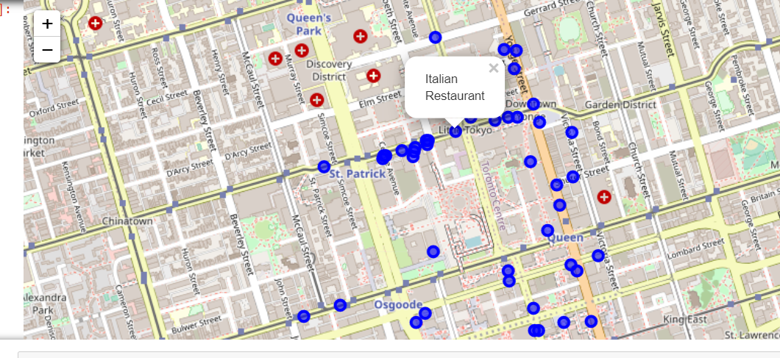

We then group by the total number of records according the cuisine to get the following data

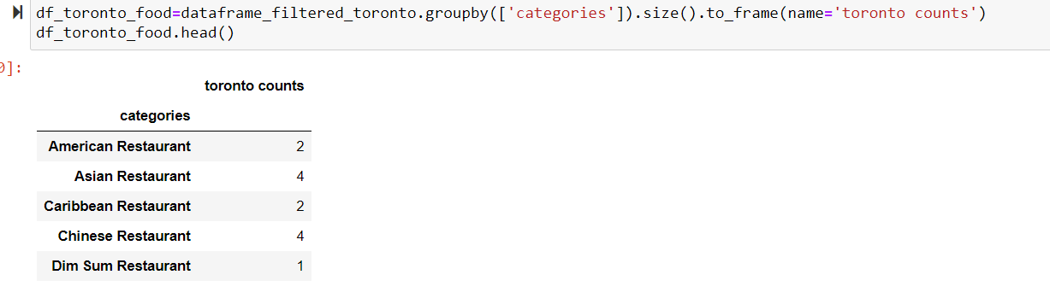

Once we get all the data for Toronto, now we need to find the information about New york. By Python geocoder we found the geographical coordinate of New york are 40.7127281, -74.0060152.

With this coordinates we called the Foursquare API to get the restaurants and their categories in New york.

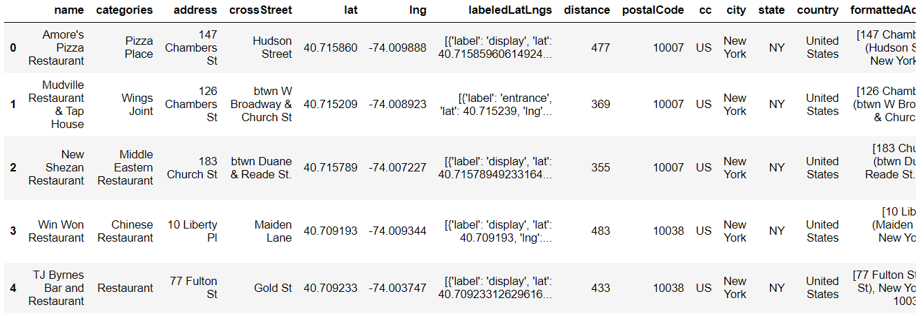

We then pass the record to Folium api to get the map of the new york restaurants.

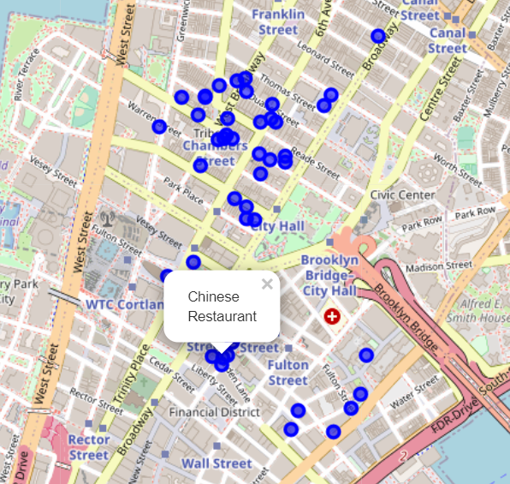

We then group by the restaurants according to their category to get the following table.

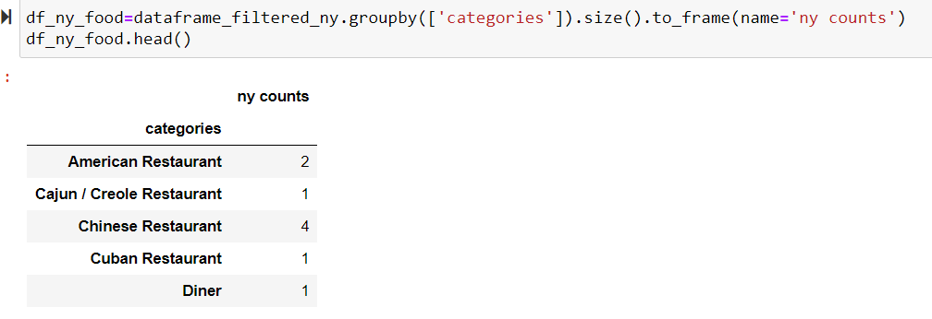

Now we have two dataframes for each city. We are using pandas concat of outer join to join both the dataframe to create a new dataframe.

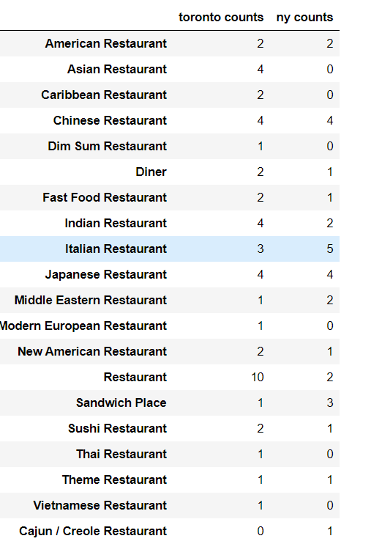

We now use a matplotlib pyplot to create a bar chart of the above dataframe for easy user understanding.

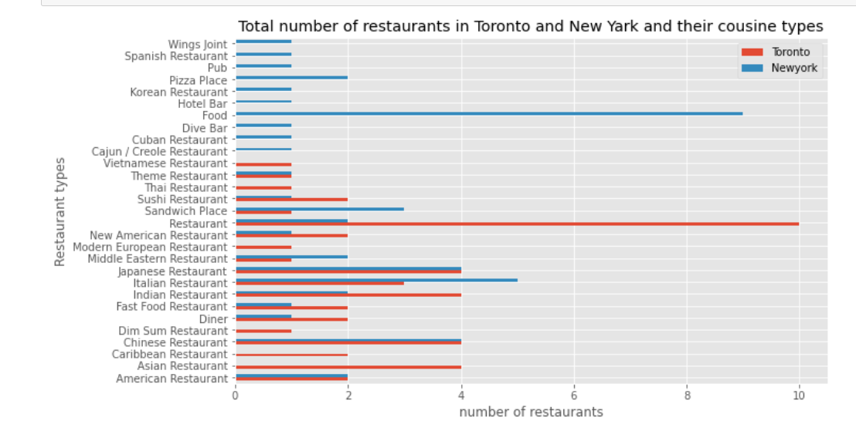

**Conclusion**

As you can see in the above diagram New york has way too many variety of cuisines and options than Toronto. If you want to open a restaurant in Toronto then there are so many types of cuisines are yet to occupy their taste buds. This not only will increase the profit of restaurant owners but also will attract lot of immigrants and tourist to visit Toronto. This project will also help the upcoming restaurant owners to choose the area of their restaurants to choose the place with less competition of their cuisine.