**Input 1**: I am going to buy a laptop suggest me a good laptop to buy under 40,000

['advice', 'budget', 'entertainment']

--------------------

[98.16282987594604, 86.39339804649353, 68.62016916275024]

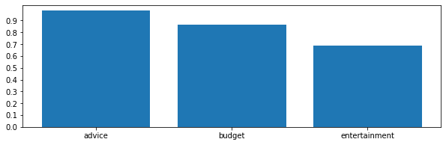

**Input 2**: I love to eat Biryani

['food', 'budget', 'Reminders']

--------------------

[99.51476454734802, 39.092159271240234, 18.563364446163177]

