**AGILE MODEL-TASK_3**

The Agile SDLC model is a combination of iterative and incremental [process models. This model focuses on process adaptability and customer satisfaction by rapid delivery of working software products. Agile methods break the process into smaller incremental builds. These builds are provided in iterations. Each iteration lasts from one week to four weeks. Each iteration involves cross functional teams working simultaneously on various areas like:

* Planning
* Requirement analysis
* Design
* Coding
* Unit Testing
* Acceptance Testing.

After completion of iteration the working product is shown to the customer and important stake holder.

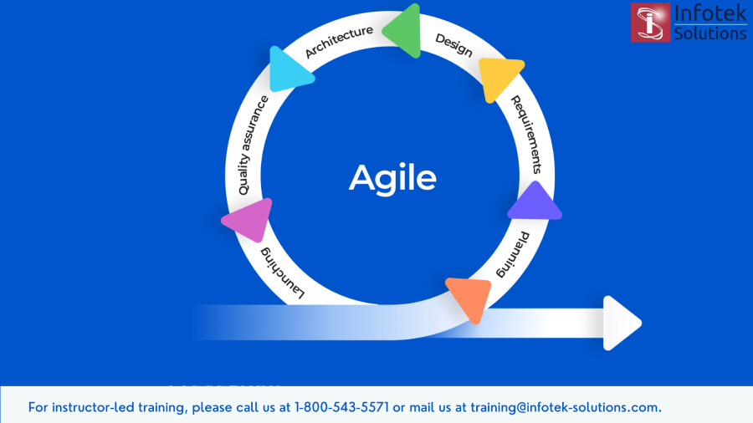

Agile is an adaptive software development method, whereas the other traditional methods like waterfall models use predictive approach. Agile uses an adaptive approach where there is no detailed planning and there is clarity on future tasks only in respect of what features need to be developed.

**Advantages:**

* It is a very realistic approach to software development.
* Promotes teamwork and cross training.
* Functionality can be developed rapidly and demonstrated.
* Resource requirements are minimum.
* Suitable for fixed or changing requirements
* Delivers early partial working solutions.
* Good model for environments that change steadily.
* Minimal rules, documentation easily employed.
* Enables concurrent development and delivery within an overall planned context.
* Little or no planning required.
* Easy to manage.
* Gives flexibility to developers.

**DISADVANTAGES:**

* Not suitable for handling complex dependencies.
* More risk of sustainability, maintainability and extensibility.
* An overall plan, an agile leader and agile PM practice is a must without which it will not work.
* Strict delivery management dictates the scope, functionality to be delivered, and adjustments to meet the deadlines.
* Depends heavily on customer interaction, so if the customer is not clear, the team can be driven in the wrong direction.
* There is a very high individual dependency, since there is minimum documentation generated.
* The transfer of technology to new team members may be quite challenging due to lack of documentation.

**AGILE TESTING METHODS:**

* SCRUM
* CRYSTAL
* DYNAMIC SOFTWARE DEVELOPMENT METHOD
* FEATURE DRIVEN DOCUMENT
* LEAN SOFTWARE DEVELOPMENT
* EXTREME PROGRAMING

**SCRUM:**

Scrum is an agile project management that helps teams' structure and manage their work through a set of values, principles and practices. People often think of scrum and agile as a similar thing but agile is an ideology and scrum is a framework. It acknowledges that the team doesn’t know everything at the start of a project and will evolve through experience. Scrum is structured to help teams naturally adapt to changing conditions and user requirements, with re-prioritization built into the process and short release cycles so your team can constantly learn and improve.

They are three roles in it, and their responsibilities are:

**SCRUM MASTER**: The scrum can set up the master team, arrange a meeting and remove the obstacles from the process.

**PRODUCT OWNER**: The product owner makes the product backlog, prioritizes the delay and is responsible for the distribution of functionality on each repetition.

**SCURM TEAM**: e team manages its work and organizes the work to complete the sprint or cycle.

**SPRINT**:

A sprint is the actual time when the scrum team works together to finish an increment. Two weeks is a typical sprint length, though some teams find a week to be easier to scope or a month to deliver a valuable increment. During this period, the scope can be re-negotiated between the product owner and the development team if necessary.

The duration of a sprint is determined by the scrum master., the team's facilitator and manager of the Scrum framework. Once the team reaches a consensus for how many days a sprint should last, all future sprints should be the same. Traditionally, a sprint lasts 30 days (about 4 and a half weeks).

At the end of the sprint, the team presents its completed work to the project owner and the project owner uses the criteria established at the sprint planning meeting to either accept or reject the work

Artifacts provide the information a scrum team needs to understand the product under development and completed and planned activities for the project. Artifacts include:

* backlog
* Burn down charts
* User stories

Ceremonies are meetings that are held every spring. Ceremonies include:

* Sprint planning meeting
* Daily scrum daily story meeting and Sprint review
* Sprint or Agile retrospective.

**CRYSTAL**:

The crystal method is an agile framework considered a lightweight or agile methodology focusing on individuals and their interactions. The methods are color-coded to significant risk to human life. It is mainly for short-term projects by a team of developers working out of a single workspace. Among a few Agile SDLC models' crystal is considered as one of the Agile SDLC models.

Two core beliefs of the Crystal method:

* Find your own way and methods to optimize workflow.
* Make use of unique methods to make the project unique and dynamic.

**KANBAN:**

Kanban is a popular Agile Software development methodology. It is basically a signaling device that instructs the moving of parts in a ‘pull’ production system, developed as part of the TPS (Toyota Production System). Kanban is about envisioning the existing workflow in terms of steps. These steps can be created on the whiteboard.

The main aim of Kanban is to reduce WIP (Work-In-Progress), or inventory, between processes by ensuring the upstream process creates parts if its downstream process needs it. The goal of the Kanban execution is to ensure work items move to the next steps quickly to realize business value faster.

The Kanban method is an approach to evolutionary and incremental systems and process change for organizations. A work-in-progress limited pull system is used as the central mechanism to uncover system operation (or process) complications and encourage collaboration to improve the system continuously.

**DYNAMIC SOFTWARE DEVELOPMENT METHOD:**

DSDM is an iterative code method within which every iteration follows the 80% rule that simply enough work is needed for every increment to facilitate movement to the following increment. The remaining details are often completed later once a lot of business necessities are noted or changes are requested and accommodated.

DSDM is a rapid application development strategy for software development and gives an agile project distribution structure. The essential features of DSDM are that users must be actively connected, and teams have been given the right to make decisions. The techniques used in DSDM are:

1. Time Boxing
2. Moscow Rules
3. Prototyping

**The DSDM project contains seven stages:**

1. Pre-project
2. Feasibility Study
3. Business Study
4. Functional Model Iteration
5. Design and build Iteration
6. Implementation
7. Post-project

**FEATURE DRIVEN DEVELOPMENT:**

This method focuses on "Designing and Building" features. In contrast to other smart methods, FDD describes the small steps of the work that should be obtained separately per function.

### **Lean Software Development:**

Lean software development methodology follows the principle "just in time production." The lean method indicates the increasing speed of software development and reducing costs. Lean development can be summarized in seven phases.

* Eliminating Waste
* Amplifying learning
* Defer commitment (deciding as late as possible)
* Early delivery
* Empowering the team
* Building Integrity
* Optimize the whole

**EXTREME PROGRAMMING:**

The type of model used when the customer is constantly changing the demands or requirements or when they are not sure about the system performance.