**TASK-5 STLC-SOFTWARE TESTING LIFE CYCLE**

Software test life cycle is a sequence of actions done in the testing process. The testing activities include both verification and validation processes.

They are majorly six phases in software testing lifecycle:

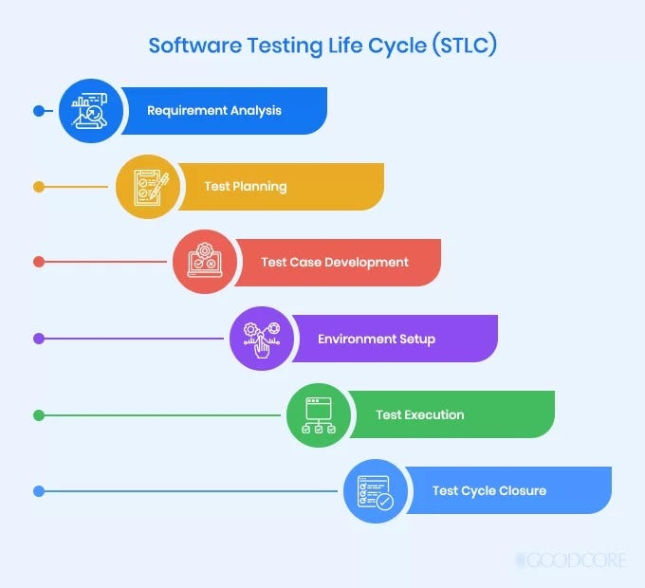

**1.Requirement analysis**: In requirement analysis the testers think about the requirements required in testing point of view.

Activities in requirement analysis phase are:

* Identify type of tests that need to be performed.
* Gather information about testing priorities and focus.
* Requirement traceable matrix- The main purpose of Requirement Traceability Matrix is to validate that all requirements are checked via test cases such that no functionality is unchecked during Software testing.
* Identify Test environment details where testing needs to be done.

**2.Test planning**: In this phase a senior quality analyst manager prepares a test strategy. This phase itself the test plan is finalized.

Test plan is a detailed document which describes software testing areas and activities. It outlines the

* test strategy,
* objectives,
* test schedule,
* required resources,
* test estimation
* test deliverables.

**Types of test plan:**

1. Master test plan: - Multiple levels of testing.
2. Phase test plan: - Designed for specific test
3. specific test plan: -Designed for major types of testing like load testing, Stress testing etc.

**Writing a test Plan:**

* analyze product structure and architecture.
* Now design the test strategy.
* Define all the test objectives.
* Define the testing area.
* Define all the useable resources.
* Schedule all activities appropriately.
* Determine all the Test Deliverables.

**Test plan attributes:**

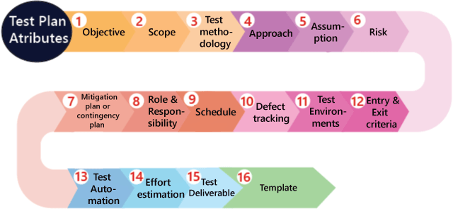

**RISK:**

These are the challenges we need to face to test the application in the current release, and if the assumptions fail, the risks are involved.

Example: the effect for an application, release date becomes postponed

**Types of Risks:**

* Customer perspective
* Resource approach
* Technical opinion

**Mitigation plan:**

The back up plan prepared to overcome risks is a mitigation plan.

3.**Testcase Development**: Test case development involves the creation, verification and rework of test cases.

**Testcase template:**

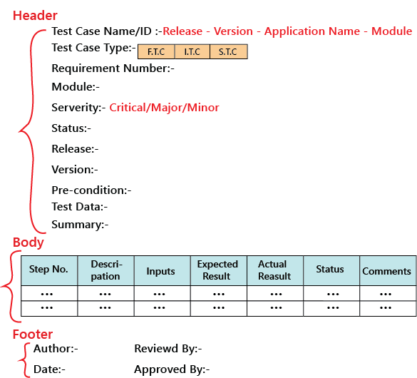

**4.Test Environment Setup**: In this step we decide in which software and hardware under which a work product is tested.

**5.Test Execution:** Test Execution Phase is carried out by the testers in which testing of the software build is done based on test plans and test cases prepared. The process consists of test script execution, test script maintenance and bug reporting.

**6.Test cycle closure:** Test cycle closure Phase is completion of test execution which involves several activities like test completion reporting collection of test completion matrices and test results. The test cycle closure report includes all the documentation related to

* software design,
* development,
* testing results,
* defect reports.

|  |  |  |
| --- | --- | --- |
| **ENTRY CRITERIA** | **STLC PHASES** | **EXIT CRITERIA** |
| 1. Requirement document (both functional and nonfunctional) 2. Application architecture document 3. Acceptance criteria defined | 1.Requirement analysis. | 1. RTM-Requirement traceable matrix 2. Auto machine feasibility report |
| 1. 1.Requiements document 2. 2.RTM 3. 3.Auto machine feasibility report | 2.Test planning. | 1. 1.Teast plan or strategy document 2. 2.Effort estimation document |
| 1. Requirements document 2. RTM and test plan 3. Auto machine analysis report | 3.Test case development. | 1. Reviewed and signed test cases/scripts 2. Reviewed and signed test data |
| 1.System design and architecture document  2.Envirnment setup plan | 4.Test Environment setup. | 1.Environment setup is working as per test plan and checklist.  2.Test data setup is complete  3.Smoke test is successful |
| 1.Baselined RTM, Test plan, Test case/Scrips are available.  2.Test environment set up is ready  3.Test data set is done  4.Unit/Integration test report for the built to be tested is available. | 5.Test Execution. | 1.All Tests planned are executed  2.Defects logged and tracked to closure. |
| 1.Testin has been completed  2.Test results are available  3.Defect logs are available | 6.Test cycle closure. | Test closure report signed by the client. |

**DIFFERENCE BETWEEN SDLC AND STLC:**

|  |  |
| --- | --- |
| **SDLC-SOFTWARE DEVELOPMENT LIFE CYCLE.** | **STLC –SOFTWARE TESTING LIFE CYCLE.** |
| 1.Requirements Gathering- In this phase all the users and stakeholders gather and document software requirements. | 1.Requirement analysis: In requirement analysis the testers think about the requirements required in testing point of view. |
| 2.Planning: In planning we plan about the entire scope of the project, what kind of output we need from the project | 2.Test planning: In this phase a senior quality analyst manager prepares a test strategy. This phase itself the test plan is finalized. |
| 3.Desigining: In the designing phase, the entire architecture of the project is designed which includes both low level and high-level designing. | 3.Test case Design: Test case development involves the creation, verification and rework of test cases. |
| 4.Developing: The development includes developing a standard code which can give the required output and review the code and make the required chances needed to make in code. | 4.Test environment setup: In this step we decide in which software and hardware under which a work product is tested. |
| 5.Testing: A minimum amount of testing is done in all steps of the cycle. Therefore, here all the errors or bugs need to be found out and fixed before deployment | 5.Test Execution: Test Execution Phase is carried out by the testers in which testing of the software build is done based on test plans and test cases prepared. The process consists of test script execution, test script maintenance and bug reporting. |
| 6.Deployment and Maintenace: After completion of testing and removing all the bugs, erasing all the errors and making sure no defect is present, the project is deployed to the customer. | 6.Test closure: Test cycle closure Phase is completion of test execution which involves several activities like test completion reporting, collection of test completion matrices and test results. |