**1. Create a procedure to insert data to a table by passing at least one column value as input argument**

CREATE OR REPLACE PROCEDURE insert_proc (val1 VARCHAR(20) , val2 VARCHAR(20))

RETURNS VARCHAR

LANGUAGE JAVASCRIPT

AS

$$

var stmt = snowflake.execute({

sqlText: "INSERT INTO cutomer VALUES('"+VAL1 +"','"+VAL2 +"') ;"

});

return 'SUCCESS';

$$;

**OUTPUT:**

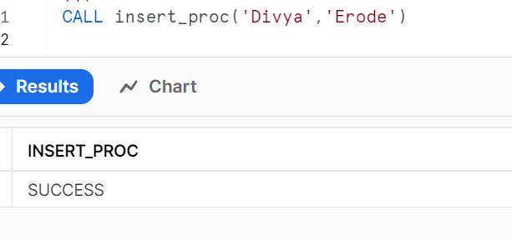

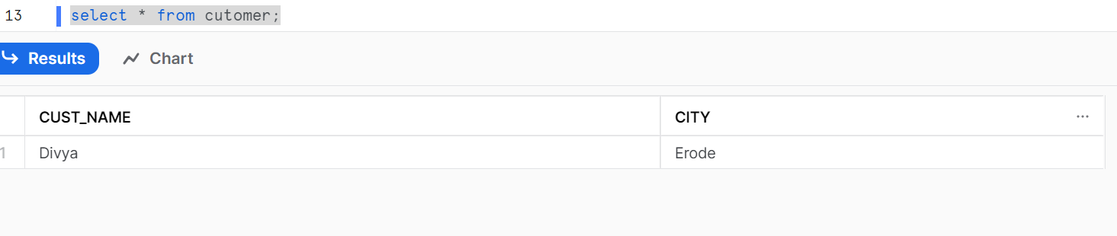

**2. Create a procedure to count the number of rows in a table and return row count**

CREATE OR REPLACE PROCEDURE count_proc()

RETURNS NUMBER

LANGUAGE SQL

AS

DECLARE

vale NUMBER;

BEGIN

SELECT COUNT(*) INTO vale FROM cutomer;

return vale;

END;

**OUTPUT:**

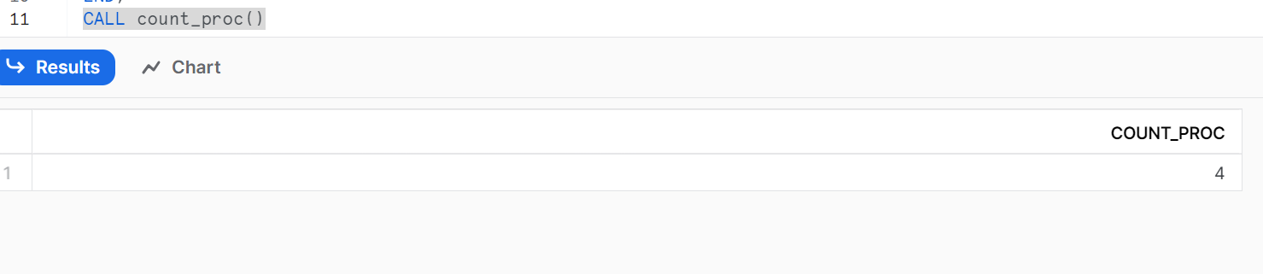

**3. Create a procedure to log errors to a table**

CREATE OR REPLACE PROCEDURE error_log_proc()

RETURNS VARCHAR

LANGUAGE JAVASCRIPT

AS

'

var output="";

try{

var stmt = snowflake.execute({

sqlText: "INSERT INTO customer VALUES(CURRENT_USER(),CURREN_TIMESTAMP()) ;" });

output = "Success";

}

catch (err) {

var err_code=err.code;

var err_state=err.state;

var err_message=err.message;

var stmt = snowflake.execute({

sqlText: "INSERT INTO error_log VALUES(''" + err_code + "'',''" + err_state + "'',''" + err_message + "'',current_timestamp());" });

output = "Failure";

}

return output;

';

**OUTPUT:  
