**Line Tracer**

Rules and Regulations

1. Bots made using ready-made kits will be disqualified

2. The bot must fit into a cube of 20 x 20 x 20 cm.

3. Teams of four.

4. Inter college teams are allowed.

5. It is the duty of the team members to stay updated with the changes made.

No personal intimation will be done.

6. In case of disputes, the decision of event in-charge will be final.

7. Organizers possess the right to change part of rules if necessary.

8. Decisions of the Competition In-charges are final and binding.

**Problem Statement / Task Details**

The competition is conducted as two levels. In the first level, the bot must

complete a line track in minimum time. The track consists of acute angles,

obtuse angles, right angles and smooth curves. The teams completing the 1st

round will qualify for the second round.

The second round is a ‘Trap the Rat’ track. This round consists of a line

following track with black and white stripes blocking the path, representing

rats and rat traps respectively. The bot must indicate the detection of the rat

and the trap by sounding a buzzer/LED. The objective of the bot is to count the

number of rats and rat traps and to indicate the number of free rats (no. of

rats - no. of traps) using a buzzer/LED.

Points will be awarded in the second round based on the following formula:

Points = (600-T) + (50*I) – 10*P

T - Total time taken to complete the track, in seconds.

I - Number of correct detection of rat and trap.

P - Number of times the bot goes off track.

**Additional 10 points will be awarded if the indication of final answer is

correct.

**If no team is able to finish the second round, winners will be decided

based on the number of checkpoints reached.

Teams unable to complete the first round will be eliminated.

Winners will be declared based on points achieved.

Arena Details

Round 1-

1. The track will be 3 cm wide.

2. The track consists of black line on white background with

checkpoints.

3. There will be acute angles, obtuse angles, right angles and smooth

curves.

Round 2:-

1. The track will be 3 cm wide.

2. The track consists of black line on white background.

3. The end of the track will be indicated by colour inversion, at end of

track the track will be white with a black background

4. There will be acute angles, obtuse angles, right angles and smooth

curves.

5. Rats and traps are as shown in the figure.

6. In case the bot goes off track, it can be reset next to the last rat or

trap.

Image of a Rat:

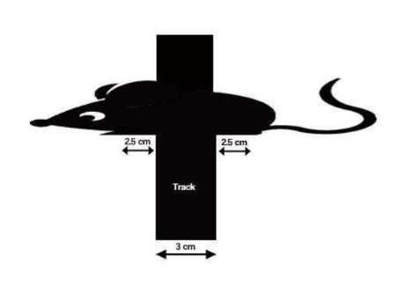

Image of a Trap:

