TripME — Screen Reference & Wireframes
Release 0.1.1 · MVP
Team DEBUGGERS · Captured from the live product, not mocked up

Method — why these are screenshots, not drawings
A wireframe is normally a proposal: this is what we intend to build. TripME is already built and deployed, so a drawing of it would be a less accurate artefact than the thing itself — and it would carry the risk that the drawing and the product disagree. Every image in this document was therefore captured from the running application.
Capture parameter | Value
Source | https://tripme-khaki.vercel.app — the live deployment, not a local build
Captured | 6 August 2026
Desktop viewport | 1440 × 900 CSS pixels, captured at device resolution
Mobile viewport | 390 × 844 CSS pixels — the narrowest mainstream phone
Account | The built-in test-user path, so every gated screen is reachable by a reviewer
Data | Two of the four zero-quota sample plans, plus one genuinely live plan generated during capture

One capture was deliberately live. Screens 12 to 14 were produced by running a real brief — solo, relax, ₹25,000, three days, departing from Pune — through the actual seven-agent pipeline during this capture session. Nothing in them is staged, which is why the Referee's intervention in screen 13 is a real event rather than an illustration.

How to read each screen
Every screen below has a purpose line — the job that screen does — and a what to look at list pointing at the specific detail that matters for evaluation. Several of those details exist because something went wrong first; where that is the case it is said plainly, because a design decision with a cause is stronger evidence than one without.

1 · Landing — the mood-first proposition
The first screen has one job: make it obvious that TripME does not need you to know where you are going. Every competitor opens with a destination field; this one opens with a feeling and a budget.
What to look at
- The seven-agent pipeline is shown as a strip along the bottom — the architecture is a selling point, not an implementation detail hidden from the user.
- Two entry points, deliberately unequal: Start planning for intent, See a sample trip for the much larger group who arrive sceptical and will not fill in a form to find out whether it works.
- The three claims below the fold are all measurable, and one of them — planning time — is measured live in the product and shown on every trip page.
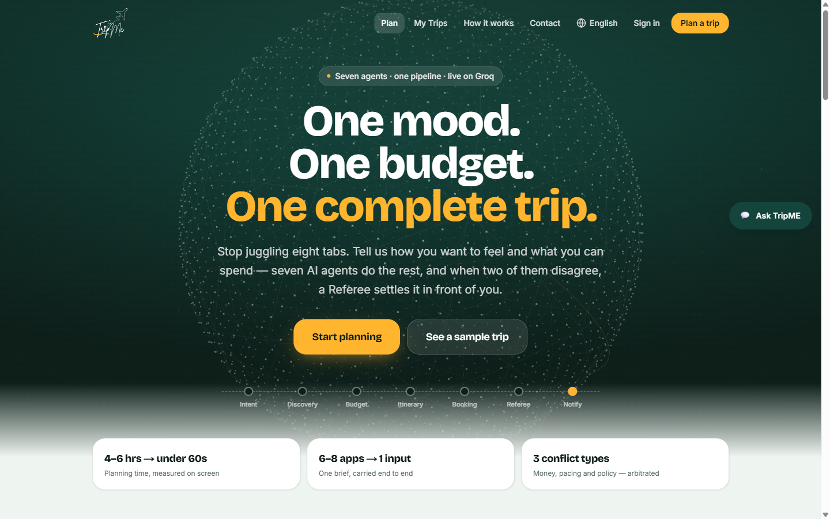
Landing — above the fold, 1440 × 900
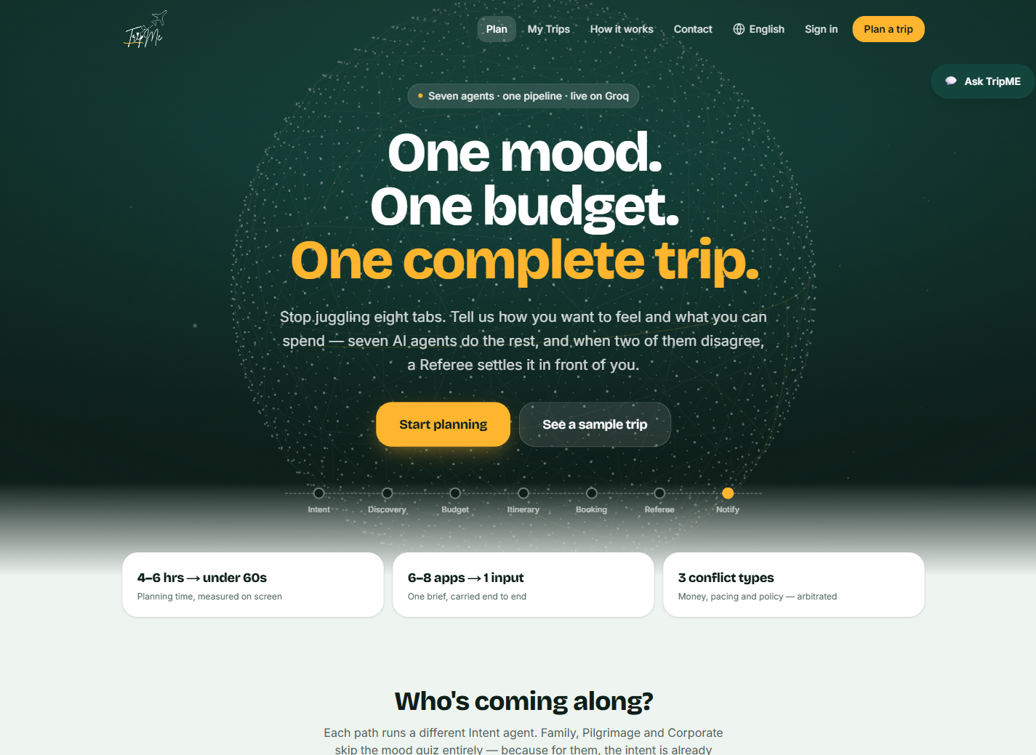
Landing — full page — 1 of 5
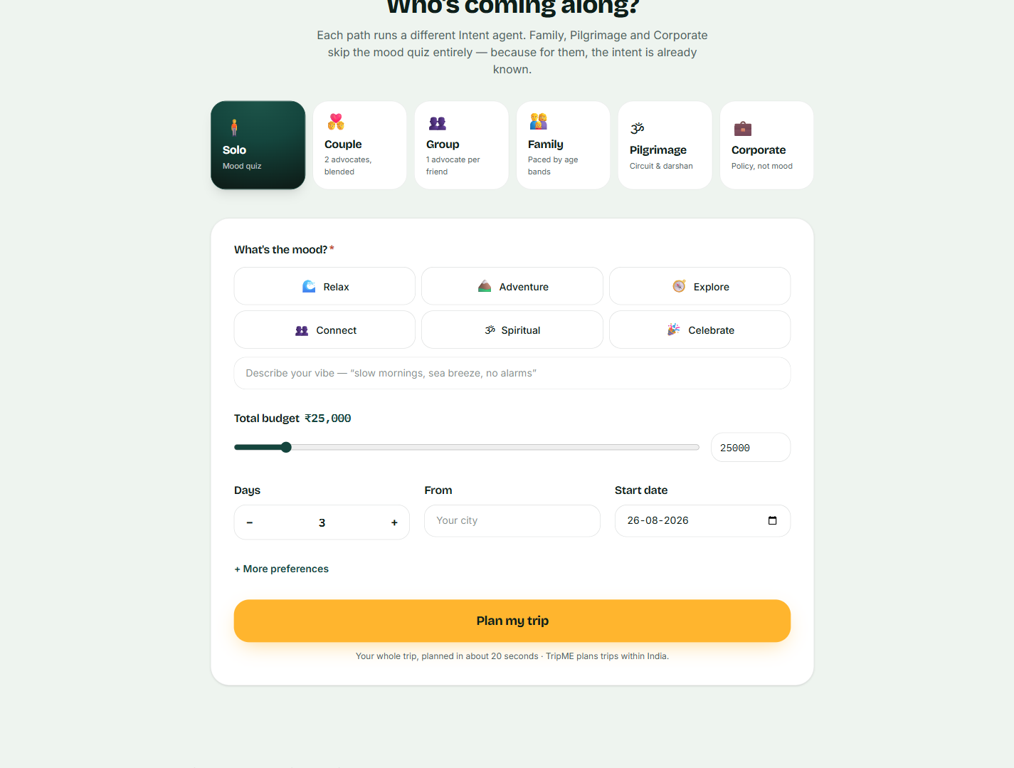
Landing — full page — 2 of 5
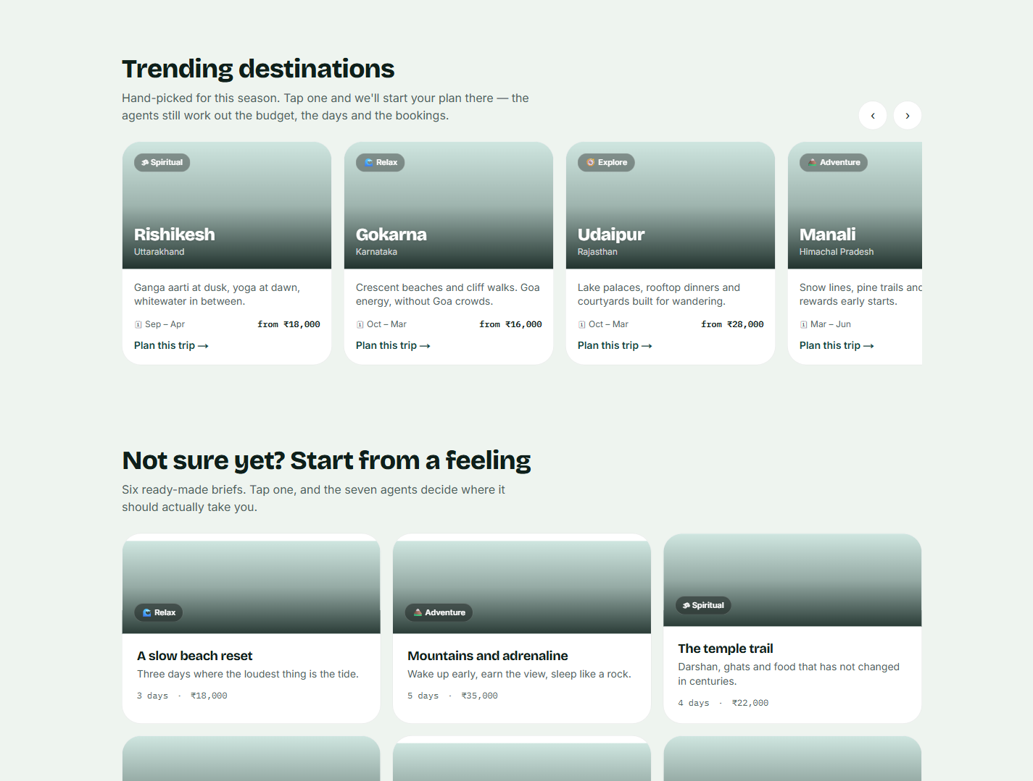
Landing — full page — 3 of 5
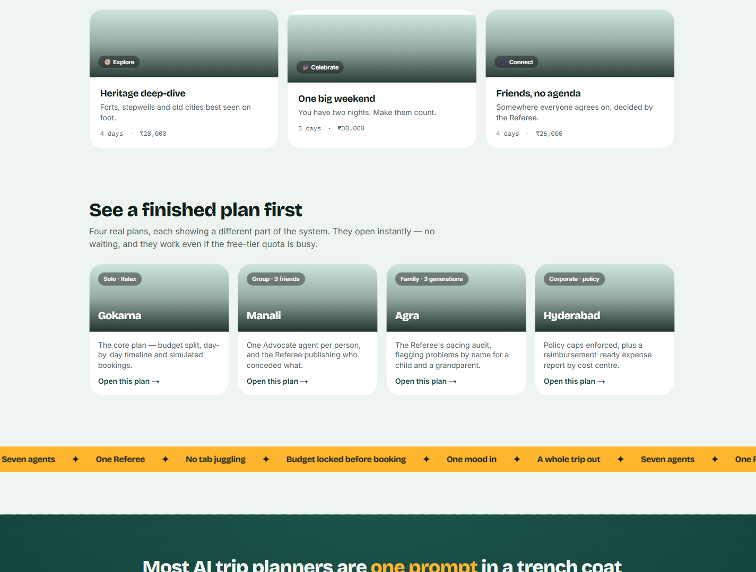
Landing — full page — 4 of 5
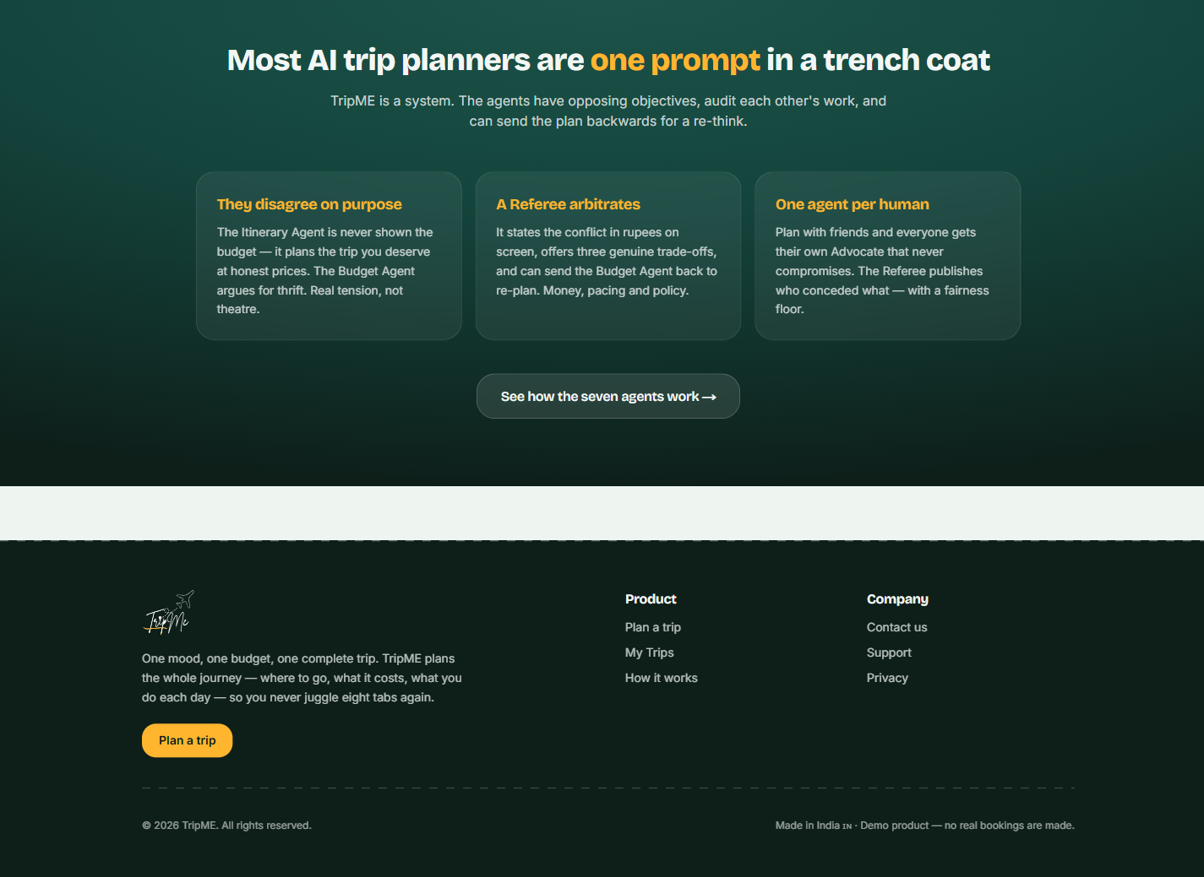
Landing — full page — 5 of 5

2 · Planner — six travel paths as first-class choices
Who is travelling changes which questions are worth asking, so the path is chosen before the brief. These are six genuinely different intent flows, not one form with a dropdown.
What to look at
- Family, Pilgrimage and Corporate skip the mood quiz entirely — for them the intent is already known, and asking anyway would be a survey rather than a conversation.
- The From field is empty, with a "Your city" placeholder. It previously pre-filled "Bengaluru", which leaked through the Booking Agent into the reminders of travellers who had chosen somewhere else. Nothing about the traveller is now assumed.
- Budget is a slider with a typed value beside it — a range for people who are exploring, an exact figure for people who already know.
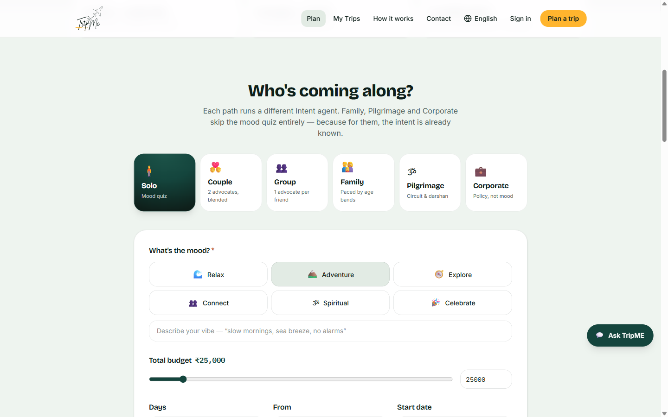
Path selection and mood capture
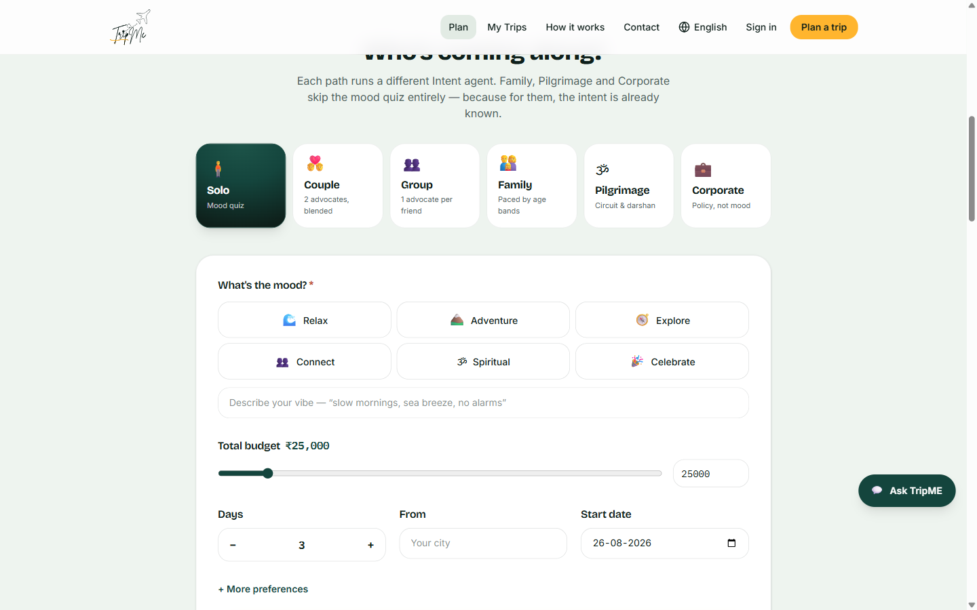
Budget, duration, origin and start date

3 · Sample plans — the zero-friction entry
Four complete plans that open instantly, with no brief, no account and no model call. This is the answer to a real risk: an entry point with no destination field can read as broken rather than novel.
What to look at
- Each sample is chosen to demonstrate a different part of the system — the core plan, group arbitration, a family pacing audit, and corporate policy enforcement.
- They require no quota at all, which makes them the guaranteed-working path during a demonstration.
- Photography is real and properly licensed, sourced from Wikimedia Commons rather than stock imagery.
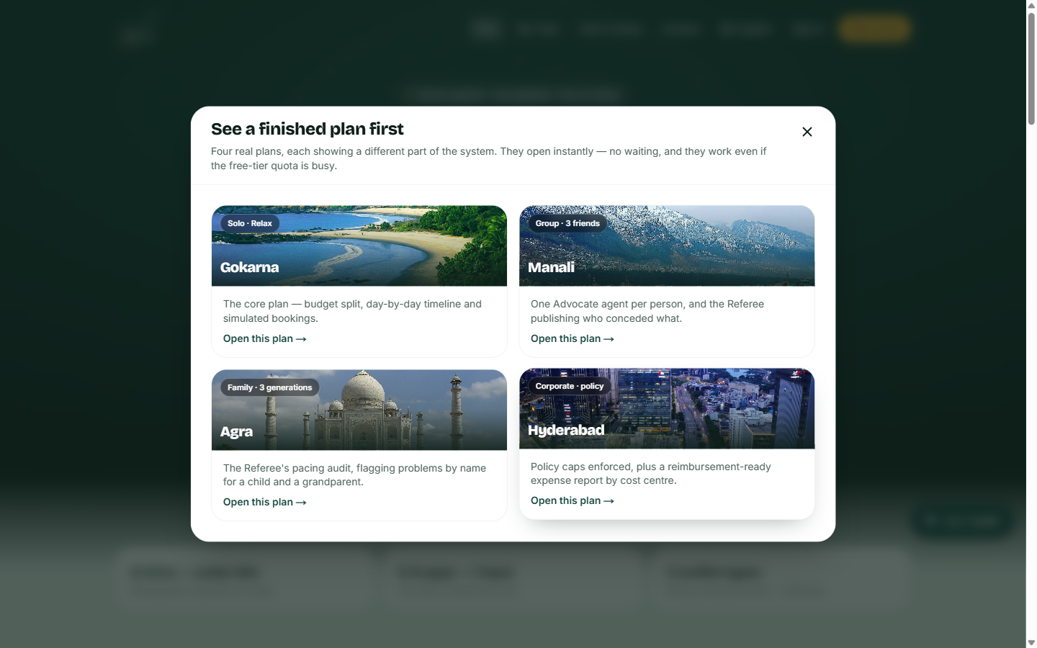
The sample chooser — four plans, four different capabilities

4 · Trip page — the plan, and why it is this plan
The single most important screen in the product. It has to carry a destination, a rationale, a budget, three days of itinerary, simulated bookings and an arbitration record without becoming a wall.
What to look at
- The header states how many agents ran and how long they took — the product measures its own performance claim rather than asserting it in marketing.
- The Discovery Agent's reasoning is immediately below the fold, with "It also considered these" — the rejected alternatives are visible, which is what makes the choice interrogable.
- The right rail is a persistent summary: status, dates, origin, budget and a live approved/committed/unspent breakdown that updates as the traveller acts.
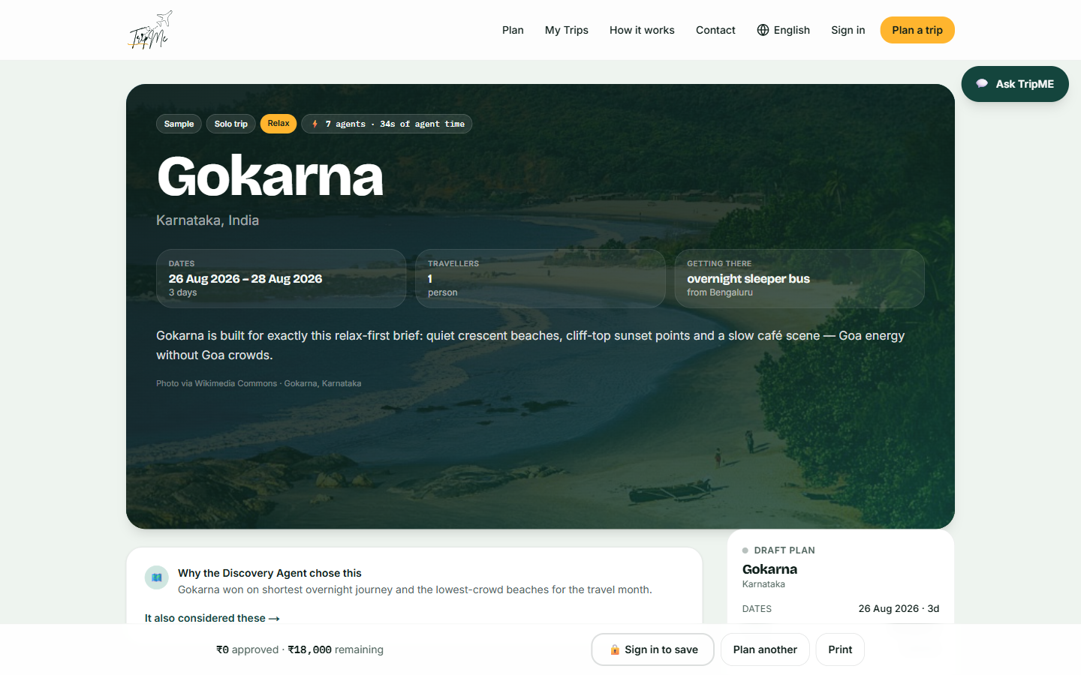
Trip header — destination, brief summary and agent metrics
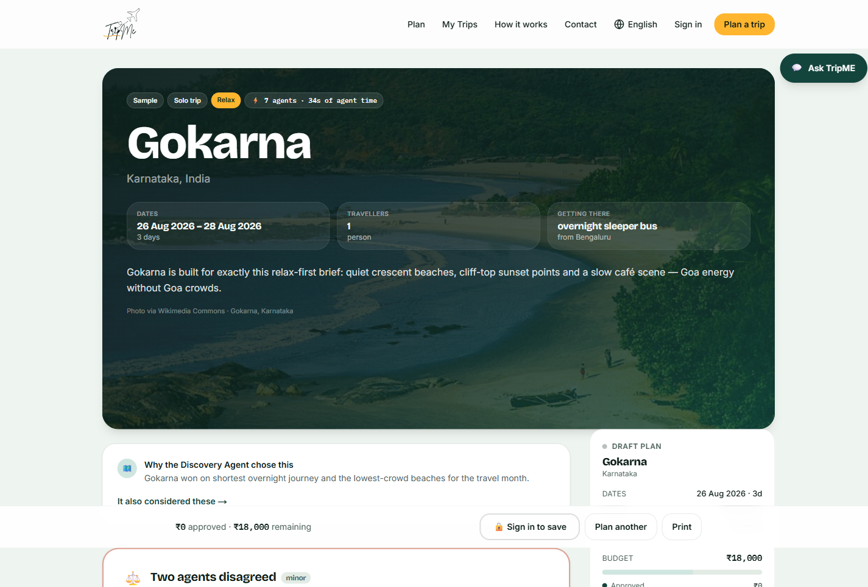
Trip page — full page — 1 of 7
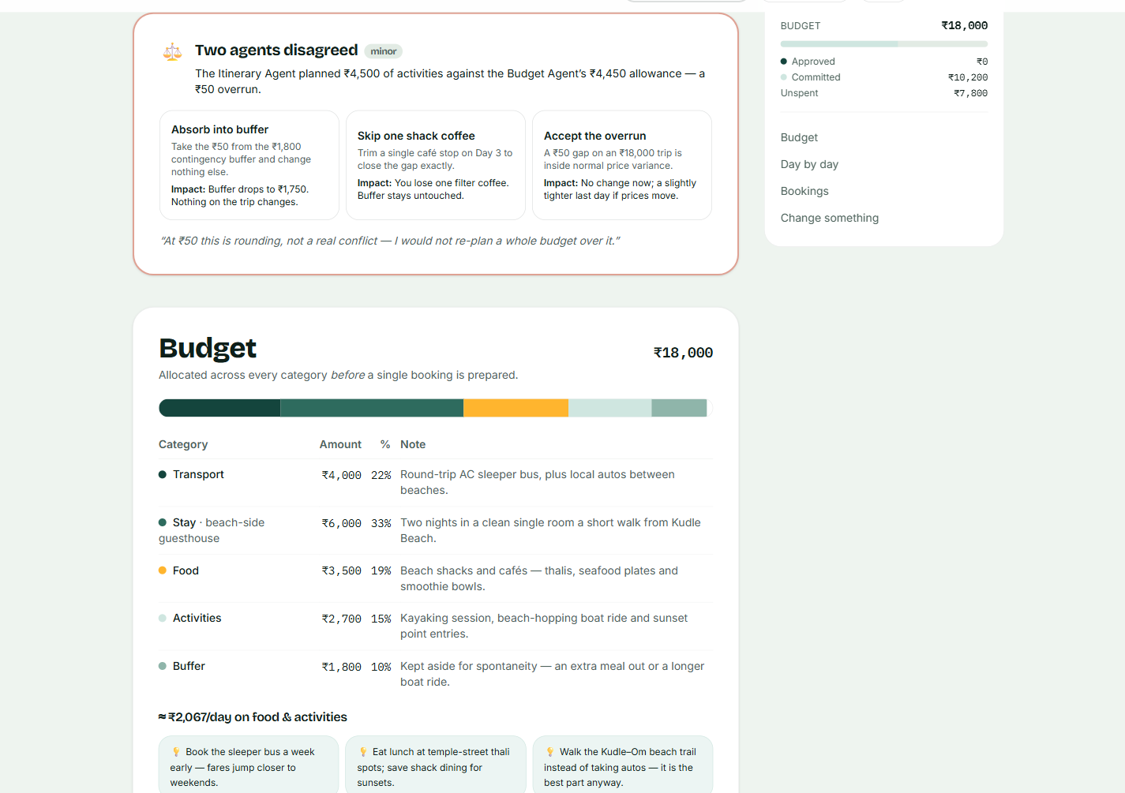
Trip page — full page — 2 of 7
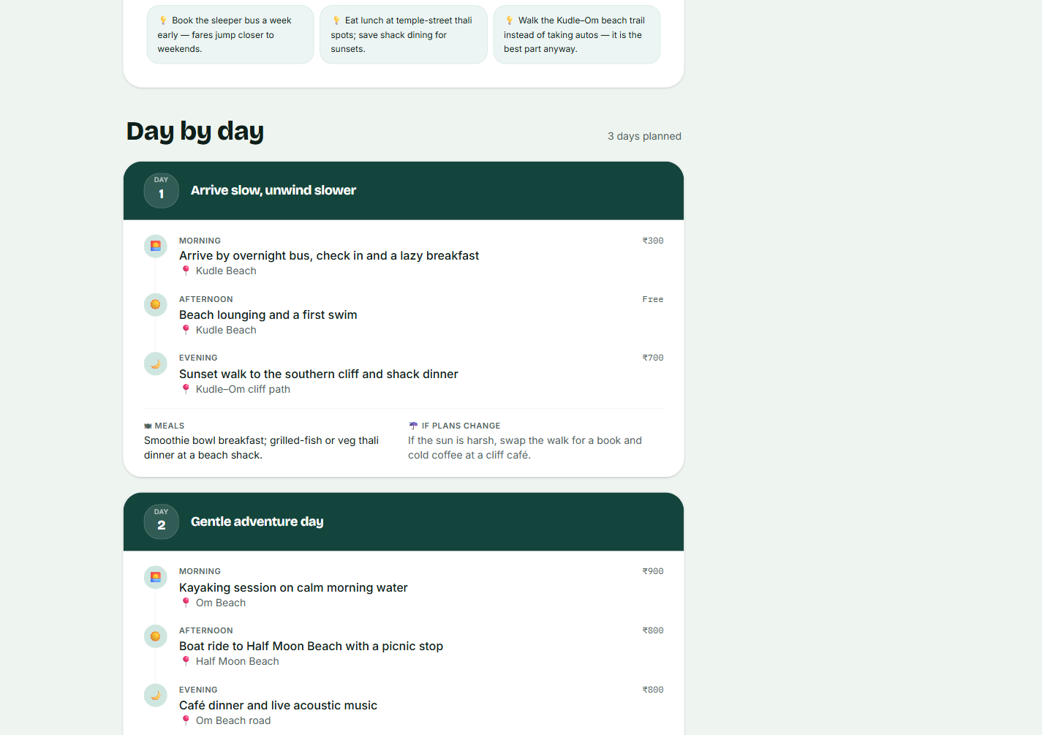
Trip page — full page — 3 of 7
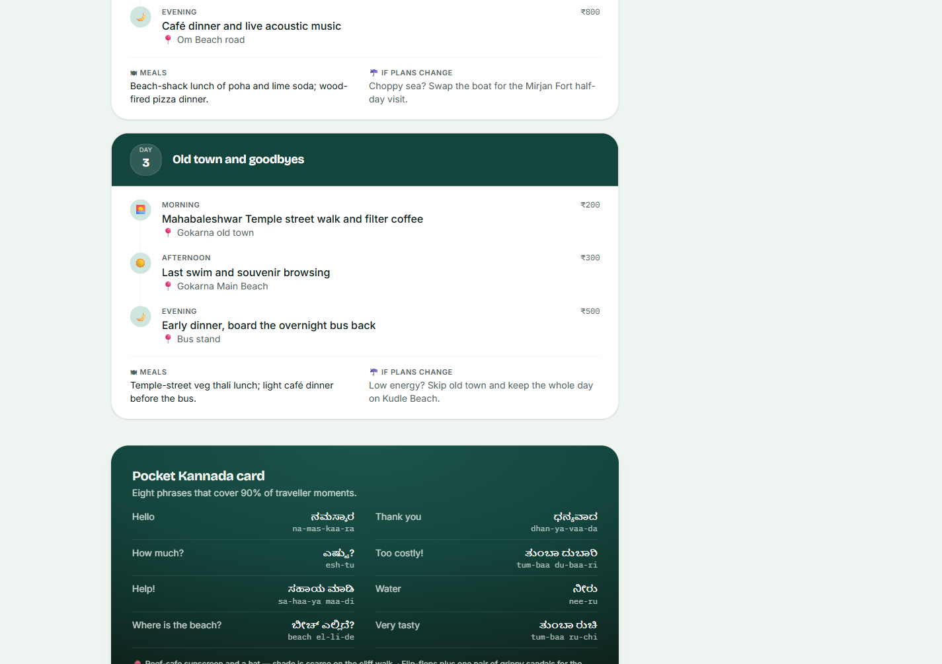
Trip page — full page — 4 of 7
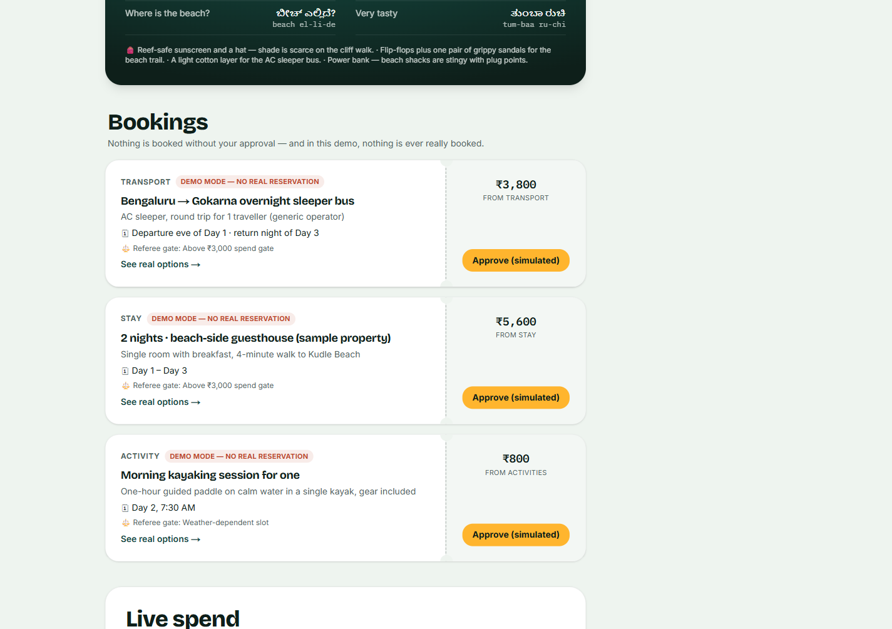
Trip page — full page — 5 of 7
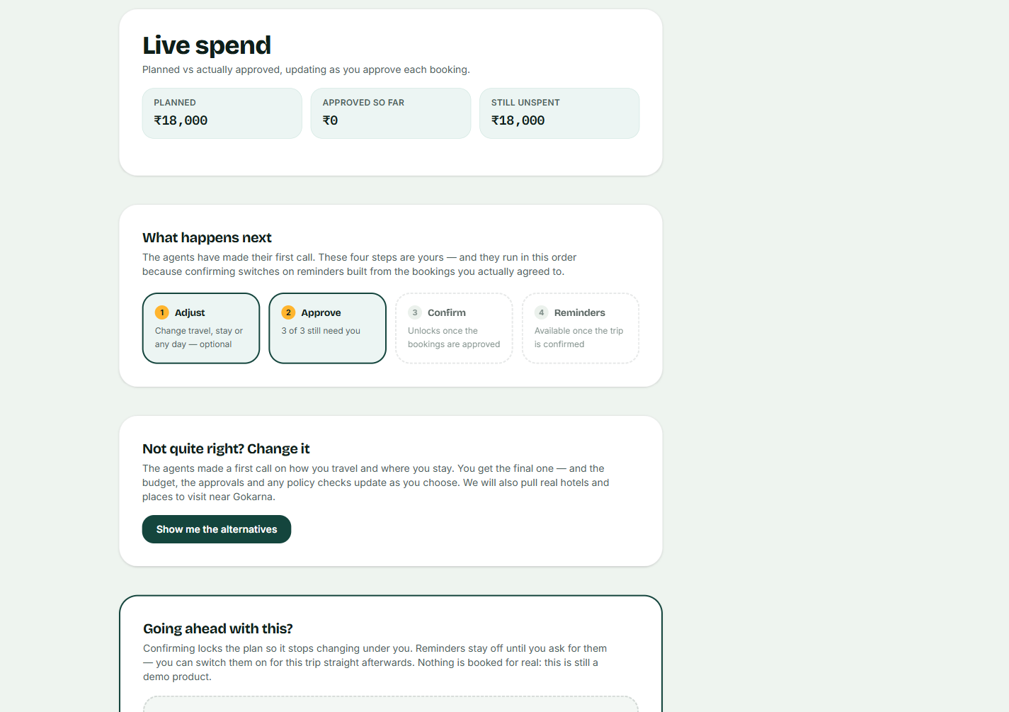
Trip page — full page — 6 of 7
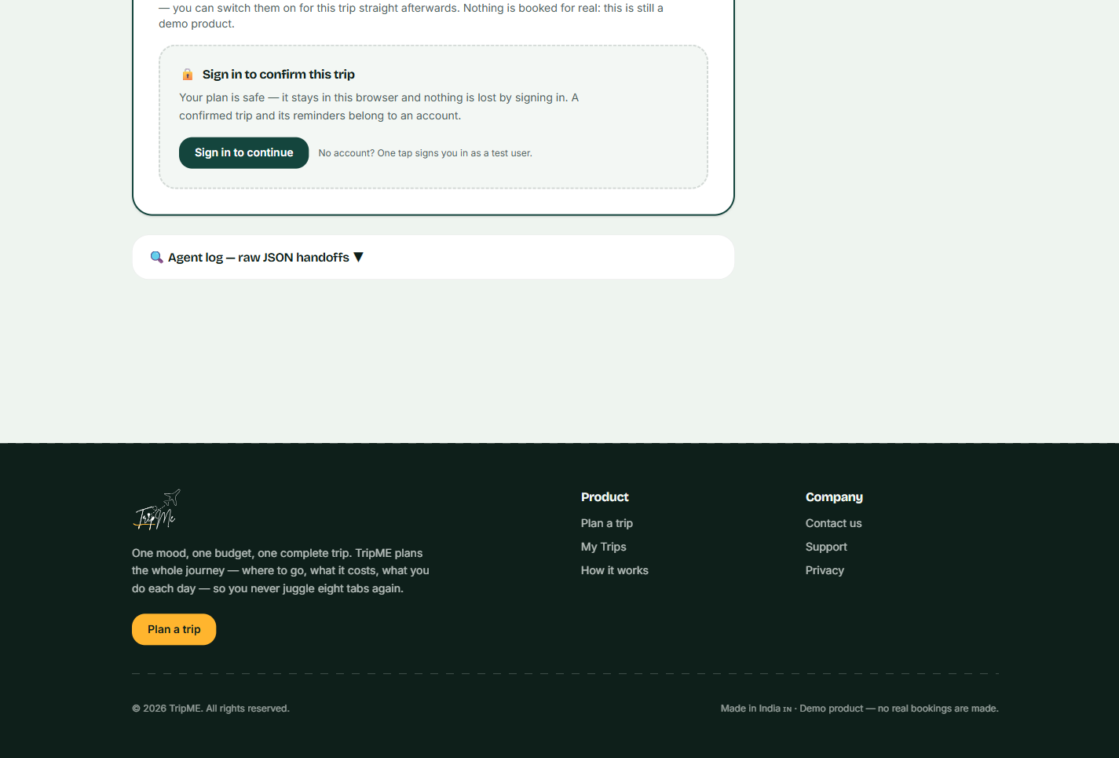
Trip page — full page — 7 of 7

5 · Arbitration — the Referee stating a conflict in rupees
This is the screen that separates a multi-agent system from a single long prompt. Two agents produced incompatible outputs, and rather than silently reconciling them, the product shows the disagreement and the options for settling it.
What to look at
- The conflict is quantified — ₹4,500 of planned activity against a ₹4,450 allowance — not described vaguely as a "tension".
- Three resolutions are offered with their consequences spelled out, so the traveller chooses rather than being told.
- The Referee grades its own finding as minor and says so: *"At ₹50 this is rounding, not a real conflict."* An arbitrator that escalated everything equally would be noise.
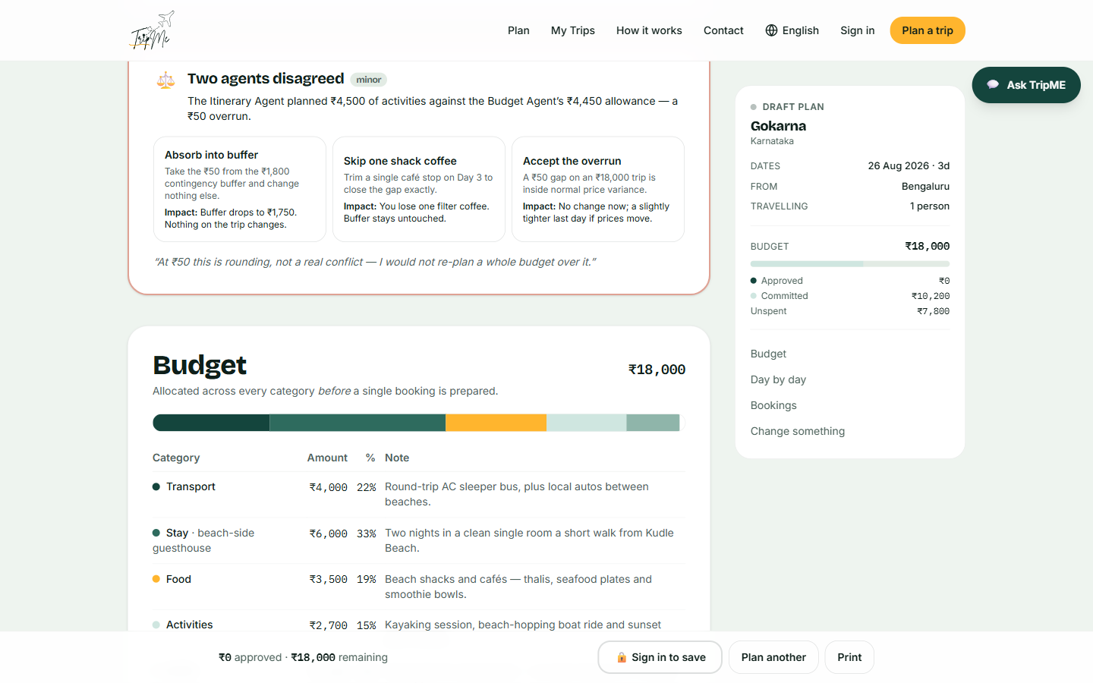
Referee output on a solo plan, with the budget allocation below

6 · Group arbitration — Advocates and the concession matrix
On a group trip the product instantiates one Advocate agent per traveller, each arguing for one person. The Referee then publishes exactly who conceded what — which is the part of group travel that actually breaks down.
What to look at
- A five-column matrix: wanted, got, conceded, and a satisfaction score per person. Nobody has to take the plan on trust.
- The fairness floor is visible in the closing line — *"Nobody conceded twice."* Without it, arbitration converges on whoever asked for least.
- The trade is explained causally: Priya's trek won the best weather window, so Rohan absorbed the early start and was compensated with both free afternoons.
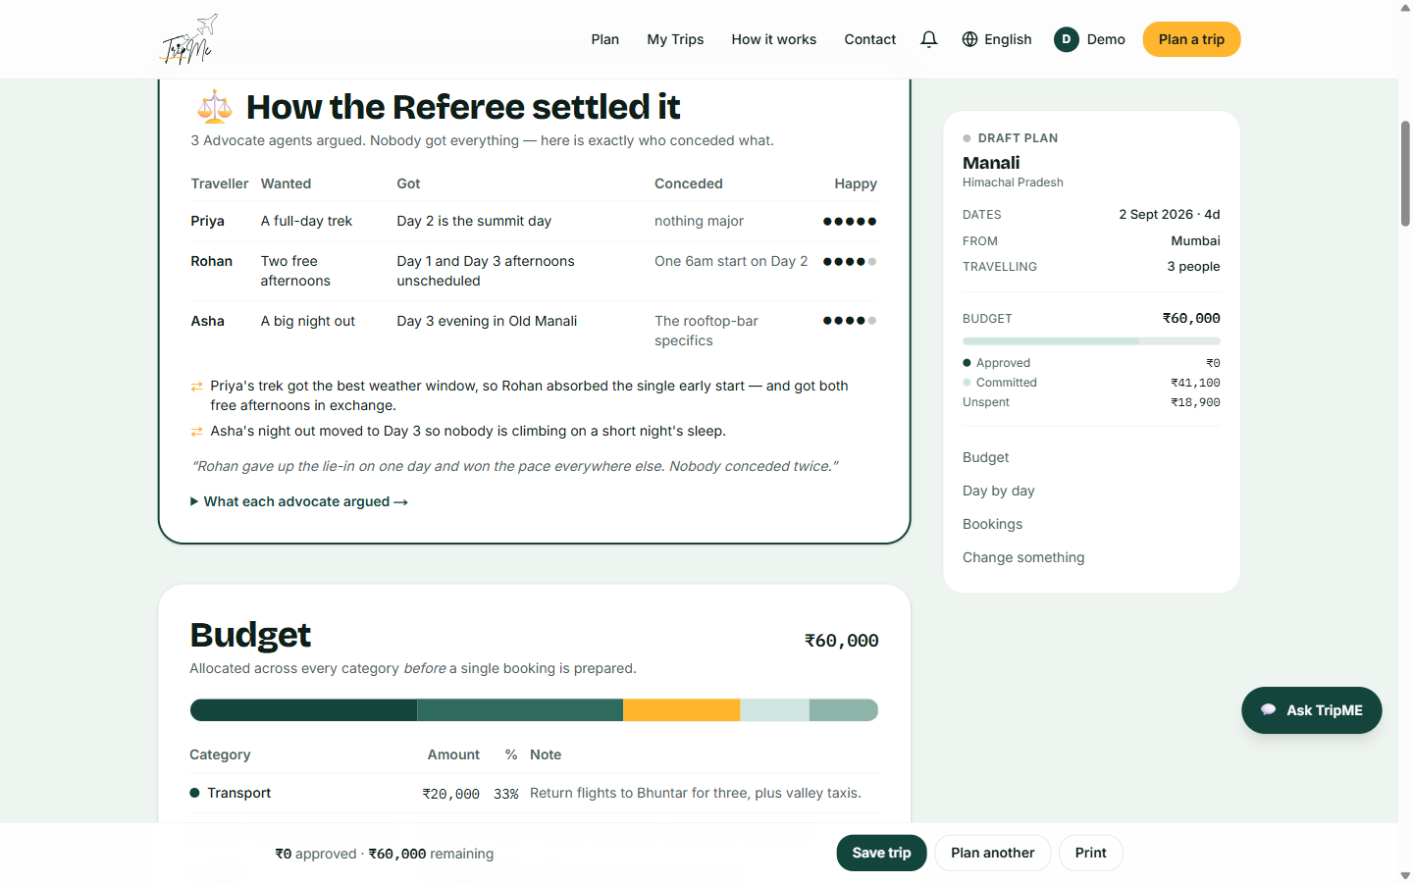
Three Advocates arbitrated into one plan

7 · Bookings — approval gates and honest labelling
Every item of spend above a threshold requires explicit approval, and every item is labelled as simulated. This is the screen where the product is most tempted to overstate itself, and most deliberately does not.
What to look at
- DEMO MODE — NO REAL RESERVATION on every booking, in the product itself and not only in the documentation.
- Each gate states its reason — "Above ₹3,000 spend gate", "Weather-dependent slot" — so the gate is a rule, not an obstacle.
- Changing an amount revokes its approval. Before this was fixed, a traveller could approve ₹8,000 and confirm ₹14,000; approvals now expire when the thing they approved changes.
- "See real options" links out to genuine providers — the deep links are real even though the bookings are not.
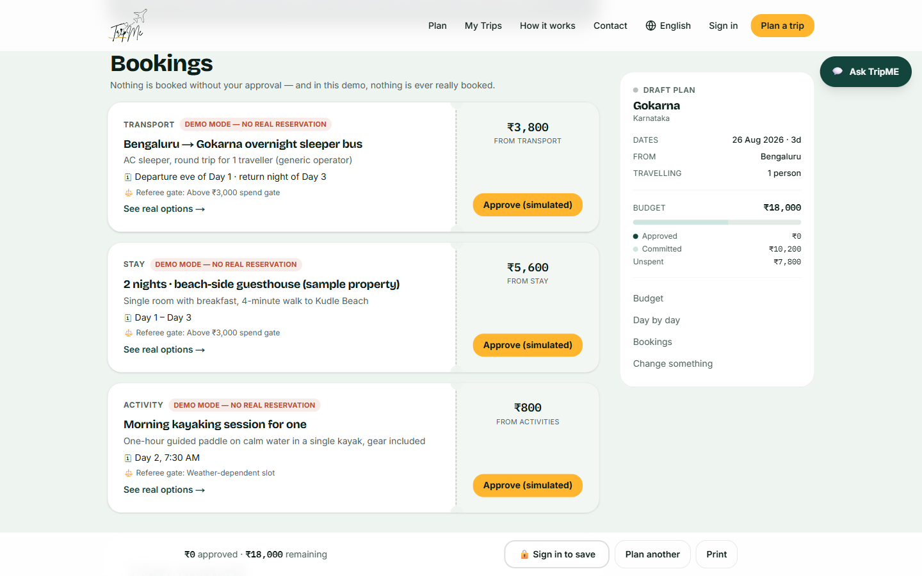
Three bookings, each gated and each labelled

8 · Alternatives — the traveller overruling the agents
The agents make the first call, not the last one. Transport, local travel, stay and every individual day can be changed, and the money recomputes in code rather than by asking a model again.
What to look at
- Options carry honest trade-offs rather than marketing — "Cheapest, but arrives at 4am", "Meters are often refused — agree the fare first".
- Prices are marked est. with the reason stated: live rates are behind paid inventory APIs this project does not use.
- Hotels are real listings pulled from OpenStreetMap, with map and website links. Photographs appear where a properly-licensed one exists — for a small guesthouse none does, so the product shows a map pin rather than a stock photograph of somewhere else.
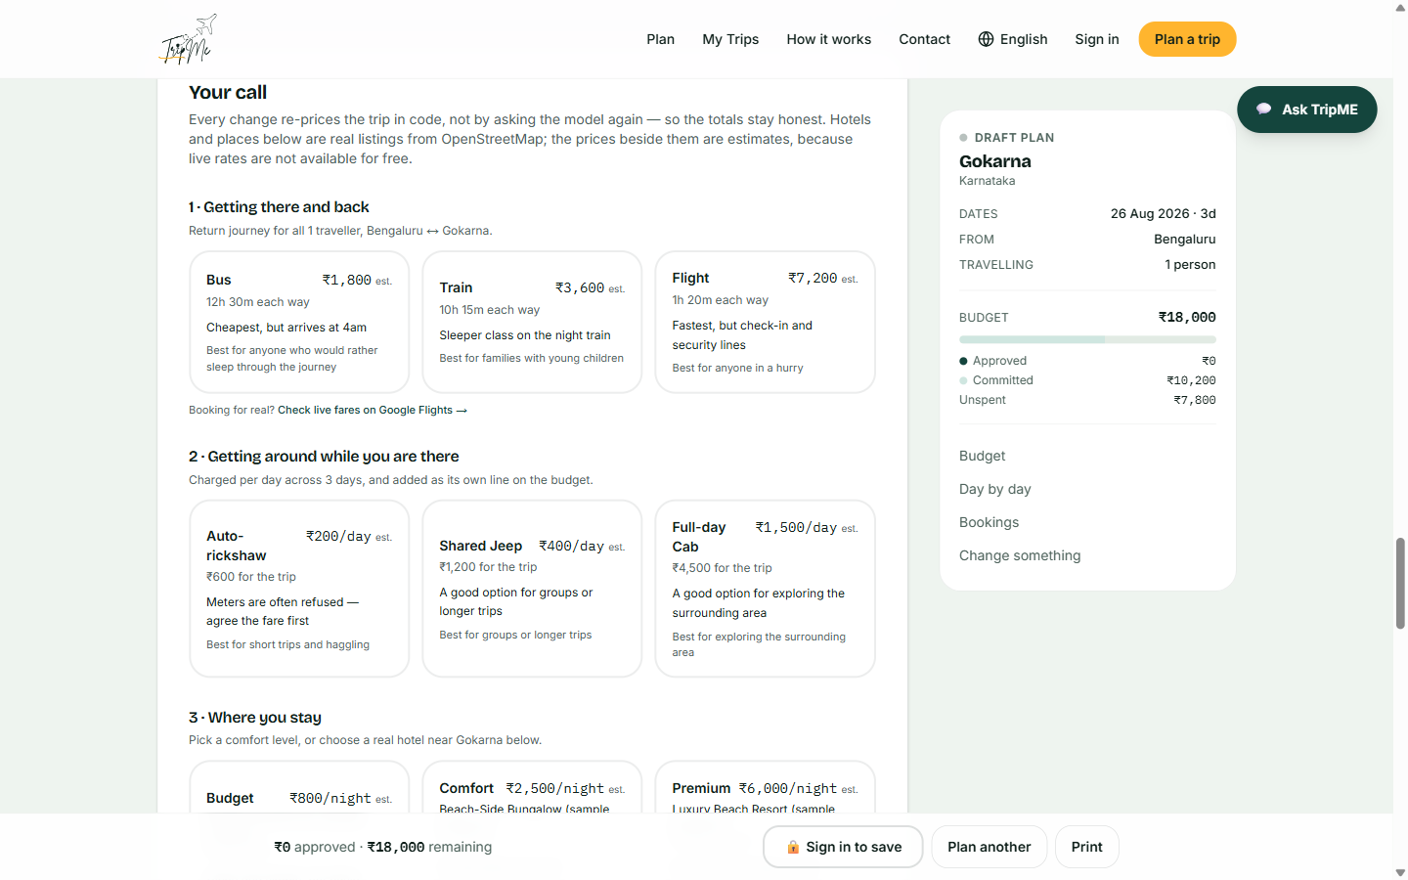
Transport and local travel, with trade-offs stated
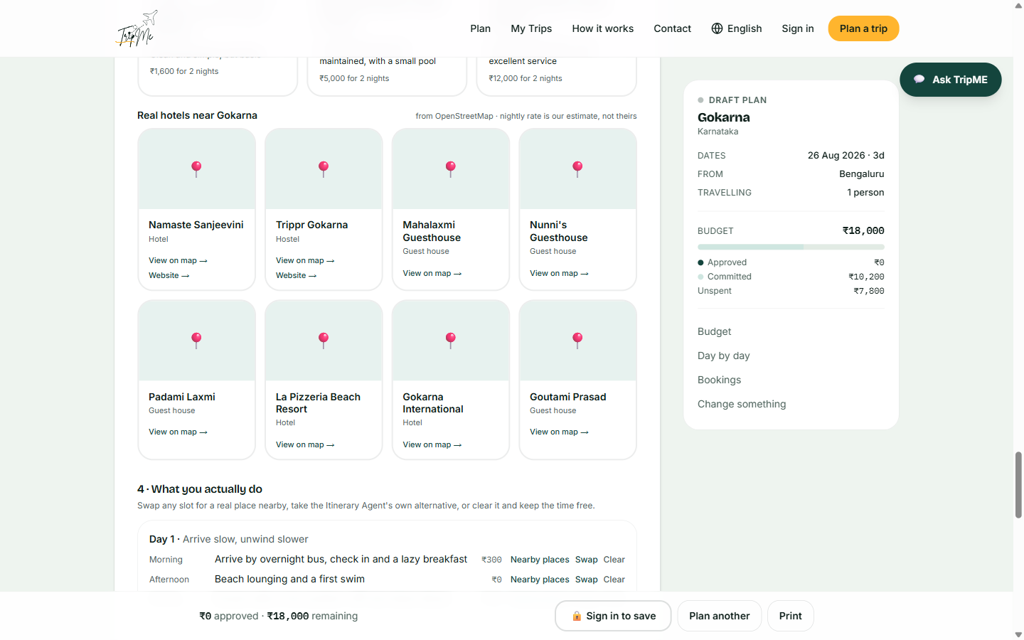
Real OpenStreetMap listings near the destination

9 · Progress — making the gate chain visible
This component exists because of a specific failure. Confirm, reminders and email were all built and deployed, and none of them was visible, because each only appears once the previous step is complete. A gate that hides what is behind it is indistinguishable from a feature that was never built.
What to look at
- Four steps, stated from the moment a plan exists: Adjust → Approve → Confirm → Reminders, with the current one highlighted.
- Each step says what unlocks it — "Unlocks once the bookings are approved" — so nothing is mysteriously greyed out.
- The order is explained rather than imposed: confirming builds the reminder schedule from the bookings actually agreed to.
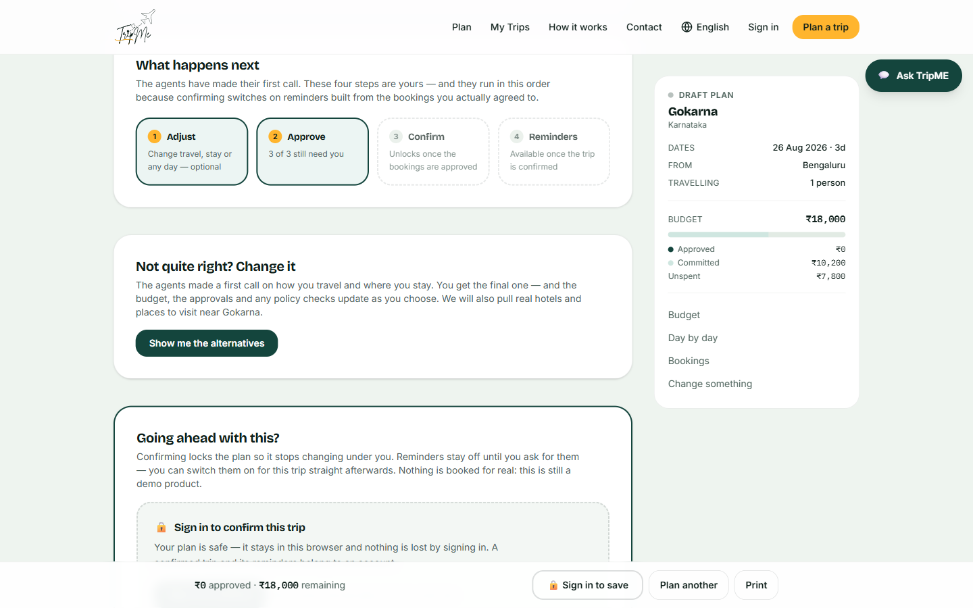
The stepper, the alternatives entry point and the confirm gate

10 · Sign in — placed at commitment, not at entry
Planning works entirely signed out. An account is required only to confirm or save a trip, because a confirmed trip and its reminders have to belong to someone.
What to look at
- Continue as a test user — a password-less path so any reviewer can reach every gated feature. The Google consent screen is still in testing, and rather than hide that, the page says so.
- The privacy position is stated on the page and not buried in a policy: trips stay in the browser, the account holds only what Google returns, and signing in does not move trips between devices.
- "Plan a trip without signing in" is offered as an explicit exit — the gate is honest about being optional.
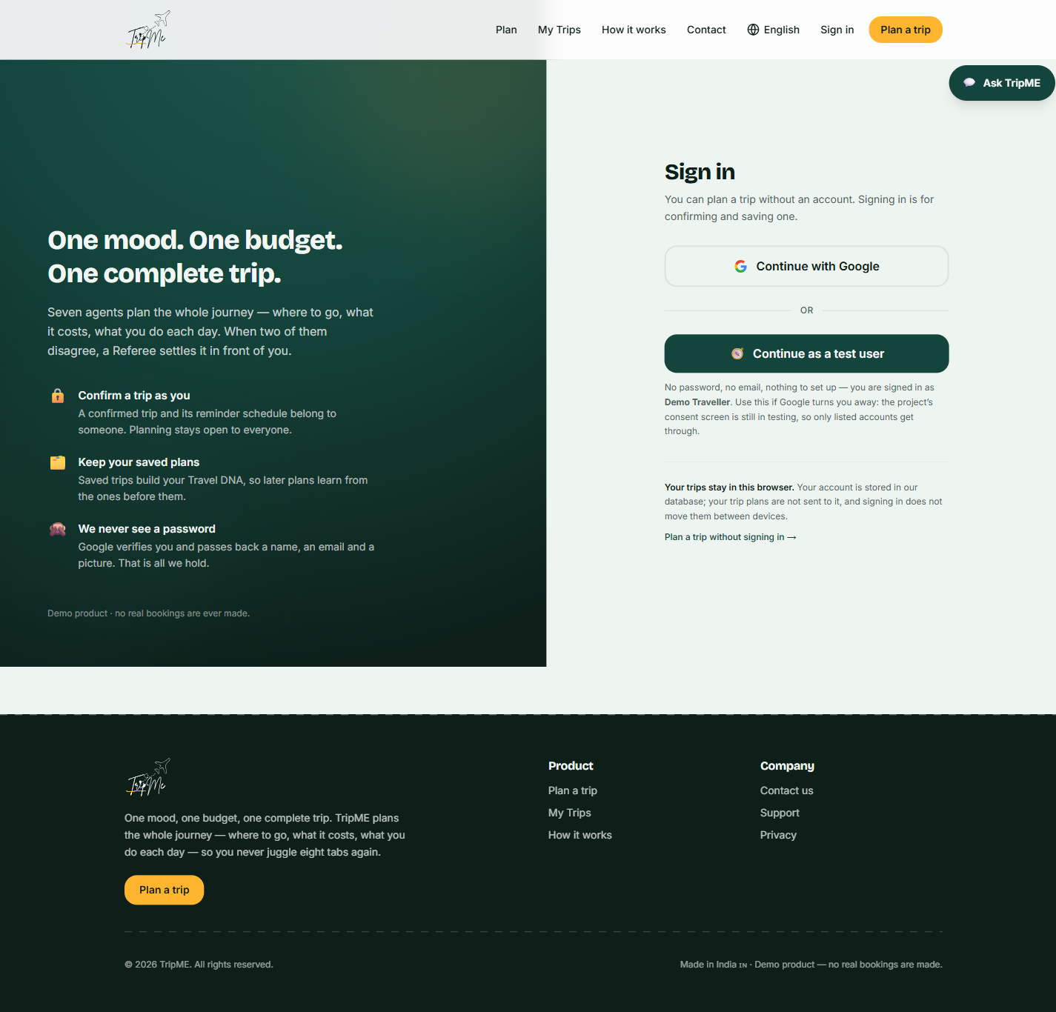
Sign-in, with the test-user path and the privacy position

11 · Confirmed — reminders opt in, per trip
Confirming locks the plan. Reminders are then offered — off by default, on per trip, and switchable off in one click.
What to look at
- The schedule is built from the bookings actually approved. Before this was fixed, reminders could name a hotel the traveller had rejected.
- Reminders are time-anchored to real events — departure, check-in, each activity — never to engagement targets.
- The delivery limitation is stated where the feature is, not in a footnote: reminders appear in the bell while TripME is open; a closed-app push needs infrastructure this demo does not have.
- The status chip changes DRAFT PLAN → CONFIRMED, and the action bar changes from "Sign in to save" to "Save trip".
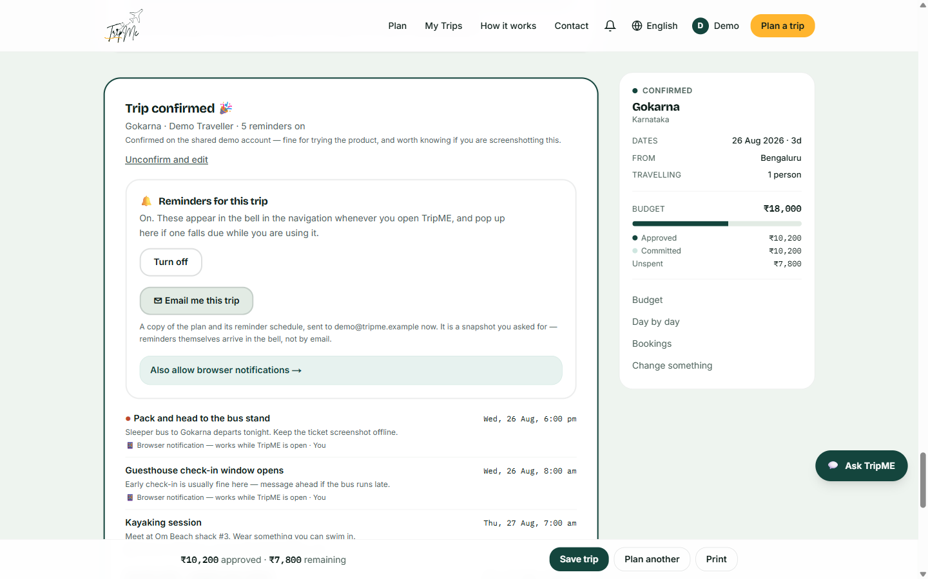
Confirmed, five reminders on, with the email option
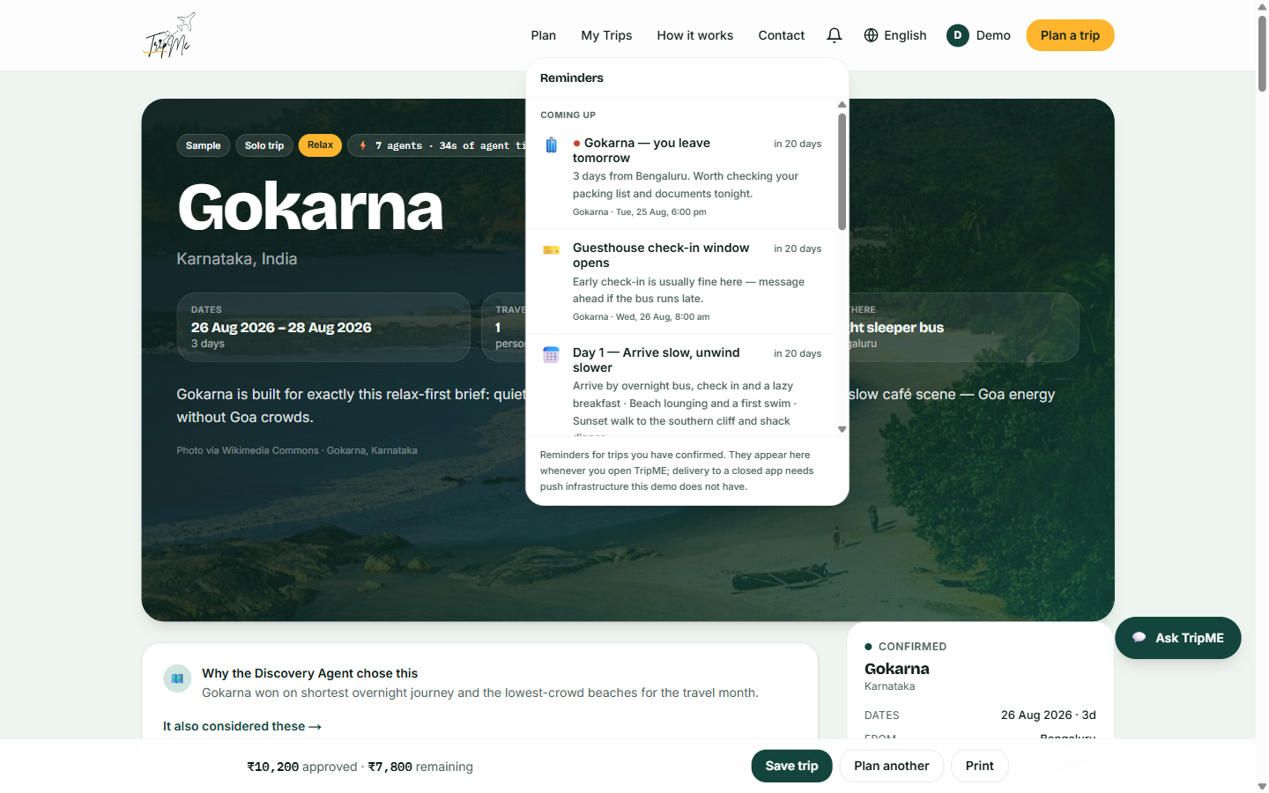
The bell — grouped, time-anchored reminders

12 · The agent pipeline running live
Captured during a genuinely live run rather than staged. Seven agents execute in sequence, each reporting as it completes, with the brief pinned alongside so the traveller can see what the agents were given.
What to look at
- Each agent reports what it decided, not merely that it finished — "Picked Kerala Backwaters (+2 alternates)", "Allocated ₹25,000 · ₹2,667/day".
- The clock is honest about what it measures: agent time only, excluding free-tier queueing and the deliberate pauses that make each handoff readable.
- The brief shows FROM: Pune throughout — the origin fix verified again on production, from a city the prompts never mention.
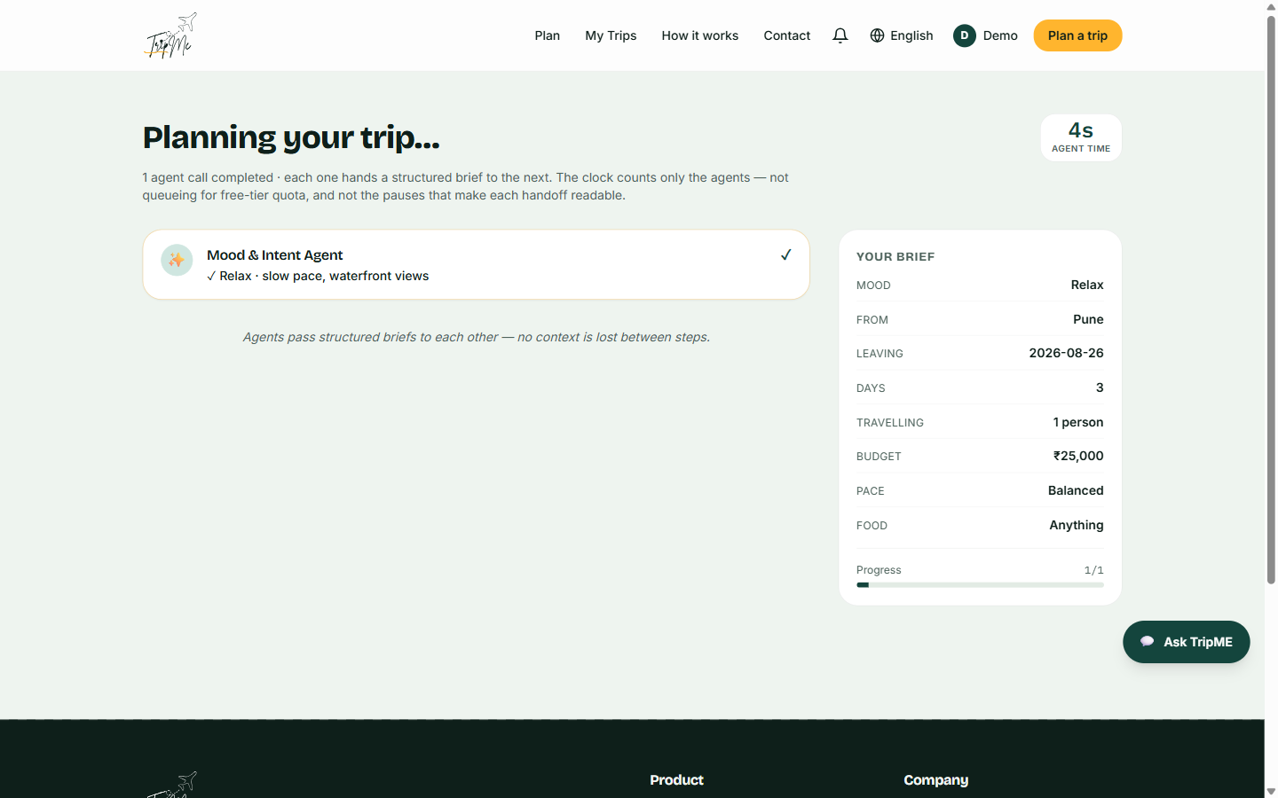
The first agent completes, four seconds in

13 · The backward edge — the Referee sending work back
The most important screen in this document. Most "multi-agent" systems are a chain: each step hands forward and nothing is ever reconsidered. Here the Referee audited the Itinerary Agent against the Budget Agent, found a ₹5,000 overrun, and sent the brief backwards.
What to look at
- Referee Agent · budget audit flags the conflict — ₹10,000 of planned activity against a ₹5,000 allocation.
- Budget Agent · re-planning, tagged *triggered by Referee* — activities re-allocated from ₹2,000 to ₹7,000.
- Itinerary Agent · revised to fit, also triggered by the Referee — the affected steps re-run.
- This is why the architecture is a graph rather than a pipeline, and it happened unprompted during capture.
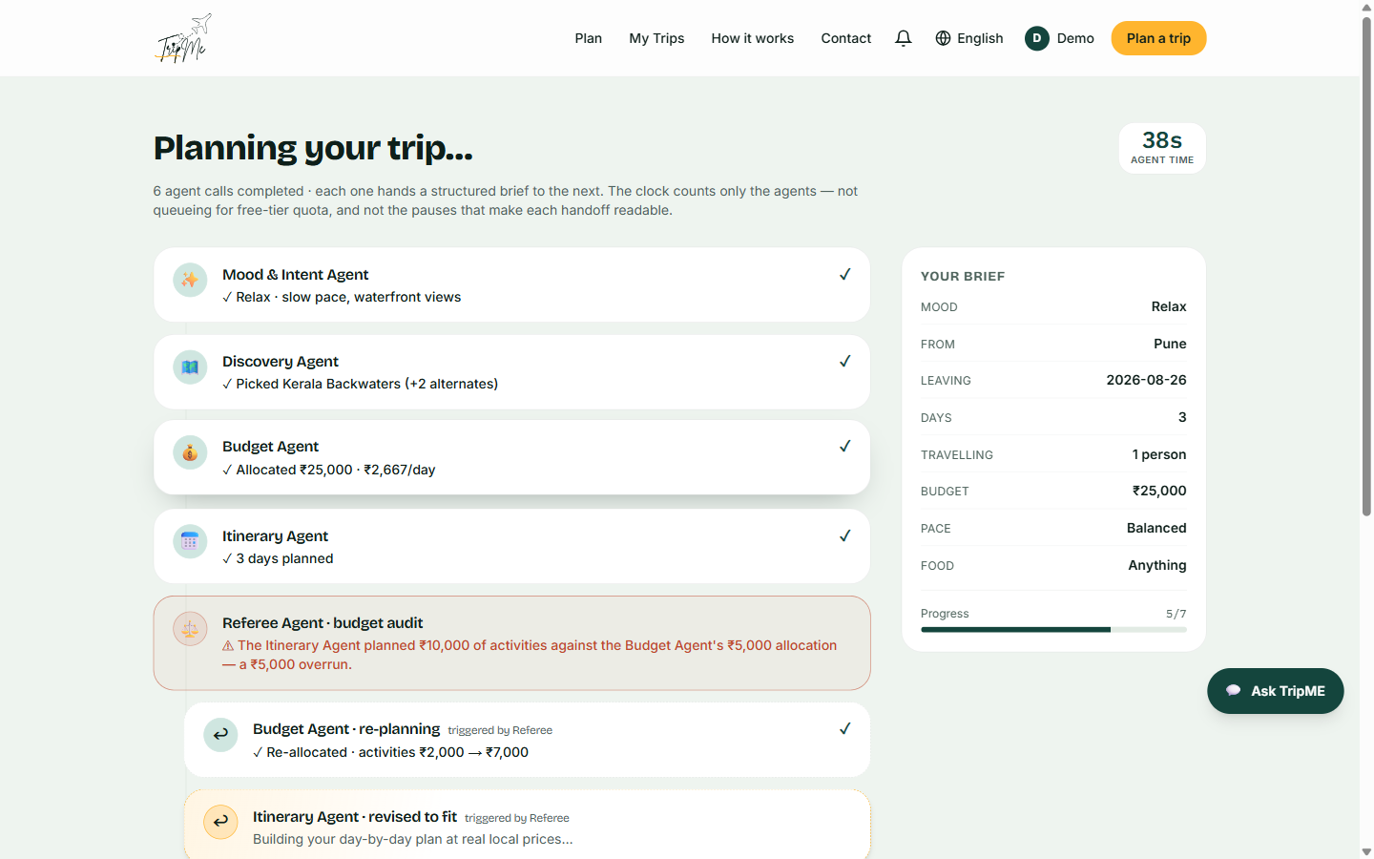
The Referee rejects, and two agents re-run

14 · The finished live plan
The result of the run above: a real destination, chosen for a real brief, with the re-planning recorded in the header.
What to look at
- 9 agents · 58s of agent time · Re-planned by Referee — nine calls rather than seven, because two agents ran twice after the Referee rejected the first attempt.
- The rationale quotes the traveller's own words back — "soothing, gentle escape", "calm waters and greenery" — evidencing the match rather than asserting it.
- Transport reads "train and taxi from Pune", carrying the origin correctly all the way to the output.
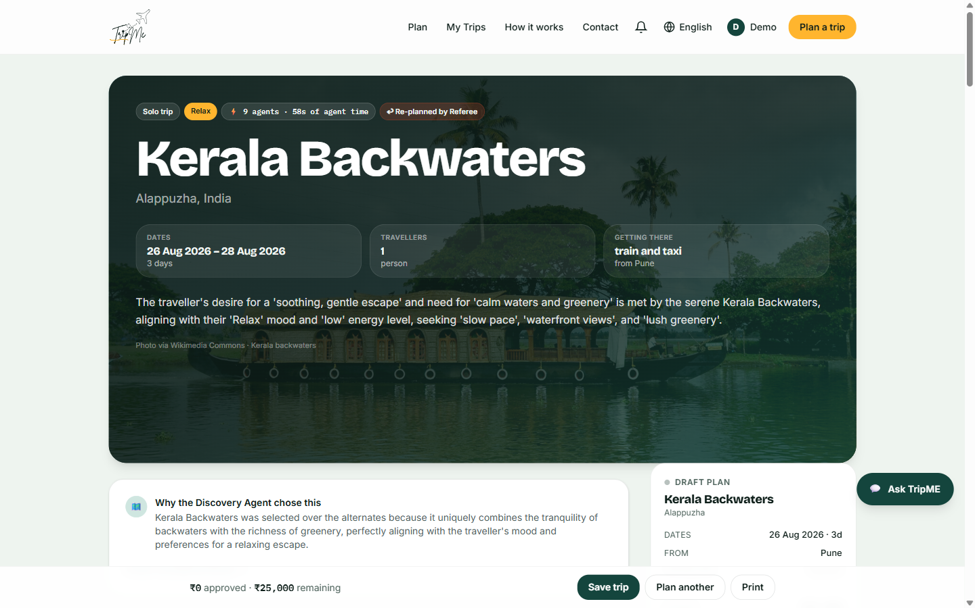
Kerala Backwaters — generated live during this capture session

15 · Corporate — policy enforced, not suggested
The corporate path replaces mood with policy. Caps are enforced in code and the Referee adds a compliance audit.
What to look at
- A Policy compliance panel with an explicit compliant/breach verdict.
- The city is fixed by the meeting, so the Discovery Agent chooses the district rather than the destination — the same agent doing a different job.
- The plan is built to produce a reimbursement-ready expense report by cost centre.
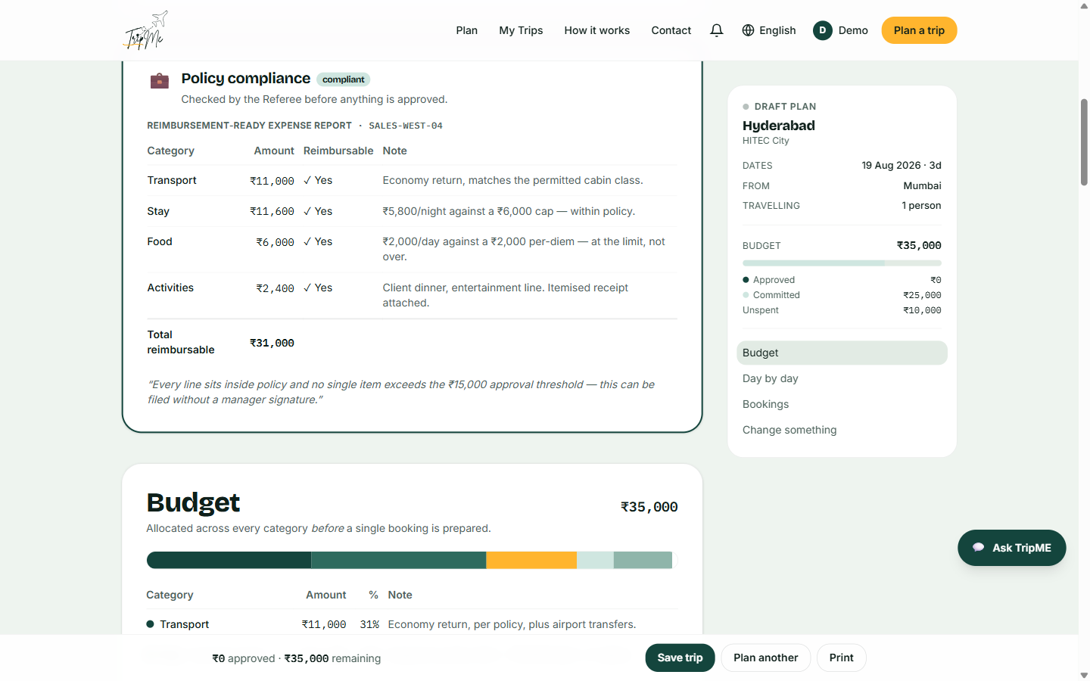
Corporate path — policy compliance panel

16 · Group settle-up — splitting inside the plan
Planned against actually-approved spend, per traveller, updating as each booking is approved. This was listed in an earlier draft as *not* in the MVP; it is built.
What to look at
- "No separate app" is the point — splitting happens against the plan that was approved, not reconstructed afterwards from receipts.
- Planned, approved-so-far and still-unspent are shown separately, because they answer three different questions.
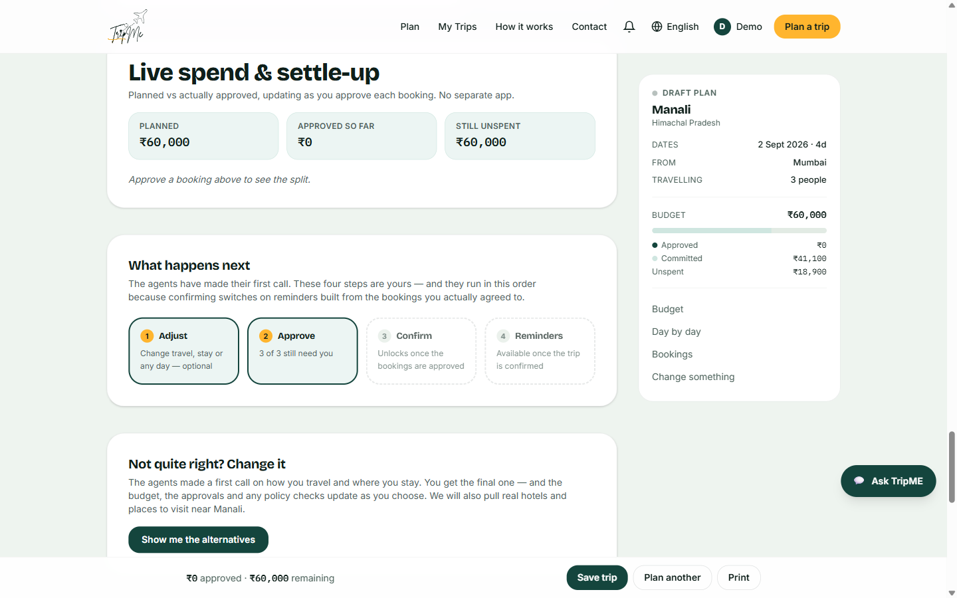
Live spend and settle-up on a three-person trip

17 · The global assistant
Reachable on every page, draggable both collapsed and open, and aware of the trip currently being viewed.
What to look at
- The greeting is context-aware — it names the trip on screen and offers to explain the product itself.
- Pre-made questions fill the input rather than firing immediately, so the traveller can edit before asking.
- It is explicitly positioned to answer "what is real and what is simulated" — the assistant is part of the honesty surface, not a sales channel.
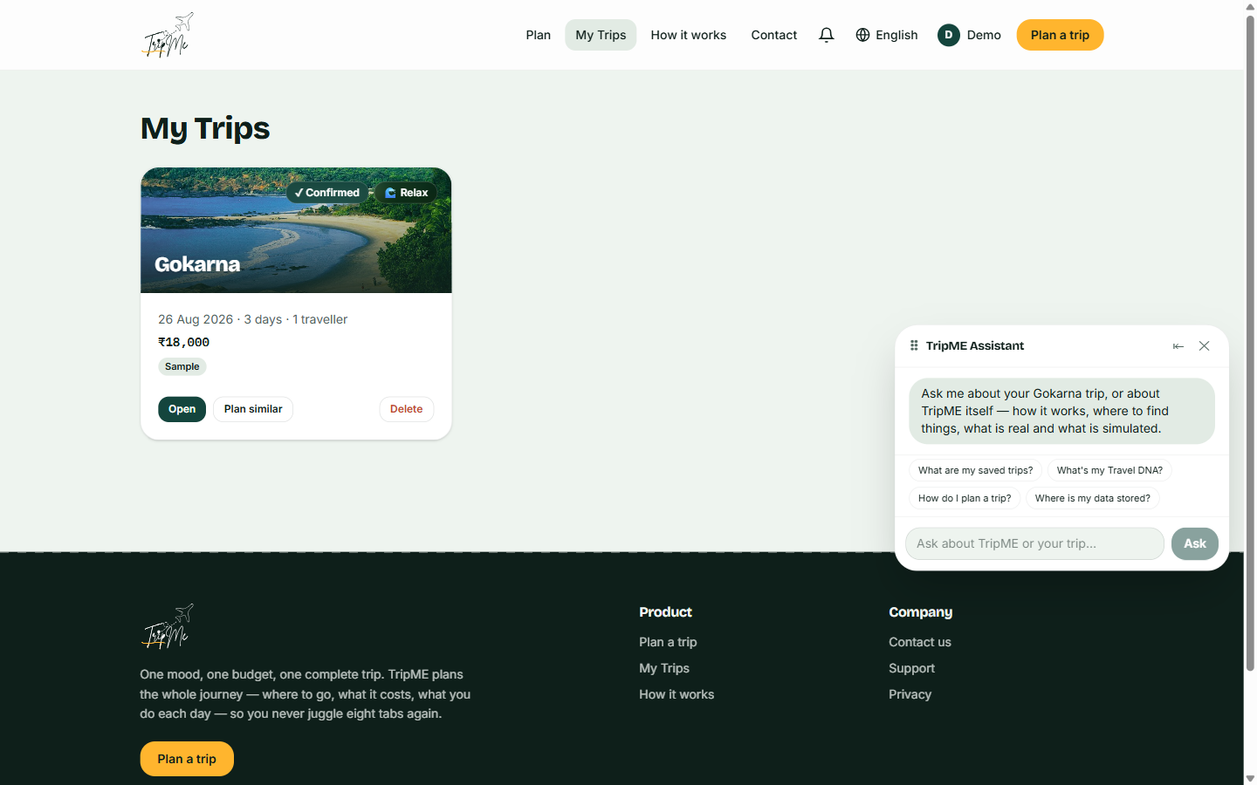
The assistant, open, on the My Trips page

18 · My Trips
Saved trips with their status. One card per trip.
What to look at
- A single card for a single trip. An earlier defect minted a new identifier on every save, so one trip saved six times produced six cards; saving now updates in place.
- Status is on the card — Confirmed, and the mood it was planned for.
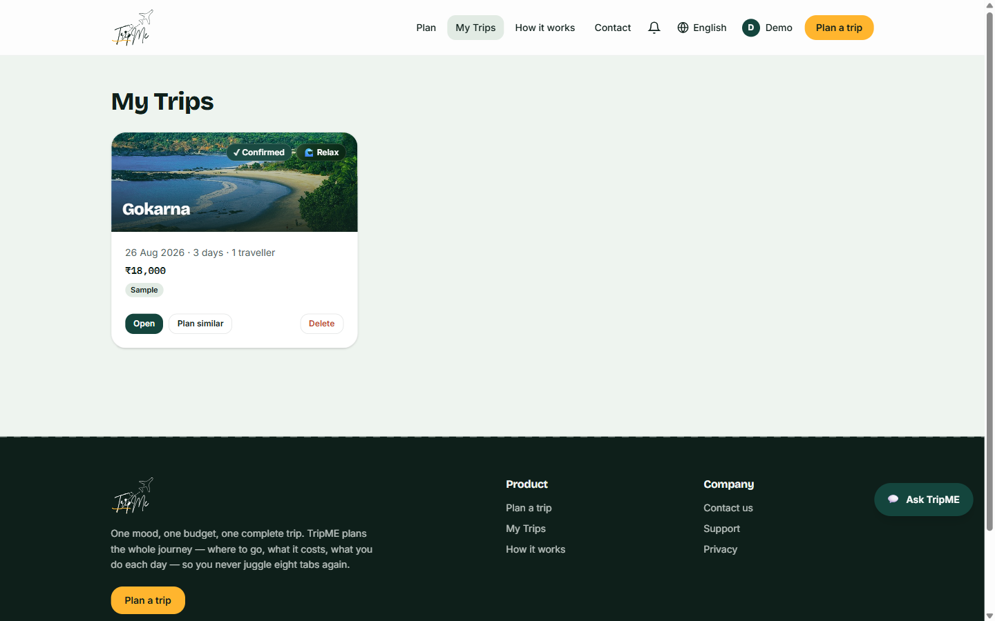
My Trips — one confirmed trip, no duplicates

19 · Seven languages, including what the agents wrote
The interface, the itinerary, the budget notes and the Referee's reasoning are all translated. Most multilingual products translate the buttons and leave the content in English.
What to look at
- The Referee's re-planning narrative is translated with the figures preserved — ₹2,000 → ₹7,000 survives intact, including the strikethrough.
- Currency, dates and percentages are deliberately left in their original form rather than converted to another numeral system.
- Translation runs after generation completes, so the agents reason in one language and the traveller reads in another.
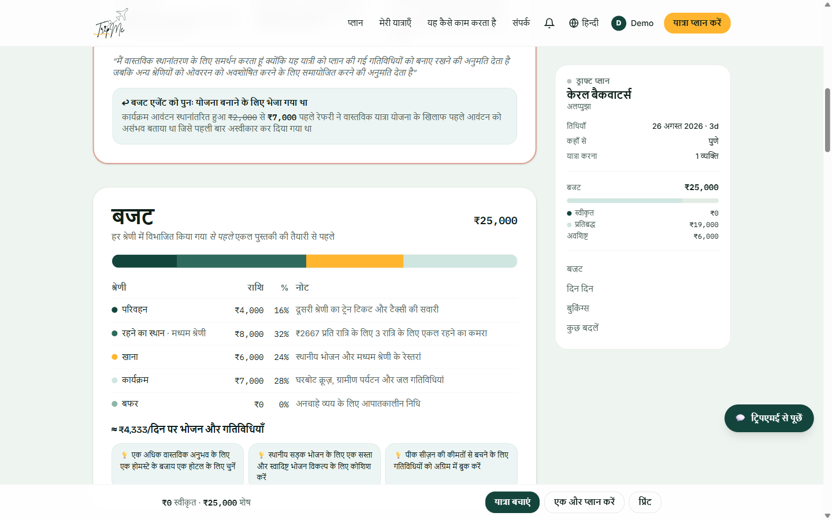
A live-generated plan, fully translated into Hindi

20 · Responsive — the full flow at 390px
Not a reduced product. Every function available on desktop is available on a 390-pixel phone; what changes is density, not capability.
What to look at
- Single column, hamburger navigation, and the assistant collapsed to a bubble.
- The action bar stays pinned, and drops "Print" — the one action that genuinely does not belong on a phone.
- The agent metrics chips wrap rather than truncate, so nothing is lost.
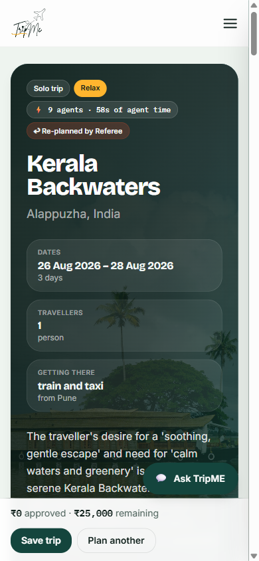
Trip page at 390 × 844
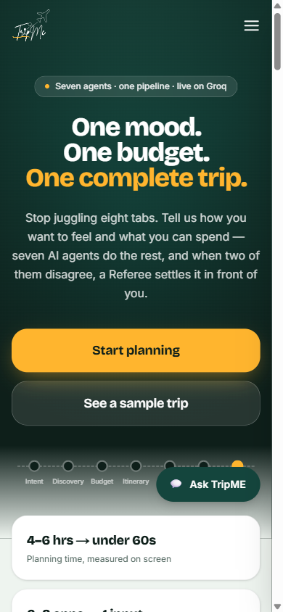
Landing at 390 × 844

21 · How it works — the architecture, stated publicly
A full page explaining the seven agents, the six paths, what is real and what is simulated. Most products hide this; here it is a trust surface.
What to look at
- A What's real, what's simulated panel that separates real, estimated, simulated and partly-delivered — the same honesty the documentation claims, visible to any user.
- "India, and only India" is stated as a scope decision with a reason, not hidden until a user hits it.
- The seven agents are described by what they do, including the Referee's ability to send the brief back to the Budget Agent.
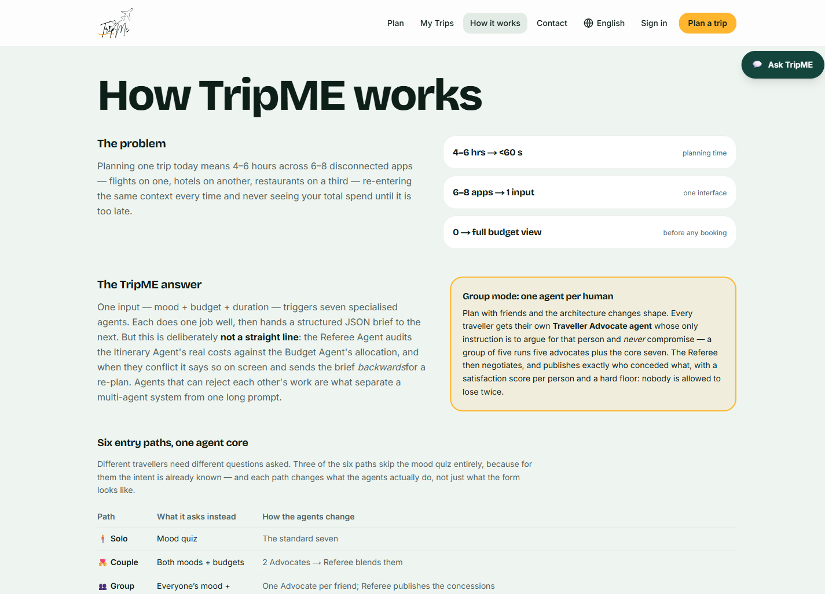
How it works — full page — 1 of 4
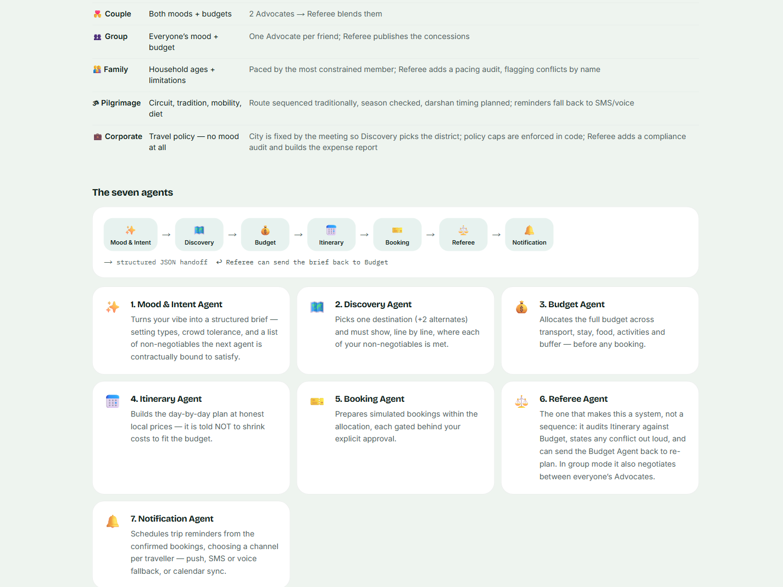
How it works — full page — 2 of 4
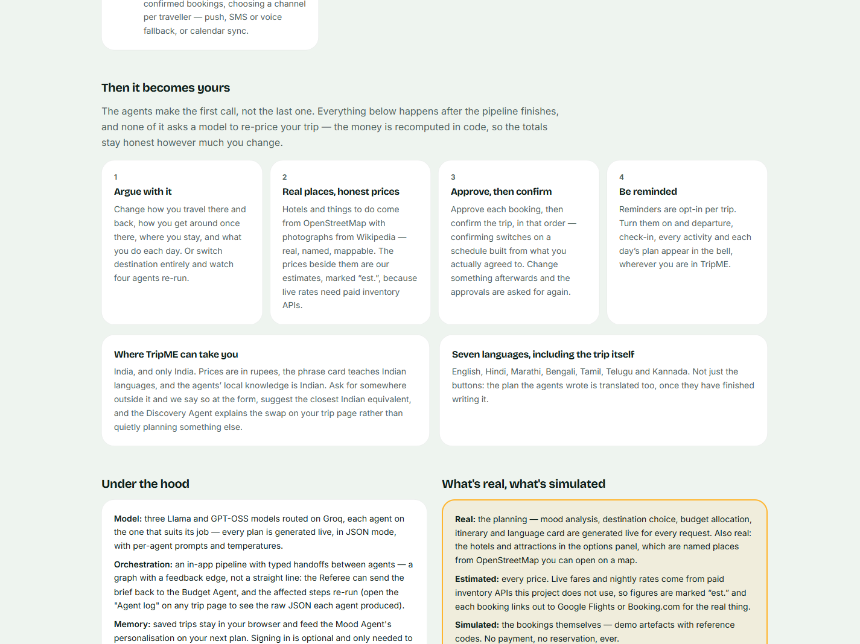
How it works — full page — 3 of 4
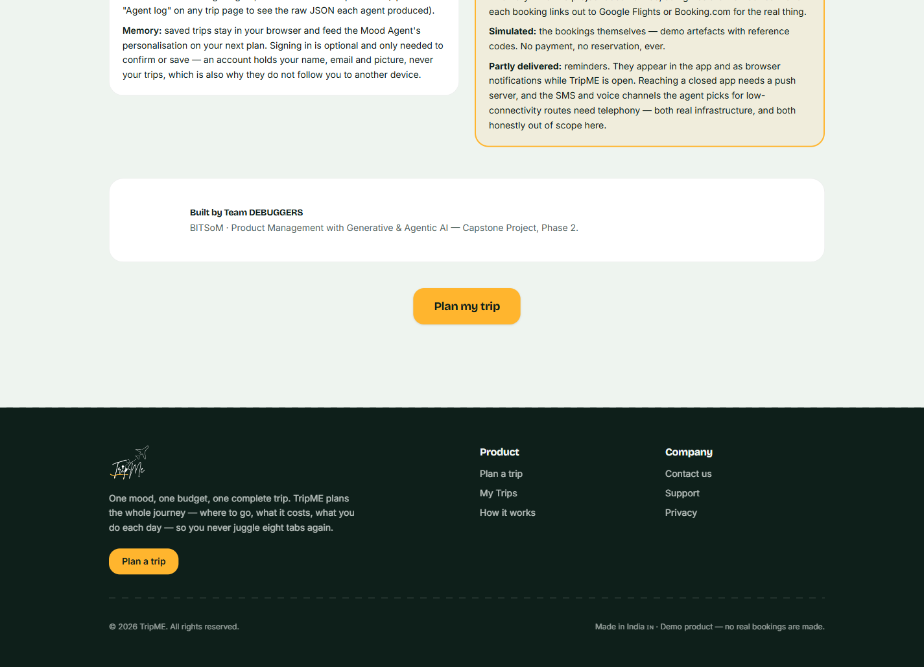
How it works — full page — 4 of 4

22 · Contact
A supporting page, held to the same standard as the product pages.
What to look at
- Consistent with the rest of the product in voice and layout — supporting pages are a common place for a brand to fall apart.
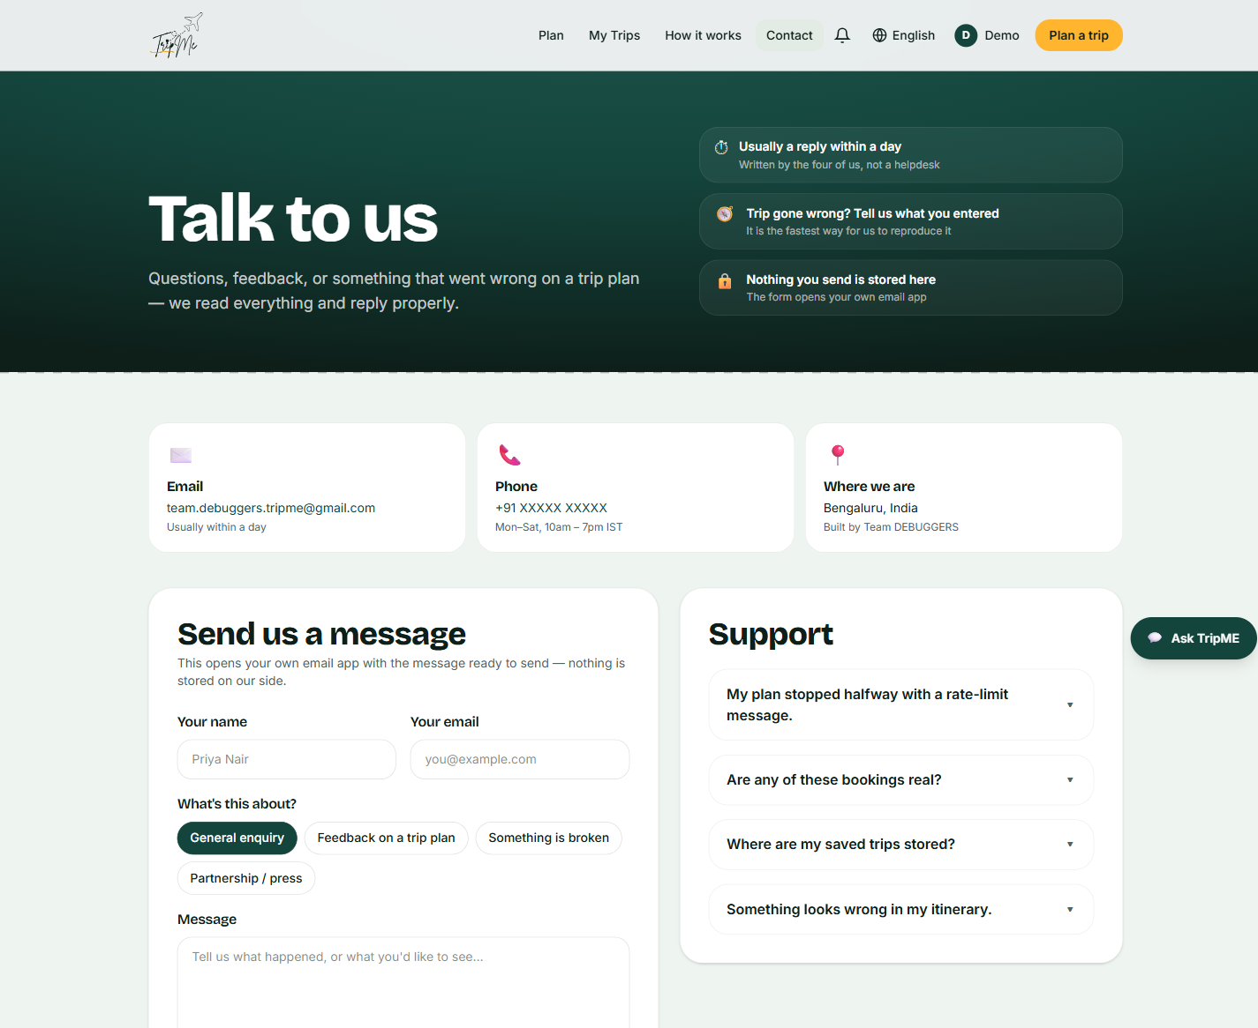
Contact — full page — 1 of 2
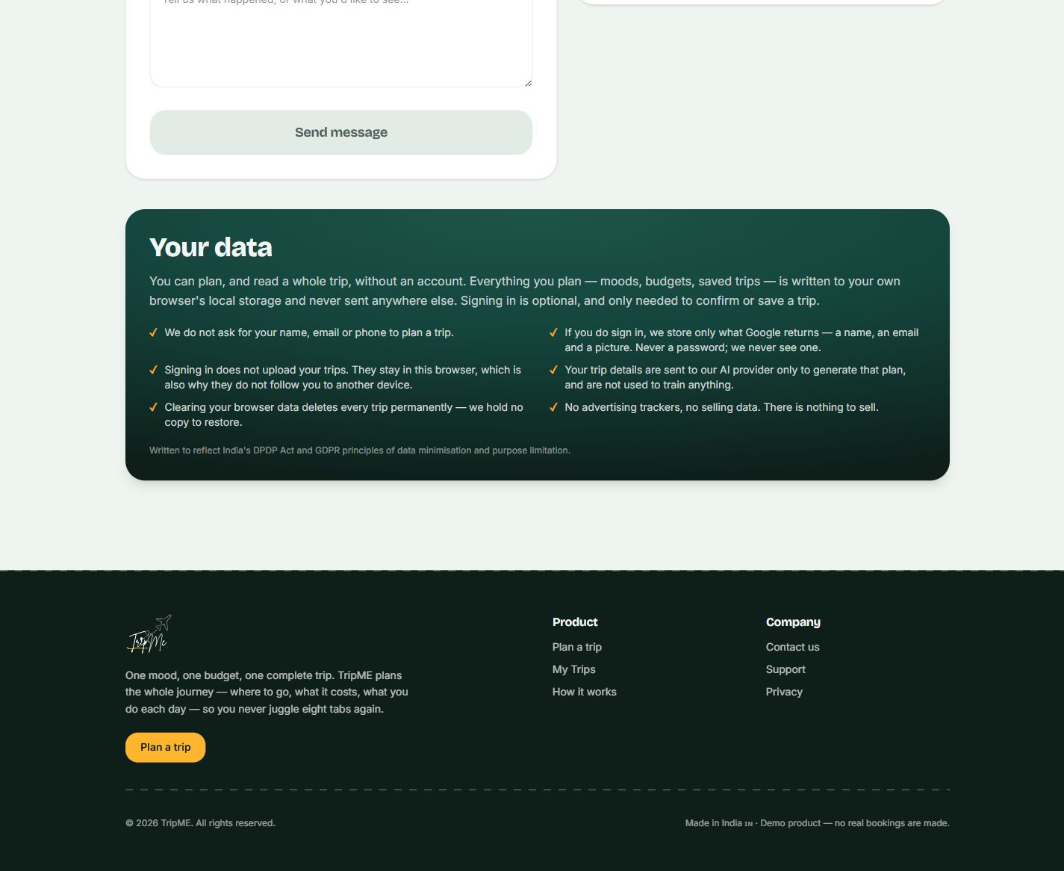
Contact — full page — 2 of 2

Screen index and evaluation mapping
Which screen evidences which claim. This exists so a reviewer can check a specific assertion in the submission against a specific image rather than taking the narrative on trust.
Claim made in the submission | Evidenced by
Seven specialised agents, not one prompt | Screens 12, 13, 14, 21
The architecture is a graph — agents can reject each other's work | Screen 13 (live capture)
Arbitration is visible and quantified in rupees | Screens 5, 6
One Advocate per traveller, with a published fairness floor | Screen 6
Money is deterministic and re-prices on every change | Screens 5, 7, 8, 16
Approvals are revoked when the amount changes | Screen 7
Bookings are simulated and labelled as such | Screens 7, 21
Mood-first entry with no assumed origin | Screens 1, 2, 12
All six travel paths are built | Screens 2, 6, 15
Expense splitting is built | Screen 16
The Notification Agent is built; reminders are opt-in per trip | Screen 11
Authentication gates commitment, not planning | Screens 9, 10
Seven languages including agent-generated output | Screen 19
Real places from open map data | Screen 8
Responsive to 390px | Screen 20
India-only scope, stated rather than hidden | Screen 21
Zero-quota demonstration path | Screen 3

Observed during capture — limitations and rough edges
Recorded because a screen reference that only shows the product at its best is a brochure. Everything below was observed in this capture session on the live deployment.
Observation | Assessment
Whole-page translation of a large live plan took roughly 100 seconds to complete, with a persistent "Translating…" indicator while it ran. | Real limitation, correct behaviour. Translation is chunked and the free tier's per-minute token limit throttles it. The output is correct when it lands and figures are preserved. It is slow, not broken — but it is slow enough that a demonstration should switch language before opening a plan, not after.
A few translated strings are awkward — "Live spend" becomes a literal rendering closer to "alive spend". | Minor quality issue. The glossary in the translation prompt covers agent and product terms; a handful of UI idioms are not yet in it.
Individual small hotels show a map pin rather than a photograph. | Correct behaviour, not a defect. Wikimedia has a properly-licensed photograph of Gokarna but none of a particular guesthouse in it. The alternative — a stock photograph of somewhere else — would be a small dishonesty on a page whose whole argument is that it does not overstate.
Reaching the confirm step requires signing in and approving every booking first. | Deliberate, and the reason the stepper in screen 9 exists. It is worth knowing before a live demonstration, since the confirm and reminder features are invisible until the chain is walked.
The Google consent screen is still in testing, so only listed accounts can sign in with Google. | Known and mitigated by the test-user path, but it must be published before any external demonstration where reviewers use their own accounts.

Design system
The values below are implemented in the product, not proposed.
Token | Value | Role
Pine | #14453D | Primary — headers, primary buttons, the dark ground of the hero
Marigold | #FFB52E | Accent — reserved almost entirely for the single primary action on a screen
Off-white | #EFF3F1 | Page ground
Card | #FFFFFF | Surfaces, at a 24–32px radius
Flag | #B4361E | Warnings, simulated-booking labels, destructive actions
Display face | Bricolage Grotesque | Headings — gives the brand a voice
Text face | Inter | Body
Numeric face | IBM Plex Mono | All money and metrics — this product asks people to trust its arithmetic, so figures are monospaced and aligned

Layout: a 1440px content frame with a persistent right rail on the trip page, collapsing to a single column below 1024px. Motion is restrained — a three.js globe on the hero for capable devices, disabled elsewhere, because atmosphere should not cost a traveller their battery.
[ TO BE INSERTED ] Figma component sheet, if the team wants a separate design-system artefact. — Optional — the values above are the implemented source of truth, and this document supersedes the wireframe placeholder in the Phase 2 submission, Section 29.

