**User guide of Colombo Institute of Studies**

**© Colombo Institute Of Studies 2023**

**Introduction**

Welcome to the "Colombo Institute of Studies Employee Management System" User Guide. The purpose of this tutorial is to help HR managers and administrators use the newly built system's capabilities and navigate it. The system's goal is to automate and expedite the process of maintaining employee data, allowing HR staff to work more effectively on a variety of duties.

**About the System**

The "Colombo Institute of Studies Employee Management System" is a user-friendly and easy-to-use program designed to make the duties of the HR department easier. HR managers may effortlessly add and manage departments, designations, workers, and user accounts with the system. To provide safe and restricted access to the system, administrators can make new accounts for HR Managers and HR Assistants.

1. Adding a New Department:

Log in as HR Manager.

Select the "Add Department" option.

Enter the department name and submit.

1. Adding a New Designation:

Log in as HR Manager.

Select the "Add Designation" option.

Enter the designation name and submit.

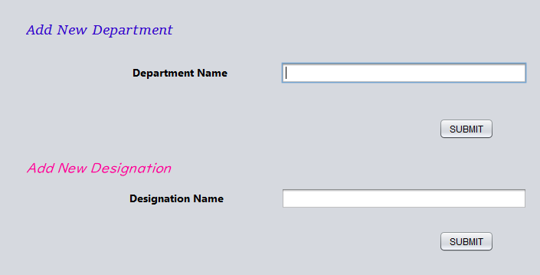

1. Adding a New Employee:

Log in as HR Manager.

Select the "Add Employee" option.

Enter employee details (name, ID, contact, department, designation) and submit.

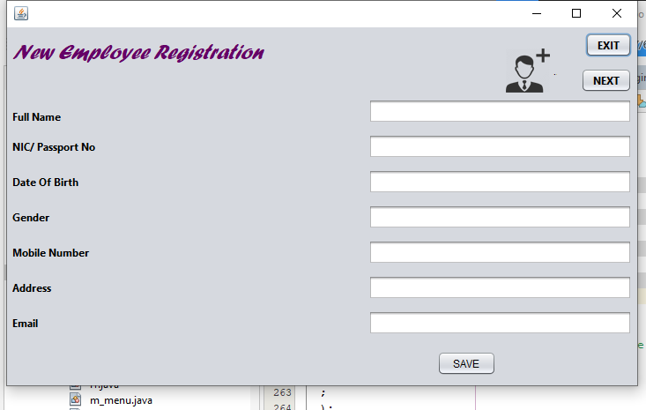

1. Searching for Employee Details:

Log in as HR Manager.

Select the "Search Employee" option.

Enter search criteria (department, designation, name, employee ID, etc.) and submit.

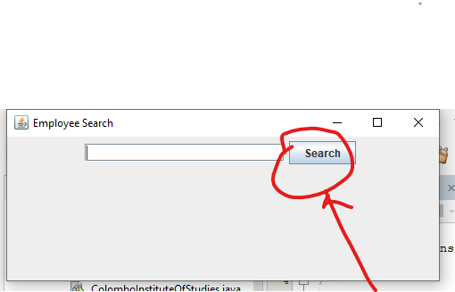

1. Creating a New Account:

Log in as Admin.

Select the "Create Account" option.

Choose the user type (HR Manager or HR Assistant).

Enter user details and submit.

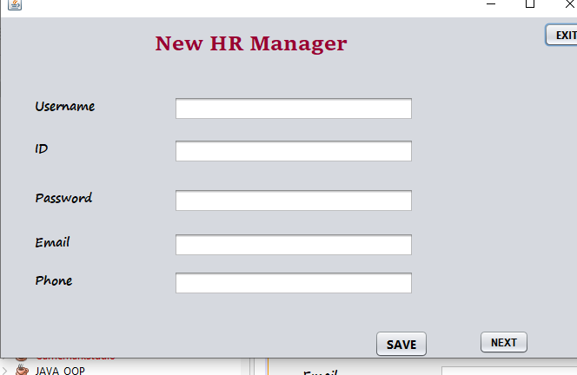

Same UI for HR assistant

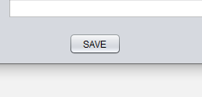

*Note: Ensure to save data regularly using the "Save" option to prevent data loss. Data save in a file .*

Thank you .