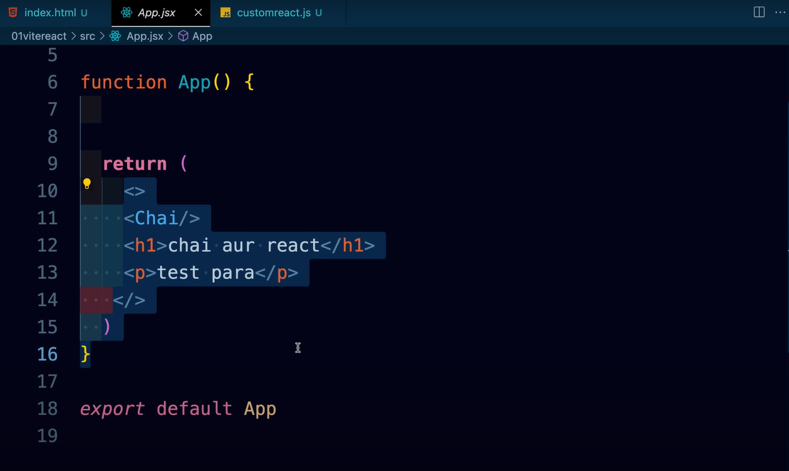
This is a component which is exported to main.jsx file to be injected inside of index.html file

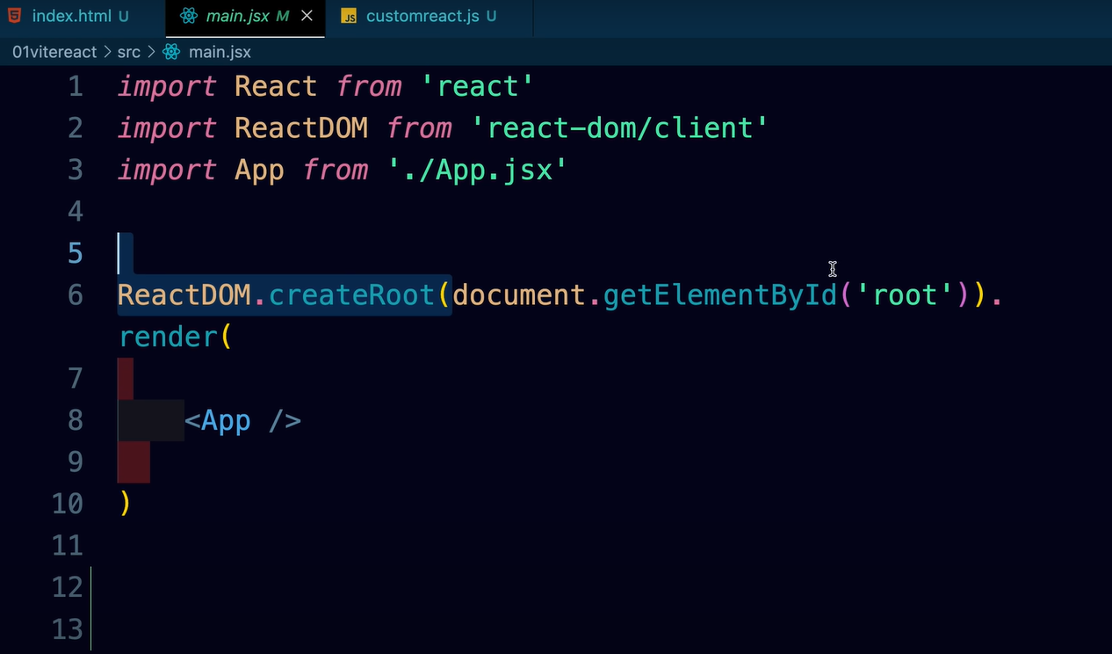
here is our ReactDOM.createRoot function that takes a container present in index.html having id of “root” after which a desired output in generated once the react app is started using script “start run dev”
here is the abstract representation of createRoot.
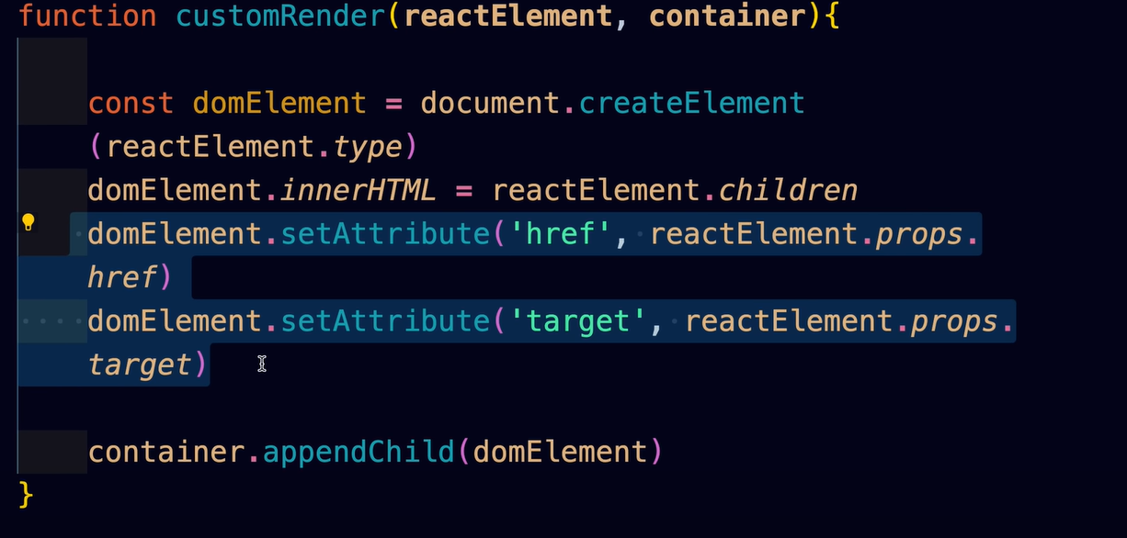

Now when we send a component in the createRoot function it converts the html into into a object.

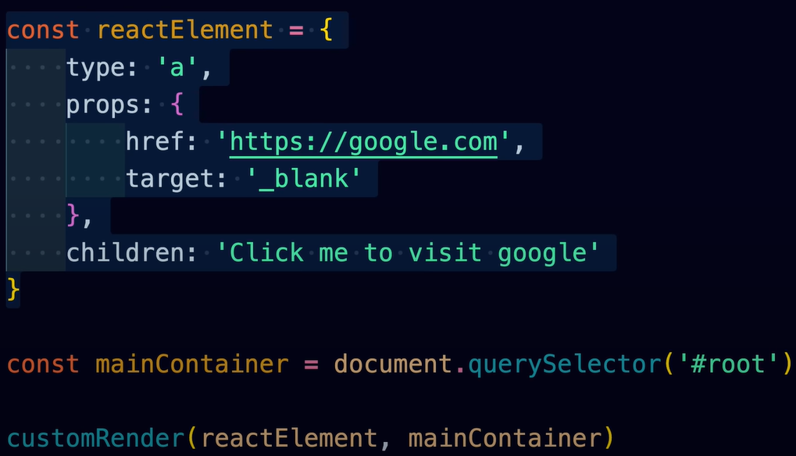

We can send following things in render function:
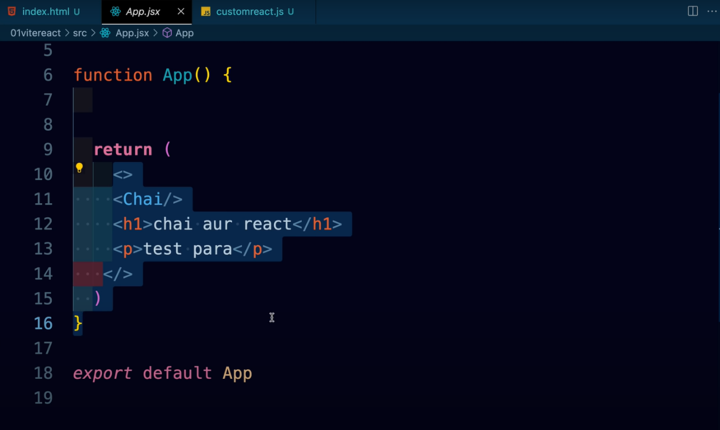
- a component:

- A jsx html:

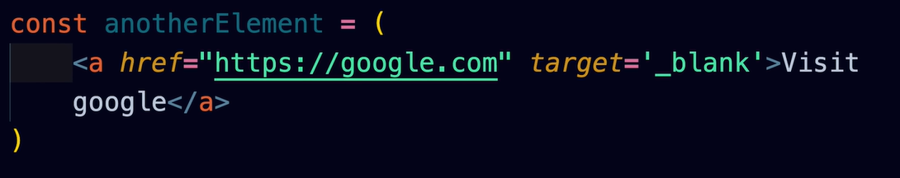

- A react element:

