1. what is software ? what is software engineering ?

ANS software mean set of instruction provided to the system for execution is know as software

and software engineering mean deals with web application, testing, maintenance is know as

software engineering.

1. Explain type of software ?

ANS There are two main type of software 1 system software , 2 application software

1 system software : is software that directly operates the computer hardware and

provide the basic functionally to the user as well as to the other software to operate

smoothly is know as system software. Ex windows , android , ios.

2 application software : software that perform special functions or provide function

that are more than basic operation of computer is known as application software ex

MS word , web browser ,game.

1. what is SDLC ?explain each phases of SDLC ?

ANS SDLC mean minimize project risks through forward planning so software meet consumer

Expectation during production is know SDLC

1. planning : when an organization identifies and assign the task to the resource they

analyzed and build the structure.

1. analysis : analysis mean gathering all the specific information identifying issues and

the recommend or develop possible system improvement

1. designing : designing prototype provide a basic idea that how application looks and

what it can do is know as designing.

1. implementation : implementation is putting plan into an action breaking a project into

logical stage is know as implementation

5 testing: testing mean the process of executing a program or part of program

with the intention of finding error

6 maintenance : maintenance mean performance of improvement , security

Enhancement, and re-evaluating is know as maintenance

1. What is DFD? Create a DFD diagram on Flipkart?

ANS DFD mean maps out the flow of information for any process or system.

Is know as DFD

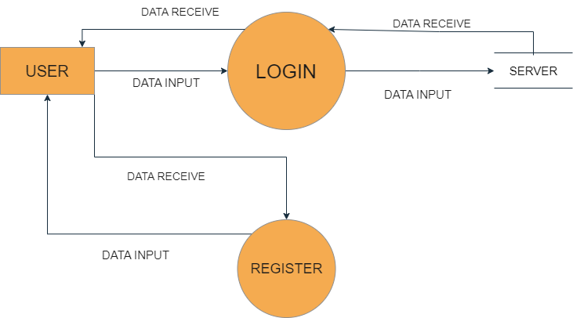

LEVEL 0 DFD OF REGISTER AND LOGIN OF FLIPKART

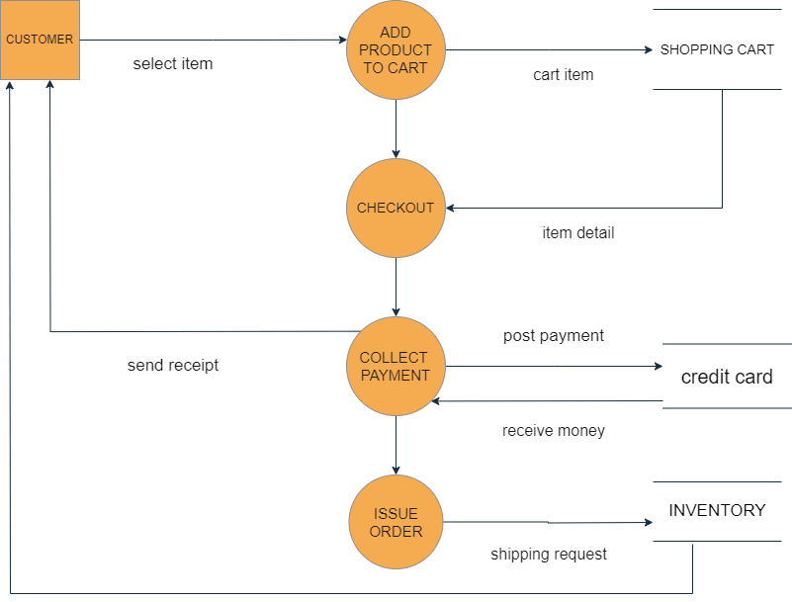

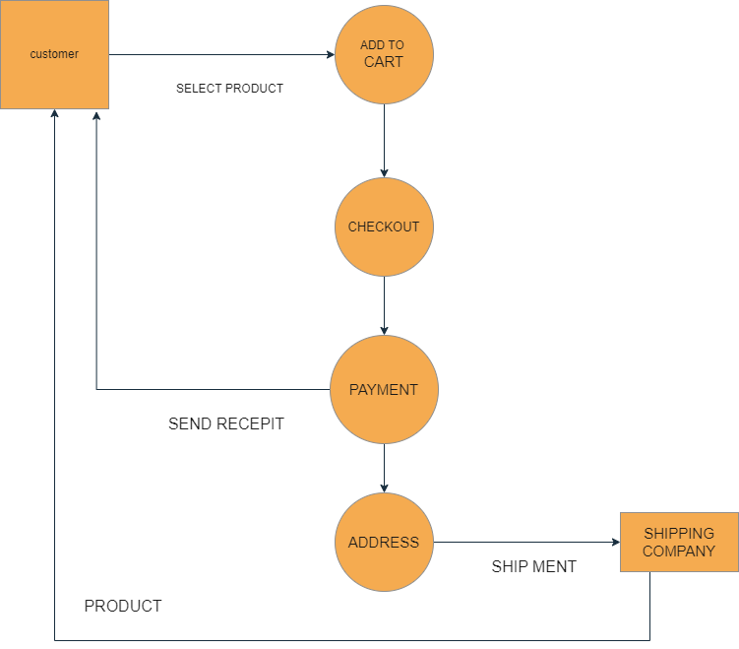 LEVEL 1 DFD CART OF PRODUCT IN FLIPKART

LEVEL 2 DFD SHIP MENT OF PRODUCT ON FLIPKART

1. What is Flow chart? Create a flowchart to make addition of two numbers?

ANS  flowchart is a diagram that illustrates the steps, sequences, and decisions of a

Process of workflow.

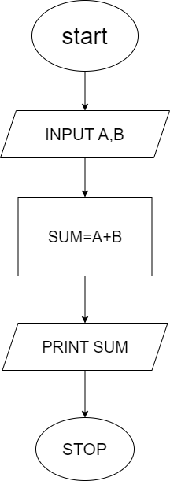

1. What is Use case Diagram? Create a use-case on bill payment on payment?

ANS use case diagram involves deconstructing processes in order to reveal a

basic overview of your system.

