**Software Definition**: Dropbox prototype

**Goal**:

To provide a solution for storing data and files online with ease of internet and allow to access, share, download data when it needed with proper authorization.

**Purpose:**

The purpose of this application is providing a system which allows user to put their file online and access it from anywhere.

It also allows user to download the file when they needed. System also provide the facility to share the files among other users or someone outside the system. It also allows user to quickly view the stared files.

**System Design:**

We are using **MERN Stack** which include

1) **Mongo DB** as database,

2) **Express Js, Node Js** as backed server

3) **React Js** as frontend.

**Mongo DB**:

Mongo DB is much more better than our traditional RDBMS databases.

Below are some properties which make it better than traditional RDBMS databases.

* **Schema less** − It is a document database. One collection can hold different kind of documents. Number of fields, content and size of the document can differ from one document to another.
* Clear Structure for a single object.
* complex joins not allowed.
* document-based query language: MongoDB supports dynamic queries on documents using a document-based query language that's nearly as powerful as SQL.
* Easy to tune.
* **Easy to scale-out** − MongoDB is easy to scale and its one of its inbuild functionality.
* BSON: Application objects can be directly stored in mongo DB. We do not need to convert them in database object form.
* Fast access: It Uses internal memory for storing the working set, which is allowing fast access of data.

These are not only features which make it better. Below are some more points which make it the best for our purpose.

* **Document Oriented Storage** − Data is stored in the form of JSON style documents.
* It allows index on every attribute
* It allows inbuilt replication and in result high availability
* It includes Auto-sharding
* Fast in-place updates

In our solution we have used mongo DB with only **one server** i.e. without replication.   
We are using our awn **connection pooling** to accommodate high number of database calls without opening and closing connections. Connection pooling is described in later topics.

Also, for ease of work, a **database util** file is created to accommodate all the database operations and a centralize access of connection from one file itself.

**Node JS :** It is used for the server implementation in our solution.

Some of the benefits using node Js is as below.

* **Asynchronous I/O**

The core of node js is to handle asynchronous I/O calls from the ground up and it is a useful solution for most of web- and network-development problems.

In addition to fast JavaScript execution, Node Js has benefit of asynchronous I/O calls which makes the system much faster.

* **Javascript**

Node.js is Javascript.  As we always have javascript on client side, we are making our whole system running on java script and making it single language application.

* **Community Driven**

It’s a community driven language which makes is more open for new enhancements added by the wild java script community available in outer world. One of the most famous is  [Socket.io](http://socket.io/), a module to manage persistent connections between client and server, enabling the server to push real-time updates to clients.

Node mailer is another example of the same and it is also used in our solution.

In our solution, Node js is used for back end business logic implementation. As it is asynchronous, it allows fast execution and high throughput for the application.

Modularity is implemented in the system by putting proper code in the proper directory. This also improves the readability of the system.

Each function is made as small API calls for reusing purpose to reduce the code redundancy.

**Express JS:** Express js is used for web framework.

Express Js has benefits over plain vanilla node js.

* Using express js, the web service implementation is made easy when compares to plain vanilla node js.
* Express js allows access to node modules like CORS for multi domain application.

The CORS technique is used to separate the client and server and still maintains integrity.

We have app.js as controller of the server which catches all the incoming request and redirect them to the handler.

**React JS**: On Client Side, we are using React Js**.**

* The purpose of using react js is to take advantage of unidirectional data flow in UI and partial rendering technique.
* It allows use to render a small part of DOM where the change is needed. Also the changes made are really quick as they are event driven.
* The CORS technique allows the React client to send data to the Node Server.
* Easy support for bootstrap using react-bootstrap module

In reach Js we have a request sender named API.js which is taking care of all the request sending and response gathering from the node server.

Bootstrap and material UI is used to make the system more interactive.

Apart from MERN stack, other components are also used to make the solution more durable and more reliable. Those technologies are as below.

**Kafka Message Queue**: Kafka message queue is used to increase throughput of the application in case of multiple servers available.

Benefits of using **Kafka** is as below.

* **Kafka is Highly Scalable**
* **Kafka is Highly Durable**
* **Kafka is Highly Reliable**
* **Kafka Offers High Performance**

**To get benefits of above mentioned features, Kafka is used in the solution provided.**

**The whole back end is divided into 2 parts.**

1. **Express/Node backend webserver: This part contains Express web application which handles incoming requests and redirect them to respected node handler.  
   Node handler puts the request in the message que and start listening on the response queue. When response received, it revert it back to the client.**
2. **Kafka back end application : This part keep listening on kafka queue for any request message.  
   If any message received, it is transferred to proper api to handle and process the request.  
   The output of API is then appended to the response que.**

**Passport JS:** The main purpose of passport Js is User Management as a Service.

Passport JS allows us to provide our own user authentication, also Everyauth of passport js allows us to authenticate user by using Google, Yahoo, Twitter etc accounts.

Passport Js stores User Session ins database and so the session management is made horizontally scalable.

Passport Js is used with express session and express cookie management.

**Connection Pooling**: a custom connection pool is implemented to make pool of connection in bulk and use them when needed.

The connection pooling technique Pseudo code is as below.

**var** *createConnectionPool*=**function**(count,callback){  
 **for**(**var** i=0;i<count-1;i++){  
 *createConnection*( **function**(err, _db){  
 free_pool.push(_db);  
 });  
 }  
 callback(**false**,**true**);  
}

**var** *getConnection* = **function**(callback){  
  
   
 **while**(free_pool.**length**==0);// wait till pool has some connection to give  
 **var** db = free_pool[0]; //taking first connection from pool  
 free_pool = free_pool.slice(1,free_pool.**length**); // removing connection

// from pool  
   
 callback(db);  
   
};

**var** *closeConnection* = **function**(db){  
 free_pool.push(db);// pushing connection back to the pool  
}

**Prepared Statement**: For eliminating all kind of SQL injection, prepared stamen technique is used while communicating with database.

**Centralize DB API**: one centralize API is made to work with database and accommodate all possible DB operations in one file and to reuse the same code everywhere.

Also it allows the system to be open for any enhancement in connection creation and pooling ways as its only one file where we need to put the change and all other files will be automatically changed.

**Authenticity Interceptor:** In Express The system is using one server interceptor to authenticate each and every request. If requests is authenticated, it will be redirected to handler else the unauthorized access status will be send to the client.

**bCrypt**: While storing passwords into the database, **bCrypt** encryption is applied to make passwords unreadable.

The Salt and Hash technique is used to make password more secure.

**NodeMailer** is used to send sharing notification to the users about file sharing.

**Database Designs:**

**Users:** To store user signup information and user profile information

**Directories**: The Collection is used to keep track of directories in the system.

**Directory_Logging**: this Collection is used to store the operations performed on the directory by user

**Directory_permission**: This Collection is used to store directory sharing information

**Staerddir**: This Collection is used to store starring information of directory by user

**Usergroup**: This Collection is used to store data related to user group and associated users in the group.

**System Flow:**

The system starts with the login/Signup pages.

**Sign Up**:  This is the functionality which a user can use to register themselves with the system to use its functionality.

The users will have a screen where they must insert some basic information such as first name, last name, username, email address, password.

After successfully inserting data, user clicks on the Signup button and the system is doing basic validation on the values entered by the user.

If all data are correct, the system is generating a new account for the user and redirect them on the signin page to use the system.

As the password is the most crucial thing,It's encrypted before storing in the database.

Collection Used to store information: **users**

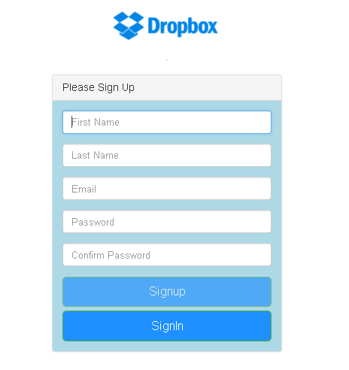

**Sign In:**

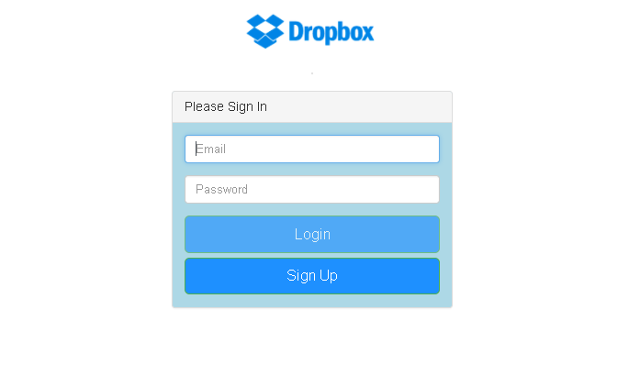

This is the entry page to the system. User must have to login to access the application.

On this page, user have to insert username and password for validation.

After successfully inserting the information, user clicks on sign in button and the server validates the inputs entered by the user.

Then the system matches the data with the available records in the database. If it matches , it allows the user to get into the system and use the feature.

The system then redirects the user to the welcome/home page.

Collection Used to get information: **users**

**Home Page:**

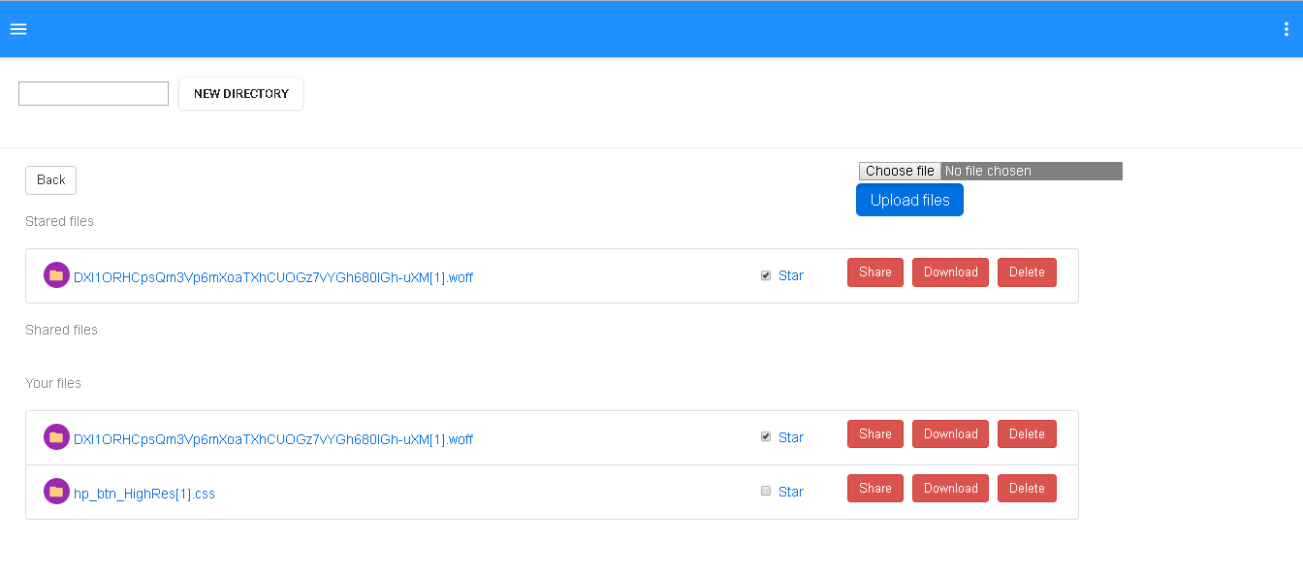

This is the page where most of the functionality of the application resides.

It contains File listing, file sharing, file download, file deletion.

It also includes directory creation and links to the user profile and user activity logs.

**File Listing:**

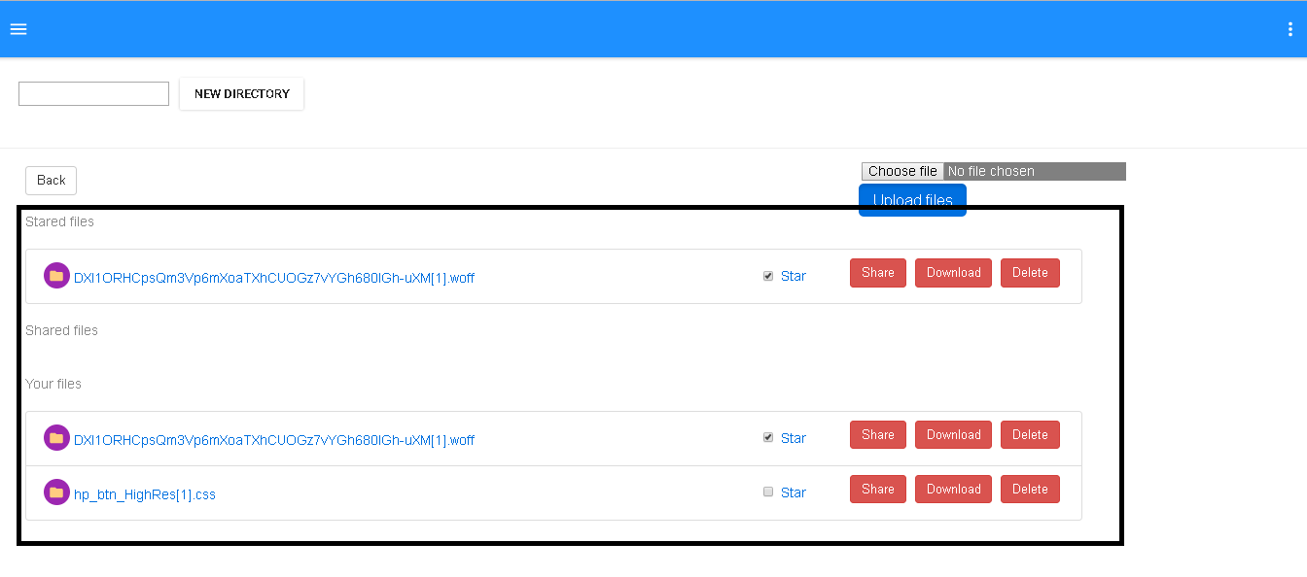

Each user has their own set of directories which they can access. On home page, the user by default have the list of already uploaded or shared files.

User can also Star the file and it will be shown in the starred tab of the screen.

Collection Used to get information: **Directories**

**Upload File**:

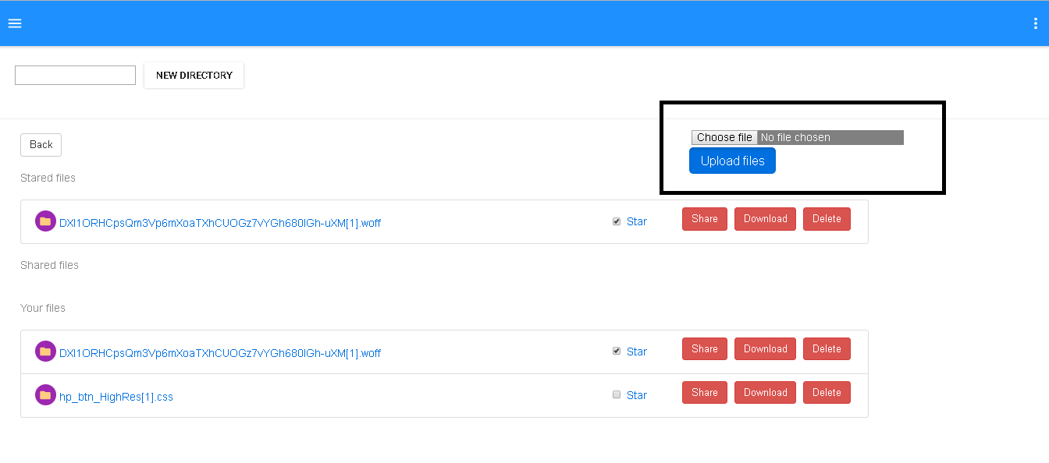

This functionality allows user to upload their own file into the system.

User can select a file from file chooser available in the screen and click on upload. After that, the system will check the current directory to upload the file. The file will be uploaded and the same will be noted down in the tables.

Collection Used to store information: **Directories, directory_logging**

**Create Directory**:

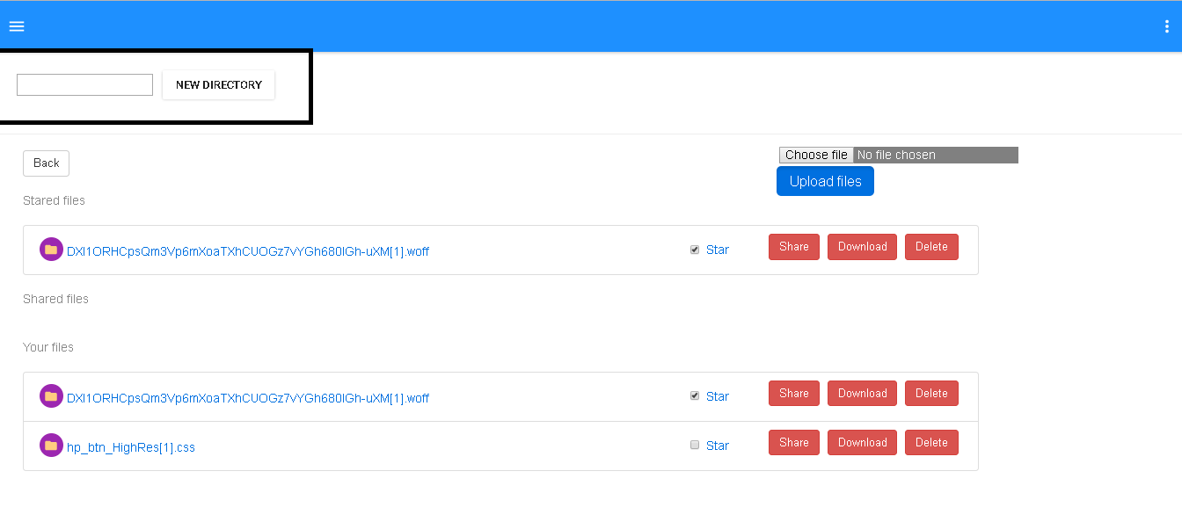

This feature allows user to create new directory. The user can input name in the text box and clicks on the new directory button. In response, the system creates new directory and logs that in respected collections.

Collections Used to store information: **Directories, directory_logging**

**Star Directory:**

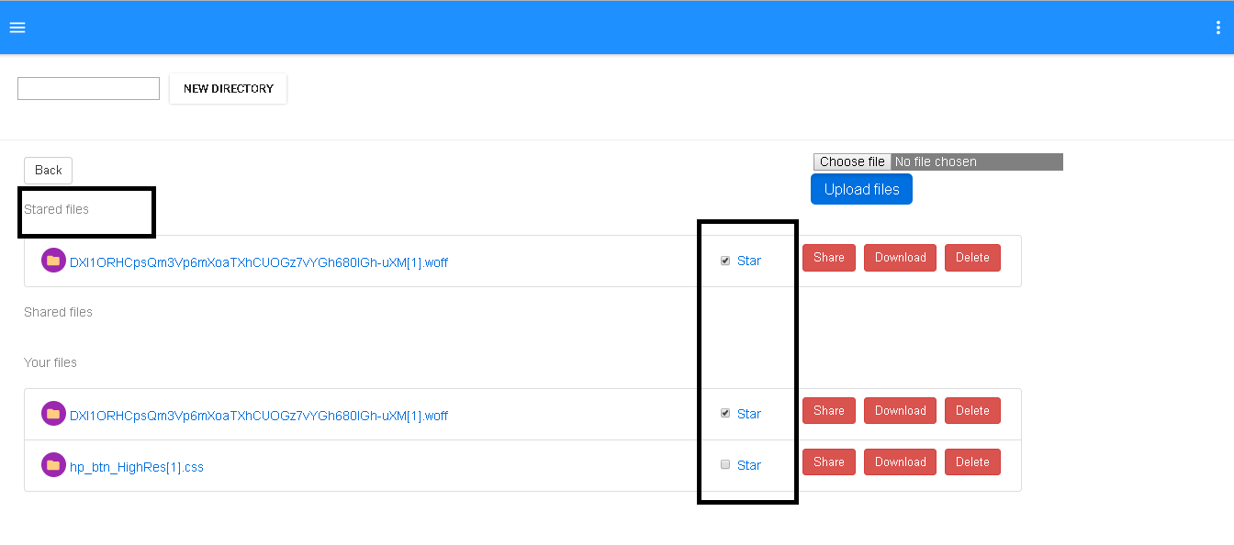

User can start a directory or file to show them always up in the stack. The user will click on the star checkbox and the system will toggle the star status of the directory/file.

Tables Used to store information: **stardir**

**Share Directory/File:**

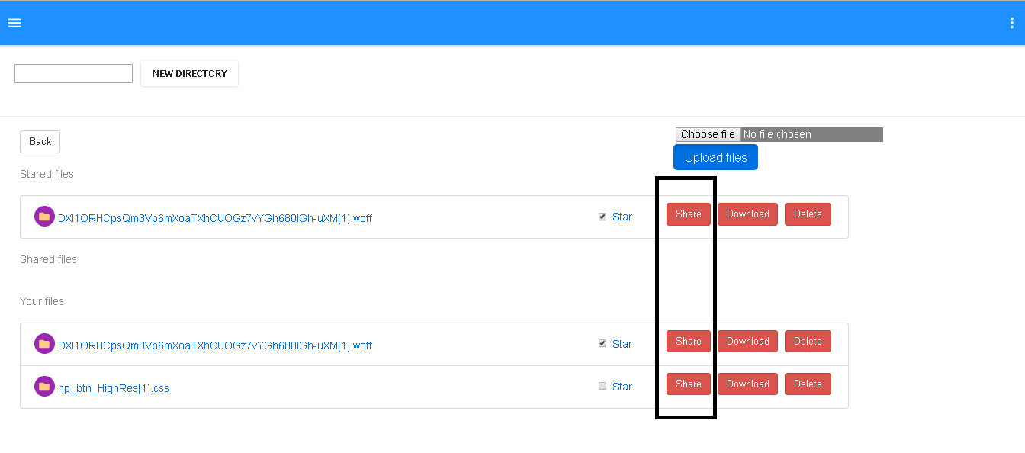

The user can select the share button and a text box will pop up which allows user to enter comma separated email address. By clicking the share button, the user submits the request.

The system then decides that given email address are contains all existing user or any user outside the system.

If any user is outside the system, system asks user that the sharing is going to happen by link and anyone having the link can accept it.

After having user’s consent, system shares file as link and send a message to notified users.

If all the emails are of existing customers only, te system shares file as user permission and shared users can see the file in their file list.

Tables Used to store information: **directory_permissions**

**Download File :**

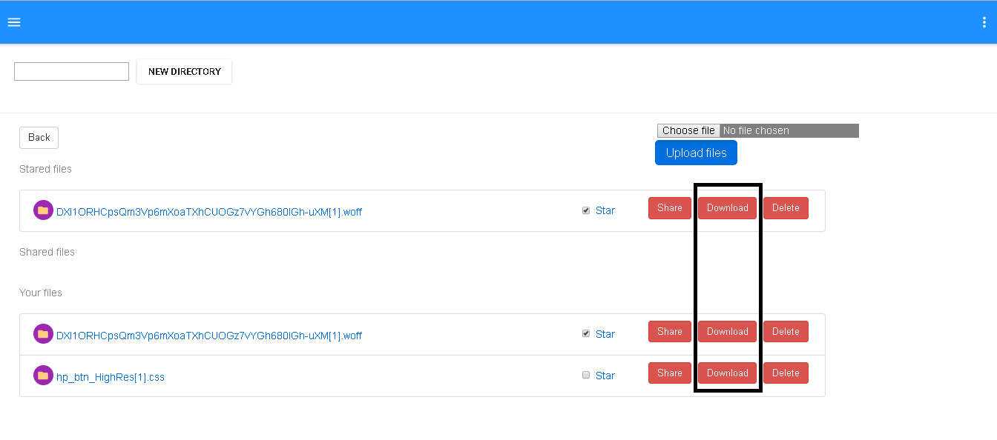

This functionality allows user to download particular file . User will just click on the download button and the system will download the file on the browser.

**User Profile:**

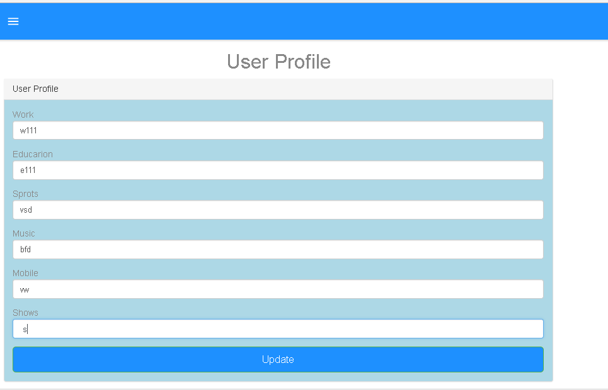

This feature allows users to add/update their user profile which contains user’s extra information.

Users will enter the details in the text boxes and clicks on the update button.

The system then stores data into the system and repopulate it on the screen.

Tables Used to store information: **userprofile**

**User Activity Logs:**

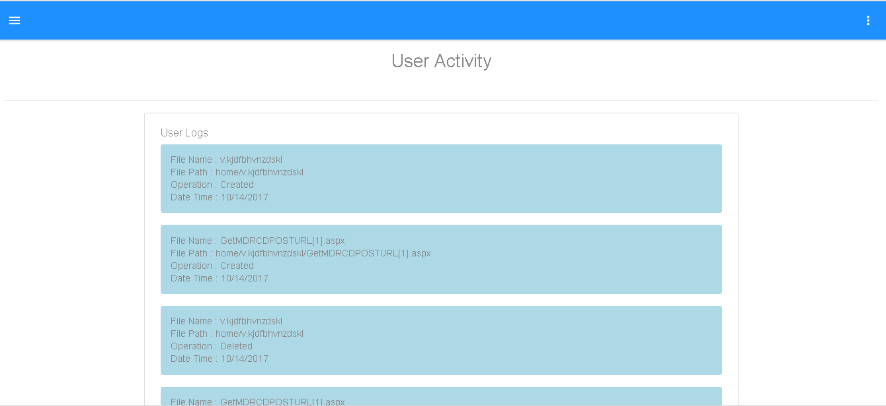

This functionality is used to show user’s their activity log on the files. The user can see their file activities in a table.

Tables Used to store information: **directory_logging**

**Sign Out:**

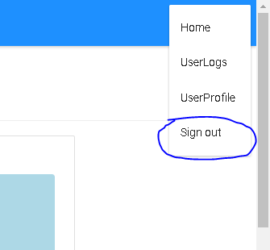

This functionality allows users to securely letting user to logout from the system.

**Performance**

After running the system, performance being measured is as follow.

1. The system is responding every request within 10 seconds.
2. The System is handling all the expected errors
3. System is changing routes for the functionalities accordingly
4. System allows users to insert data in UI when necessary
5. System is changing necessary part of DOM instead of refreshing whole page
6. Every operation is well performed and executed properly on the server
7. Whenever needed, proper loggings are performed to the operations
8. Crucial data are safe and not shown on the UI
9. UI is always free for the user to perform any task as all the activities are asynchronized
10. Code is calling proper API for proper operations
11. System is not allowing any unauthorized calls to get data

Why This Performance?

React JS is used to **prevent unnecessary refreshing of pages**. Instead of that it only renders the necessary part of the DOM.

The **UI never freeze** and allows user to interact with other functionalities due to **unidirectional** flow of React JS.

**API calls** are written to minimize the server calls and make code more readable.

As node JS in available in backend, the **callback functionality** is used to make the calls **asynchronous** when needed.

**Small methods** are implemented to perform small tasks to **remove code redundancy** **and increase code reusability**.

**Connection Pooling** is used to decrease time of connection creation and closing. Which improves the response time of the system.

**Prepared Statements** are used to make the database inserts more reliable and secure by preventing possible SQL injection attacks.

**Q1)** **Explain the encryption algorithm used in your application. Mention different encryption algorithms available and the reason for your selection of the algorithm used.**

**Encryption Algorithm** :

The algorithm used in the system is bCrypt with salt and hash technique.  bCrypt is hashing based algorithm which was designed first in 1999 by Niels Provos and David MAzieres.It is based on the Blowfish cipher, and presented at USENIX in 1999.

In today's’ time where security is the most concern for IT industry, there are a lot encryption algorithms available to claim a proper security of data. Some of them are as below.

1. bCrypt
2. RSA
3. SHA-256
4. SHA-512
5. AES
6. Triple DES
7. Twofish

These all are mainly categories in Sympatric Encryption, Asymmetric Encryption and Hashing Algorithm.

**WHY bCrypt?**

bCrypt is a hashing encryption algorithm which claims of being slow. Which allows less scope for the attackers to run the bulky script fast. This automatically decreases the risk of brute force attacks.

To add more, most of the industrial attackers prefer to avoid PC over GPU as they are allowing more use of cycles. As bCrypt relies on the hashing table throughout, this method works fast in individual PC then the GPU systems. So attackers are not getting boost which they used to have while cracking other encryption algorithms.

Also this 11 + year old algorithm is also recommended by a lot industry experts.

**Q2) Compare the results of graphs with and without connection pooling of database. Explain the result in detail and describe the connection pooling algorithm used in your code.**

**With Connection Pooling**

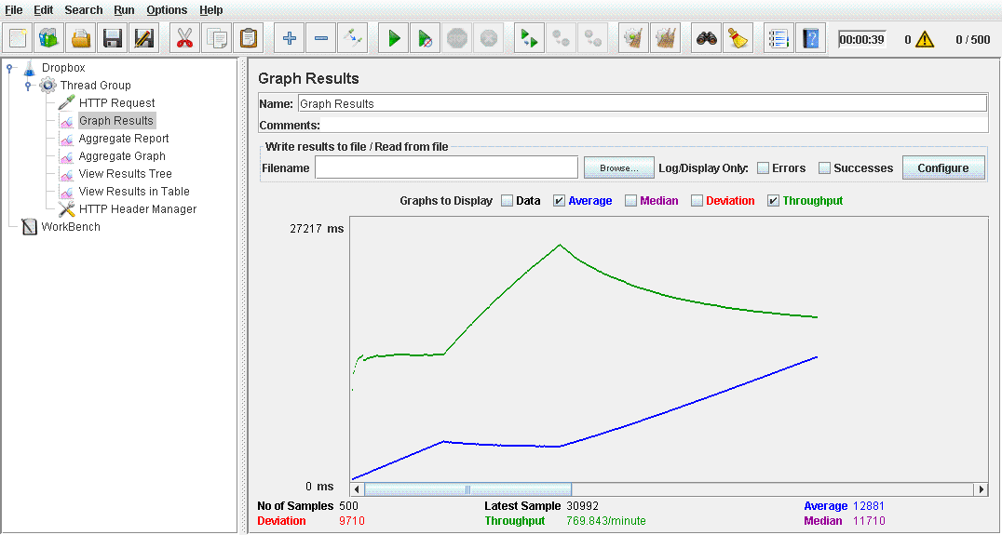

**Without Connection Pulling**

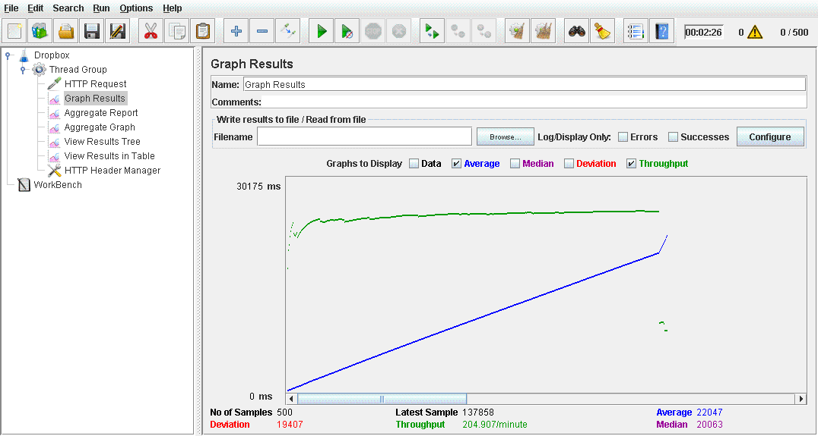

1. While comparing the graphs which of Jmeter tests i).Before connection pooling, ii). With connection pooling clearing shows that connection pooling is much better.
2. We can see the average time low when we are using connection pooling over not using it.
3. Also the throughput is high with connection pooling which allows multiple simultaneous calls from the users.
4. When number of concurrent user increase, the connection pulled db will not affect more as we don’t need to constantly open and close the connection. We are already having a thread of pool which is configurable according to the application use. If we are not using pooling, then we need to constantly create and close the connection which is very high weight process and needs much time.

In the code, the connection pooling algorithm used is the default mysql connection pooling algorithm. This algorithm actually creates the configurable number of connection and create a pool of it. When we need a connection, it returns us a connection available in the pool which is not being used by any other activity. When the work done, instead of closing the connection, it actually put it back in the pool and make it available to use.

**Q3) What is SQL caching? What all types of SQL caching is available and which suits your code the most. You don’t need to implement the caching, write pseudo code or explain in detail.**

SQL caching is the technique to store the sql data in physical memory to reduce the DB io calls.

SQL caching can be of many type. Some of them are as follow.

1. Adhoc query caching
2. Autoparameterization
3. Prepared queries
4. Stroed Procedures or other compiled objects

Adhoc Query caching are type where the database caches some adhoc queries and stores them as a cache. As this query are adhoc, we cannot actually rely on them as the tables can be altered after the caching.

Auto parameterization: This kind of caching we can refer to the prepared statements. When we are running same query again and again multiple times with same or different parameters, the database changes the parameter part as a generic part where different parameter can be put and executes.

As we can see this is useful in redundant query scenarios, we have to do the forceful auto parameterization to store all such queries and which will increase the number of unnecessary queries stored.

Prepared queries: we can create such kind of batches in the code and execute them in batch to reduce the server’s query plan generating process. Also, the DB has its own prepared queries storages.

Stored Procedures: This are known type of SQL caching where we can actually store the queries in the Database and use them when needed.

Also, now a days, server side caches are available such as memcache. We can store the queries which their desired output by assuming that the content of the table is not going to be changed.

They are storing data as key (query), value (table data) pair from where we can easily access it.

Ref: <https://msdn.microsoft.com/en-us/library/cc293623.aspx>

**Q4) Is your session strategy horizontally scalable? If YES, explain your session handling strategy. If NO, then explain how can you achieve it.**

Yes, as the system manages session on server side, rather than client side it is horizontally scalable.

Also, it is using rest less API and passes the unique identity of client via session.

Here we are achieving a stateless protocol and managing the sessions on server side. The Sessions are not actually stored in the server but they are recognized by the server as it was created on server itself.

In my application, server has the sole responsibility to manage the sessions.  Sessions are generated, altered and passed in any response which server is sending to the client.

The client does not know anything about the session, it just gets it in response and pass it again in every response and the rest is all up to the server.

In the system, sessions are also used to authenticate the logged in user request and fulfill the stateless protocol. The system has one interceptor which is tracing all the request from the client and checking about the authenticity, if it founds that the request has no session or invalid session, it stops the request and responses with the 501-unauthorized access status.

**Jmeter Testing for DropBox (Restfull API)**

1. **Without Connection Pooling**

**100 users**

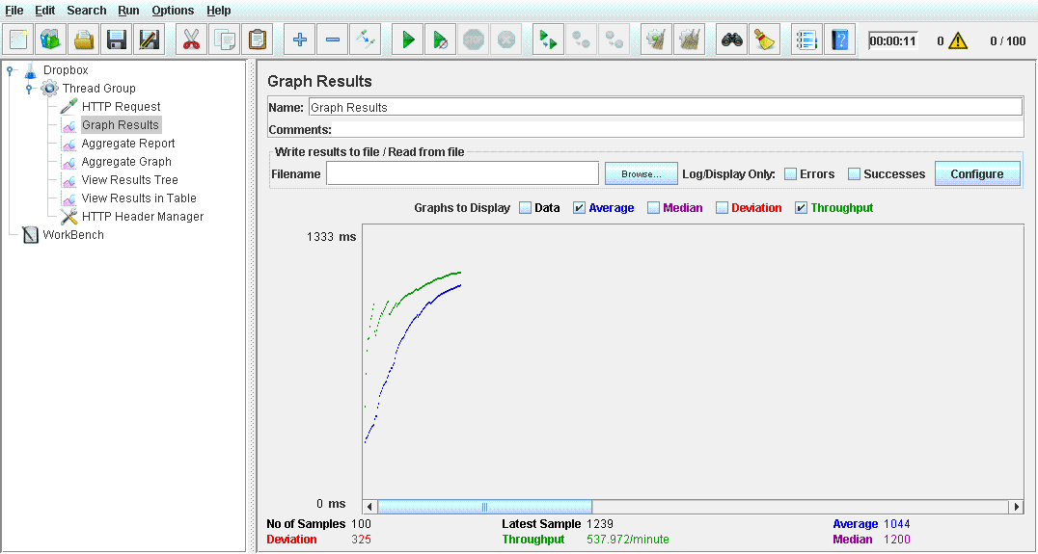

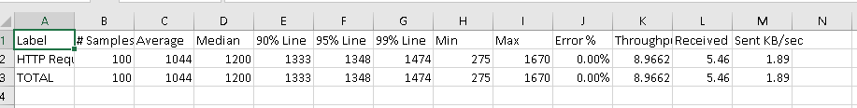

**200 users**

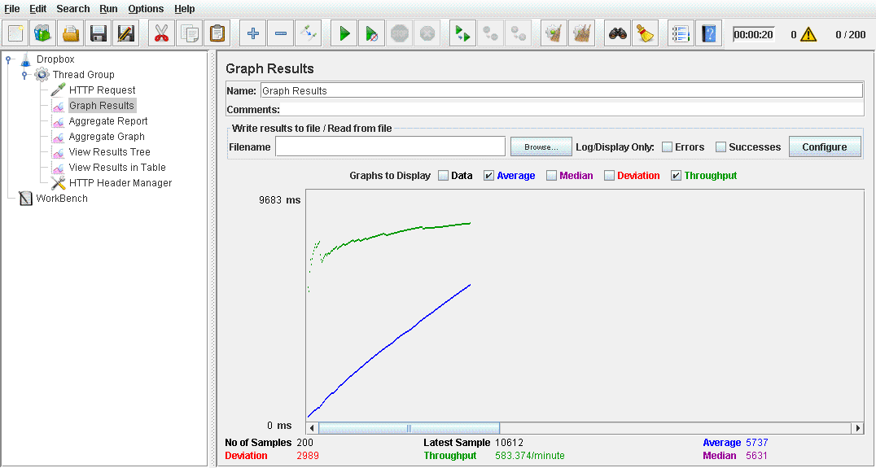

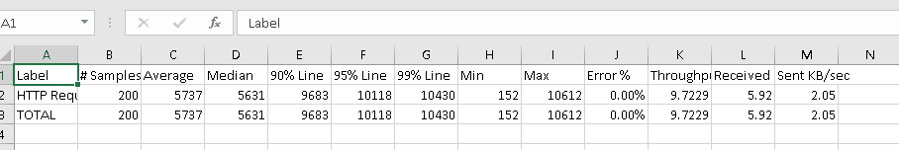

**300 users**

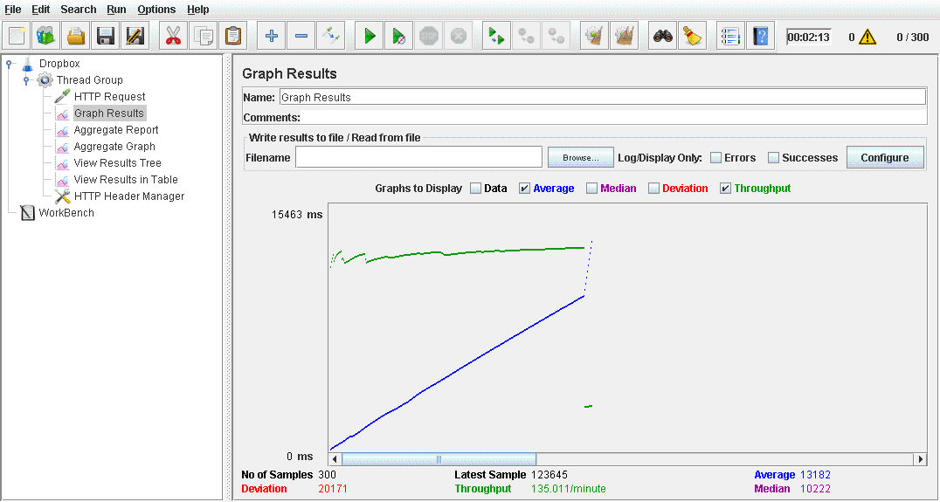

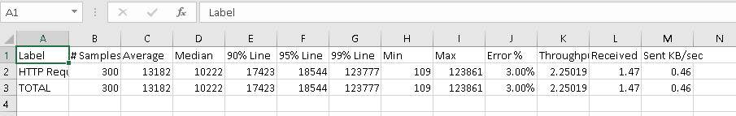

**400 users**

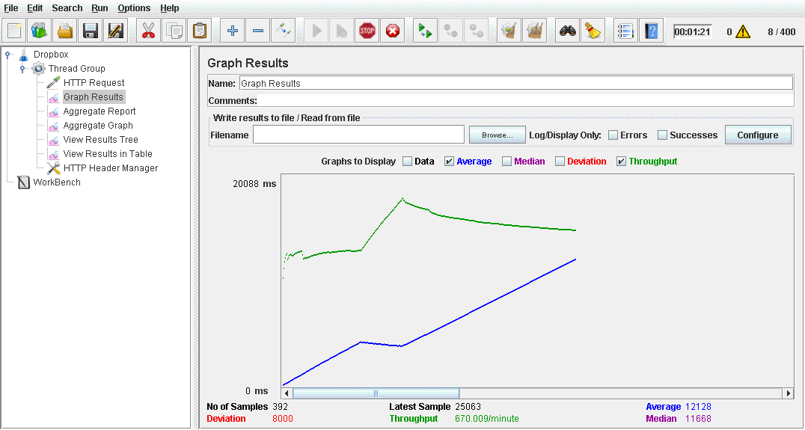

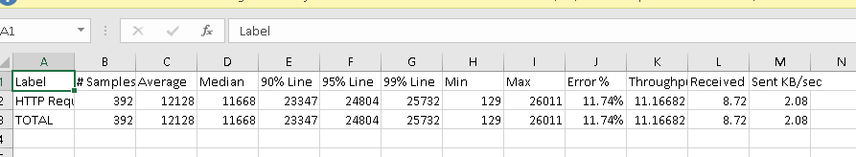

**500 users**



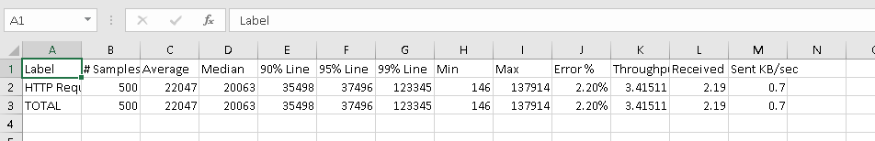

1. **With Connection Pooling**

**100 users**

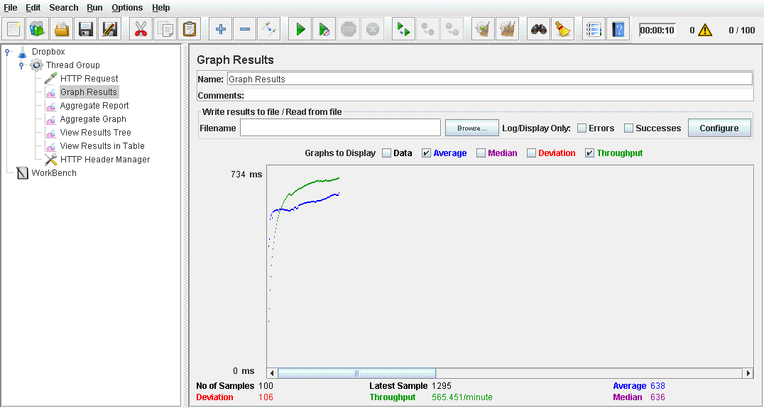

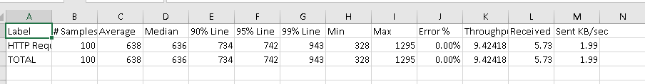

**200users**

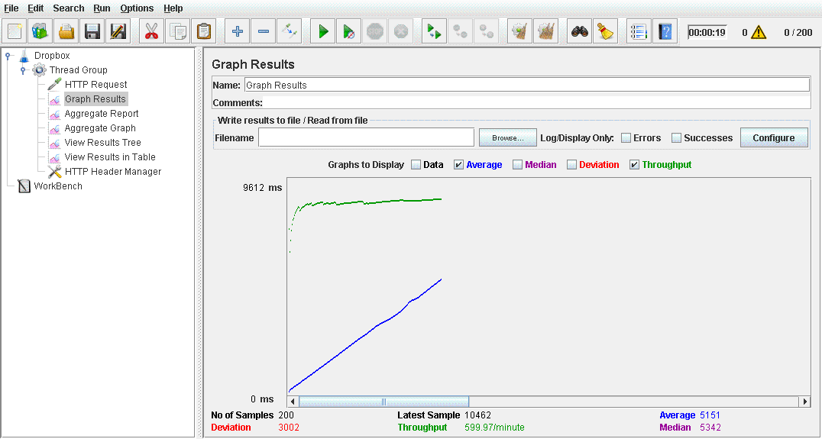

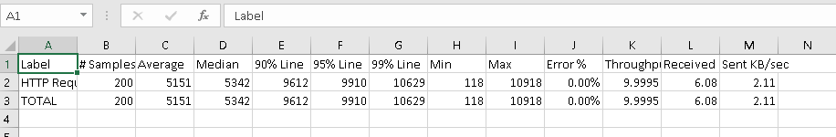

**300 users**

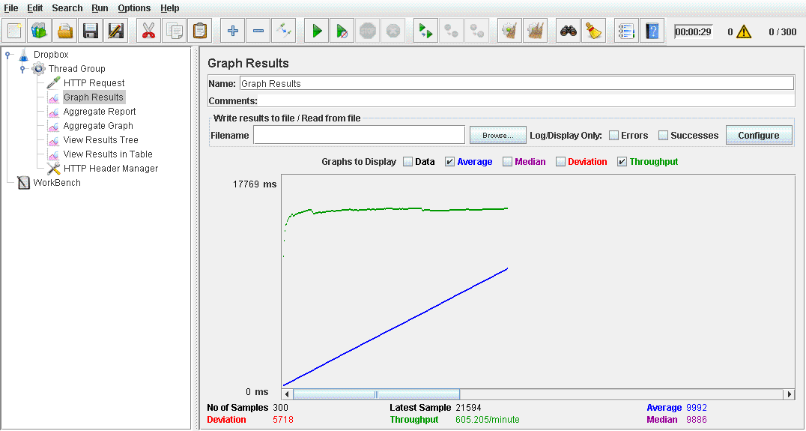

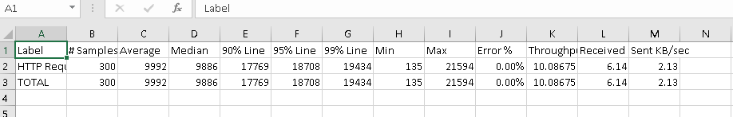

**400 users**

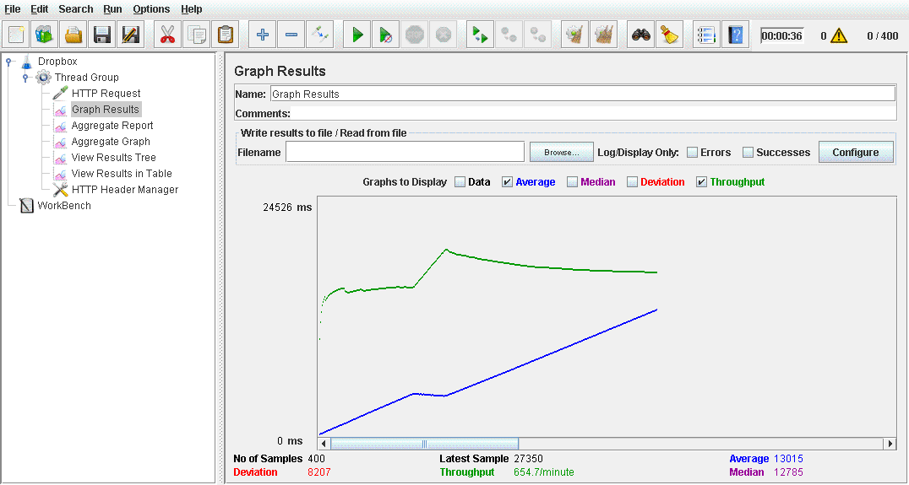

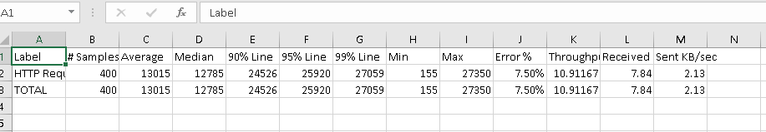

**500 users**



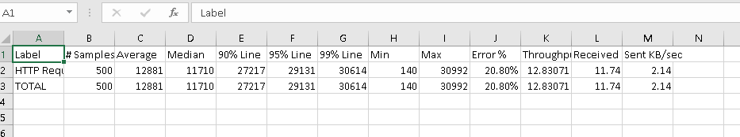

**Calculator**

**Jmeter Tests:**

1. **1,000 calculator calls on randomly selected tasks**

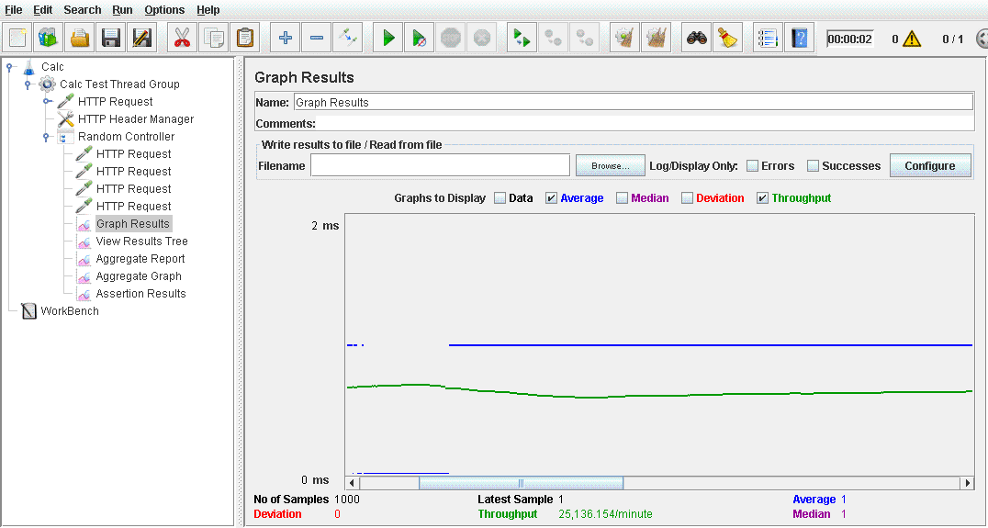

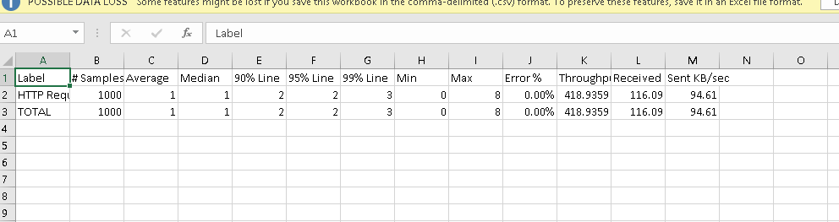

**5,000 calculator calls on randomly selected tasks**

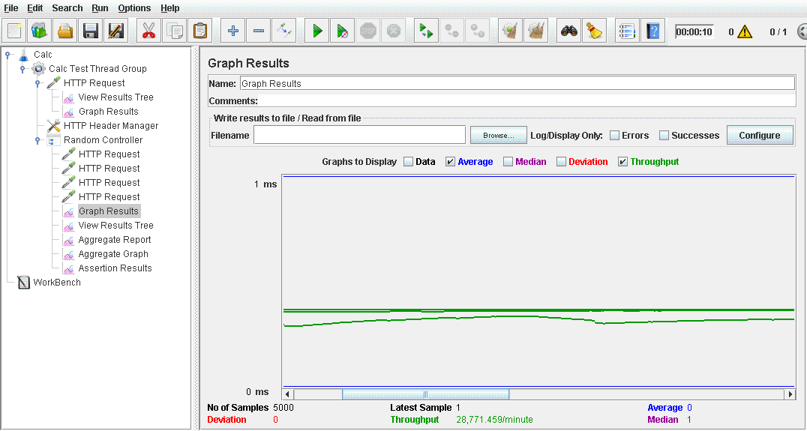

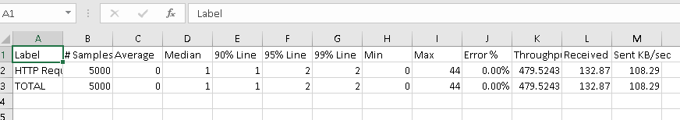

**100 concurrent users with 1000 calls each to calculator on randomly selected tasks**

