Goal:

I want to scrap the data on kream.  
Model number, name, english name and the link.

Detailed goal:

1. I want to scrap every product on kream.(roughly 50,000 products)
2. I want the products’ link(e.g.<https://kream.co.kr/products/83900>)
3. I want the brand name(e.g.[**Jordan**](https://kream.co.kr/brands/jordan))
4. I want the product’s model number(e.g. DZ5485-612)
5. I want the product’s model number, **but without dash(-)** (e.g. DZ5485 612)
6. I want the name of the product(e.g.조던 1 레트로 하이 OG 시카고 2022)
7. I want the english name of the product(e.g. Jordan 1 Retro High OG Chicago 2022)
8. I want the result with excel file.

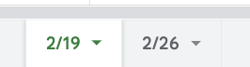

Kream(<https://kream.co.kr/search?per_page=40>)

* Fashion shopping mall close to <https://stockx.com/en-gb>
* People can buy and sell products there
* Responsive web

~~~~~~~~~~~~~~~~~~~~~~~~~~~~~~~~~~~~~~~~~~~~~~~~~~~~~~~~~~~~~~~~~~~

Goal:

I want to scrap the data on okmall([https://www.okmall.com](https://www.okmall.com/)).  
Model number, and the link.

Detailed goal:

1. I want to scrap every product on okmall.(roughly 70,000 products)
2. I want the products’ link (e.g.<https://www.okmall.com/products/view?no=190816&item_type=&cate=20008687&uni=B>)
3. I want the brand name
4. I want the product’s name, including brand name

[saint james 추가생산 MINQUIERS MODERNE (9859-50) (ECRU/MARINE) (밍콰이어 모던)]

**PHOTO**

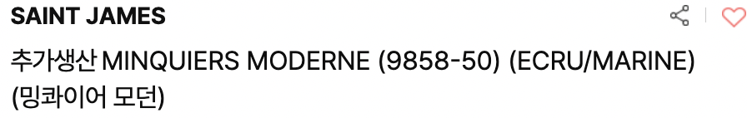

1. I want the product’s name, including brand name. **But without dash(-)**

[saint james 추가생산 MINQUIERS MODERNE (9859 50) (ECRU/MARINE) (밍콰이어 모던)]

1. I want the result with an excel file.

~~~~~~~~~~~~~~~~~~~~~~~~~~~~~~~~~~~~~~~~~~~~~~~~~~~~~~~~

result



~~~~~~~~~~~~~~~~~~~~~~~~~~~~~~~~~~~~~~~~~~~~~~~~~~~~

After having this bot, I want to expand to nike korea, new balance korea, abc mart korea and etc.  
   
I want to compare the price between those sites to kream.

~~~~~~~~~~~~~~~~~~~~~~~~~~~~~~~~~~~~~~~~~~~~~~

Goal:

Find the overlapping products on both sites(Okmall and Kream)

Detail:

#Kream’s model number consists with dash(-)

1. Find the Okmall product that includes kream’s model number(without dash) [e.g.7715Q0519 V0029]
2. Record it on excel with kream’s model number, kream’s link and Okmall’s link

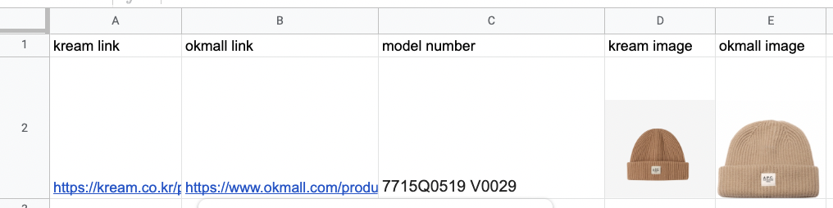

1. After step 2, remove the products that are found(to avoid getting the same result again). And then find products only with the model number before dash[e.g.7715Q0519] - I am doing it as not many products are found with full kream model number. as the two sites title the model number differently.
2. I want to get the script of this bot(programme). I will run bot every new week to track the new products.

# if more than one okmall products are found with one kream model number, please list them all.(e.g. One kream product with multiple okmall products.

#List the okmall products’ links and both sites’ images on downwards(don’t put kream link)

# a person is going to check the final result and every product is going to match as 1:1