# Introduction

Our Project titled “Employee Database & Payroll Management” has been designed & developed to make employee management easy. We have developed the database using MS SQL & we have also developed a web interface to manage the employee data. Using the web interface, we can view & update employee records which makes HR based tasks very simple and easy to work with. Human Resources issues are faced by organizations across the world. Every organization has data of employees which needs an efficient system to be managed and processed to give meaningful insights. So, we have designed an efficient database management system which meets the requirement of any organization.

We made this document to explain the design, functioning & specifications of the database along with the web interface. Now, using this the admin has all access to the records & can update the entries accordingly. This system saves a lot of time in manual entry & updating of information. The system is quite secure as well as it is managed by an admin using their credentials.

# Project Category: Web based Application

## Available Technology

**Languages:** HTML5, CSS3, JavaScript

**RDBMS:** Microsoft SQL Server

**Development platform:** Microsoft SQL Server

## Tool used

**Editor used:** Sublime Text 3 for front end development and PHP

**Operating System:** Windows 8.1

## Hardware used

**Processor:** Intel core i5

**RAM:** 12 GB

**Hard Disk:** 1 TB HDD

## Assumptions

* Each employee has only one manager
* Only admin can update the records

# Use Case Diagram

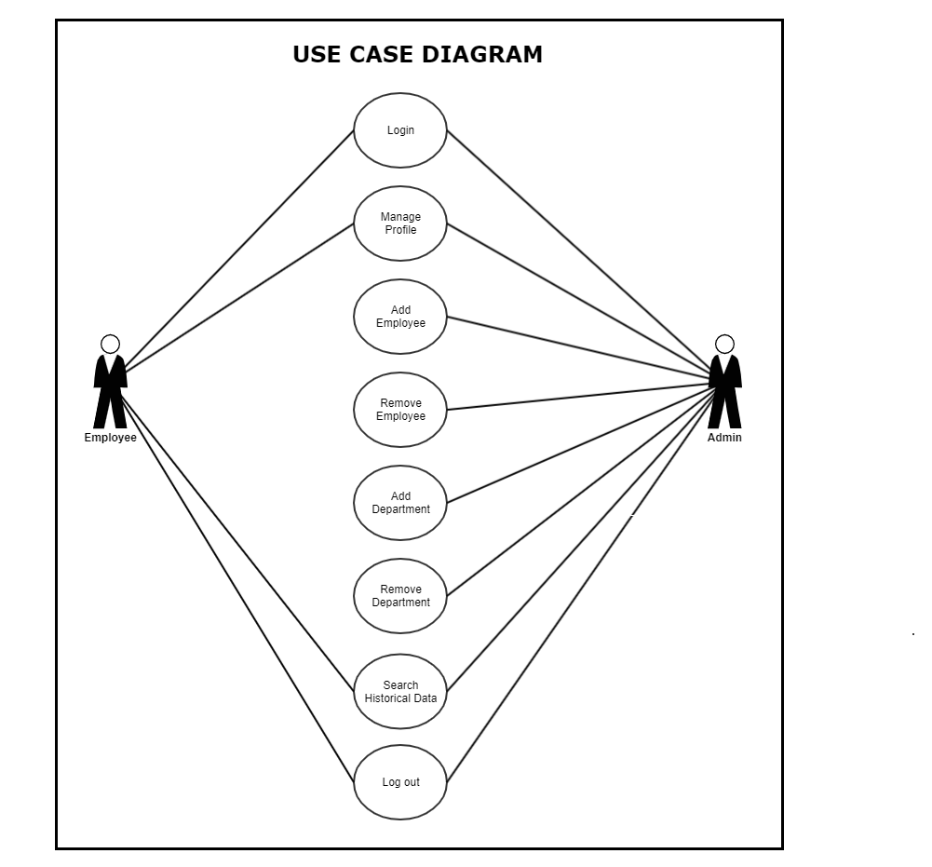

# Sequence Diagram

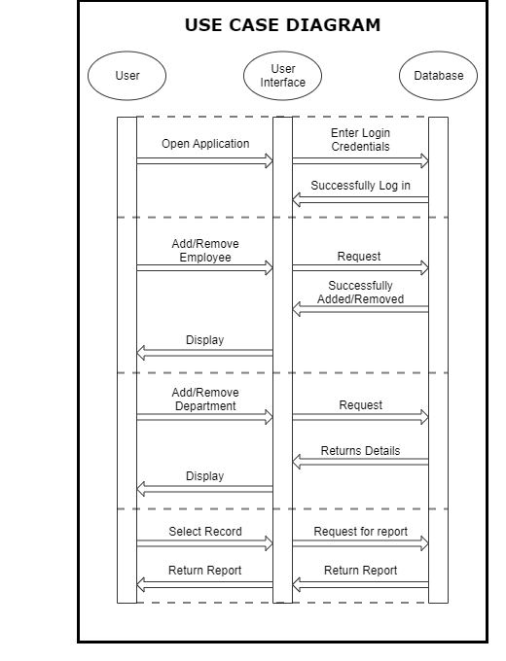

# Entity Relationship Diagram

# WWW

## Index

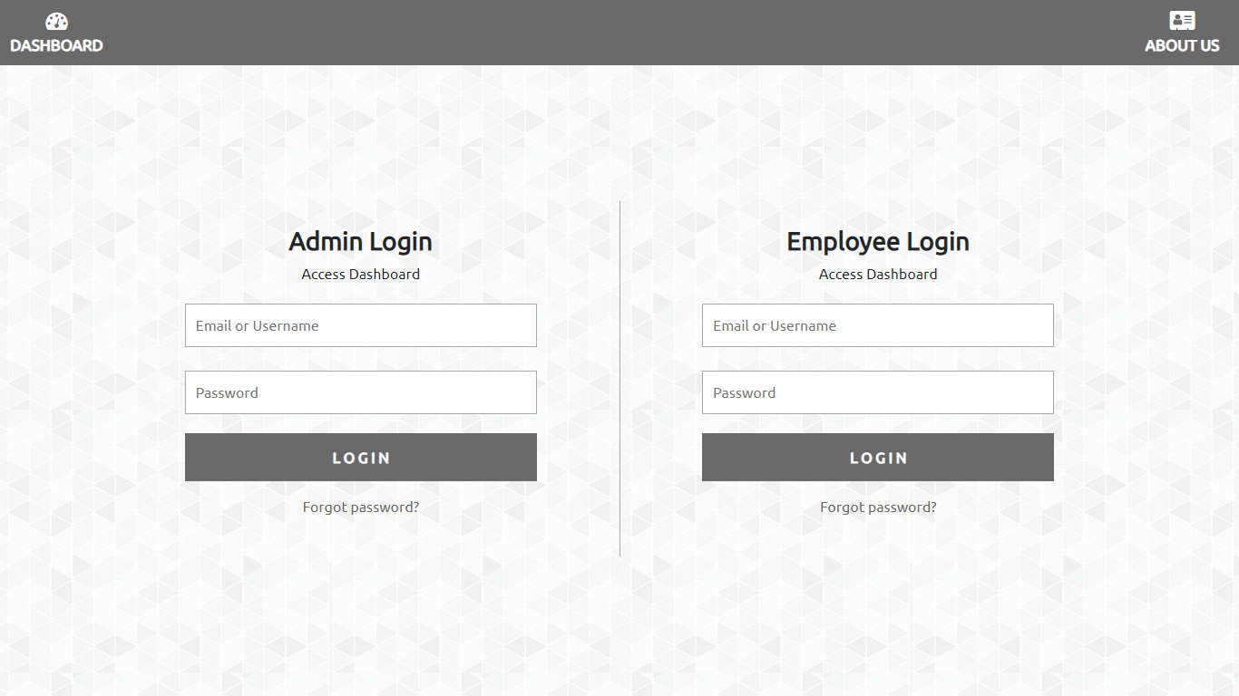

## Admin dashboard

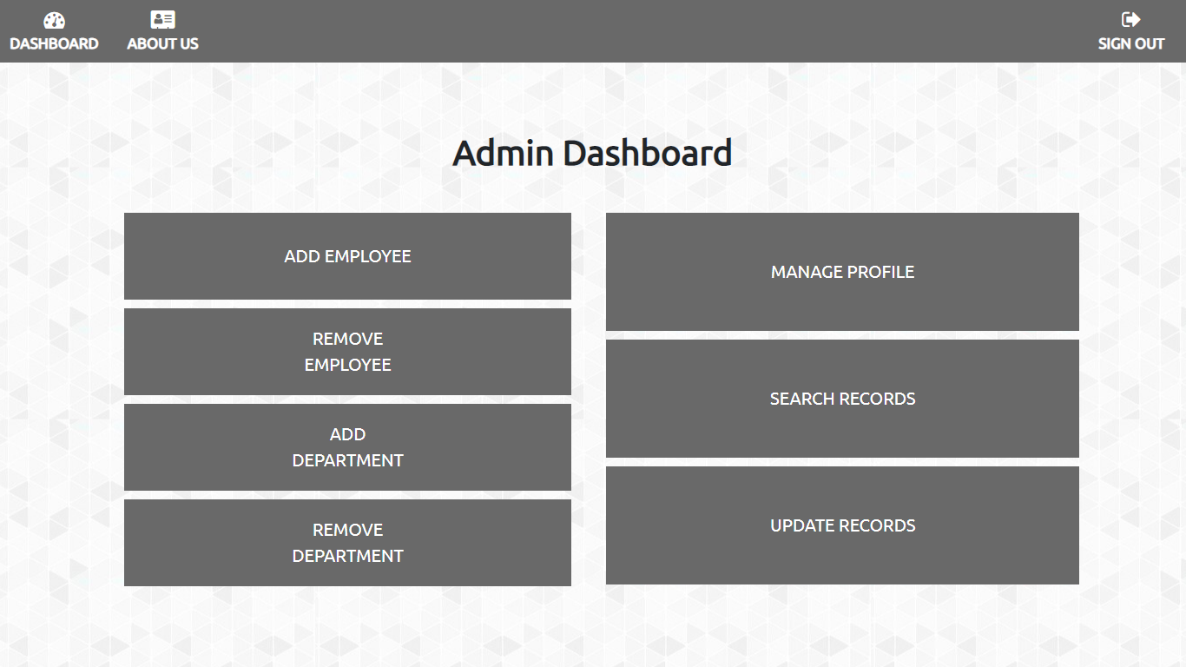

## Employee dashboard

## 

# Database Design

We have taken the database Employees from the USF Oracle Database server. We then migrated all the tables from Oracle SQL Developer to Microsoft SQL Server Management Studio. The database consists of 7 tables:

1. Employees
2. Departments
3. Locations
4. Countries
5. Job History
6. Regions
7. Jobs

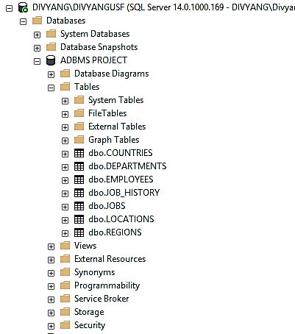

## Table 1: Employees

|  |  |  |
| --- | --- | --- |
| **Attributes** | **Type** | |
| Employee_ID (PK) | numeric (6, 0) | Not Null |
| First_Name | varchar (20) | Not Null |
| Last_Name | varchar (20) | Not Null |
| Email | varchar (25) | Not Null |
| Phone_Number | varchar (20) |  |
| Hire_Date | date | Not Null |
| Job_ID (FK) | varchar (10) | Not Null |
| Salary | numeric (8,2) |  |
| Commission_PCT | numeric (2,2) |  |
| Manager_ID | numeric (6,0) |  |
| Department_ID | numeric (4,0) |  |

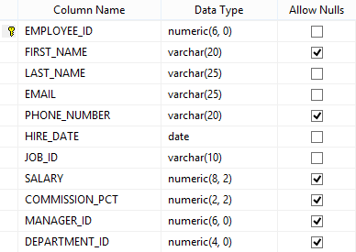

## Table 2: Departments

|  |  |  |
| --- | --- | --- |
| **Attributes** | **Type** | |
| Department_ID (PK) | numeric (4, 0) | Not Null |
| Department_Name | varchar (30) | Not Null |
| Manager_ID (FK1) | numeric (6, 0) |  |
| Location_ID (FK2) | numeric (4, 0) |  |

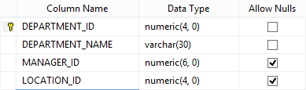

## Table 3: Locations

|  |  |  |
| --- | --- | --- |
| **Attributes** | **Type** | |
| Location_ID (PK) | numeric (4, 0) | Not Null |
| Street Address | varchar (40) | Not Null |
| Postal Code | varchar (20) | Not Null |
| City | varchar (25) | Not Null |
| State Province | varchar (20) |  |
| Country_ID (FK) | date | Not Null |

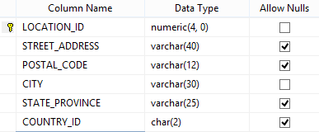

## Table 4: Countries

|  |  |  |
| --- | --- | --- |
| **Attributes** | **Type** | |
| Country_ID (PK) | numeric (4, 0) | Not Null |
| Country_Name | varchar (40) |  |
| Region_ID (FK) | numeric |  |

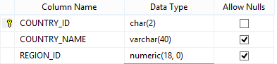

## Table 5: Job History

|  |  |  |
| --- | --- | --- |
| **Attributes** | **Type** | |
| Employee_ID (PK) (FK1) | numeric (6, 0) | Not Null |
| Start_Date | date | Not Null |
| End_Date | date | Not Null |
| Job_ID (FK2) | varchar (10) | Not Null |
| Department_ID (FK3) | numeric (4, 0) |  |

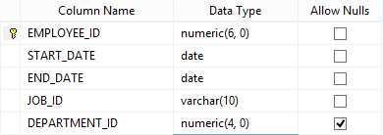

## Table 6: Regions

|  |  |  |
| --- | --- | --- |
| **Attributes** | **Type** | |
| Region_ID (PK) | Numeric | Not Null |
| Region_Name | varchar (25) |  |

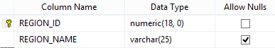

## Table 7: Jobs

|  |  |  |
| --- | --- | --- |
| **Attributes** | **Type** | |
| Job_ID (PK) | varchar (10) | Not Null |
| Job_Title | varchar (35) | Not Null |
| Min_Salary | numeric (6, 0) |  |
| Max_Salary | numeric (6, 0) |  |

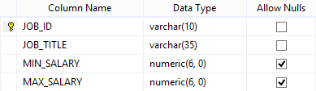

# Future Scope

1. The Feature to regularly backup data of Employees so as to have data offline in case of a disaster where the data is lost.
2. Option to show leaves available & availed leaves by employee.
3. Option to take a printout of the records.

# References

1. W3 Schools
2. Tutorials Point
3. YouTube KudVenkat Channel