ICASE Assignment

Contents

Introduction 2

Use Case Diagram 3

User 1: Student 4

User 2: Professor 4

User 3: Staff 4

Class Diagram 5

State Chart Diagram 7

Chart Diagram 1: Add/drop class (Student’s perspective) 7

Chart Diagram 2: Check Prerequisite Status (Professor’s perspective) 8

Chart Diagram 3: Student Advise (Staff perspective) 9

# Introduction

Online Access Student Information Systems (OASIS) is an online platform at USF for course registration. With the advent of technology, course registration has become an online task. For a university, it is required that the portal works with as few glitches as possible. It enables students to create and update their profile, add or drop courses, manage their semester schedule and other features like paying tuition fees and applying for financial aid. It also enables professors to This report contains the flow of the system by using it’s Use Case diagram, Class Diagram and State Chart Diagram.

# Use Case Diagram

Use case diagram is a representation of interaction between users and system entities. Following use case diagram show interaction of a system with three categories of users: Students, Professors and Staff.

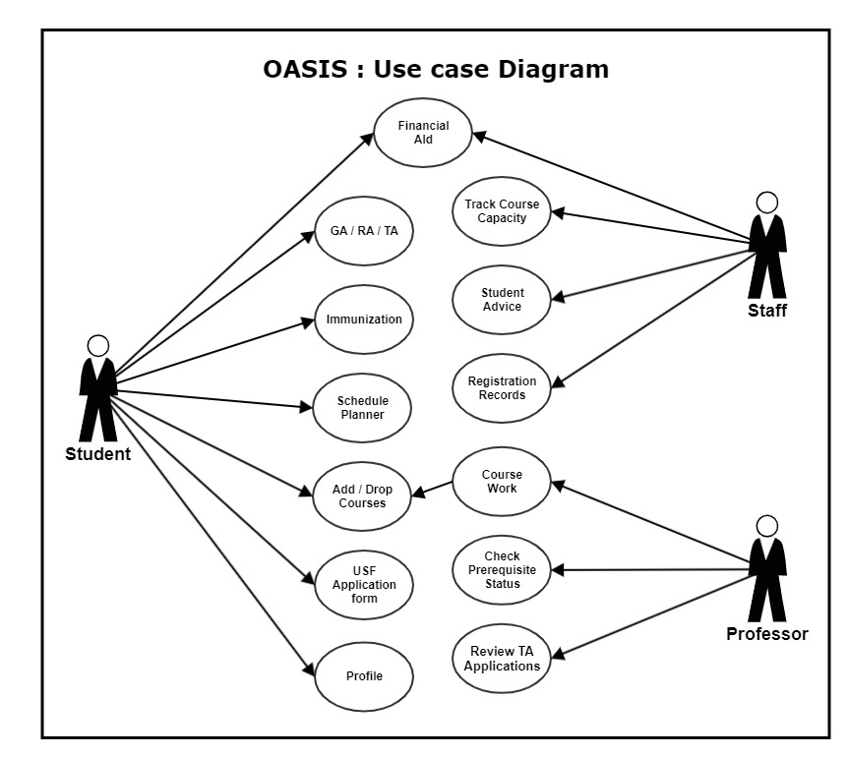

## User 1: Student

* **Profile** – Students can create and update their profile once they sign up. Information like First Name, Last Name, Admitted Year and Intake, Address, Phone number, Email etc.
* **USF Application form Status** – Once signed up, students can apply for undergraduate, graduate or doctorate by submitting a detailed application form to USF before the deadlines. Students can also check the status of their form once submitted successfully.
* **Immunization** – Students are required to submit an immunization form that meets with the USF health services requirements. Students can upload a scanned copy of the complete immunization form in order to remove the immunization holds.
* **Add/Drop Courses** – Once admitted, students can select courses and professors, review the course work and schedule, add or drop courses, etc.
* **Financial Aid** – Students can apply for financial aid by providing academic as well as professional profile in order to receive a grant.
* **GA/TA/RA** – Students can also apply for Graduate/Teaching/Research Assistantship under certain listed professors and staff members in order to enhance their skills and explore the domain along with helping the professor as well as fellow students.
* **Schedule Planner** – Once the courses are registered, students can view their weekly course schedule along with the start and due data of assignments and quizzes in order to plan the week ahead of the time

## User 2: Professor

* **Check Prerequisite Status** – Each student is given mandatory prerequisite courses once admitted into their respective programs. Professors can check the status of prerequisite done by students. Students can submit a course certificate in order as an acknowledgement for the professor.
* **Course work** – Professor can upload a short description of the course work, breakdown of grades and flow of course when students are registering for the course for them to select the course in their interest.
* **Review Teaching Assistantship Applications** – Professors can review the applications for assistantships submitted by students and either appoint someone as an assistant or to decline the assistantship.

## User 3: Staff

* **Registration records** – Staff can focus on the management part like keeping track of current and new students with updated details.
* **Modify seating capacity** – Class capacity of the course can be tracked by staff members and notify students about any changes in course work or capacity.
* **Student Advise** – Newly admitted students are unaware many documentations procedure, staff members can advise them on topics like how to apply for financial aid, how to remove the immunizations hold and a few more.
* **Financial Aid** – Students based on their academic as well as professional profiles can choose to apply for the financial aid.

# Class Diagram

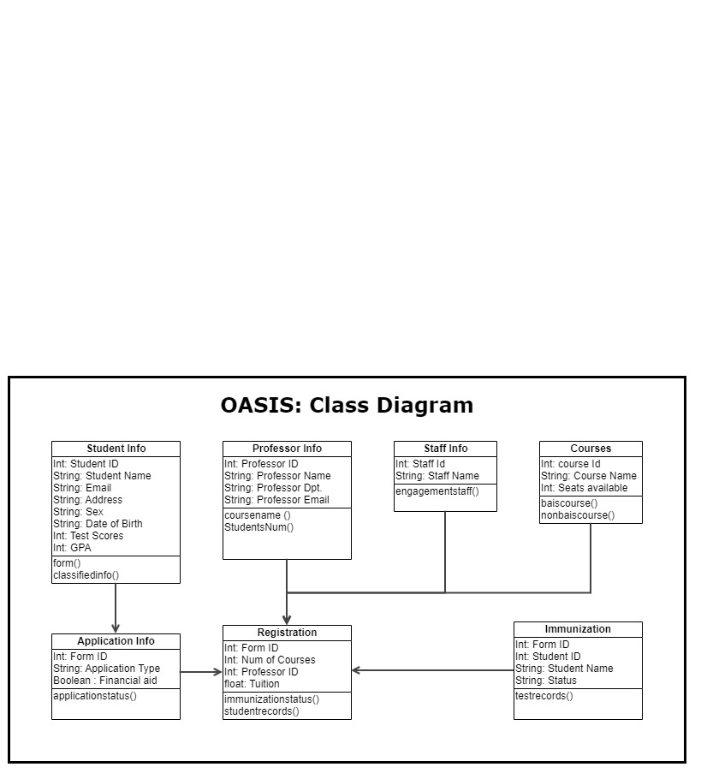

**Database Description:**

|  |  |  |
| --- | --- | --- |
| **Table Name** | **Attribute** | **Functions** |
| Student Info | Student ID, Student Name, Email, Address, Sex, Date of Birth, Test Scores, GPA | form()  classifiedinfo() |
| Professor Info | Professor ID, Professor Name, Professor Dpt, Professor Email | coursename()  StudentsNum() |
| Staff Info | Staff Id, Staff Name | Engagementstaff() |
| Courses | Course ID, Course Name, Seats available | baiscourse()  nonbaiscourse() |
| Application info | Form ID, Application Type, Financial aid | applicationstatus() |
| Registration | Form ID, Num of Courses, Professor ID, Tuition | immunizationstatus()  studentrecords() |
| Immunization | Form ID, Student ID, Student Name, Status | testrecords() |

# State Chart Diagram

## Chart Diagram 1: Add/drop class (Student’s perspective)

Once admitted, students can start registering for the courses for that semester. New students can sign-up on the OASIS portal and existing students can sign-in using their netID. Students can search for courses once registration begins. Student can also view the course work and breakdown of grades provided by the students and see if it fits in the interest of the students as students have different priorities when it comes to choosing between conceptual course and a practical course. After selecting and updating the courses, student can confirm their courses by paying the tuition fee before the given deadline

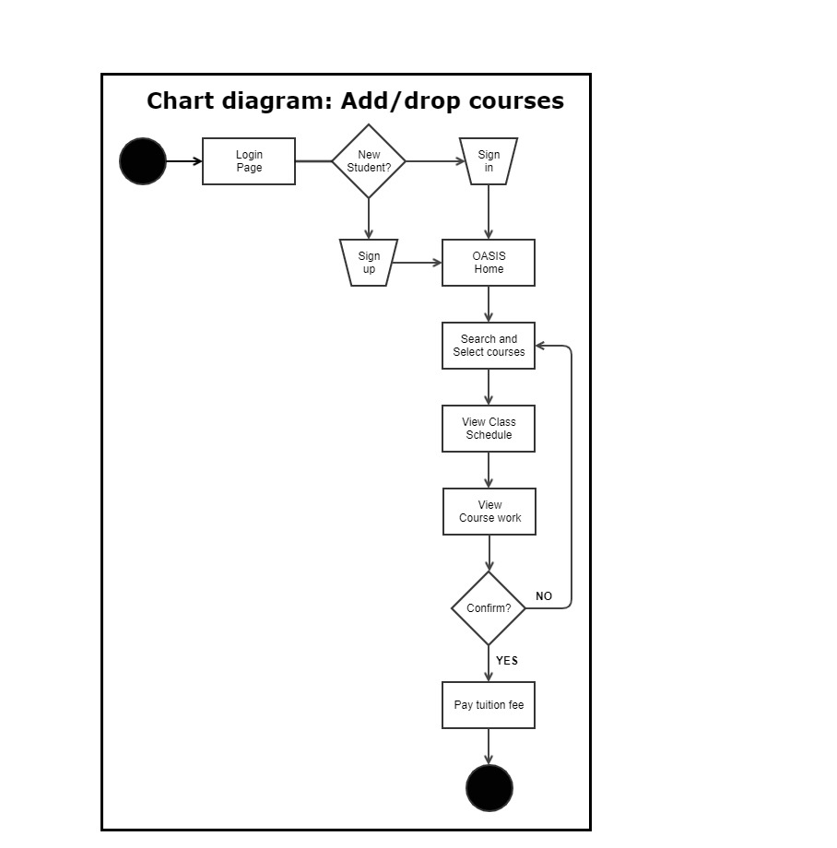

## Chart Diagram 2: Check Prerequisite Status (Professor’s perspective)

Students are given prerequisites by their department in order to keep them at par in the course work. Professors can keep the track of students who are yet to complete the prerequisite and notify them to finish the prerequisite before the deadline in order to take the course.

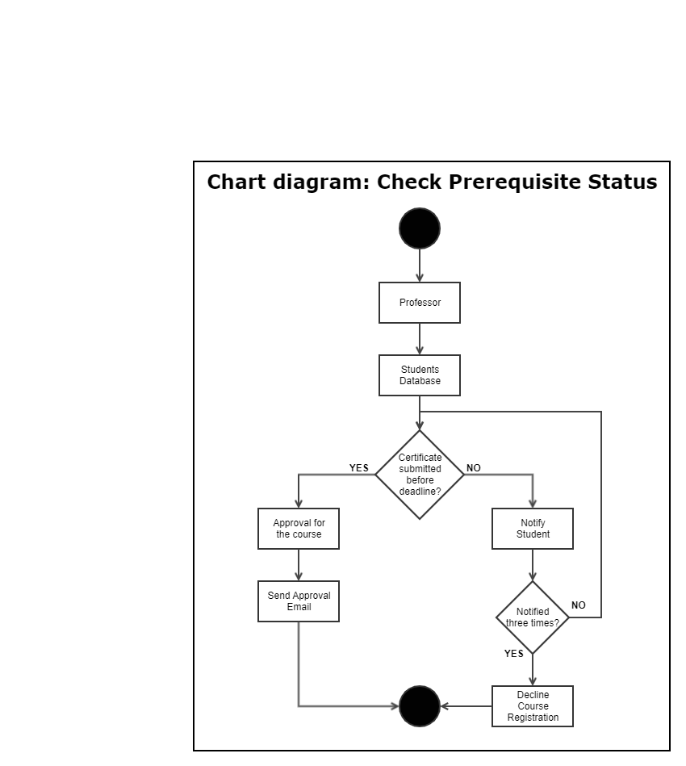

## Chart Diagram 3: Student Advise (Staff perspective)

Staff members can help students in various ways like, advising students on important courses to take in specific semesters, guide them on immunization holds process, help them by reviewing their cover letters and project reports for Assistantships and financial aid.

