This notebook trains a sequence to sequence (seq2seq) model for English to Hindi translation with reverse dictionary.

After training the model we will be able to input a English sentence, such as "someone who maintains and audits business accounts", and return the Hindi translation: "START_ वह कर्मचारी जो आय-व्यय आदि का हिसाब लिखता या रखता हो _END" and word “**गणक**”

The translation quality is reasonable, but the generated attention and its corresponding word is perhaps more interesting.

**Encoder-Decoder model**

Implement an encoder-decoder model with attention, which is similar to [Neural Machine Translation (seq2seq) tutorial](https://github.com/tensorflow/nmt).

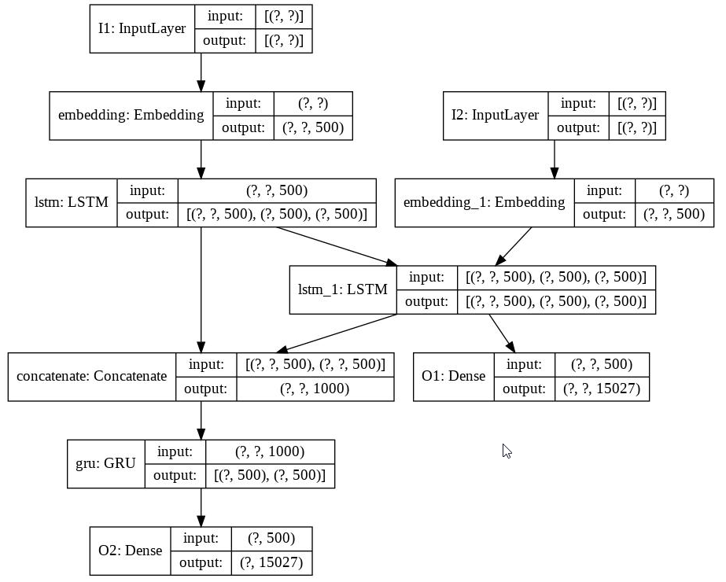

Which can be realized as

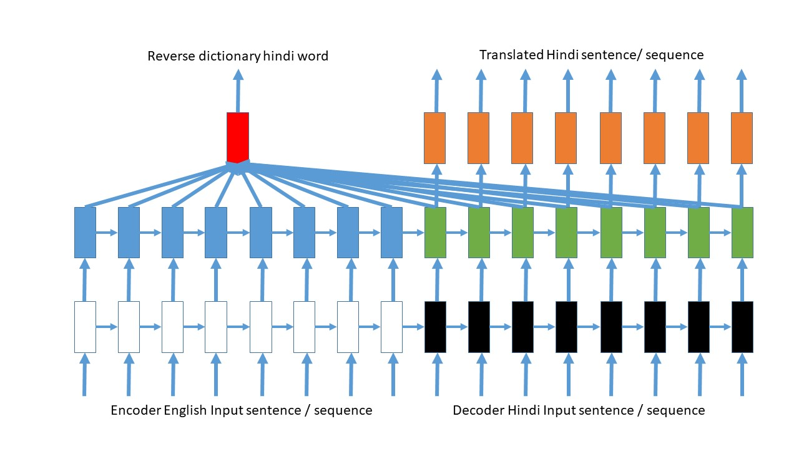

Here the reverse dictionary word is predicted along with translated sequence.

This shows which parts of the input sentence has the model's attention while translating:

