LINUX COMMANDS:

1> pwd - This command use to print name of current working directory

eg . pwd

2> vi- command use to open program and text editor

eg. vi text.txt

3. touch-

4> mkdir- Command use to create directory

eg . mkdir (directory name)

5> rm -  Remove files or directories

eg . rm text.txt , rm directory

6> ls - Command is used to list directory content

eg . ls -lrt , lsrt , ls (directory name)

7> echo - Command display a line of text

eg. echo lineabc

8. cat - This command oncatenate files and print standard output

eg . cat text1.txt text2.txt

cat -n text1.txt

9> who - Command shows who is logged on

eg. who , who -q

10> cd This command is used to change directry

eg. cd (directory name)

11> date - this command shows the date of the system

eg. date

12> cal - this command shows calender

eg. cal

13> mv - move files to source destination

eg. mv text.txt directory , mv text1.txt text2.txt

14> cp - This command use to copy files and directories

eg. cp text1.txt text2.txt

15> which – this command used to identify the location of executables

Eg . which

Screenshots for output of commands :

* ls -lrt , ls , pwd

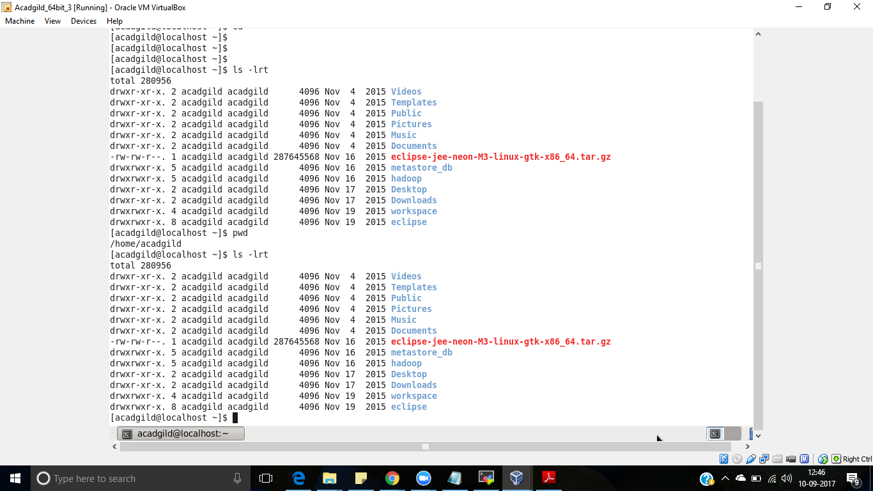

* vi , vim

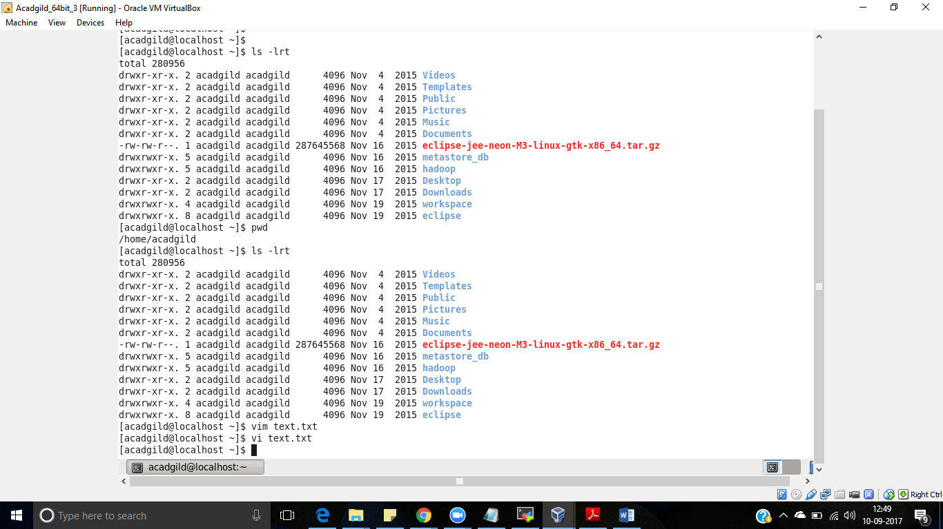

* mkdir

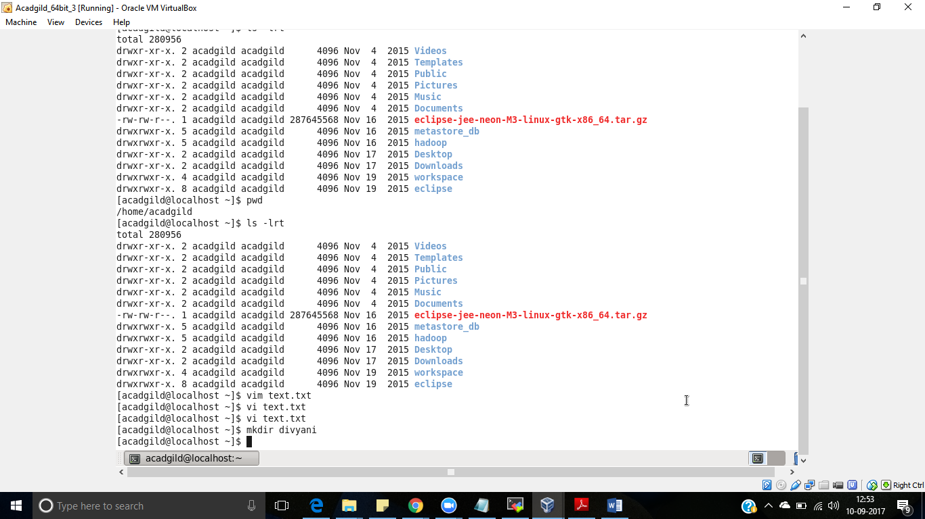

* rm

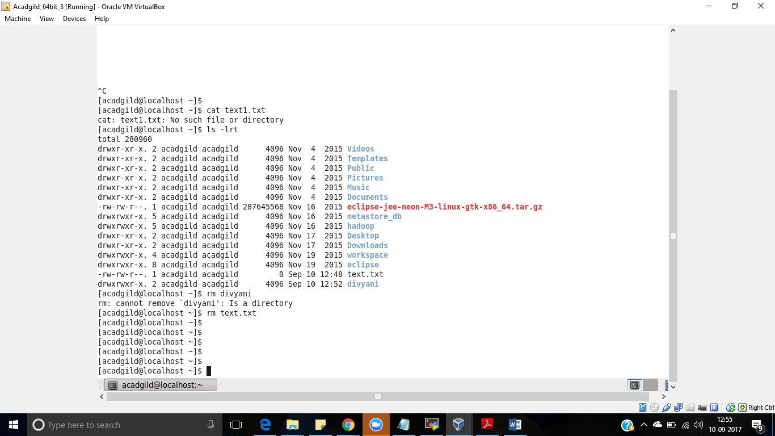

* date , cal , echo

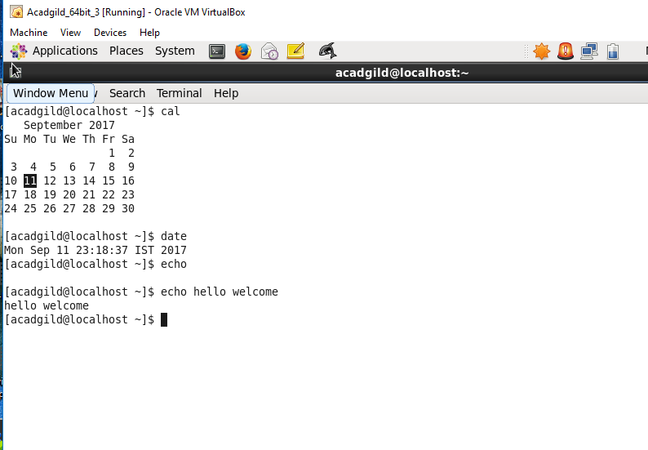

* mv , cd

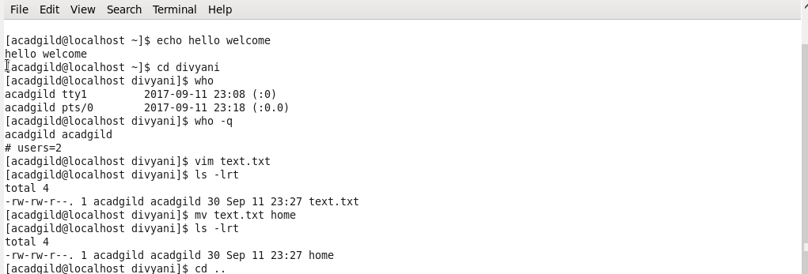

* cp

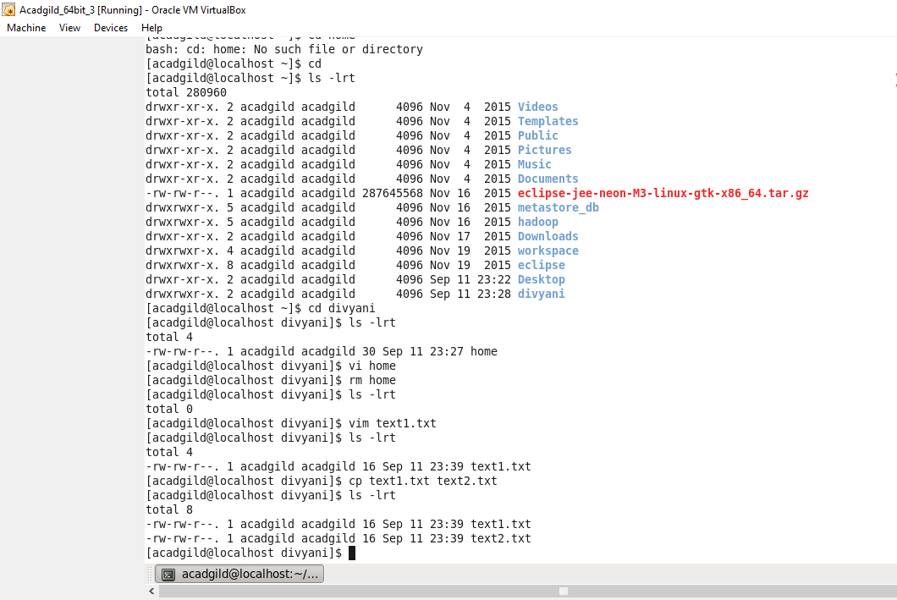

* which

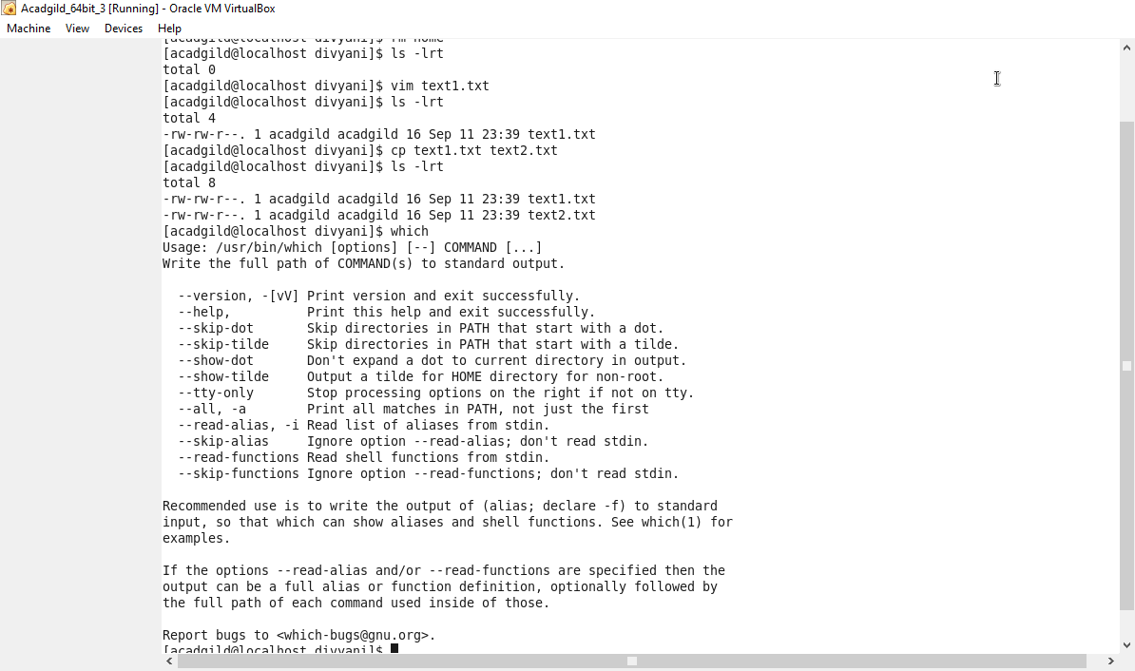

* cat

